ARCIGA, Erica Aurelle P. 2ECE-D

BOBIS, Allen Joseph M.

**Machine Problem 2 Output (MATLAB)**

Point 1: (2,1); Point 2: (-3,4); Point 3: (1,-3)

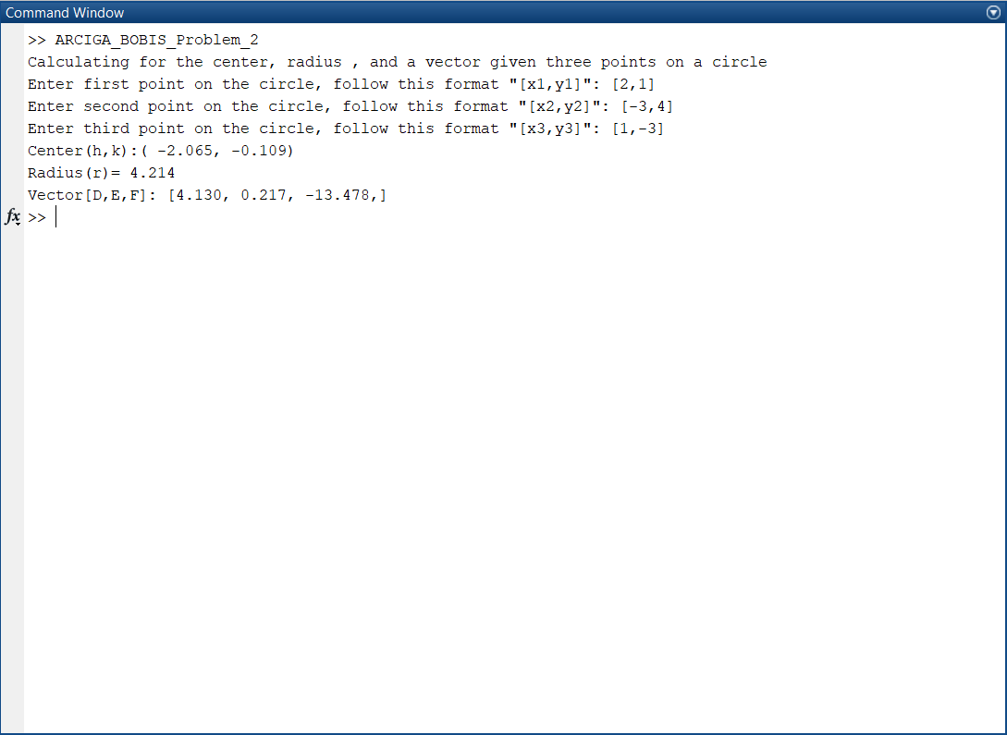

Point 1: (3,4); Point 2: (4,5); Point 3: (1,-4)

