ARCIGA, Erica Aurelle P. 2ECE-D

BOBIS, Allen Joseph M.

**Machine Problem 4 Output (MATLAB)**

1. Initial height is zero

Initial Height=0, Velocity=20, Angle=30, Acceleration(x)=5, Acceleration(y)=-15

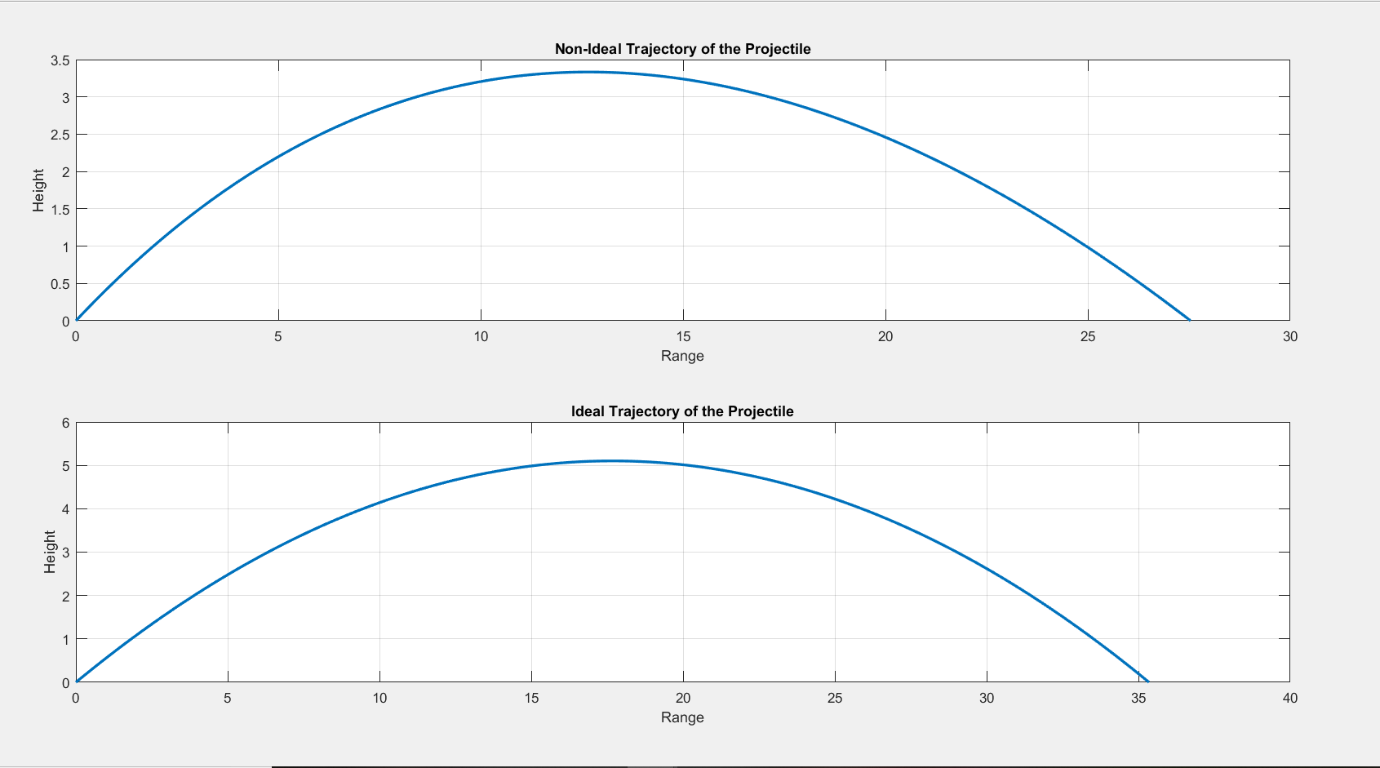

1. Initial Height is elevated

Initial Height=5, Velocity=20, Angle=30, Acceleration(x)=5, Acceleration(y)=-15

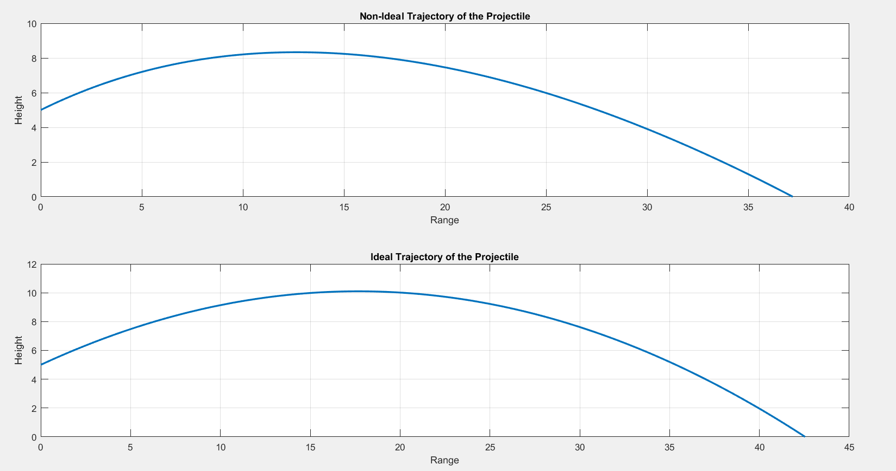

1. Y-component of acceleration is -9.8, but X-component of acceleration is not 0

Initial Height=5, Velocity=20, Angle=30, Acceleration(x)=5, Acceleration(y)=-9.8

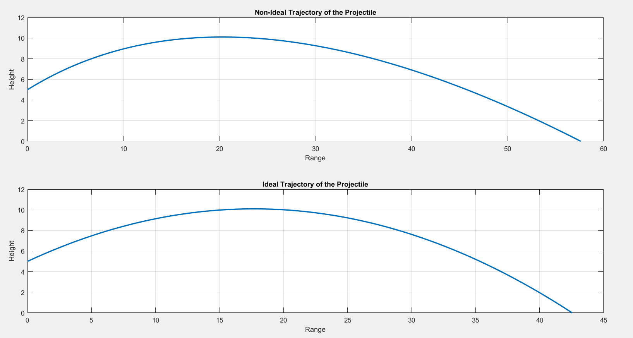

1. Y-component of acceleration is 0

Initial Height=5, Velocity=20, Angle=30, Acceleration(x)=5, Acceleration(y)=-0

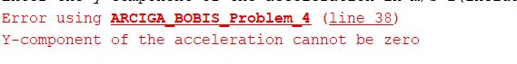

1. Initial Height is negative

Initial Height=-5, Velocity=20, Angle=30, Acceleration(x)=5, Acceleration(y)=-15

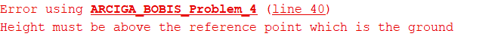

1. Velocity is zero

Initial Height=5, Velocity=0, Angle=30, Acceleration(x)=5, Acceleration(y)=-15



1. Angle is negative

Initial Height=5, Velocity=20, Angle=-30, Acceleration(x)=5, Acceleration(y)=-15

