**PROBLEM 1**

Firs part: Merged DataFrames

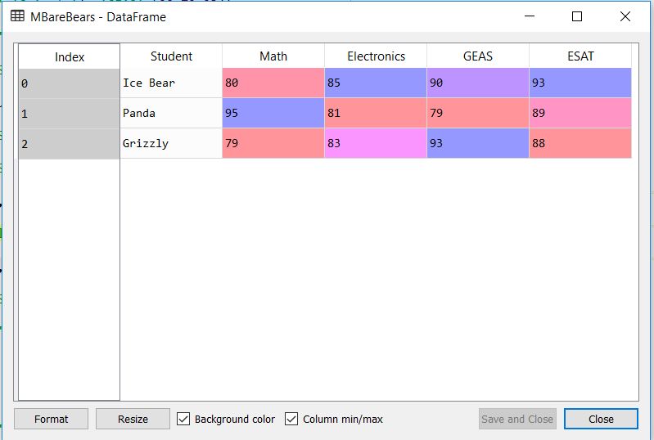

Second Part: Long Format

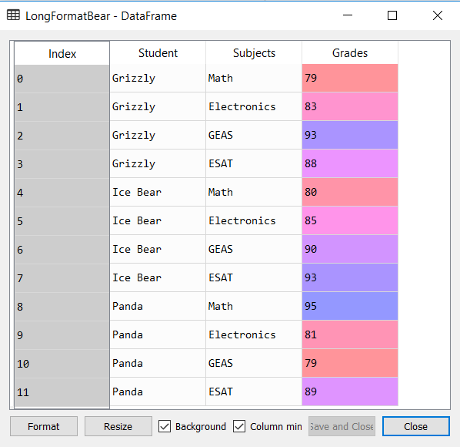

**PROBLEM 2**

First Part: TidyData

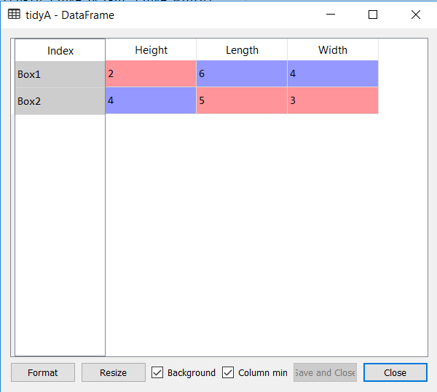

Second Part: TidyDatawithVolume

