BACKEND DESIGN DOCUMENT

GitHub Repository
Watch Dashboard
TypeScript + Express + Zod + GitHub REST API
Learning project designed to practice production-style service engineering

Purpose: Build a functional backend that accepts repository requests, calls a real external API, validates untrusted data, transforms it into an internal model, persists a watchlist in memory, exposes reports, and centralizes errors. The design intentionally mirrors the milestone-driven structure of the internship reference document.

1. Overview
The GitHub Repository Watch Dashboard is a small backend service that lets a client look up public GitHub repositories, add selected repositories to a watchlist, retrieve/remove watched repositories, refresh their metadata, and generate simple reports. The service is intentionally small enough to finish, but layered enough to practice the same engineering skills used in a larger production codebase.
The internship reference describes an operator workflow that crosses multiple backend services and emphasizes end-to-end integration, API models, validation, unit tests, real-data testing, edge cases, and later deployment. This project adopts those same habits at a smaller scale.

1.1 Goals
- Build a real Express 5 API in TypeScript rather than a toy in-file CRUD example.
- Call a real external endpoint (GitHub REST API) and treat external JSON as untrusted.
- Use Zod for runtime validation and TypeScript types for compile-time safety.
- Separate routing, middleware, handlers, services, and persistence responsibilities.
- Practice request parameters, query parameters, request bodies, status codes, async/await, error propagation, and dependency injection.
- Test each milestone before adding the next one.
- Leave a clean path to a later frontend, PostgreSQL, automated integration tests, authentication, and AWS deployment.

1.2 Non-goals for the first backend version
- No user accounts or authentication.
- No PostgreSQL yet; persistence is intentionally in-memory.
- No background jobs or queues.
- No GitHub OAuth or private-repository access.
- No attempt to mirror the full GitHub API.
- No production deployment until the local service is correct and tested.

2. High-Level Design Flow
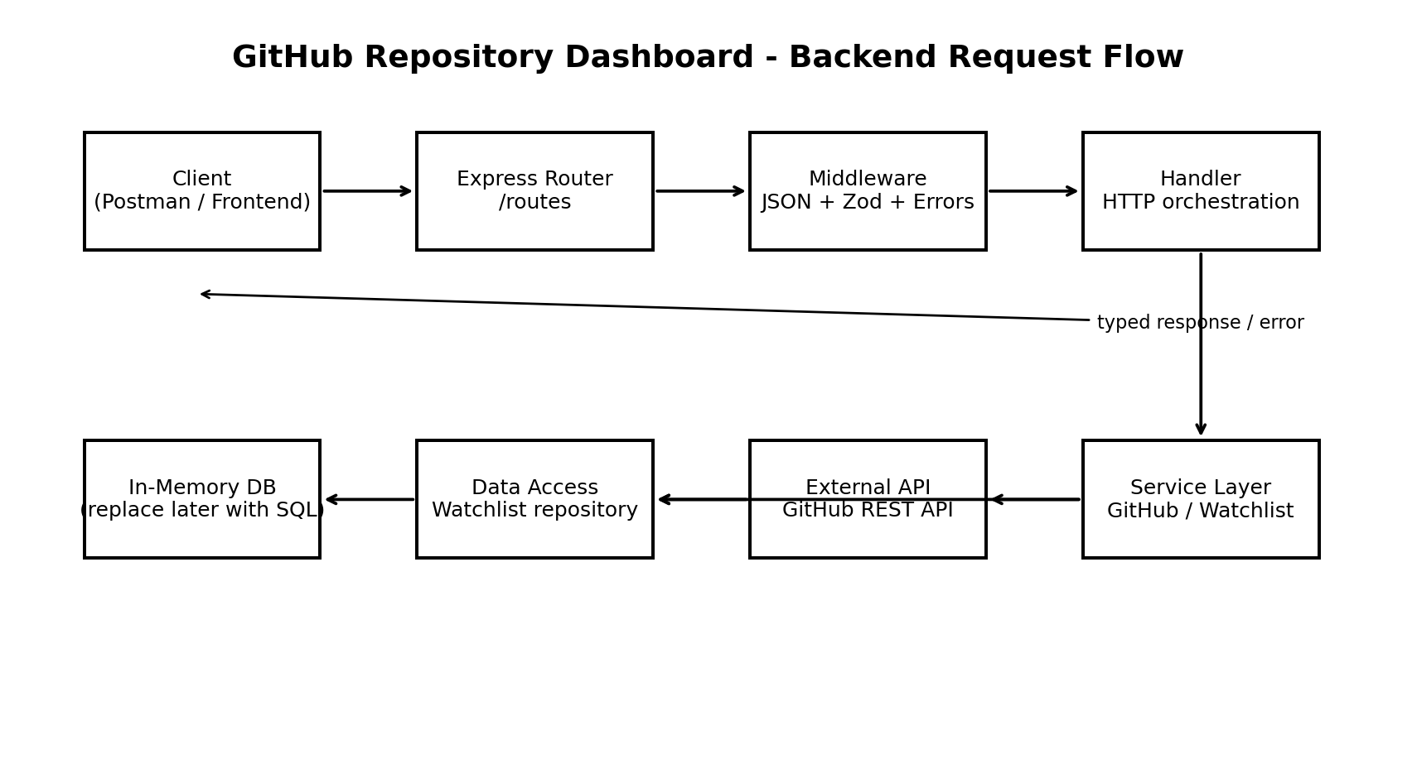
Figure 1. Backend request flow and responsibility boundaries.
A request enters through Express routing, passes through cross-cutting middleware, reaches a handler, and then delegates actual work to a service or data-access dependency. External GitHub responses are validated before becoming trusted application data. Errors are forwarded to centralized error middleware rather than formatted independently in every handler.
Example request path
GET /repos/facebook/react
|
v
repo.routes.ts
|
v
getRepository handler
|
v
GitHubRepositoryService
|
v
fetch(api.github.com/repos/facebook/react)
|
v
unknown JSON -> Zod validation -> Repository
|
v
200 JSON response

3. Proposed Source Structure
src/
├── server.ts
├── app.ts
├── api/
│ ├── repos/
│ │ ├── repo.routes.ts
│ │ └── repo.handlers.ts
│ ├── watchlist/
│ │ ├── watchlist.routes.ts
│ │ ├── watchlist.handlers.ts
│ │ └── watchlist.schemas.ts
│ └── reports/
│ ├── report.routes.ts
│ └── report.handlers.ts
├── models/
│ └── repository.ts
├── services/
│ └── githubRepositoryService.ts
├── data/
│ ├── inMemoryDatabase.ts
│ └── watchlistDataAccess.ts
├── middleware/
│ ├── requestLogger.ts
│ └── errorHandler.ts
└── shared/
└── errors.ts
tests/
├── unit/
└── integration/
Layer | Responsibility | Should NOT do
Router | Map HTTP method/path to middleware + handler. | Business logic or direct GitHub calls.
Middleware | Cross-cutting request processing: JSON, logging, validation, errors. | Own the feature workflow.
Handler | Translate HTTP input into service calls and HTTP output. | Know GitHub payload details or DB internals.
Service | External API/business logic and transformations. | Depend on Express Request/Response.
Data access | Persistence operations for watchlist data. | Format HTTP responses.
Model/schema | Define trusted internal data and runtime validation. | Perform network or persistence work.

4. Core Models, Parameters, and Interfaces

4.1 Internal repository model
export interface Repository {
owner: string;
name: string;
description: string | null;
stars: number;
forks: number;
language: string | null;
url: string;
}
export interface WatchedRepository extends Repository {
id: string;
addedAt: string;
refreshedAt: string;
}
The internal model intentionally contains only fields the dashboard needs. The service should not leak the entire GitHub response to callers.

4.2 Request models
export interface RepoParams {
owner: string;
repo: string;
}
export interface PopularReportQuery {
minStars?: string;
}
export interface AddWatchlistBody {
owner: string;
repo: string;
}

4.3 Runtime schemas
import { z } from "zod";
export const AddWatchlistSchema = z.object({
owner: z.string().trim().min(1),
repo: z.string().trim().min(1),
}).strict();
export const PopularReportQuerySchema = z.object({
minStars: z.coerce.number().int().min(0).default(0),
});

4.4 Service contracts
export interface RepositoryLookup {
getRepository(owner: string, repo: string): Promise<Repository>;
}
export interface WatchlistStore {
add(repository: Repository): Promise<WatchedRepository>;
getAll(): Promise<WatchedRepository[]>;
get(owner: string, repo: string): Promise<WatchedRepository | undefined>;
remove(owner: string, repo: string): Promise<boolean>;
update(repository: Repository): Promise<WatchedRepository | undefined>;
}
Design expectation: Handlers should depend on contracts/objects that can be replaced with fakes in tests. They should not create a GitHub client or database inside every request.

5. API Contract
Method | Path | Input | Success | Purpose
GET | /health | none | 200 | Confirm process is running.
GET | /repos/:owner/:repo | path params | 200 | Fetch live repository data from GitHub.
POST | /watchlist | JSON body | 201 | Validate, fetch live repo, add to watchlist.
GET | /watchlist | none | 200 | Return all watched repositories.
GET | /watchlist/:owner/:repo | path params | 200 | Return one watched repository.
DELETE | /watchlist/:owner/:repo | path params | 204 | Remove one watched repository.
POST | /watchlist/:owner/:repo/refresh | path params | 200 | Refetch GitHub metadata and update stored item.
GET | /reports/languages | none | 200 | Count watched repositories by language.
GET | /reports/popular | query: minStars | 200 | Return watched repos meeting star threshold.

5.1 Status-code expectations
Status | Use
200 | Successful read/update.
201 | New watchlist item created.
204 | Successful delete with no response body.
400 | Malformed/invalid request input.
404 | Repository or watchlist item does not exist.
409 | Repository already exists in watchlist.
429 | Optional mapping for GitHub rate-limit response.
502 | GitHub/upstream returned an unusable failure.
500 | Unexpected internal error.

6. Milestone Plan
The milestone structure deliberately follows the internship document's pattern: first establish an end-to-end path, then integrate a real service, add models/validation, add tests, handle edge cases, and only then broaden functionality.

Milestone 1 - Project setup + health route
Features / implementation
- Initialize npm/TypeScript project.
- Configure Express and express.json().
- Create app.ts and server.ts.
- Implement GET /health.
- Add dev script with tsx.
How to test
- GET /health returns 200.
- Body equals {"status":"ok"}.
- Unknown path returns 404 (either now or when global 404 is added).
- Changing code and restarting/reloading reflects the change.
Exit criteria: You can explain app creation vs server startup, what a port is, and the full lifecycle of GET /health.

Milestone 2 - Live GitHub repository lookup
Features / implementation
- Implement GET /repos/:owner/:repo.
- Create GitHubRepositoryService.
- Use fetch() against the public GitHub repository endpoint.
- Check response.ok.
- Initially inspect raw data, then return only selected fields.
How to test
- Known repo such as facebook/react returns 200.
- A nonsense owner/repo produces a controlled 404.
- Network/upstream failure does not crash the process.
- Log or inspect the actual external response once during development.
Exit criteria: The handler delegates; GitHub URL construction/fetch logic lives in the service.

Milestone 3 - Runtime validation + transformation
Features / implementation
- Treat response.json() as unknown.
- Create a Zod schema for only the GitHub fields needed.
- Validate external response.
- Transform GitHub field names (e.g., stargazers_count) into the internal Repository model.
How to test
- Valid real GitHub response parses.
- A fake malformed payload fails validation.
- Nullable description/language are accepted.
- Missing required fields fail cleanly.
Exit criteria: No blind `as Repository` cast. External data becomes trusted only after validation.

Milestone 4 - Watchlist request validation + in-memory persistence
Features / implementation
- Create POST /watchlist.
- Validate body with Zod.
- Fetch live repository before storing it.
- Create generic or repository-specific in-memory storage.
- Create WatchlistDataAccess.
- Prevent duplicates.
How to test
- Valid body returns 201 and stored object.
- Missing owner/repo returns 400.
- Extra keys are rejected if strict schema is used.
- Nonexistent GitHub repo returns 404.
- Adding same repo twice returns 409.
- GET /watchlist returns the created item.
Exit criteria: Request typing and runtime validation are both present; persistence is behind a data-access boundary.

Milestone 5 - Read + delete watchlist resources
Features / implementation
- Implement GET /watchlist.
- Implement GET /watchlist/:owner/:repo.
- Implement DELETE /watchlist/:owner/:repo.
How to test
- List empty state returns [].
- Known item returns 200.
- Unknown item returns 404.
- Delete returns 204.
- Deleted item is no longer returned.
Exit criteria: CRUD behavior is consistent and status codes are intentional.

Milestone 6 - Refresh live metadata
Features / implementation
- Implement POST /watchlist/:owner/:repo/refresh.
- Read existing item.
- Refetch live GitHub data.
- Update stored fields and refreshedAt.
- Return updated item.
How to test
- Unknown watchlist item returns 404.
- Successful refresh returns 200.
- refreshedAt changes.
- A GitHub failure leaves existing stored data intact.
- Service call can be mocked in a unit test.
Exit criteria: This milestone practices coordinating persistence + external dependency without corrupting state on failure.

Milestone 7 - Reports + query parameters
Features / implementation
- Implement GET /reports/languages.
- Use map/filter/reduce or Record<string, number>.
- Implement GET /reports/popular?minStars=N.
- Use Zod coercion for query string -> number.
How to test
- Language counts are correct for a seeded watchlist.
- Null language maps to a deliberate category such as Unknown.
- minStars=100 filters correctly.
- Negative/non-numeric input returns 400 or schema-defined behavior.
Exit criteria: You can explain path params vs query params and why HTTP query values require runtime parsing.

Milestone 8 - Centralized errors + logging
Features / implementation
- Create custom NotFound/Conflict/Upstream errors as useful.
- Handlers forward failures to next(error).
- Create final error middleware.
- Add simple request logging.
How to test
- Expected errors map to correct status codes.
- Unexpected Error maps to 500.
- Stack traces are logged locally but not returned as HTML.
- One failing request does not terminate the server.
Exit criteria: No duplicated try/catch response formatting scattered through handlers.

Milestone 9 - Dependency injection + unit tests
Features / implementation
- Construct service/data access once in app composition.
- Inject dependencies into handlers or handler factories.
- Create fake RepositoryLookup for tests.
- Test handlers/service behavior without hitting GitHub.
How to test
- Happy-path unit tests pass with fake service.
- 404/upstream/error cases are deterministic.
- Tests verify observable output/calls, not private implementation details.
- At least one integration test exercises router -> middleware -> handler.
Exit criteria: You can swap the real GitHub dependency for a fake without editing business logic.

Milestone 10 - Hardening + handoff
Features / implementation
- Test edge cases and rate-limit behavior.
- Measure basic response times.
- Write README setup/API instructions.
- Document known issues and future PostgreSQL/frontend work.
How to test
- Run full endpoint checklist from a clean process.
- Test empty data, malformed data, duplicate data, GitHub 404, GitHub rate limit/failure.
- Another person could clone, install, run, and call the API from README instructions.
Exit criteria: Backend is complete enough to support the frontend section and to be extended rather than rewritten.

7. Detailed Feature Flows

7.1 GET /repos/:owner/:repo
Request
-> repoRouter
-> getRepositoryHandler
-> repositoryLookup.getRepository(owner, repo)
-> fetch GitHub
-> if GitHub 404: NotFoundError
-> response.json(): unknown
-> GitHubRepositorySchema.parse(...)
-> transform to Repository
-> res.status(200).json(repository)

7.2 POST /watchlist
Request JSON
-> express.json()
-> Zod request validation
-> handler
-> check duplicate
-> repositoryLookup.getRepository(owner, repo)
-> dataAccess.add(repository)
-> res.status(201).json(watchedRepository)

7.3 Refresh
POST /watchlist/:owner/:repo/refresh
-> locate watched repo
-> if absent: 404
-> fetch latest GitHub data
-> validate + transform
-> update stored record
-> return 200
Important: do not overwrite stored data until the GitHub call succeeds.

7.4 Reports
GET /reports/languages
-> getAll()
-> reduce into Record<string, number>
-> return counts
GET /reports/popular?minStars=50000
-> validate/coerce query
-> getAll()
-> filter(repo => repo.stars >= minStars)
-> sort descending if desired
-> return Repository[]

8. Test Strategy
Use manual HTTP tests while building, but progressively move stable behavior into automated tests. The internship reference explicitly paired service integration with validation/unit tests and later real-scenario/edge-case testing; this project should do the same.
Test level | What it proves | Examples
Manual smoke | Server and route work end-to-end. | curl/Postman GET /health, GET live repo.
Unit | One function/class behaves correctly in isolation. | GitHub transformation, report reducer, handler with fake service.
Integration | Express routing + middleware + handler cooperate. | POST invalid watchlist body -> 400; GET known item -> 200.
External integration | Assumptions about GitHub API are still valid. | One small test/manual check against a real public repo.
Edge-case | Failure modes are intentional. | 404, malformed upstream data, duplicate, empty list, rate limit.

8.1 Minimum test cases before frontend work
- GET /health -> 200.
- GET known GitHub repository -> transformed 200 response.
- GET nonexistent GitHub repository -> controlled 404.
- POST valid watchlist item -> 201.
- POST invalid body -> 400.
- POST duplicate -> 409.
- GET watchlist -> array.
- GET one watched repo -> 200 / missing -> 404.
- DELETE -> 204 and subsequent GET -> 404.
- Refresh -> updates timestamp; failed upstream refresh preserves old record.
- Language report returns expected counts.
- Popular report validates/coerces minStars.
- Unexpected error -> JSON 500, server remains alive.

9. Engineering Expectations
Area | Expected competence after project
TypeScript | Use interfaces, generics, unknown, narrowing, async/await, utility types, modules without tutorial-level guidance.
HTTP | Choose sensible method/path/status code and distinguish body/path/query/header data.
Express | Build routers, middleware, handlers, error middleware, and JSON APIs.
Validation | Explain why TypeScript alone cannot validate HTTP/external data; use Zod appropriately.
Architecture | Explain why handler/service/data-access responsibilities are separated.
Testing | Identify happy path, malformed input, missing data, dependency failure, and boundary cases.
Debugging | Trace a request across modules and isolate whether failure is routing, validation, service, external API, or persistence.
DI | Replace real dependencies with fakes/mocks in tests without rewriting feature logic.

10. Future Extensions (After Backend Milestones)
- Frontend dashboard consuming these endpoints.
- PostgreSQL replacing in-memory storage while preserving the WatchlistStore contract.
- Authentication and per-user watchlists.
- GitHub rate-limit handling/caching.
- Scheduled refresh jobs using a queue/worker model.
- AWS deployment, structured logging, metrics, alarms, and CDK.
- CI pipeline running lint/build/unit/integration tests.

