Федеральное государственное автономное образовательное учреждение высшего образования
«Санкт-Петербургский политехнический университет Петра Великого»
Институт компьютерных наук и кибербезопасности
Высшая школа программной инженерии



По дисциплине «Инструменты программной инженерии»

Отчет по проектной работе «Автоматизация контроля качества и форматирования JavaScript-кода с использованием ESLint и Prettier»

Руководитель Юркин В.А.
Студенты гр. 5130904/40006 Нехведович А.А.,
Лесовников С.А.,
Ширяева Д. К.,
Черепков И.М., Хегази А. Б.

Санкт-Петербург
2026

1. Tool, Problem Statement and Repository
Tool name: ESLint & Prettier
Public repository: https://github.com/arcoirius/ipi

The main goal of this project is to automate JavaScript code-quality control. ESLintperforms static analysis without executing the program and detects issues such as var usage, unused variables, non-strict equality, and cases where const should be used. Prettier complements ESLint by automatically applying consistent code formatting. The project uses a small calculator application as a controlled environment to demonstrate configuration, successful checks, intentional errors, and their correction.

2. Configuration Files
This section contains the main configuration files used in the project and brief comments on the key directives.

2.1 package.json
{
"name": "ipi",
"version": "1.0.0",
"description": "Quick-start ESLint static analysis demo for a JavaScript project",
"main": "src/app.js",
"scripts": {
"start": "node src/app.js",
"lint": "eslint src",
"lint:fix": "eslint src --fix",
"format": "prettier --write \"src/**/*.js\"",
"format:check": "prettier --check \"src/**/*.js\"",
"check": "npm run lint && npm run format:check"
},
"repository": {
"type": "git",
"url": "git+https://github.com/arcoirius/ipi.git"
},
"keywords": [],
"author": "",
"license": "ISC",
"type": "module",
"bugs": {
"url": "https://github.com/arcoirius/ipi/issues"
},
"homepage": "https://github.com/arcoirius/ipi#readme",
"devDependencies": {
"@eslint/js": "^10.0.1",
"eslint": "^10.11.0",
"globals": "^17.12.0",
"prettier": "^3.9.9"
}
}

Directive / element | Purpose
"type": "module" | Enables ECMAScript modules, allowing import and export syntax in .js files.
start | Runs the demonstration application with Node.js.
lint | Runs ESLint against the src directory without modifying files.
lint:fix | Runs ESLint with automatic fixes for violations that provide a safe fixer.
format:check | Checks whether JavaScript files match the configured Prettier style.
format | Rewrites matching JavaScript files using Prettier.
check | Runs ESLint first and Prettier formatting validation second. The second command starts only if linting succeeds.
devDependencies | Contains development-time tooling. ESLint and Prettier are not required by the calculator at runtime.

2.2 eslint.config.js
import js from '@eslint/js';
import globals from 'globals';
export default [
js.configs.recommended,
{
files: ['src/**/*.js'],
languageOptions: {
globals: globals.node,
},
rules: {
'no-var': 'error',
'prefer-const': 'error',
'no-unused-vars': 'error',
eqeqeq: 'error',
},
},
];

Directive / element | Purpose
js.configs.recommended | Enables the standard recommended ESLint rules for JavaScript.
files: ['src/**/*.js'] | Applies this configuration to JavaScript source files inside src and nested directories.
globals.node | Declares the global identifiers provided by the Node.js runtime as valid for static analysis.
no-var | Reports use of var and promotes modern let/const declarations.
prefer-const | Requires const when a variable binding is never reassigned.
no-unused-vars | Reports variables that are declared but never used.
eqeqeq | Requires strict equality operators === and !== instead of == and !=.
error severity | Makes each configured rule a linting error and causes a failed lint command when violated.

2.3 .prettierrc
{
"semi": true,
"singleQuote": true,
"tabWidth": 2,
"trailingComma": "all",
"printWidth": 80
}

Directive / element | Purpose
semi: true | Adds semicolons at statement endings.
singleQuote: true | Uses single quotes where possible.
tabWidth: 2 | Uses an indentation width of two spaces.
trailingComma: "all" | Adds trailing commas in supported multi-line constructs.
printWidth: 80 | Uses 80 characters as the preferred line-width target when formatting.

2.4 Supporting Git configuration
node_modules/
coverage/
dist/
*.log

The .gitignore file prevents generated or environment-specific files from being committed to the repository. In particular, node_modules is recreated from package.json and package-lock.json and therefore does not belong in version control.

3. Tool Execution Results
The screenshots in this section must be captured from the final local repository during the live demonstration. Replace each placeholder below with the corresponding terminal or editor screenshot before uploading the report to the university system.

3.1 Successful application execution
The command npm start executes src/app.js with Node.js. The demonstration application imports four arithmetic functions and prints their results. With the current input values 10 and 5, the expected output is shown below.
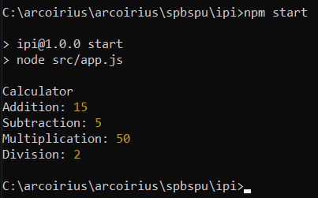
Figure 1 — Successful execution of the demonstration application

3.2 Successful static-analysis and formatting check
The command npm run check executes ESLint first and then Prettier formatting validation. This command represents the normal quality gate of the project. A successful run confirms that no configured ESLint violations are present and that the source files match the Prettier formatting rules.
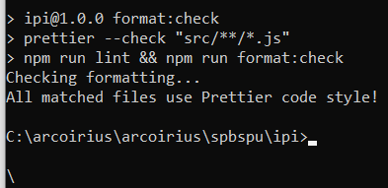
Figure 2 — Successful combined quality check

3.3 ESLint edge-case demonstration
To demonstrate a tool-specific failure, several violations are intentionally introduced in src/app.js during the live demo:
var demo = 10;
if (demo == '10') {
console.log('Lint demo');
}
const unused = 42;

This code intentionally violates no-var, eqeqeq, and no-unused-vars. Running npm run lint must therefore fail and display the corresponding diagnostics. The failure demonstrates that ESLint detects configured code-quality problems without executing the application.
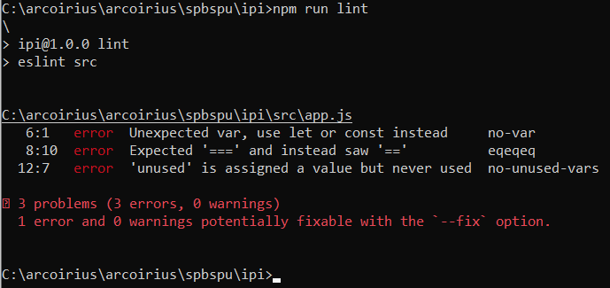
Figure 3 — ESLint detects intentional code-quality violations

3.4 Correction and repeated verification
The command npm run lint:fix is then used to apply safe automatic fixes. Any remaining violations are corrected manually. The source code is checked again with npm run lint. The second run must complete successfully, demonstrating the detect–fix–verify workflow.
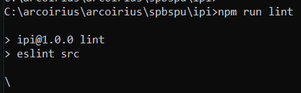
Figure 4 — Successful ESLint verification after correction

3.5 Prettier failure and automatic formatting
A separate formatting edge case is demonstrated by temporarily adding code that is syntactically valid but does not match the project style:
const message="Prettier demo"
console.log(message)

Running npm run format:check reports a formatting mismatch. The command npm run format then rewrites the file according to .prettierrc. A repeated npm run format:check must succeed. This demonstrates that Prettier checks and fixes formatting independently from ESLint code-quality rules.
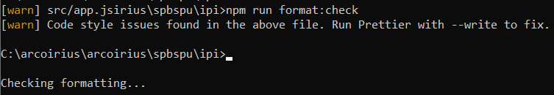
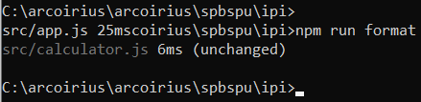
Figure 5 — Prettier formatting failure and successful correction

4. Conclusion
The project demonstrates the setup and configuration of ESLint for static analysis of a small JavaScript application. ESLint checks code quality using recommended and custom rules, while Prettier ensures consistent formatting.

The solution is tested in both normal and failure scenarios: successful checks are demonstrated first, then intentional linting and formatting issues are introduced, detected, and corrected.

The project also highlights the difference between static analysis, runtime validation, and formatting. npm scripts make the checks reproducible, while package-lock.json fixes dependency versions and node_modules is excluded from Git because it can be restored with npm.
ПРИЛОЖЕНИЕ А
Листинг демонстрационного решения

A.1 src/app.js
import { add, subtract, multiply, divide } from './calculator.js';
const firstNumber = 10;
const secondNumber = 5;
// var demo = 10;
// if (demo == '10') {
// console.log('Lint demo');
// }
// const unused = 42;
// const message = 'Prettier demo';
// console.log(message);
console.log('Calculator');
console.log('Addition:', add(firstNumber, secondNumber));
console.log('Subtraction:', subtract(firstNumber, secondNumber));
console.log('Multiplication:', multiply(firstNumber, secondNumber));
console.log('Division:', divide(firstNumber, secondNumber));

The commented fragments are reserved for the live edge-case demonstration. They can be temporarily uncommented to reproduce ESLint and Prettier failures and then disabled again after the demonstration.

A.2 src/calculator.js
export function add(a, b) {
return a + b;
}
export function subtract(a, b) {
return a - b;
}
export function multiply(a, b) {
return a * b;
}
export function divide(a, b) {
if (b === 0) {
throw new Error('Division by zero');
}
return a / b;
}

