SECTION L — GRID
Q18. Please rate each brand on the scale shown below.
SCRIPTER: build the grid exactly as shown in the screenshot.
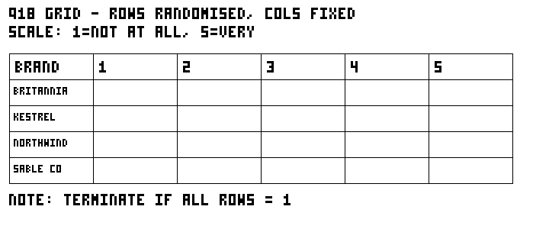
Q19. And overall, which brand would you choose?


