WEEK 2 PROJECT REPORT
Exploratory Data Analysis and Visualization
Using Python | UCI Wine Recognition Dataset

Student Name | Aditya Rauniyar
Project | Week 2 – Exploratory Data Analysis and Visualization
Tools | Python, Pandas, Matplotlib, Scikit-learn
Dataset | UCI Wine Recognition Dataset

1. Executive Summary
This project performs an exploratory data analysis (EDA) of the public Wine Recognition dataset. The dataset contains 178 observations, 13 numeric chemical features and 3 wine classes. The analysis checks data quality, summarizes distributions, compares class-level patterns, examines relationships between variables and applies dimensionality reduction and exploratory clustering. The first two principal components explain approximately 55.4% of the standardized feature variance. K-means clustering with three clusters produces a silhouette score of 0.285; this is used only as an exploratory measure, not as proof that the clusters are identical to the known labels. Overall, the visualizations show that chemical measurements contain useful structure and that some features vary noticeably across the three classes.

2. Objectives
- Understand the structure, variables and quality of a public dataset.
- Calculate descriptive statistics and inspect missing values.
- Visualize class balance and feature distributions.
- Explore correlations and relationships between selected variables.
- Use PCA and K-means as additional exploratory techniques.
- Translate the findings into practical conclusions and further-analysis ideas.

3. Dataset Description
The Wine Recognition dataset originates from chemical analysis of wines grown in the same region in Italy but derived from three different cultivars. It is distributed with scikit-learn as a convenient copy of a public dataset. Each row represents one wine sample. The 13 numeric attributes include alcohol, malic acid, ash, alkalinity of ash, magnesium, total phenols, flavanoids, nonflavanoid phenols, proanthocyanins, color intensity, hue, OD280/OD315 of diluted wines and proline. The target identifies one of three classes.
Dataset dimensions: 178 rows × 13 measured features, plus target/class label.
Class counts: class_1: 71; class_0: 59; class_2: 48.
Data quality: No missing values were found in the inspected columns.

4. Tools and Methodology
Python was used for reproducible analysis. Pandas handled tabular inspection and grouping; Matplotlib created charts; scikit-learn supplied the dataset, standardization, PCA and K-means. The workflow began with shape, data types, missing-value checks and summary statistics. Next, class frequencies and feature distributions were visualized. Pearson correlations were calculated for numeric features. Finally, features were standardized before PCA and K-means because measurements use different scales.

5. Exploratory Data Analysis and Visualizations

5.1 Class distribution
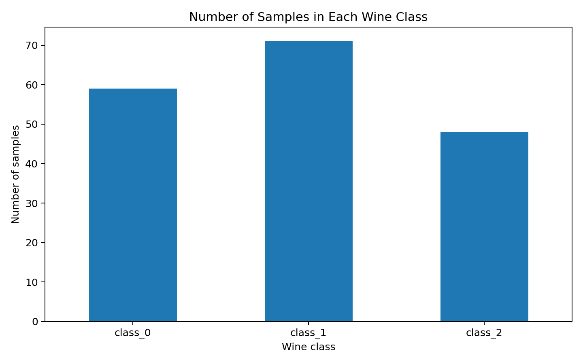
Interpretation: The dataset contains three classes with different sample counts. The bar chart makes this imbalance visible. Since the classes are not exactly equal in size, later predictive modelling should use stratified splitting and class-wise metrics rather than accuracy alone.

5.2 Alcohol distribution by class
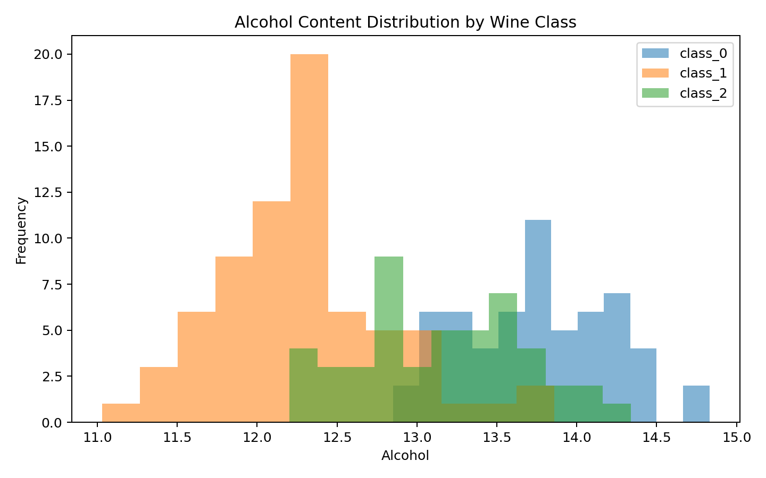
Interpretation: The histograms show how alcohol measurements are distributed within each class. The amount of overlap indicates that alcohol alone cannot perfectly distinguish every sample. Distribution plots are useful for comparing central tendency, spread and overlap before building a predictive model.

5.3 Correlation analysis
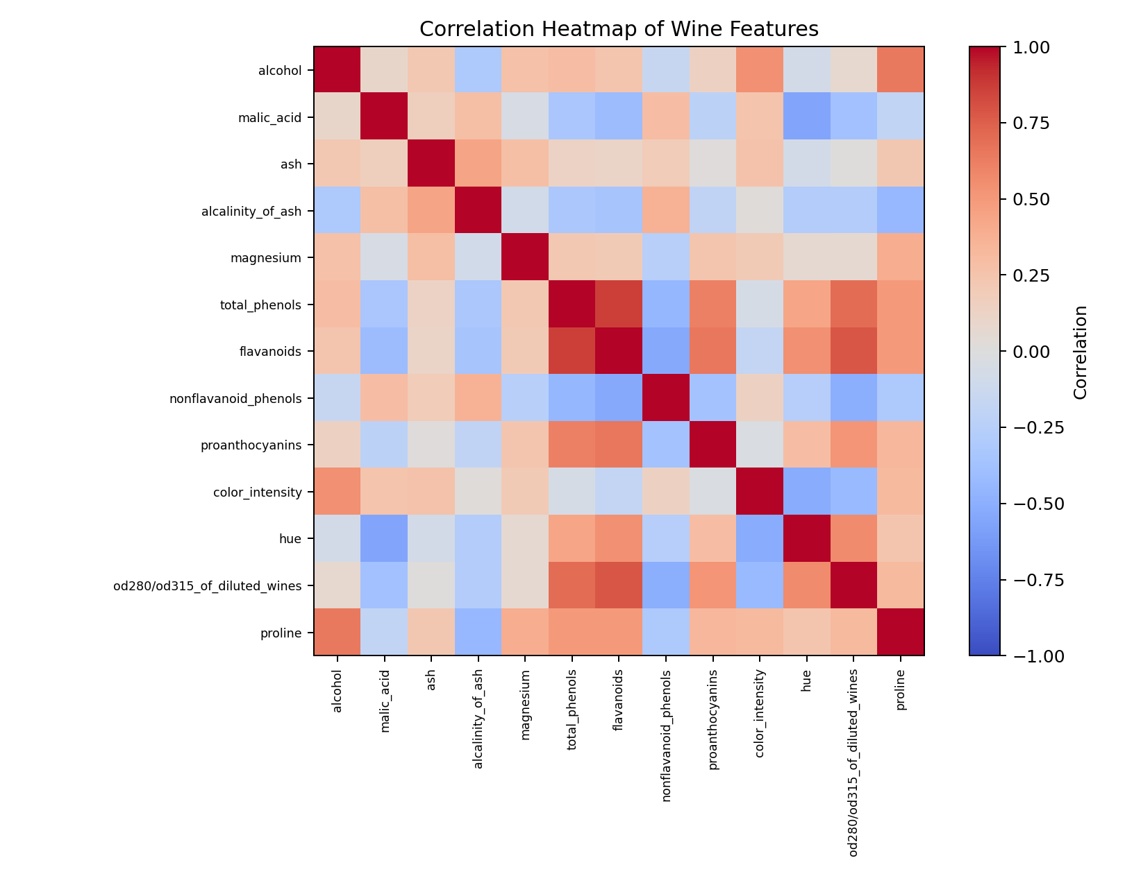
Interpretation: The heatmap shows pairwise Pearson correlations. Strong positive or negative relationships suggest that some measurements move together and may contain overlapping information. Correlation does not establish causation. Highly correlated predictors should be considered when interpreting coefficients or selecting features.

5.4 Feature relationship
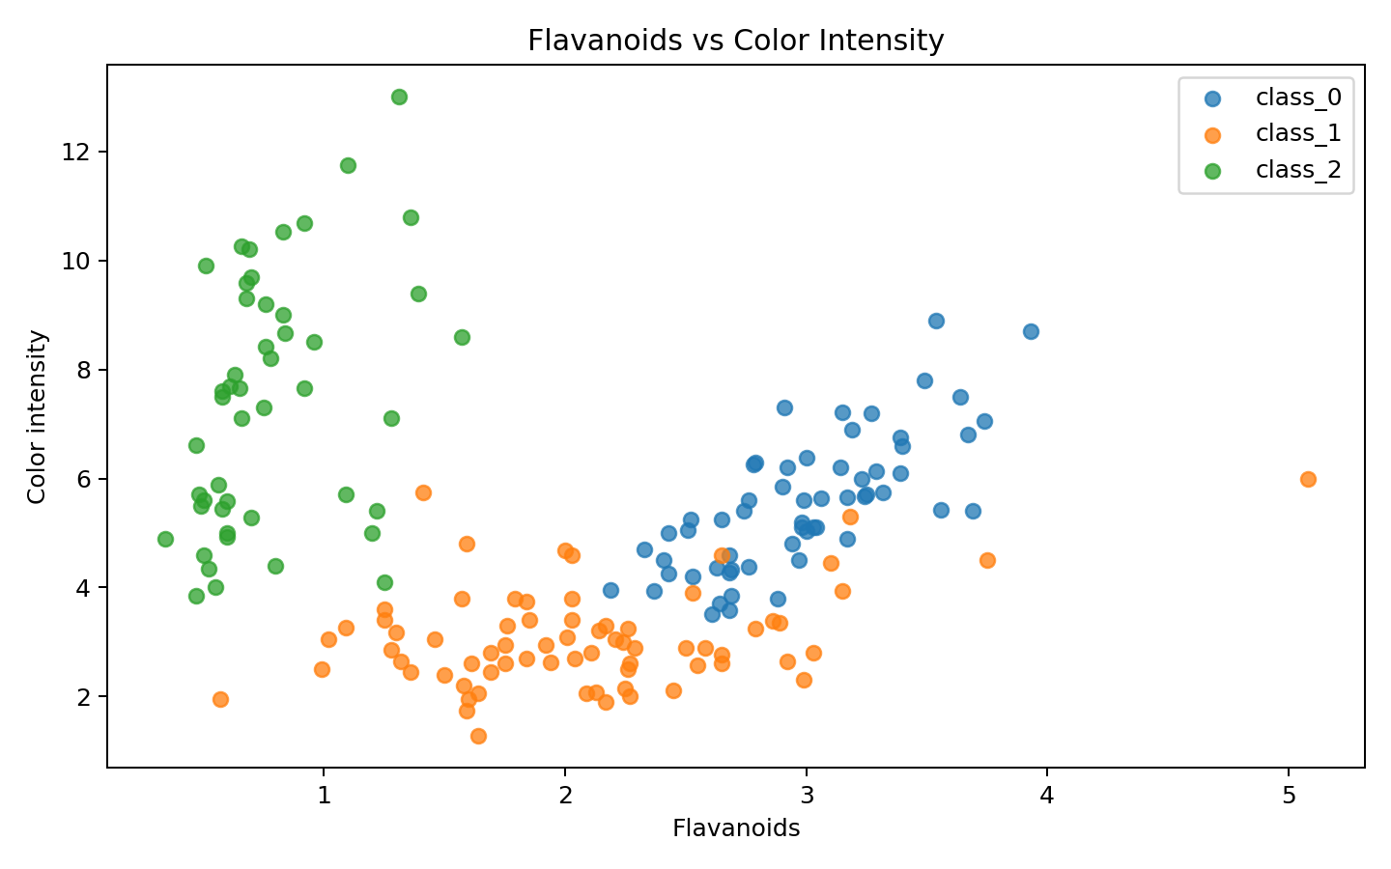
Interpretation: The scatter plot compares flavanoids with color intensity and colors points by known class. The visible grouping and overlap indicate that multiple chemical attributes may help distinguish classes, while no single two-dimensional view captures all information.

5.5 PCA projection
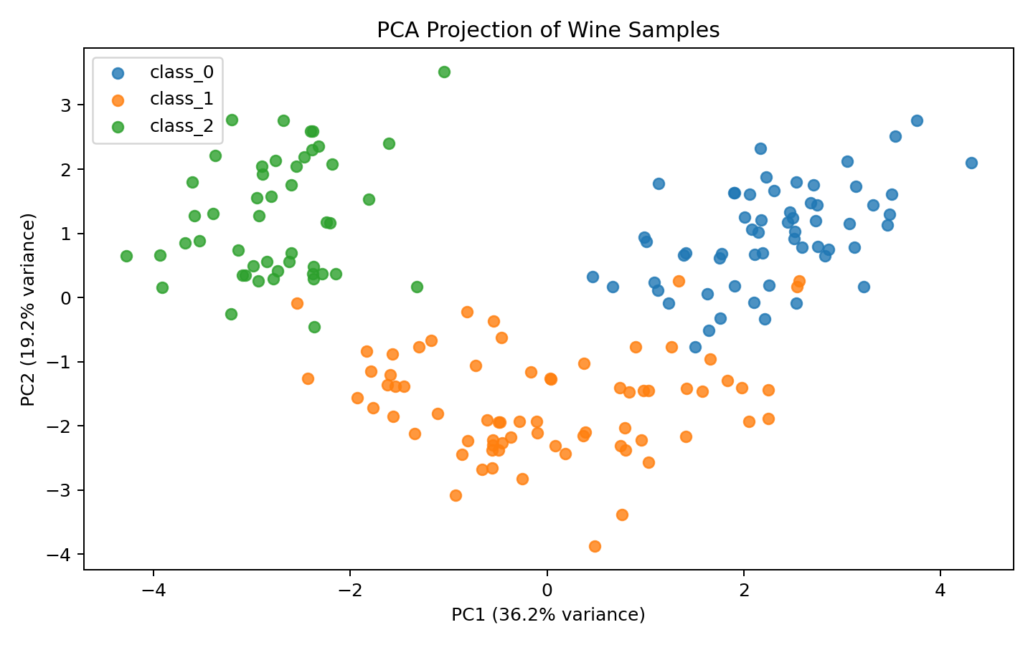
Interpretation: PCA compresses the 13 standardized features into two dimensions. The first two components explain 55.4% of total standardized variance. Separation between colored groups suggests multivariate structure, although some overlap remains because two components cannot preserve every detail of the original 13-dimensional dataset.

6. Summary Statistics and Class-Level Patterns
The following table presents average measurements by wine class. These averages help identify which chemical attributes differ between groups.
Class | alcohol | malic_acid | flavanoids | color_intensity | hue | proline
class_0 | 13.74 | 2.01 | 2.98 | 5.53 | 1.06 | 1115.71
class_1 | 12.28 | 1.93 | 2.08 | 3.09 | 1.06 | 519.51
class_2 | 13.15 | 3.33 | 0.78 | 7.4 | 0.68 | 629.9
The full descriptive-statistics table (count, mean, standard deviation, minimum, quartiles and maximum) can be regenerated by running the accompanying Python script.

7. Exploratory Clustering
K-means was run with three clusters after standardizing all 13 features. The silhouette score was 0.285. A silhouette score ranges from -1 to 1; higher values generally indicate more compact and separated clusters. This score is an internal clustering metric. Cluster IDs are arbitrary and should not be assumed to correspond directly to the original wine class labels. Further validation, alternative cluster counts and domain review would be needed before using clusters operationally.

8. Key Findings
- The dataset has 178 observations, 13 numeric predictors and three target classes.
- The inspected dataset has no missing values, so no imputation was required.
- Class frequencies are not perfectly equal; class-aware evaluation is recommended for future modelling.
- Alcohol distributions overlap across classes, showing why a single feature is not sufficient for reliable separation.
- The correlation heatmap reveals relationships among chemical measurements and potential redundancy.
- The flavanoids–color intensity scatter plot and PCA projection show multivariate structure with some class overlap.
- The first two PCA components retain about 55.4% of standardized variance; dimensionality is reduced but information is lost.

9. Business / Practical Implications
In a quality-control or product-characterization setting, exploratory patterns can help analysts identify measurements that are informative for distinguishing product groups. A laboratory could use these findings to prioritize measurements for deeper validation, investigate unusual samples and design a supervised classification model. Any operational use would require representative new samples, measurement-quality checks, validation against expert labels and monitoring for changes in production or sourcing. The present analysis is educational and does not establish commercial wine quality or consumer preference.

10. Limitations and Further Work
- The dataset is relatively small and comes from a specific historical study; findings may not generalize to all wines.
- EDA identifies associations and patterns but does not prove causal relationships.
- PCA reduces dimensionality and therefore discards some information.
- K-means assumes distance-based cluster structure and is sensitive to scaling and the selected number of clusters.
- Next steps could include outlier review, feature selection, stratified train/test splitting, cross-validation and comparing logistic regression, decision tree and SVM models.

11. Reproducibility: Code Snippets
Load the dataset and inspect data quality:
from sklearn.datasets import load_wine
wine = load_wine(as_frame=True)
df = wine.frame
print(df.shape)
print(df.isnull().sum())
print(df.describe())
Calculate correlations:
features = list(wine.feature_names)
correlation_matrix = df[features].corr()
print(correlation_matrix.round(2))
Standardize features and perform PCA:
from sklearn.preprocessing import StandardScaler
from sklearn.decomposition import PCA
X_scaled = StandardScaler().fit_transform(df[features])
pca = PCA(n_components=2, random_state=42)
components = pca.fit_transform(X_scaled)
print(pca.explained_variance_ratio_.sum())

12. Conclusion
This project completed a structured EDA workflow using Python. Data inspection, descriptive statistics, distribution plots, correlation analysis, scatter visualization, PCA and exploratory clustering were used to understand the Wine Recognition dataset. The visualizations reveal meaningful variation and relationships among chemical measurements, while also showing overlap between classes. The work provides a reproducible starting point for more advanced classification and validation. The attached script recreates the charts and prints the key numerical summaries.

13. References
- Scikit-learn documentation, Wine recognition dataset: https://scikit-learn.org/stable/datasets/toy_dataset.html#wine-recognition-dataset
- UCI Machine Learning Repository, Wine dataset: https://archive.ics.uci.edu/dataset/109/wine
- Pandas documentation: https://pandas.pydata.org/docs/
- Matplotlib documentation: https://matplotlib.org/stable/
- Scikit-learn documentation: https://scikit-learn.org/stable/

