WEEK 1 INTERNSHIP TASK
Data Acquisition and Pre-processing in Python
Dataset: Iris Flower Dataset

Intern Name | Aditya Rauniyar
Task | Week 1 – Data Acquisition and Pre-processing
Tools | Python, Pandas, NumPy, scikit-learn, Matplotlib

1. Introduction
The objective of this task is to build a complete data acquisition and pre-processing pipeline using Python. Data pre-processing is an essential stage of data science because raw data may contain missing values, duplicate records, inconsistent formats, or extreme observations. Cleaning and transforming data helps make it suitable for reliable analysis and machine-learning models.

2. Dataset Selection and Relevance
The Iris Flower Dataset was selected because it is a well-known, publicly available dataset used for learning data analysis and classification. It contains measurements of iris flowers from three species: setosa, versicolor, and virginica. The four numerical attributes are sepal length, sepal width, petal length, and petal width (all measured in centimetres). The target column is the flower species.
The dataset is relevant to data science because it supports exploratory analysis, visualization, feature selection, and supervised classification.

3. Data Acquisition Method
The data is acquired using the load_iris(as_frame=True) function from scikit-learn's datasets module. The Iris dataset is distributed with scikit-learn, so a separate web download or API key is not required. The feature table and target labels are combined into one Pandas DataFrame. The raw dataset is saved as iris_raw.csv for reproducibility.
Example code:
from sklearn.datasets import load_iris
iris = load_iris(as_frame=True)
df = iris.data.copy()
df['species'] = iris.target_names[iris.target]
df.to_csv('iris_raw.csv', index=False)

4. Initial Data Inspection
The DataFrame is inspected using head(), shape, dtypes, isnull().sum(), duplicated().sum(), and describe(). These commands reveal the number of records and columns, data types, missing-value counts, duplicate rows, and numerical summary statistics.
Expected dataset dimensions are 150 observations and 4 numerical input features, plus the species target column. Run the supplied Python script to print the actual inspection results in your environment.

5. Data Cleaning and Pre-processing

5.1 Duplicate handling
Exact duplicate rows are checked using duplicated(). Any duplicate rows are removed with drop_duplicates(). This prevents repeated records from unintentionally influencing analysis.

5.2 Missing-value treatment
Missing values are checked for every column. Numerical missing values, if present in a future version of the data, are replaced with the median using SimpleImputer(strategy='median'). Median imputation is less sensitive to extreme values than mean imputation. The original Iris dataset used here contains no missing values, so the imputer does not need to fill any cells.

5.3 Outlier detection and treatment
Potential numerical outliers are identified using the Interquartile Range (IQR) method. For each feature, IQR = Q3 − Q1. Values below Q1 − 1.5×IQR or above Q3 + 1.5×IQR are flagged. The script caps such values at the IQR limits rather than deleting complete observations. This preserves the dataset size. IQR flags indicate potential outliers, not automatically incorrect measurements; domain knowledge should be considered before removing any observation.

5.4 Data normalization and standardization
Two scaling methods are demonstrated. StandardScaler transforms each feature to approximately zero mean and unit variance. MinMaxScaler rescales each feature to the range 0 to 1. Scaling is useful because numerical features may have different ranges. The appropriate scaler depends on the machine-learning algorithm and the analysis objective.

5.5 Feature selection
SelectKBest with the ANOVA F-test (f_classif) is used to select the three most informative numerical features for predicting species. Feature selection can reduce unnecessary inputs and simplify a model. For a formal machine-learning evaluation, the selector and scaler should be fitted only on training data inside a pipeline to avoid data leakage.

6. Execution and Results
The complete Python implementation is supplied separately as week1_iris_preprocessing.py. It acquires the dataset, inspects it, removes duplicates, applies median imputation, detects and caps potential outliers, creates standardized and min-max scaled features, performs feature selection, saves the cleaned dataset, and generates a scatter plot.
Execution status: The Python script was executed successfully. It produced iris_raw.csv, iris_cleaned.csv, and iris_pairplot.png. The raw dataset contains 150 rows; after removing one duplicate, the cleaned dataset contains 149 rows. No missing values were found. The IQR rule flagged 4 potential outliers in sepal width; these were capped at the IQR fences.
Environment note: Spreadsheet runtime warmup failed during python startup
Traceback (most recent call last):
File "/tmp/tmp.QlpUkOUI9D/artifact_tool_v2-2.8.66/artifact_tool/patches/warm_spreadsheet_runtime_on_startup.py", line 26, in warm_spreadsheet_runtime_on_startup
File "/tmp/tmp.QlpUkOUI9D/artifact_tool_v2-2.8.66/artifact_tool/spreadsheet_warmup.py", line 785, in warm_spreadsheet_runtime
File "/tmp/tmp.QlpUkOUI9D/artifact_tool_v2-2.8.66/artifact_tool/spreadsheet_warmup.py", line 718, in _warm_feature_f

7. Challenges and Solutions
Potential challenge | Solution used
Missing numerical values | Median imputation is included as a robust, reusable step.
Duplicate observations | Exact duplicate rows are checked and removed.
Extreme numerical values | IQR fences are used to flag and cap potential outliers.
Different feature scales | StandardScaler and MinMaxScaler are demonstrated.
Too many input features | SelectKBest selects the three highest-scoring features.

8. Conclusion and Future Scope
This task demonstrates an end-to-end introductory data acquisition and pre-processing workflow using Python. The Iris dataset was loaded into Pandas, inspected, cleaned, scaled, and reduced through feature selection. The processed data and visualization are saved as output files. As a next step, the selected features can be used to train and evaluate classification models such as Logistic Regression, Decision Tree, or Support Vector Machine. A future version could also compare model performance before and after pre-processing and use a train-test split with a scikit-learn Pipeline.

9. How to Run the Project
- Install Python 3.9 or later.
- Open Command Prompt or terminal in the folder containing the Python file.
- Install dependencies: pip install pandas numpy scikit-learn matplotlib
- Run: python week1_iris_preprocessing.py
- Check the generated iris_raw.csv, iris_cleaned.csv, and iris_pairplot.png files.

10. References
Scikit-learn documentation – The Iris dataset: https://scikit-learn.org/stable/auto_examples/datasets/plot_iris_dataset.html
Scikit-learn documentation – preprocessing: https://scikit-learn.org/stable/modules/preprocessing.html
Pandas documentation: https://pandas.pydata.org/docs/

— End of Report —

Execution Evidence
Successful local execution produced the following key results:
- Raw dataset: 150 rows × 5 columns.
- Missing values: 0 across all columns.
- Duplicate rows: 1 detected and removed.
- Potential IQR outliers: 4 in sepal width; values were capped.
- Selected features: sepal length, petal length, and petal width.
- Cleaned dataset: 149 rows × 5 columns.
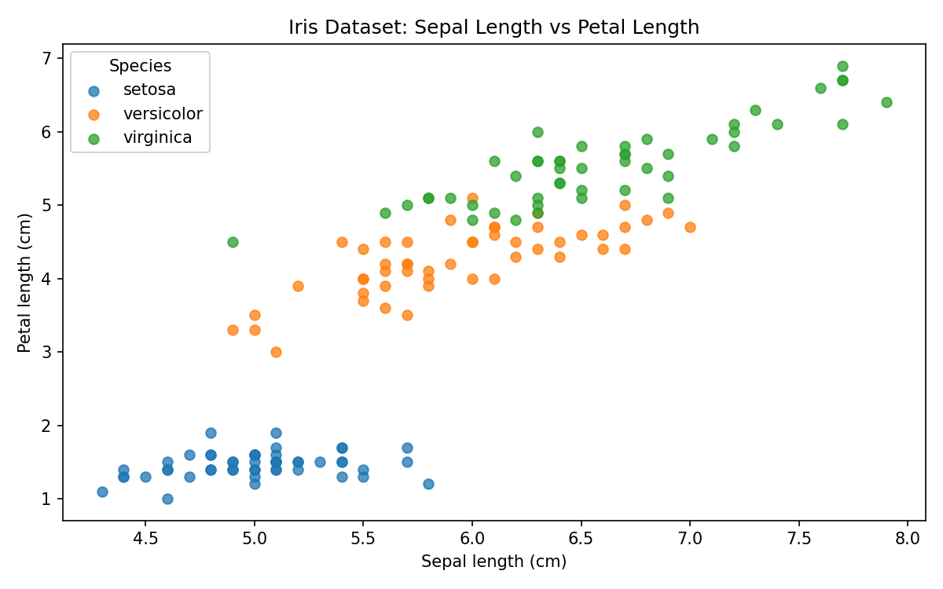
Figure: Sepal length versus petal length, grouped by Iris species.
Inspection found 0 missing values and 1 exact duplicate row. The duplicate was removed, leaving 149 records in the cleaned dataset.

