# Workflow

Get  
Data

Prepare   
Data

Clean &  
Transform Data

**E**xtract  
**T**ransform  
**L**oad

Query Editor

Query Editor Work Flow

Data & model  
View

Analysis data

Inspect, Explore and understand data

View & edit  
Relationships between Tables

Data Model

Data Model Workflow

Data Model

Report View

Data Visualization

Create Report with visuals

Report View

Report View Workflow

# Setting

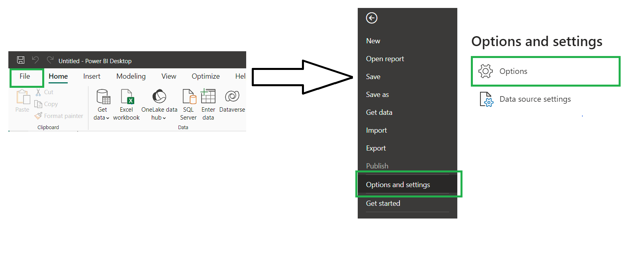

Figure : Flow setting 1

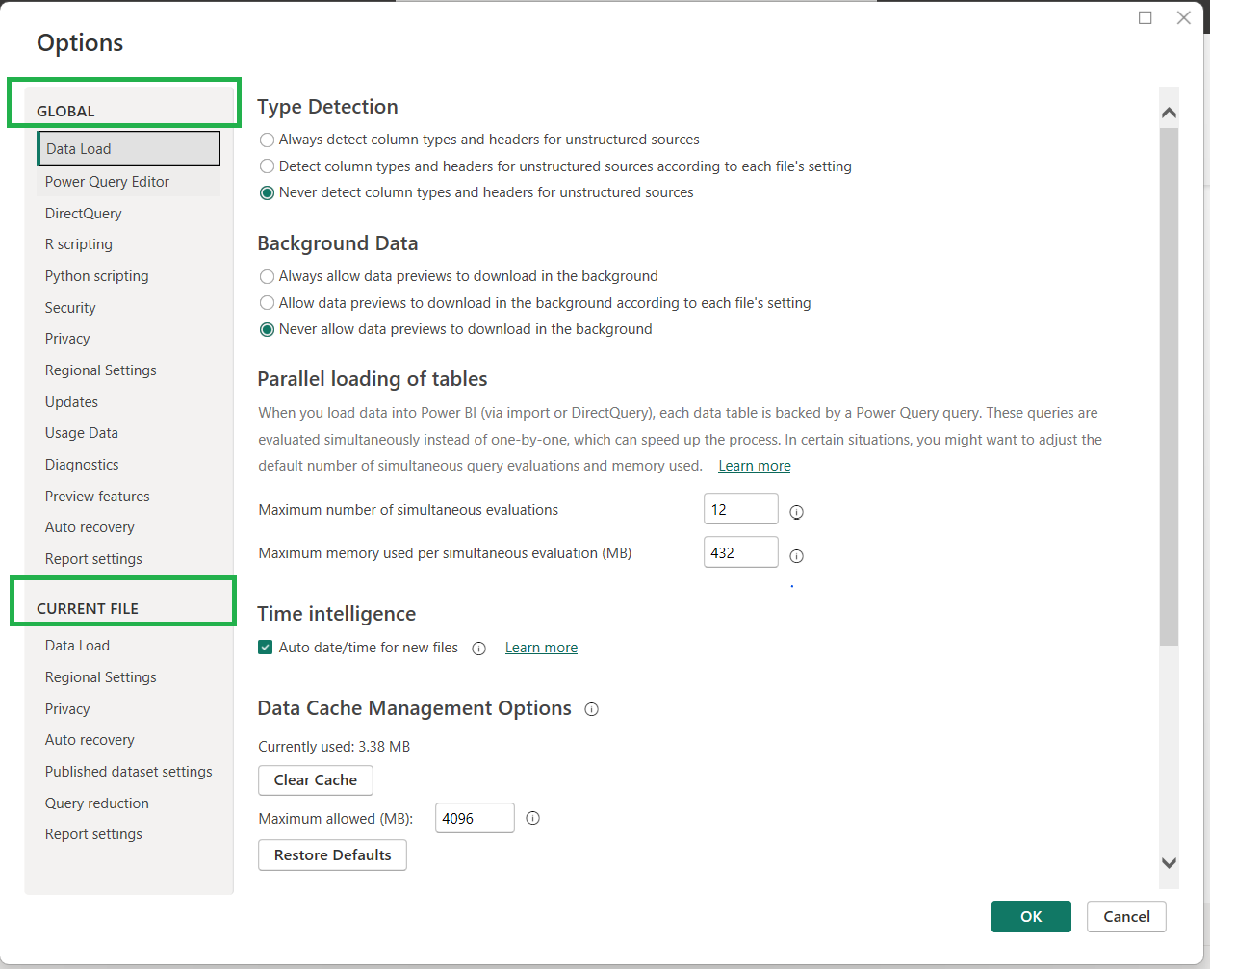

Figure : Global Option & Current File Options: Flow 2

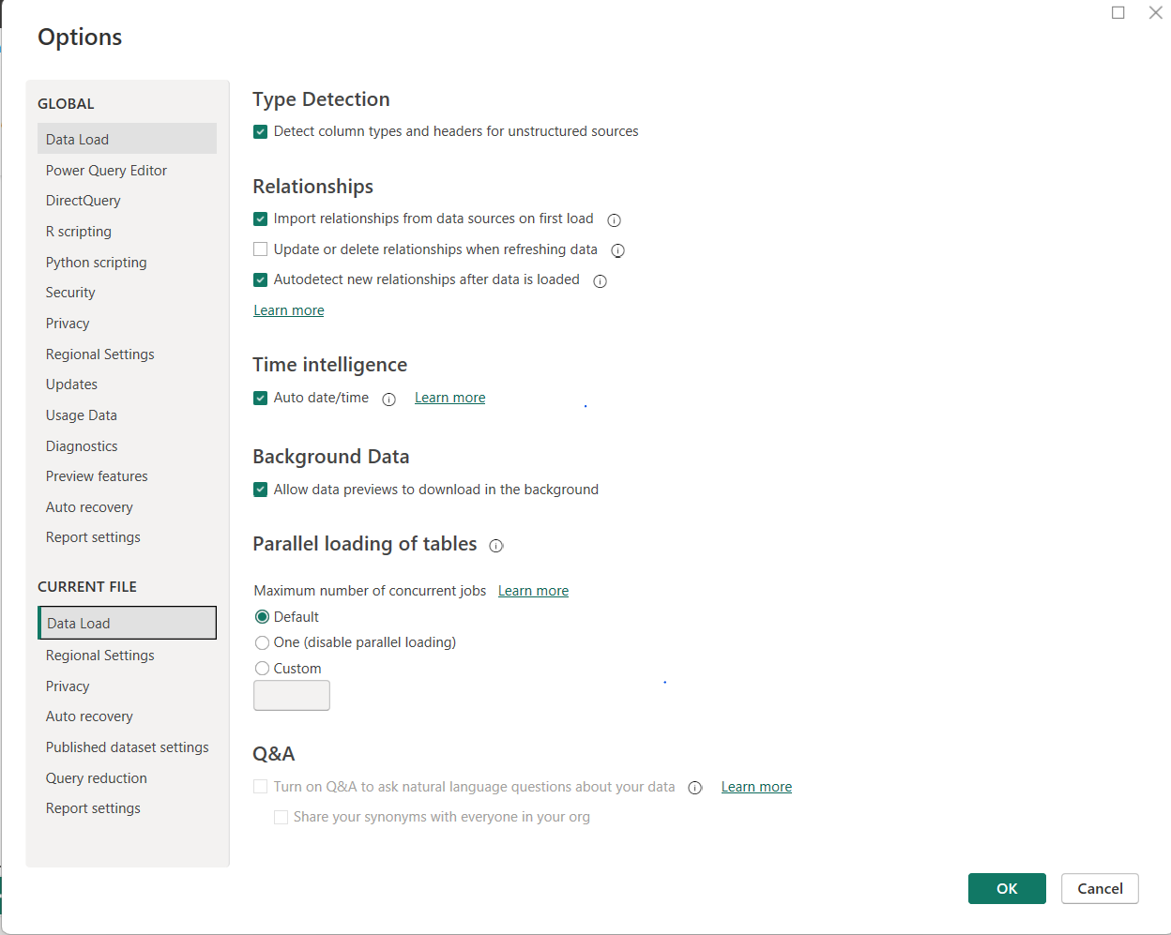

Figure :default Data load Setting: flow3

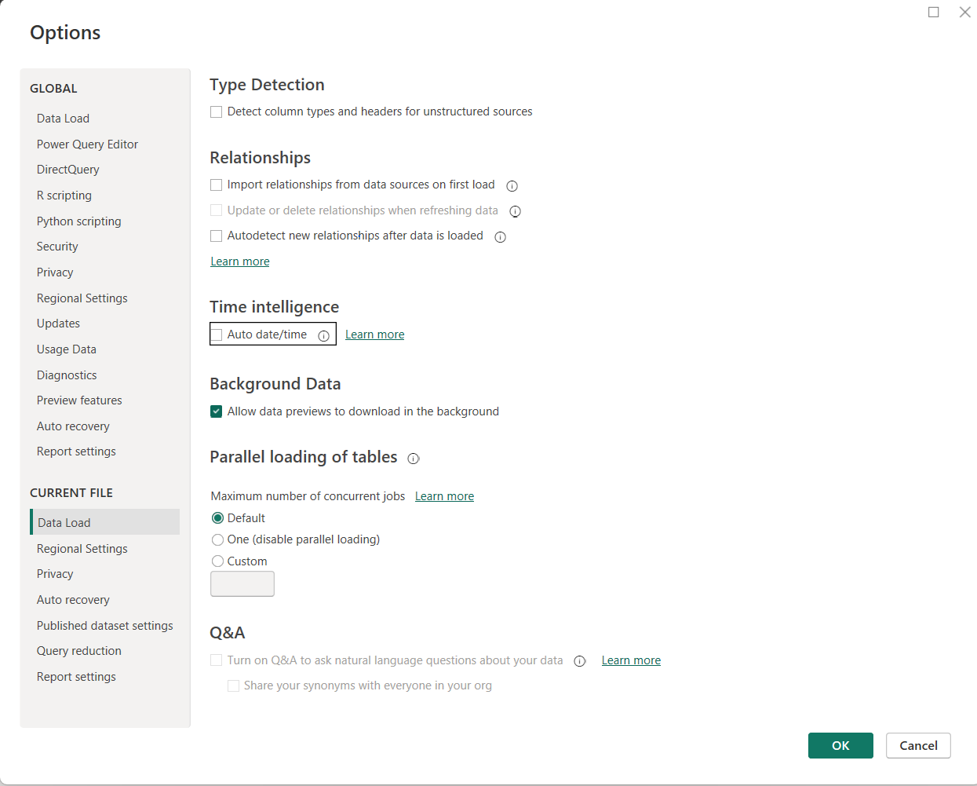

Figure : Change Data load setting: Flow 3

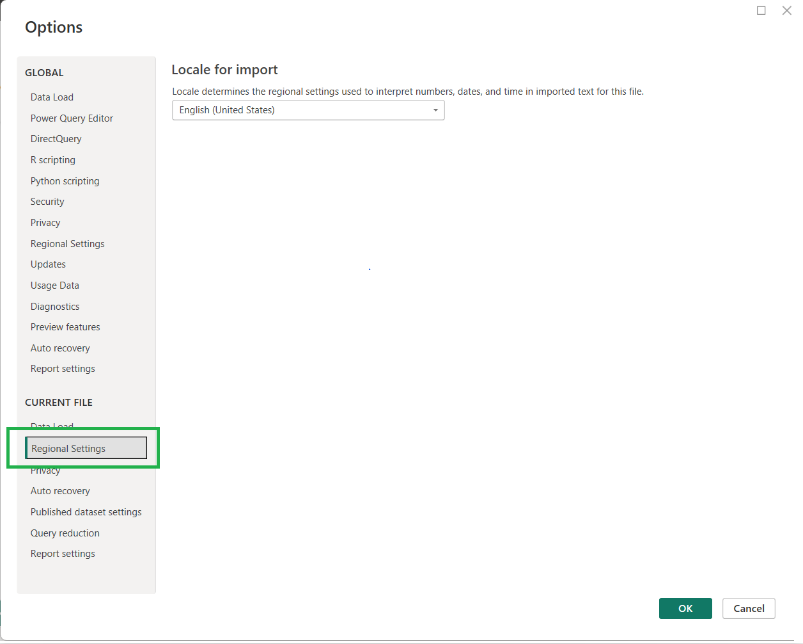

Figure : Local Setting: Flow 4

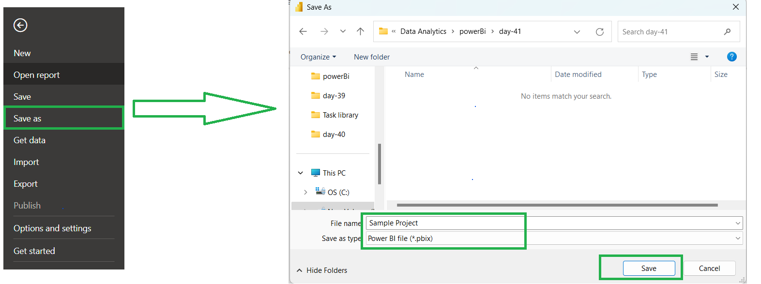

Figure : Save Sample Setting: Flow 5

# Data Cleansing / Data Cleaning

Excel

Big  
Data

Query data

Query data

Query data

Query Data

|  |
| --- |
| Remove Duplicate & Unrequired Data |
|  |
| Fix Errors, Missing Values, Empty Field |
|  |
| Format Data |
|  |
| Combine Multiple Data source |

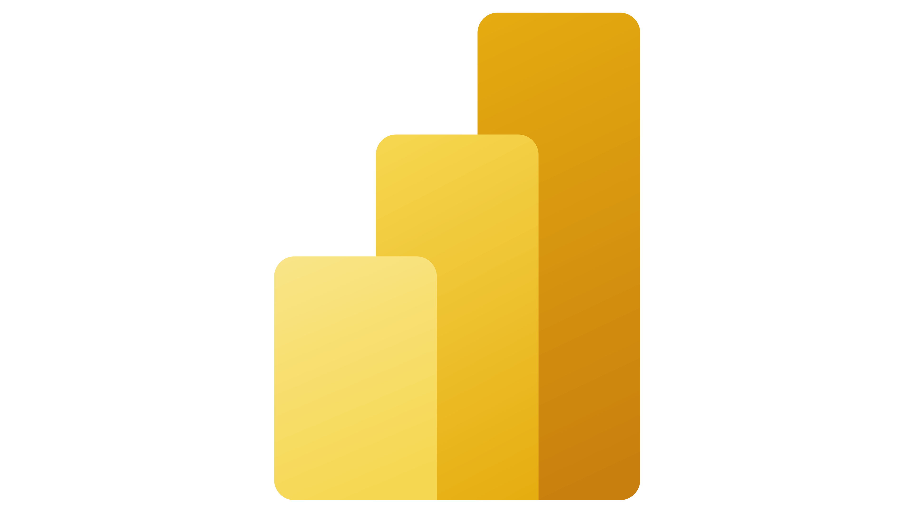

Analysis And Report

awdawdawd

Clean Data

Report

Data Base