Quarterly Operations Report
Executive summary: Document automation throughput improved 18.4% quarter over quarter while maintaining review accuracy above 99.2%.
Risk indicator: manual exception volume increased in the APAC queue.
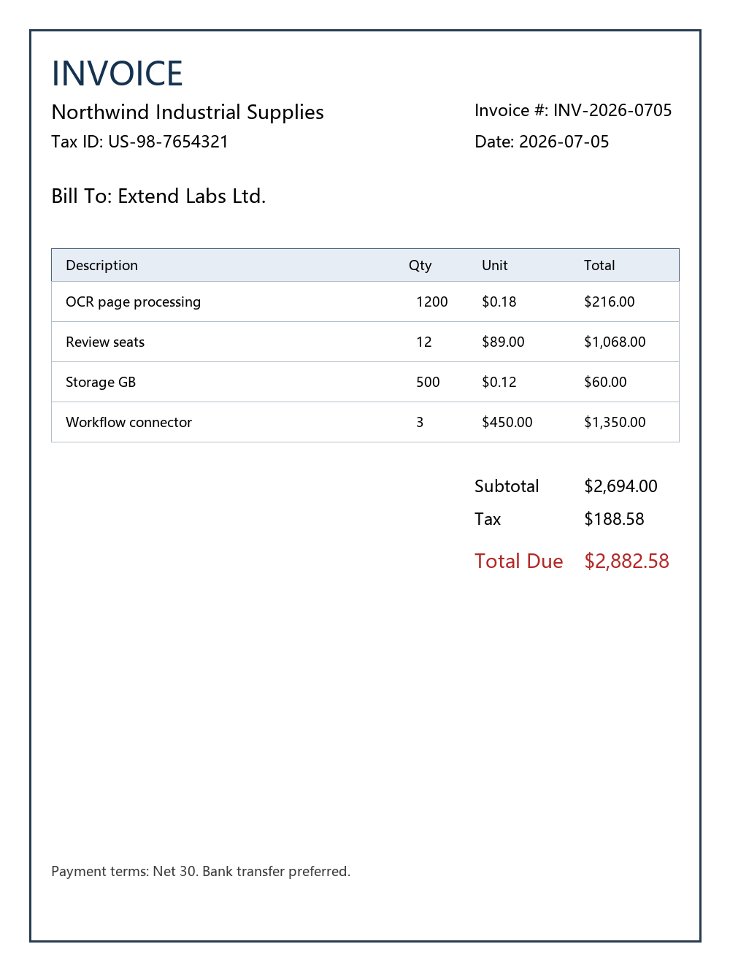
Figure 1. Synthetic invoice image used to verify embedded image rendering.

Operational Highlights
- Average extraction latency fell from 4.2 seconds to 2.9 seconds.
- Reviewer acceptance rate stayed within the control band for three consecutive months.
- The top exception categories were missing purchase order, tax mismatch, and low-confidence vendor name.

