CS 462
Brahm Lower
Bucky Frost
Assignment 2
2014-09-23

Part I

#1. Identify two examples of an IDS-relevant type of data for each of the following categories:
- Network Based Sources
  - Protocol Analysis
  - Port Scanning
- Host of Operating System Based Data Sources
  - Privilege Escalation Logs
  - User Logins
- Application Based Data Sources
  - MySQL Logging
  - Firefox History
- Mobile Device Data Sources
  - Device Battery Usage
  - Device Temperature

#2 For each of the chosen data types, provide
- An example “record” for that data type.
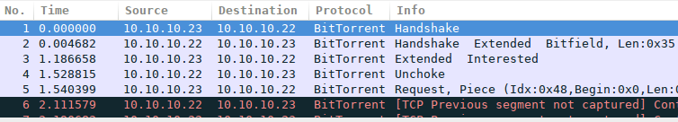
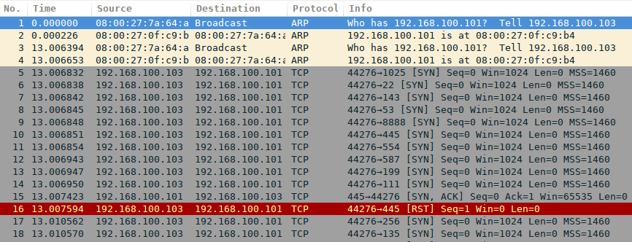
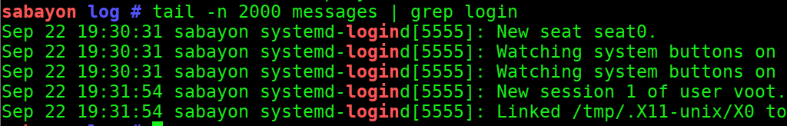
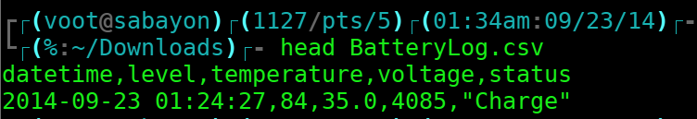
- The volume of data you would expect to receive from this data source.
- A discussion of what data reduction methods may be suitable for your example data source.

Part II

References
[1] Tae-rok, Hwang (2013). https://play.google.com/store/apps/details?id=kr.hwangti.batterylog&hl=en Accessed 2014-09-23
[2] wireshark.org wiki (2013) http://wiki.wireshark.org/SampleCaptures#BitTorrent_Protocol
Accessed 2014-09-23
[3] wireshark.org wiki (2014) http://wiki.wireshark.org/SampleCaptures? action=AttachFile&do=view&target=OptoMMP.pcap Accessed 2014-09-23

