Brahm Lower
Bucky Frost
CS 462
Assignment 3
2014-09-29

Part 1.
1. Create or find a utility that performs SHA-256 verification for the files in a given directory (and subdirectories). Your utility should
- Accept the name of a directory to be checked
- accept a filename which contains the “known good” SHA-256 hash values for the files in the directory
- Report the specific files in the following categories
  - Files that are no longer present
  - Files that have been added
  - Files that have a different hash value now that when they were originally hashes.
AIDE (Advanced Intrusion Detection Environment) is an application that creates a database based dataset for files to be monitored and report on based on a number of different criteria that can be stipulated. Below in Figure 1 shows the aide.conf file that specifies the attributes of the file to watch and the files to monitor.
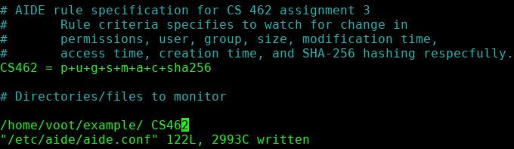Figure 1: AIDE truncated configuration
After initialization of the database the file system state can be compared against the database. For testing a file was added to the database and then modified while another file was created. The report of the file manipulation and creation are shown below in figure 2.
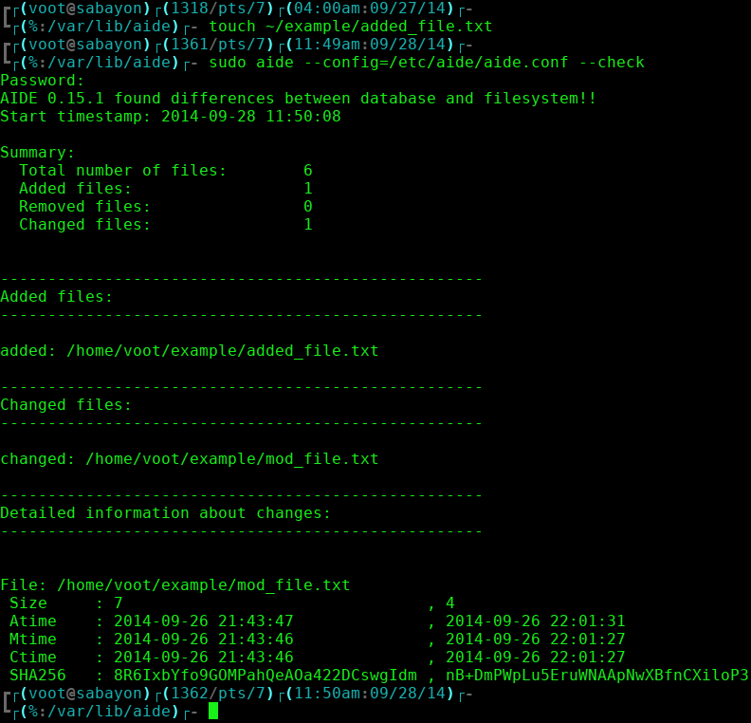Figure 2: AIDE report containing added file and file modification
The reports generated by AIDE gives a non SHA256 format. This is due to the hash being stored in a base 64 encoding to reduce the size of the hash [3]. By decoding the stored hash it is evident that the SHA256 hash is being compared compressed for storage [2].
Figure 3: SHA256 hashing of monitored file
Figure 4: SHA256 file hash decoded from AIDE database [2]
After verifying that the files are hashed with SHA256, the modified file is removed from the monitored directory. Thus, generating the report below in Figure 5.
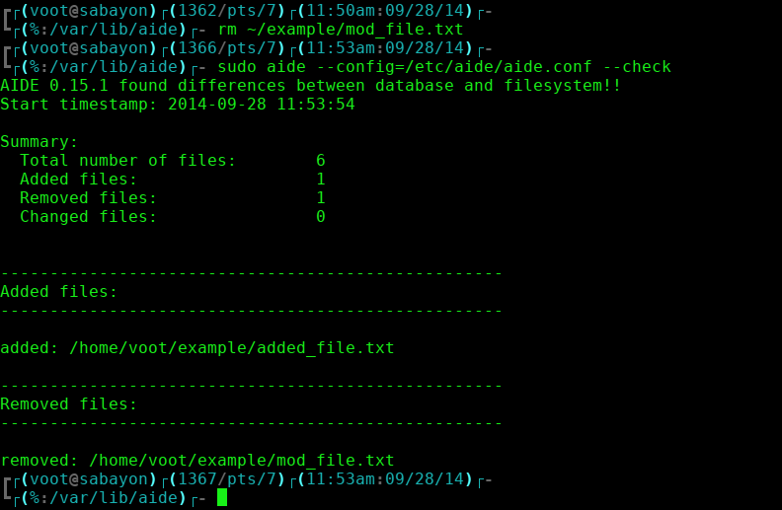Figure 5: AIDE report for removed file

Part 2.
Choose or create a visualization tool and use it to visualize some security/IDS related data, such as network activity, email activity, host statistics or logs, etc.

Intrusion
For our purposes, we chose to use RUMINT, created by Dr. Gregory Conti in 2006, for analyzing packet capture files [5]. RUMINT provides a VCR like interface for capturing live network traffic or for replaying contents of capture files. There are various windowed tool views that come from the VCR like interface to give a more in depth analysis of the captured network traffic from deep packet analysis to high level packet meta-data, such as packet length.

Tool Analysis
There are a number of features to the RUMINT package that would aid security analysts to identify intrusions. On is that there are a number of different views that can be presented on the connections and the amount of data transmitted. For example, an analyst could be reviewing a traffic capture looking at the connections being made between hosts on the network while with amount of traffic generated between the connections. If there is an unreasonable amount of traffic transmitted, then this would cause for a deeper analysis between those hosts with the deep packet viewer to see the types of data transmitted and verify that the traffic is legitimate.

Datasets
Due to the familiarity of the primary investigators' with the Collegiate Cyber Defense Competition (CCDC) a packet capture of a regional qualifier was used. The 2012 Mid-Atlantic CCDC network traffic is hosted in a number of pcap files [4]. The The packet capture would contain a number of hosts that were put into a scenario for the defense and incident response against an attacking advisory for exfiltration of sensitive data and compromising of host systems. RUMINT is applicable to this dataset in that a network defender would want to see incoming traffic real time an have a number of different views of that traffic within one tool. The only drawback to RUMINT is that only 30,000 packets can be loaded for analysis, which could be filled by legitimate traffic.

Runtime Examples
The main panel of RUMINT resembles a VHS interface in that the speed of the packet capture can be sped up or slowed to allow more analysis to specific portions of the network capture.
Current Packet
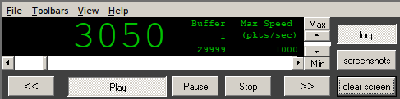Figure 6: RUMINT control panel
Loaded Packet Capture Size

One of the view tools that comes with RUMINT is the deep packet inspection that features ability to parse out ASCII strings.
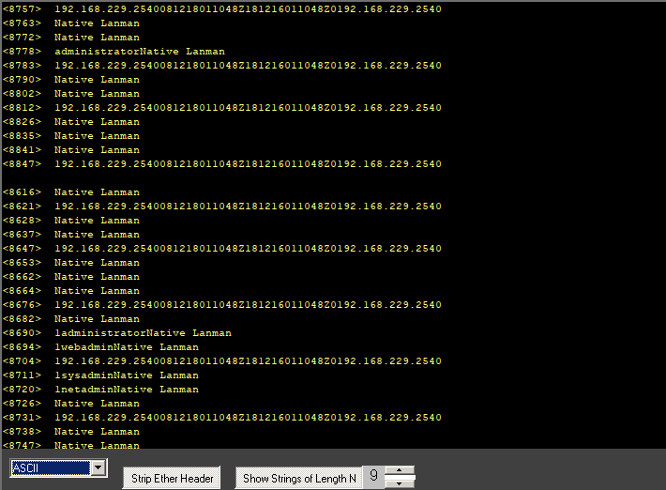Figure 7: RUMINT deep packet strings
RUMINT also offers ability to watch byte frequency or the lengths of packets real time that would denote large amount of data being exfiltrated from the network if infiltrators were moving data as rapidly as possible. The periodic points in Figure 8 below are believed to be the scoring engine validating service uptime.
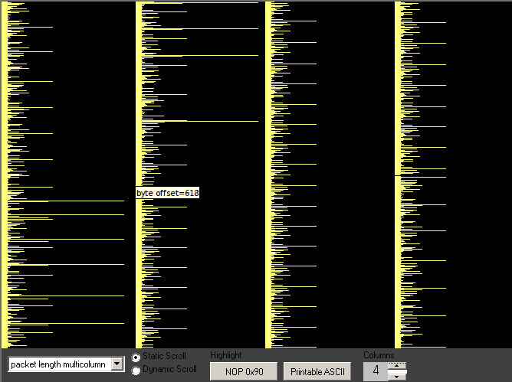Figure 8: RUMINT multicolumn packet length
References
[1] http://aide.sourceforge.net/ accessed: (2014-09-25)
[2] http://www.opensubscriber.com/message/aide@cs.tut.fi/14333362.html accessed: (2014-09-26)
[3] http://sourceforge.net/p/aide/code/ci/master/tree/src/db_file.c#l997 accessed: (2014-09-27)
[4] http://download.netresec.com/pcap/maccdc-2012/maccdc2012_00000.pcap.gz
accessed: (2014-09-29)
[5] http://www.rumint.org/gregconti/index.html accessed: (2014-09-29)
[6] http://rumint.org/ accessed: (2014-09-28)

