Bucky Frost
CS 462
Assignment 3
2014-09-29

Part 1.
1. Create or find a utility that performs SHA-256 verification for the files in a given directory (and subdirectories). Your utility should
- Accept the name of a directory to be checked
- accept a filename which contains the “known good” SHA-256 hash values for the files in the directory
- Report the specific files in the following categories
  - Files that are no longer present
  - Files that have been added
  - Files that have a different hash value now that when they were originally hashes.
AIDE (Advanced Intrusion Detection Environment) is an application that creates a database based dataset for files to be monitored and report on based on a number of different criteria that can be stipulated. Below in Figure 1 shows the aide.conf file that specifies the attributes of the file to watch and the files to monitor.
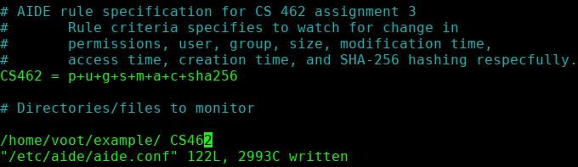Figure 1: AIDE truncated configuration
Once AIDE is properly configured the baseline database must be initiated, as shown in
After initialization of the database the file system state can be compared against the database.
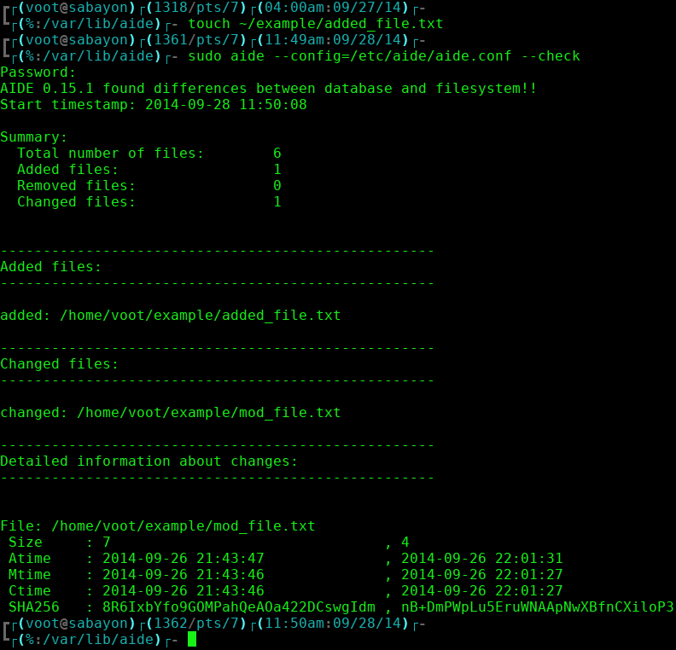Figure 2: AIDE report containing added file and file modification
The reports generated by AIDE gives a non SHA256 format. This is due to the hash being stored in a base 64 encoding to reduce the size of the hash [3]. By pulling the giving stored encoded hash, it is evident that the SHA256 hash is being compared and stored.
Figure 3: SHA256 hashing of monitored file
Figure 4: SHA256 file hash decoded from AIDE database [2]
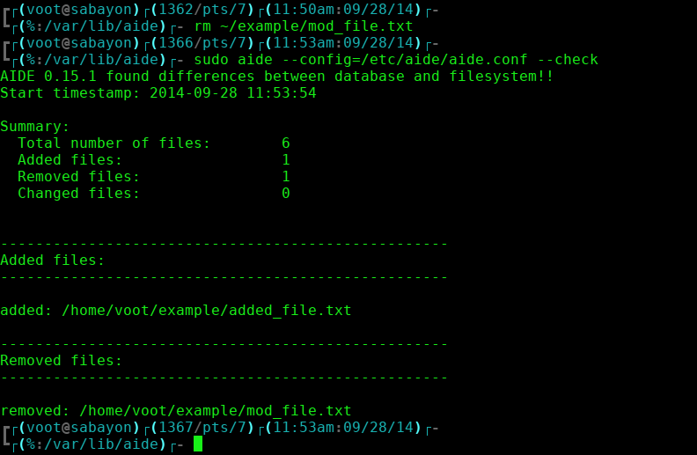Figure 5: AIDE report for removed file

Part 2.
Choose or create a visualization tool and use it to visualize some security/IDS related data, such as network activity, email activity, host statistics or logs, etc.

Intrusion

Tool Analysis

Datasets

Runtime Examples
References
[1] http://aide.sourceforge.net/ accessed: (2014-09-25)
[2] http://www.opensubscriber.com/message/aide@cs.tut.fi/14333362.html accessed: (2014-09-26)
[3] http://sourceforge.net/p/aide/code/ci/master/tree/src/db_file.c#l997 accessed: (2014-09-27)
[4] http://download.netresec.com/pcap/maccdc-2012/maccdc2012_00000.pcap.gz
accessed: (2014-09-29)

