Brahm Lower
Bucky Frost
CS 462
Assignment 04
2014-10-02

Part 1.

Part 2.
- Login to the RAVE.
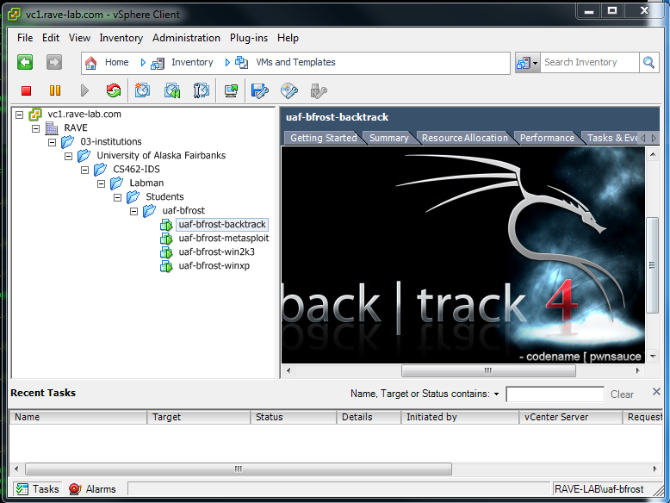Figure 1: Logging into the RAVE through vCenter in Chapman lab
- By examinging the Summary tab within the vSphere Client, we were able to see that the corrisponding virtual machines (VM) were indeed allocated IP addresses for 192.168.100.101 for the Windows XP, 192.168.100.102 for Windows 2003, 192.168.100.102 for Metasploitable, and 192.168.100.201 for the Backtrack VM.
- Successfully initiated, logged in, and launched the GUI on the Backtrack VM; please see Figure 1 for successful login.
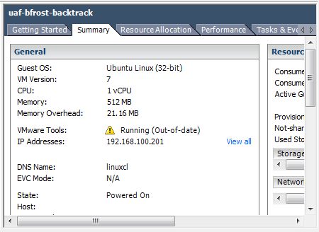Figure 2: VM IP address confirmation
- Use Nmap on the Backtrack VM to scan services and the other 3 VMs. Report services with version information.

- d
- d
- d
- d
- d
- d
- d
- d

