Software Requirements Specification
for
Amazon Webstore Clone
Version 1.2 approved
Prepared by Bucky J. Frost
University of Alaska Fairbanks
October 19, 2014

Table of Contents
1. Introduction 1
1.1 Purpose 1
1.2 Document Conventions 1
1.2.1 Typography 1
1.2.2 Definitions and Abbreviations 1
1.3 Product Scope 1
1.4 References 1
2. Overall Description 2
2.1 Product Perspective 2
2.2 Product Functions 2
2.3 User Classes and Characteristics 2
2.4 Operating Environment 2
2.5 User Documentation 2
2.6 Assumptions and Dependencies 3
3. External Interface Requirements 3
3.1 User Interfaces 3
3.2 Software Interfaces 3
3.3 Communications Interfaces 3
4. System Features 3
4.1 Browser 3
4.1.1 Description 3
4.1.2 Priority 3
4.1.3 Functional Requirements 3
4.1.3.1 Search 3
4.1.3.2 Detailed Product Information 3
4.1.3.3 Review 3
4.1.3.4 Add to Cart 3
4.2 SC 3
4.2.1 Description 3
4.2.2 Priority 3
4.2.3 Functional Requirements 4
4.2.3.1 Modify Contents 4
4.2.3.2 Exception Handling 4
5. Nonfunctional Requirements 4
5.1 Performance Requirements 4
5.2 Security Requirements 4

Index of Tables
Table 1: Document Typography Conventions 1
Table 2: SWR Document Acronyms and Definitions 1
Table 3: Product Functionality 2
Table 4: User Classes 2
Table of Graphs
Figure 1: Project Component Overview 2
Figure 2: Browser View 4

Revision History
Name | Date | Reason For Changes | Version
Bucky Frost | 2014-10-19 | Rough Draft of Software Requirements Document | 1.0
Bucky Frost | 2014-10-29 | Final Draft of Software Requirements Document | 1.2

Introduction

Purpose
The purpose of the webstore is to ingrate into existing store infrastructure to increase the online presence of the vendor on the Internet. The webstore will allow for integration into third party payment processes.

Document Conventions

Typography
Format | Description
An Example | Tasks to be accomplished in the document
Table 1: Document Typography Conventions

Definitions and Abbreviations
Acronym | Definition
SWR | Software Requirements
IS | Inventory System
AWC | Amazon Webstore Clone
SC | Shopping Cart
FAQ | Frequently Asked Questions
TLS | Transport Layer Security
PII | Personally Identifiable Information
WWW | World Wide Web
Table 2: SWR Document Acronyms and Definitions

Product Scope
The product shall be constrained to the interactions of the IS, browser, and SC in their interactions to accomplish the roles of the users with the webstore. The development team shall not have responsibility for the infrastructure for the implementation of the webstore. This includes database systems webhosting solutions.

References
Wiegers, Karl. (1999) Software Requirements Specification Template. Retrieved from www.processimpact.com/process_assets/srs_template.doc Accessed: 2014-10-18

Amazon Inc. (2014) Amazon.com: Online Shopping for Electronics, Apparel, Computers, Books, DVDs & more. Retrieved from www.amazon.com Accessed: 2014-10-17

Overall Description

Product Perspective
The AWC is a reimplementation of the interface and integration of Amazon.com. The focused elements of Amazon that will be implemented are the SC, Browser, and the IS. This will allow for a means to manage and implement the usage of the webstore.

Product Functions
Index | Function
1 | Browsing of IS
2 | User SC for purchases
Table 3: Product Functionality
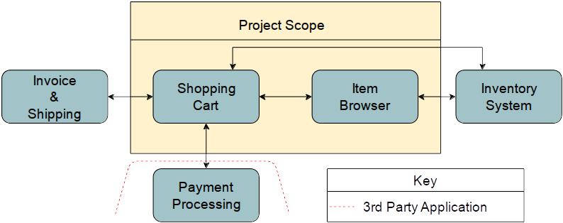Figure 1: Project Component Overview

User Classes and Characteristics

Classification | Function
User | Shopping
Employee | IS Insertion
Manager | System Review
Table 4: User Classes

Operating Environment
The webstore browser shall be a webpage interface accessible from a WWW browser with access to the other webstore components.

The browser shall connect to a secure webserver; the webserver shall connect securely with the other webstore components.

User Documentation
The user documentation provided shall be webpages on the webstore. They shall include a hierarchical help pages and a FAQ page. If a video is apt for the description of the help topic, then it shall be imbedded animation into the page for the help topic.

Assumptions and Dependencies
Assumed responsibilities of the client shall be for the form that the hosting solutions for databases and webhosting. The client shall also be responsible for the negotiation and integration of payment processing and obtaining security features, such as TLS certifications. Also, the client shall be acquiring a means for additional hardware to ease the insertion of IS data.

External Interface Requirements

User Interfaces

Software Interfaces
There shall be a database interface for the use of the IS, which will be generated from the web server that receives and validates the input from the users' browsers.

Communications Interfaces
There shall be TLS for the communications of the users' browser to ensure PII confidentiality.

System Features
The AWC shall include the three main features of Browser, IS, and SC. They shall provide a means for customers of the site to browse the IS and add content to the SC for processing. The Browser and IS shall have functionality for company employees to manipulate the system.

Browser

Description
The Browser is the interface of the users of the other features of AWC.

Functional Requirements

Search
The search functionality shall take a string and query the IS for relevant matches. The listings shall be displayed in a listing that shall include the pricing and

Detailed Product Information
The return from searching the IS shall be displayed as a listing in the browser view. Upon slecting an item for indep review, the browser view shall be of the detailed item information shown in figure {FIGURE #}.

Add to Cart
The items can be added to the chart only through

Shopping Cart

Description

Functional Requirements

Modify Contents

Exception Handling

Nonfunctional Requirements

Performance Requirements
The IS shall be able to generate results in 1 second ± 1.5 millisecond.

Security Requirements
STL shall be implemented for the traffic between the user and the web server.

Appendix A: Glossary

Appendix B: User Stories

