Vectortiles project – Documentation

The arcticSDI vectortiles project aims to create a vectortiles alternative to todays WMTS basemap. In the beginning it will be a complimentary service, but we hope in the future to able to use it as a source for the WMTS, thus enabling deletion of the WMS infrastructure.
The project originally started in around 2019 as a test between Finland and Sweden. Due to the successful completion of that project, the board gave the go-ahead to a full project involving all members of the consortium. The practical work began in 2022 with a workshop in Arlanda, where a technical infrastructure was agreed upon and work began on a common data model (to be developed by Denmark). The agreed final architecture is:

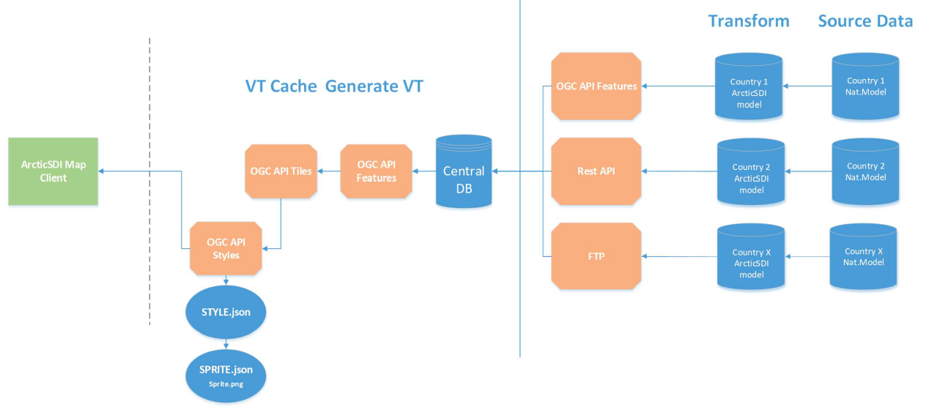

Tiles endpoint. In addition, default styles and fonts will be made available through an OGC API Styles endpoint.
While this architecture is still the overall goal for 2026, the work from 2022 - 2025 has focused on developing a working proof-of-concept (POC) that can be used to fine tune the data model and default styling.
POC Infrastructure
The POC was finalised in June 2025 and includes data from all countries apart from the Faroe Islands. The architecture for the POC is:
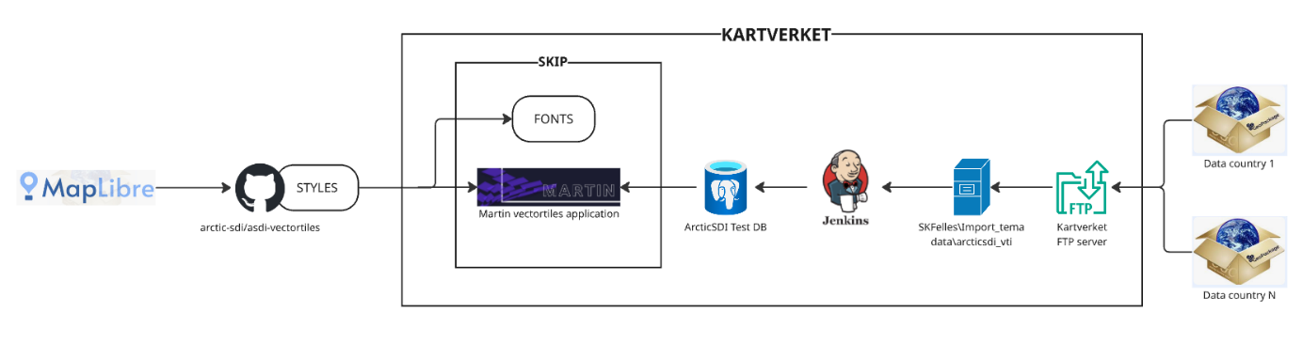

- Geopackage files are created by each country for the 1:50000 (ish) data, according to the common data model (https://github.com/arctic-sdi/asdi-vectortiles/tree/main/data_model ). Examples gpkg definitions can be found in github repo.
- The geopackage files are uploaded to Kartverkets ftp server (we use an area called ‘arcticsdi’ on ftp.statkart.no)
- The gpkg files are then copied manually to an internal server
- The Jenkins postgis import rutine is then run, using the newly imported gpkg file as a source. The jenkins rutine uses scripts managed in a Kartverket github repository (not public).
- The Martin vectortiles application has been set up in SKIP (Kartverkets Kubernetes application platform), and uses a vanilla docker image as a base, but with a customised config.yaml file. The endpoint is: https://arcticsdi.atkv3-dev.kartverket.cloud
- In addition to the Martin application, we have also set up a fontserver (same KV repo as Martin application) to make some standard fonts available for use with the service. Currently we have only included Open Sans fonts. The endpoint is: https://arcticsdi-fontserver.atkv3-dev.kartverket.cloud with the glyhys url being: https://arcticsdi-fontserver.atkv3-dev.kartverket.cloud/{fontstack}/{range}.pbf
- The example style files are available in the arcticSDI project github here: https://github.com/arctic-sdi/asdi-vectortiles/tree/main/style_sheets (style_basic is the default).
There is a codepen.io example client developed by @Thomas Ellett von Brasch here: https://codepen.io/tevbrasch/pen/yLmjLKM
and the service can be used in QGIS using this url: https://arcticsdi.atkv3-dev.kartverket.cloud/unclassifiedareas,soilsurfaceregions_s,shrubvegetation,tundravegetation,grassvegetation,agriculturalareas,woodforests,wetlands,glaciersnowfields_s,builtupareas,sea,waterbodies,watercourseareas,protectedsites,aerodromeareas,glaciersnowfields_c,soilsurfaceregions_c,watercourselines,coastline,terraincontours,glaciercontours,ferrycrossings,mainroads,regionalroads,localroads,nonregularroads,railwaylines,runwaylines,sub_nationalboundaries,nationalboundaries,populatedplaces,railwaystations,airports,heliports,seaplanebases,ports,populatedplacesnames,orographyobjectsnames,portsnames,railwaystationsnames,hydrographynames,hydroreliefobjectsnames,protectedareasnames/{z}/{x}/{y}
and using the stylesheet url: https://raw.githubusercontent.com/arctic-sdi/asdi-vectortiles/refs/heads/main/style_sheets/style_basic.json (the raw version of the document must be used)

