SMART INDIA HACKATHON 2026 | TEAM 087 (DEN OF DEVS) | PS: SIH26117
DETAILED PROJECT WORKFLOW
Eight-Stage Operational Lifecycle for Governed Industrial AI Workflows

1. The 8-Stage Closed-Loop Operational Cycle
Project CogniShift structures plant workflows into a closed-loop, eight-stage operational cycle: CAPTURE -> PROCESS -> ANALYZE -> ALERT -> VERIFY -> ACT -> LEARN -> IMPROVE. This structured pipeline ensures that every relevant engineering calculation is executed and validated through a controlled sandbox workflow, and authorized by human shift supervisors before any equipment permit is released.
Sovereignty & Safety Rule
At no point in this workflow does the AI have direct physical actuation capability. The system transitions strictly between deterministic, auditable states, concluding in cryptographic dual-supervisor sign-off.

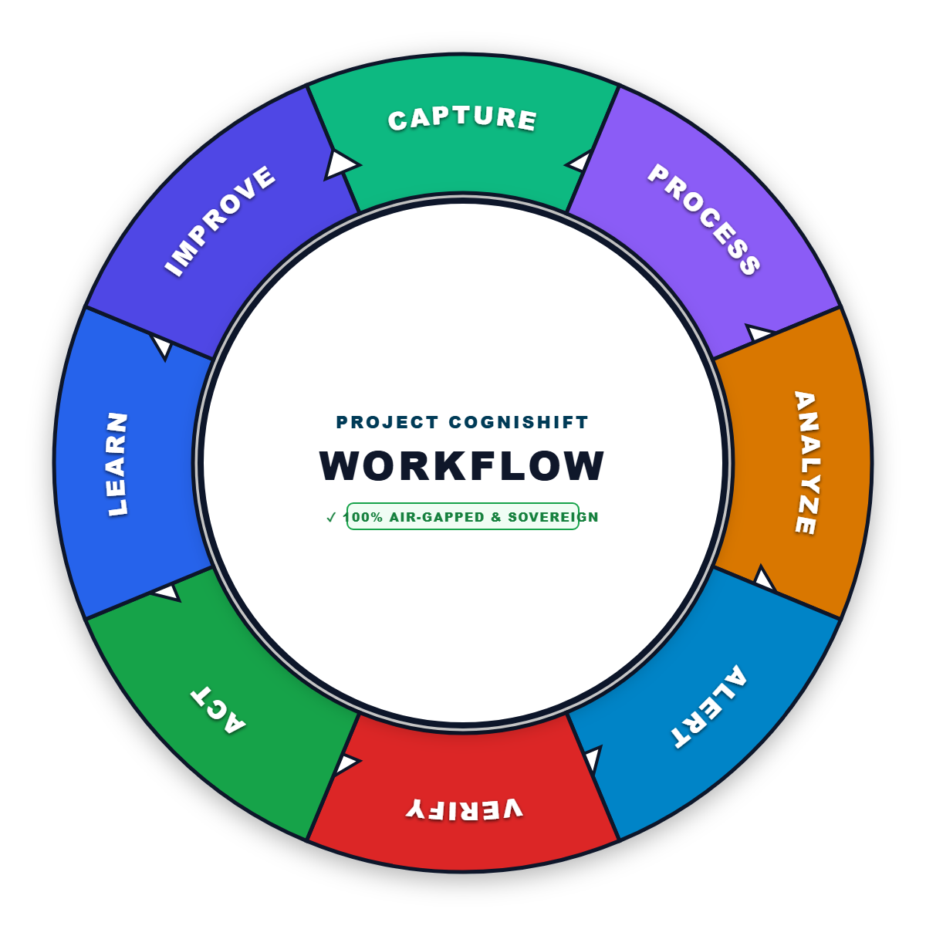
Figure 1: Project CogniShift 8-Stage Sovereign Industrial Workflow Cycle
Stage 1: CAPTURE: Air-Gapped Ingestion & Multi-Source Data Ingestion
- Blueprints & Schematics: Ingests scanned Piping & Instrumentation Diagrams (P&IDs) and electrical single-line drawings without cloud processing.
- Analog Gauge Feeds: Captures images of Bourdon tube pressure dials and level indicators directly from local maintenance cameras or operator tablets.
- Engineering Manuals: Accepts 500+ page PDF operating manuals, ASME standard codes, and manufacturer equipment rating plates.
- Network Footprint: Zero public-cloud egress during operation; all ingestion operates locally within the plant network perimeter.
Stage 2: PROCESS: Local OCR Extraction & Spatial Vectorization
- Optical Character Recognition: RapidOCR extracts text, line tags, and instrument bubble codes (e.g., 'PT-101', 'V-102') locally on CPU.
- Dial Gauge Trigonometry: Calculates needle pointer angles against calibrated minimum and maximum dial markings to infer physical pressures.
- CPU Vector Embeddings: FastEmbed generates local CPU embeddings with low-latency inference and no GPU requirement.
- Local ChromaDB Indexing: Stores chunk vectors alongside page numbers, file hashes, and equipment tags in local on-disk storage.
Stage 3: ANALYZE: 7-Intent Semantic Routing & Grounded Context Retrieval
- Intent Classification: A fast cosine router classifies operator requests into 7 discrete intents (e.g., Blueprint Query, Code Execution, Control Action).
- Ambiguity Detection: If an operator query is ambiguous or out of scope, the system halts immediately and asks for clarification.
- Configured Retrieval Threshold: Uses a configured retrieval threshold to filter weak evidence and abstain when sufficient support is unavailable.
- Multi-Step Reasoning: Qwen-2.5-Coder-7B synthesizes an execution plan referencing exact manual citations (e.g., [Manual | Page 42]).
Stage 4: ALERT: Threshold Detection & Out-of-Bounds Warning
- Operating Limit Check: Compares inferred or calculated pressures against Maximum Allowable Working Pressure (MAWP) defined in plant specs.
- Visual Console Warnings: Displays high-contrast alert badges in the operator console if a reading indicates potential equipment overpressure.
- Air-Gapped Loopback Mailer: Dispatches instantaneous email alerts to shift supervisor inboxes via a local Python SMTP service (port 1025).
- Pre-Execution Hold: Prevents operators from proceeding until safety warnings are formally acknowledged.
Stage 5: VERIFY: Sandboxed ASME Math & Self-Healing Retry Loop
- Deterministic Code Generation: The model does NOT guess calculations; it writes a self-contained Python script implementing exact ASME formulas.
- Isolated Docker Execution: The script runs inside a secured container with no network access (`--net=none`), read-only root, and 512MB RAM limit.
- Tolerance Validation: Calculated pressure drop and wall thickness values are checked against material yield strengths and design margins.
- Automated Math Retry Loop: If a script produces a traceback or syntax error, the system self-heals by analyzing stderr and re-synthesizing the code.
Stage 6: ACT: The Four-Eyes Principle (Human-in-the-Loop Safety Gate)
- Autonomous Actuation Prohibited: The AI is physically incapable of turning valves or tripping pumps directly.
- Dual Supervisor Permitting: High-consequence actions generate a formal work permit requiring sign-off from TWO independent shift supervisors.
- Cryptographic ECDSA Signatures: Supervisors sign the authorization using hardware-bound cryptographic keys (W3C WebCrypto P-256).
- Controlled Release: Only after both signatures match does the system output the verified permit for execution.
Stage 7: LEARN: Local Context Retention & Session Continuity
- Shift Handover Context: Maintains multi-turn context across consecutive operational shifts in a local SQLite session cache.
- Operator Feedback Capture: Logs operator corrections and verified parameters into local memory without altering base model weights.
- Replay Resistance: Applies a 15-minute time-to-live (TTL) and atomic nonces to ensure authorization requests cannot be replayed.
- Zero Cloud Leaks: Context retention is confined to the local workstation; zero data is transmitted to foundation model vendors.
Stage 8: IMPROVE: Verified Deliverables & Integrity-Checked Audit Logging
- Executive Deliverables: Generates formatted .docx summary reports, live .xlsx calculation sheets with active formulas, and SHA-256 signed PDFs.
- Integrity-Checked Audit Ledger: Every user prompt, retrieved citation, synthesized script, and supervisor signature is logged in an append-only SQLite WAL table.
- Traceable Audit History: Provides a traceable audit history suitable for review and investigation under industrial safety guidelines.
- Historical Analysis: Supports faster recurring maintenance analysis by preserving verified historical context.

