

**Recipe Site Using**

**Flask and SQL**

ARDA İRDEP

Table Of Contents

ABSTRACT

INTRODUCTION

RECIPE SITE USING FLASK AND SQL:

- FRONTEND

- BACKEND

- DATABASE

CONCLUSION

REFERENCES

ABSTRACT

My project was to create a complete recipe platform using Flask and SQLite3. Users will be able to find many amazing dishes on the homepage of the site or by moving around anywhere else on it. Every user who comes across something interesting while browsing can simply click on it and read all necessary information about it; what ingredients are needed for cooking this dish, approximate time spent putting together different meals as well their descriptions etc. My website ensures that all these features are incorporated in Jinja templates alongside good CSS design so that it is user-friendly.

KEYWORDS: Recipe Website, Flask, SQLite

INTRODUCTION

In a time when cooking is very much an online adventure, it is essential that computing technology be amalgamated with cuisine. That is why I decided to design an all-encompassing online cooking system using Flask and SQLite3 Database. This project was done to develop a dynamic platform that allows users to easily browse many recipes from their homepage, designed to allow users to explore diverse types of food, try new flavors and improve their cooking skills, the site also prioritized user experience using Jinja templates and CSS so that it has an attractive and user-friendly interface. The project aimed to bring technology and culinary arts together to enable people to enjoy experimenting with different foods and thus encourage everyone to enjoy cooking.

My project consists of 3 parts;

I used HTML, CSS and JavaScript in the front-end section.  
Python and Flask in the backend section.

SQLite3/DB Browser in the database section.

RECIPE SITE USING FLASK AND SQL (FRONTEND)

I used HTML CSS Jinja and JavaScript in the front-end section.  
  
After writing the main page of the website (index.html) with HTML, I created a separate html file for each recipe, since the data will be pulled from the database with the help of flask, I used Jinja so that I could both write code with a python-like syntax in html and display the data I pulled from the SQLite3 database on my html page.  
  
In the CSS part, due to the DRY principle of software engineering, I created a generic CSS file called 'recipes.css' instead of one CSS file for each html file and wrote it to adapt to all recipes.

I used JavaScript to be able to search within the recipes

.

RECIPE SITE USING FLASK AND SQL (BACKEND)

I used Python and Flask in the backend section.

First, I specified the routes using “@app.route(‘ ’)” and specified the html file to be rendered by that route using “render_template(” “)”.

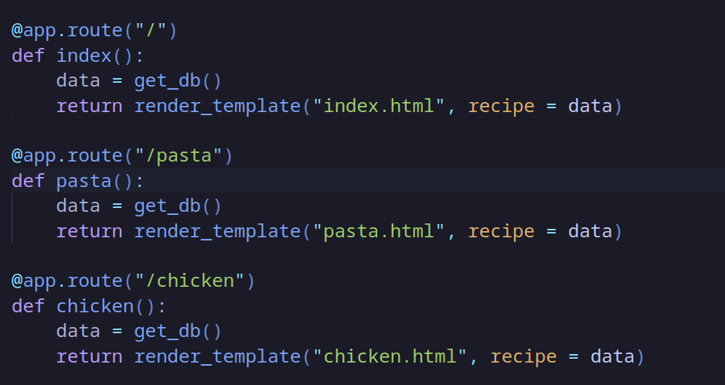

And I wrote a function called “get_db” and retrieved the food_recipes database, then I wrote the necessary queries using the cursor library I imported and assigned them to a variable called data(recipe) to get them as parameters to the render_template.

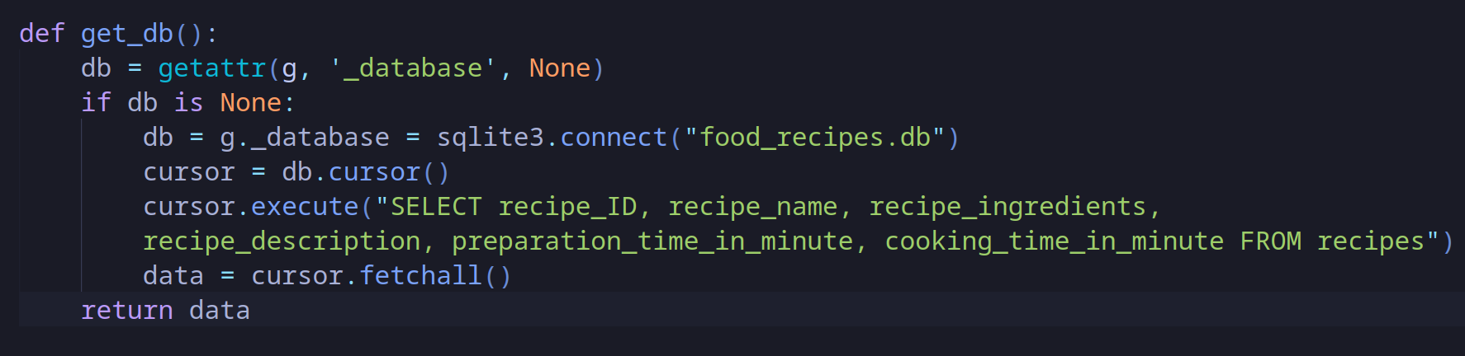

Using Jinja and this variable returned by the get_db function, I was able to access the database with array notation, so I could easily display the required values in the html pages.

Moreover, since I can write python code inside html documents using jinja, I was able to format the data extracted from the database as I wanted.

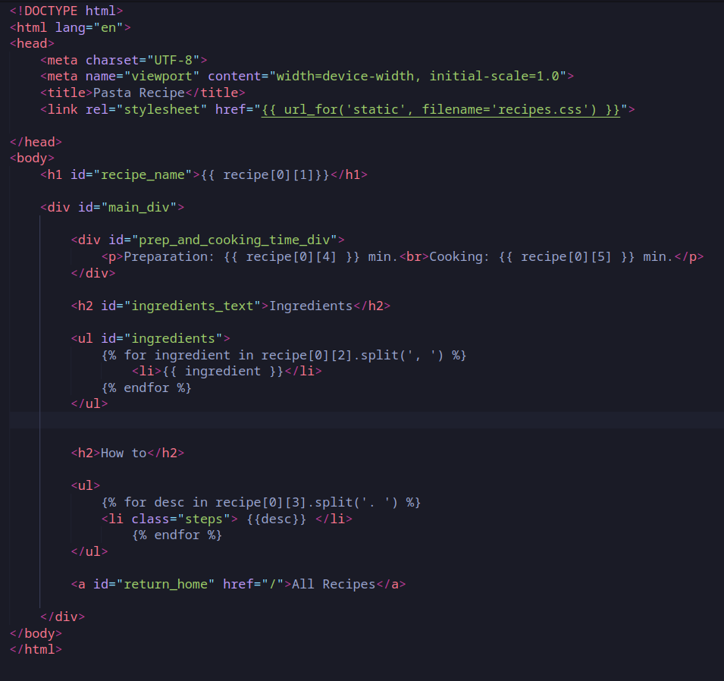

RECIPE SITE USING FLASK AND SQL (DATABASE)

I used SQLite3/DB Browser for the database section.

I created a database with SQL commands, there are 1 table in the database and 6 columns in that table:

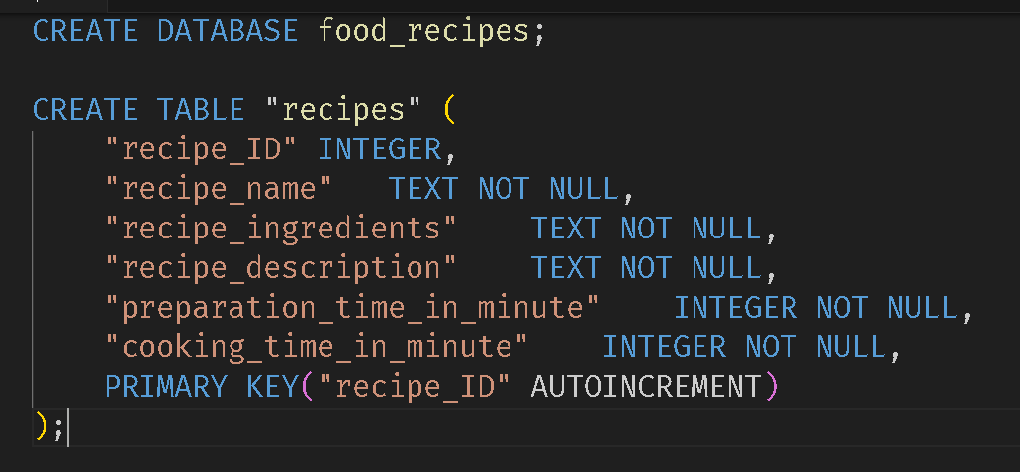

among these rows “recipe_ID” has both primary key and AUTOINCREMENT constraint, so when using insert into command, no value will be entered in the values section and the value will increase one by one.

I used the “insert into” command to insert data into these records:

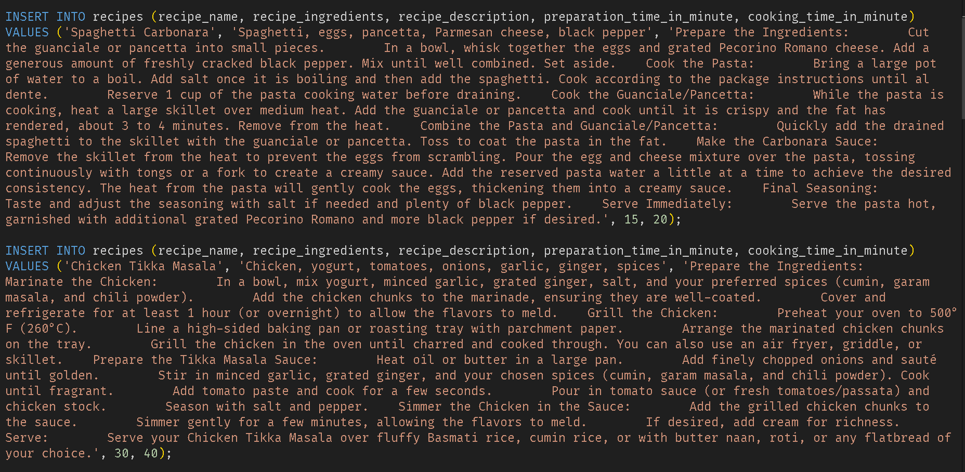

...

CONCLUSION

Through Flask and SQLite3 Database, I have developed a dynamic platform that facilitates the discovery and trying out of new recipes with ease. Besides, Jinja templates and CSS ensure a nice appearance of the site and easy navigation. Inspiring the love of cooking was our goal because I wanted to assist people in trying out diverse types of food and flavors with ease. This online cooking system offers a rich resource for those who look toward the enhancement of their culinary horizons and improvement of their cooking skills.

REFERENCES

* Flask Documentation: <https://flask.palletsprojects.com/en/3.0.x/> (Pallets Projects, Version: 3.0.x);
* Python Standard Library Documentation - sqlite3 module: <https://docs.python.org/3/library/sqlite3.html> (Python Software Foundation, Version: Python 3.0 and above).
* Jinja Documentation: <https://jinja.palletsprojects.com/en/3.1.x/> (Pallets Projects, Version: 3.1.x);
* HTML: [HTML Documentation](https://developer.mozilla.org/en-US/docs/Web/HTML) (Mozilla Developer Network)
* JavaScript: [JavaScript Documentation](https://developer.mozilla.org/en-US/docs/Web/JavaScript) (Mozilla Developer Network)
* CSS: [CSS Documentation](https://developer.mozilla.org/en-US/docs/Web/CSS) (Mozilla Developer Network), Version: Latest