**Updated Specification: Holidaze App**

My application is called Holidaze. Its purpose is for personal use and allows the user to plan out a return plane trip and receive information regarding the cheapest available flights. This will be done by utilizing Expedia’s API – Flights (<https://www.expedia.com/static/mobile/swaggerui/#!/Flights/flights-search>).

It is simple to use and navigate the app, as I have implemented features such as touch gestures. Finally, to assist the user in properly interacting with the application and make full use of its functionality, a user guide screen is a part of this application.

**UI Sketches**

**Screen Layout**

Figure - Screen Layout

A screen is reachable directly from the screen to the left of it in Figure 1.

**Screens**

**Login (MainActivity)**

1: Screen title

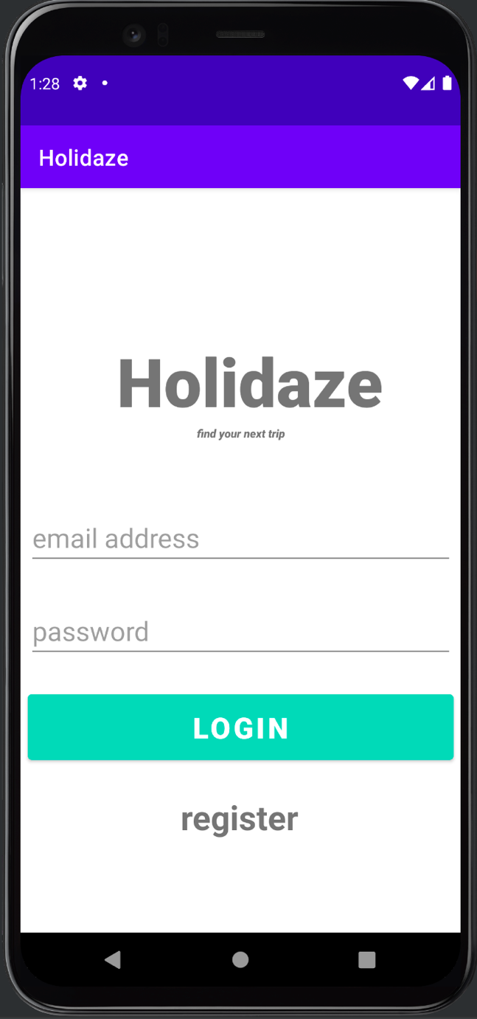

Figure - Login Screen



2: Enter username

3: Enter password

4: Initiates login process – if successful, takes user to homepage

5: If user is new and wants to register

Utilises firebase

Helper classes:

User – checks details

**Sign up (RegisterUser)**

1. Page title

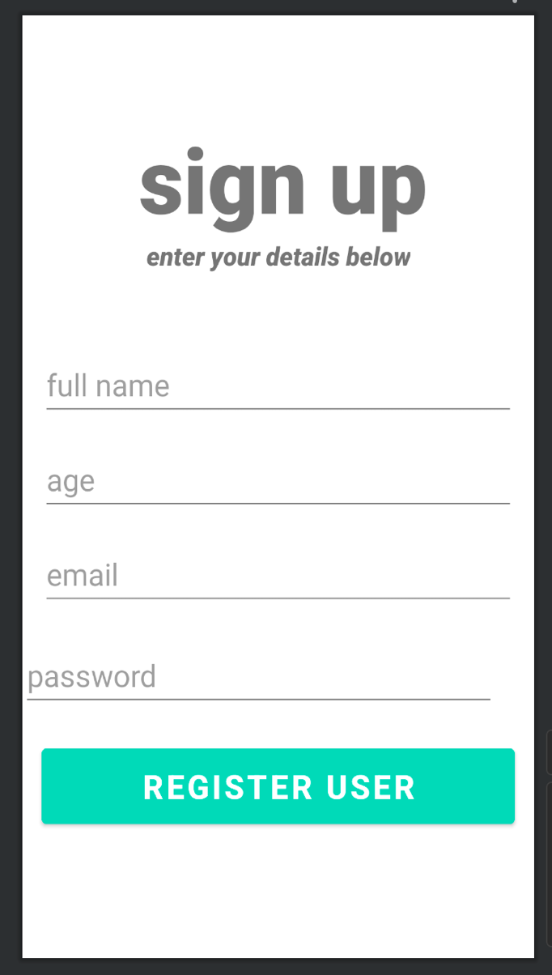

Figure - Signup Screen

2. User’s full name

3. User’s age

4. User’s email

5. User’s password

6. User is registered with above details

Utilises firebase

Helper classes:

User – saves details

**Homepage (ProfileActivity)**

Figure – Homepage Screen

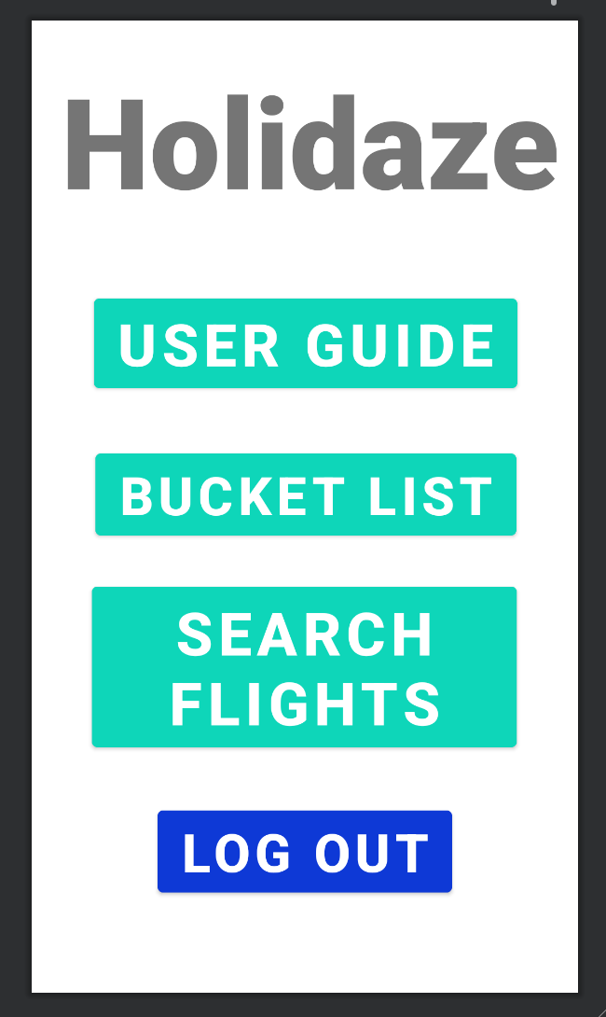

1. Screen title

2. Takes user to the user guide

3. Takes user to the bucket list page

4. Takes user to search page

5. Logs user out (on long press)

**Search (SearchActivity)**

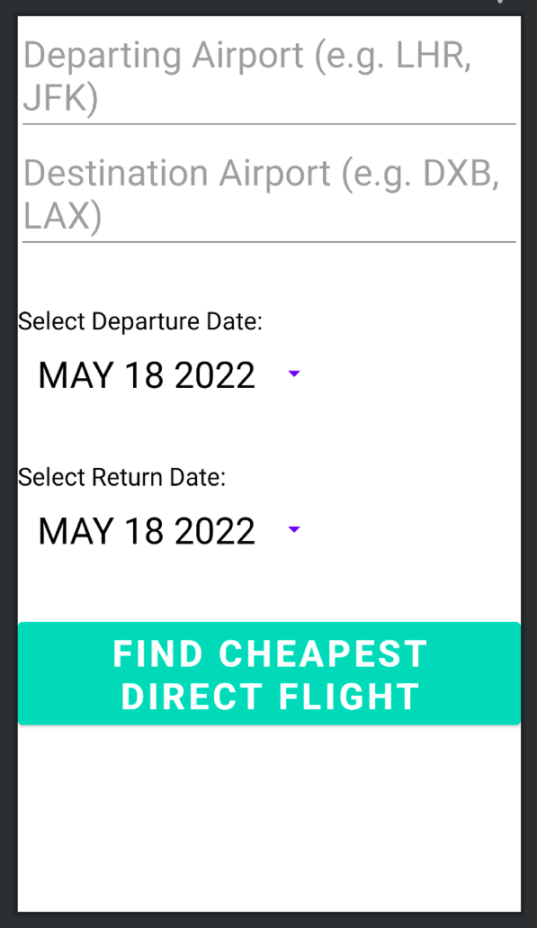

Figure - Search Screen

1. Enter origin airport IATA code (3-letters)

2. Enter destination airport IATA code (3-letters)

3. Departure date picker

4. Return date picker

5. Begin search for cheapest direct flight

Helper classes:

NetworkUtils – in utils folder, needed for API communication

MyService – plays sound while search is executed

Figure - Search Page

**Search Results (ResultsActivity)**

1. Displays total price in USD

Figure 6 - Search Results Screen

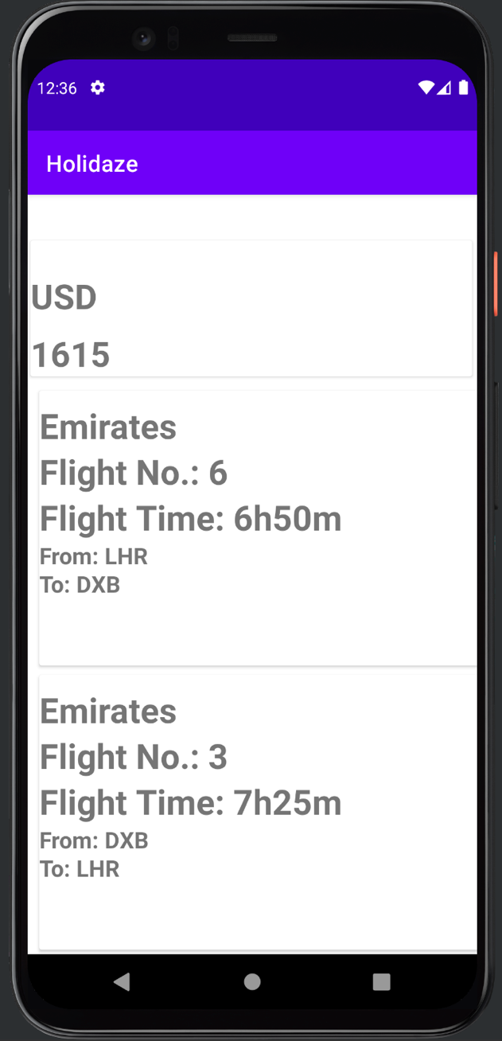

2. Displays airline, flight number, flight time for departure leg

3. Displays airline, flight number, flight time for return leg

Helper classes:

MyService – stops playing sound when results show

**Bucket List (BucketList)**

1. Adds a new item to bucket list

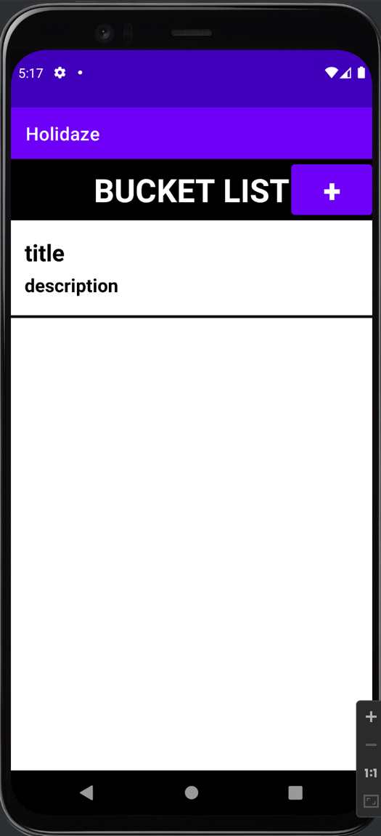

Figure - Bucket List Screen

2. Lists current items (scrollable)

Helper classes:

Note – defines the parameters to create/edit items

NoteAdapter – formats the bucket list items within the list

SQLiteManager – manages sqlite database containing bucket list items

**Add/edit bucket list items (NoteDetailActivity)**

Figure - Add/Edit Bucket List Items

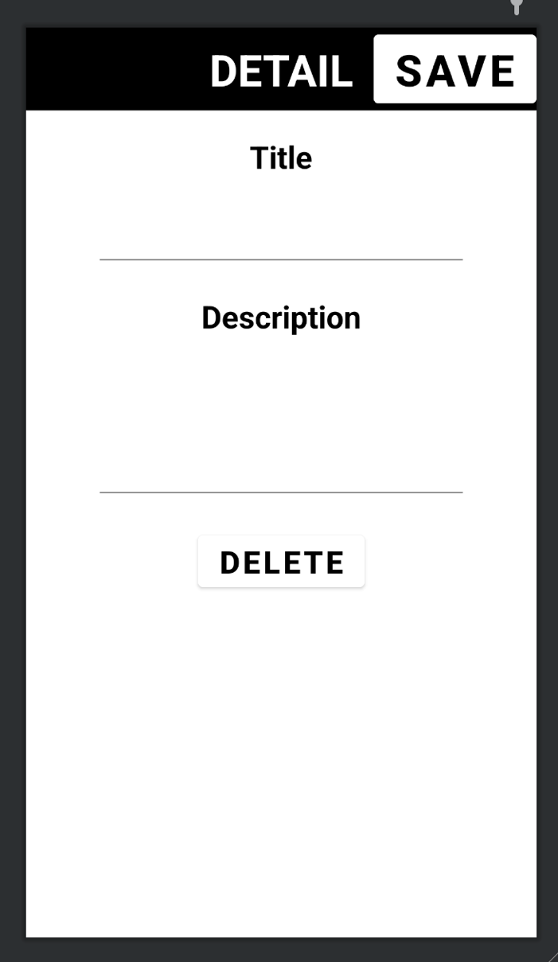

1. Save new item/ update old one

2. Item title (e.g. Dubai – DXB trip)

3. Item description (e.g. May 19th - June 1st)

4. Item deletion

Helper classes:

SQLiteManager – updates database

**User Guide (UserGuideActivity)**

Dependencies – UserGuide.html