

BILKENT UNIVERSITY

CS 342 – OPERATING SYSTEMS

PROJECT #1

ARDA AKÇA BÜYÜK

21802835

SECTION 01

**OBTAINED RESULTS:**

In the first two tables (Table 1, 2), the effect of the M value (number of characters) is observed by fixing N value to 1. In the following two tables (Table 3, 4) the effect of the N value (the number of bytes processed at a time) is observed. In Table 5, the execution times with respect to both M and N values in normal mode are observed. And in Table 6, the execution times with respect to both M and N values in tapped mode are observed.

|  |  |  |
| --- | --- | --- |
| N | M | Time (microseconds) |
| 1 | 1 | 744 |
| 1 | 4 | 743 |
| 1 | 16 | 1140 |
| 1 | 64 | 1614 |
| 1 | 256 | 1390 |
| 1 | 1024 | 1592 |
| 1 | 4096 | 2072 |

|  |  |  |
| --- | --- | --- |
| N | M | Time (microseconds) |
| 1 | 1 | 630 |
| 1 | 4 | 1140 |
| 1 | 16 | 1493 |
| 1 | 64 | 1755 |
| 1 | 256 | 2825 |
| 1 | 1024 | 1736 |
| 1 | 4096 | 1613 |

Table 1: Elapsed Time vs M (Normal Mode) Table 2: Elapsed Time vs M (Tapped Mode)

|  |  |  |
| --- | --- | --- |
| N | M | Time (microseconds) |
| 1 | 4096 | 1038 |
| 4 | 4096 | 676 |
| 16 | 4096 | 691 |
| 64 | 4096 | 1595 |
| 256 | 4096 | 656 |
| 1024 | 4096 | 857 |
| 4096 | 4096 | 824 |

|  |  |  |
| --- | --- | --- |
| N | M | Time (microseconds) |
| 1 | 4096 | 1040 |
| 4 | 4096 | 988 |
| 16 | 4096 | 1193 |
| 64 | 4096 | 814 |
| 256 | 4096 | 621 |
| 1024 | 4096 | 754 |
| 4096 | 4096 | 844 |

Table 1: Elapsed Time vs N (Normal Mode) Table 2: Elapsed Time vs N (Tapped Mode)

These are the obtained graphs according to the experiments.

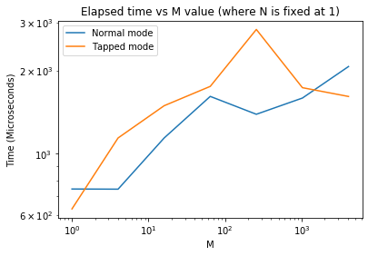 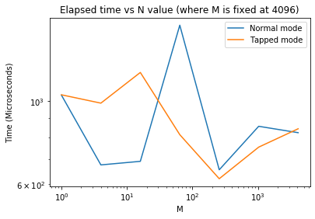

Figure 1: Elapsed Time vs M Figure 2: Elapsed time vs N

|  |  |  |  |  |  |  |  |
| --- | --- | --- | --- | --- | --- | --- | --- |
| N/M | 1 | 4 | 16 | 64 | 256 | 1024 | 4096 |
| 1 | 744 | 743 | 1140 | 1614 | 1390 | 1592 | 2072 |
| 4 | 853 | 1159 | 1553 | 1440 | 1120 | 1855 | 1387 |
| 16 | 491 | 1291 | 1869 | 1772 | 1510 | 1311 | 1244 |
| 64 | 459 | 1288 | 1499 | 1685 | 1197 | 1242 | 4650 |
| 256 | 658 | 1122 | 1156 | 1119 | 1275 | 1265 | 1267 |
| 1024 | 597 | 526 | 1304 | 1881 | 1419 | 1515 | 2002 |
| 4096 | 567 | 1341 | 1289 | 1304 | 1609 | 1284 | 1681 |

Table 5: Execution time (msec) with respect to N, M (normal mode)

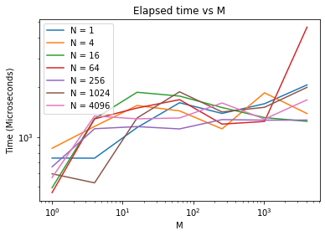

Figure 3: Execution time vs M, N (normal mode)

|  |  |  |  |  |  |  |  |
| --- | --- | --- | --- | --- | --- | --- | --- |
| N/M | 1 | 4 | 16 | 64 | 256 | 1024 | 4096 |
| 1 | 630 | 1140 | 1493 | 1755 | 2825 | 1736 | 1613 |
| 4 | 491 | 1338 | 1192 | 1179 | 1366 | 1243 | 1267 |
| 16 | 539 | 1287 | 1084 | 1613 | 1773 | 1490 | 1329 |
| 64 | 479 | 1159 | 1093 | 1173 | 1031 | 1168 | 1266 |
| 256 | 660 | 1371 | 1216 | 1142 | 1901 | 1134 | 1260 |
| 1024 | 632 | 569 | 2038 | 1573 | 1290 | 2473 | 1584 |
| 4096 | 597 | 1859 | 1378 | 1364 | 1394 | 1182 | 1287 |

Table 6: Execution time (msec) with respect to N, M (tapped mode)

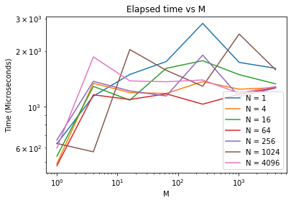

Figure 4: Execution time vs M, N (tapped mode)

**INFERENCES & DISCUSSION:**

As can be seen from Figure 1, the M value increase tends to increase the execution time as expected since M value increases the bytes processed. Therefore, the theoretical prediction matches with the experimental results. In Figure 2, despite some fluctuations, the elapsed time tends to drop while N value is increased because as N value increases, the number of bytes processed at a time increases, and the transfer of data quickens. Therefore, experimental data matches with the theoretical prediction. In figure 3, we can see that there are no major changes on the execution times as N changes. Because in normal mode, we transfer the data all at once, independent from the N value. However, in Figure 4, we can see that as N value increases, the execution times tend to drop, and as M value increases, the execution times tend to increase, as expected.