

IHSAN DOGRAMACI BILKENT UNIVERSITY

CS342 – OPERATING SYSTEMS

PROJECT #2

ARDA AKÇA BÜYÜK

21802835

SECTION 01

**Experiment 1:**

|  |  |
| --- | --- |
| N | Average Waiting Time (ms) |
| 1 | 0.00 |
| 2 | 49.40 |
| 3 | 279.87 |
| 4 | 298.13 |
| 5 | 380.68 |
| 6 | 946.30 |
| 7 | 939.63 |
| 8 | 1014.16 |
| 9 | 1199.11 |
| 10 | 1232.30 |

|  |  |
| --- | --- |
| N | Average Waiting Time (ms) |
| 1 | 0.00 |
| 2 | 0.00 |
| 3 | 77.33 |
| 4 | 222.85 |
| 5 | 338.04 |
| 6 | 575.92 |
| 7 | 535.59 |
| 8 | 821.45 |
| 9 | 790.37 |
| 10 | 1169.55 |

Table 1. FCFS & N Table 2. SJF & N

|  |  |
| --- | --- |
| N | Average Waiting Time (ms) |
| 1 | 0.00 |
| 2 | 10.90 |
| 3 | 11.50 |
| 4 | 293.58 |
| 5 | 329.50 |
| 6 | 535.00 |
| 7 | 538.57 |
| 8 | 747.15 |
| 9 | 856.15 |
| 10 | 960.49 |

|  |  |
| --- | --- |
| N | Average Waiting Time (ms) |
| 1 | 0.00 |
| 2 | 0.00 |
| 3 | 117.63 |
| 4 | 113.43 |
| 5 | 466.76 |
| 6 | 773.10 |
| 7 | 1044.81 |
| 8 | 990.75 |
| 9 | 1405.22 |
| 10 | 1666.19 |

*Table 3. PRIO & N Table 4. VRUNTIME & N*

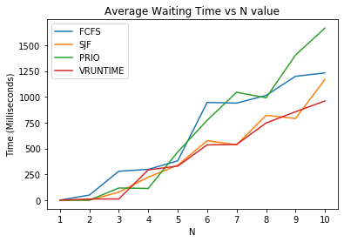

This experiment was done to compare the scheduling algorithms’ average waiting time with respect to N (number of threads). The command to conduct such experiments was:

./schedule N 10 100 150 250 500 ALG

There were 10 bursts for each thread which had an average length of 150 ms. Each thread had an average inter arrival time of 500 ms.

The results suggest us that the PRIO algorithm has the most average waiting time when compared with other algorithms. Its reason is the ignorance of the burst lengths and scheduling the CPU bursts according to their thread indexes. And the results suggest that the VRUNTIME algorithm has the least average waiting time when compared with other algorithms. It might be because of the effort to balance the lengths of the bursts with the calculation of the virtual runtime for a particular thread.

**Experiment 2:**

|  |  |
| --- | --- |
| Thread index | Average Waiting Time (ms) |
| 1 | 1646.40 |
| 2 | 1341.00 |
| 3 | 896.60 |
| 4 | 823.60 |
| 5 | 1339.80 |
| 6 | 1117.20 |
| 7 | 865.20 |
| 8 | 1588.20 |
| 9 | 1302.00 |
| 10 | 1207.60 |

|  |  |
| --- | --- |
| Thread index | Average Waiting Time (ms) |
| 1 | 776.20 |
| 2 | 409.40 |
| 3 | 546.00 |
| 4 | 818.00 |
| 5 | 974.80 |
| 6 | 371.80 |
| 7 | 361.60 |
| 8 | 998.20 |
| 9 | 569.00 |
| 10 | 603.20 |

Table 5. FCFS & N Table 6. SJF & N

|  |  |
| --- | --- |
| Thread index | Average Waiting Time (ms) |
| 1 | 728.20 |
| 2 | 290.80 |
| 3 | 1104.60 |
| 4 | 725.00 |
| 5 | 1821.00 |
| 6 | 1298.60 |
| 7 | 719.00 |
| 8 | 465.60 |
| 9 | 1073.20 |
| 10 | 1740.00 |

|  |  |
| --- | --- |
| N Thread index | Average Waiting Time (ms) |
| 1 | 0.60 |
| 2 | 266.80 |
| 3 | 431.20 |
| 4 | 924.20 |
| 5 | 985.20 |
| 6 | 298.60 |
| 7 | 1203.60 |
| 8 | 1039.80 |
| 9 | 1602.20 |
| 10 | 1169.80 |

*Table 7. PRIO & N Table 8. VRUNTIME & N*

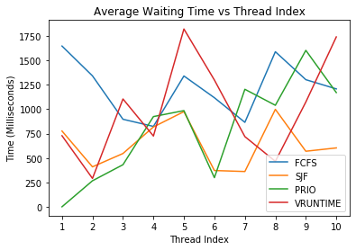

This experiment was done to compare the scheduling algorithms’ average waiting time for each thread with respect to thread index. The command to conduct such experiments was:

./schedule 10 5 100 150 250 500 ALG

There were 5 bursts for each thread which had an average length of 150 ms. Each thread had an average inter arrival time of 500 ms.

The results suggest us that the waiting time for each thread in FCFS and SJF algorithms does not directly dependent on the thread indexes, since they do not schedule according to thread indexes. However, it can be seen from the graph that as thread indexes increase, the average waiting time for that particular thread increases. This is because PRIO algorithm prioritizes lowest thread indexes.

**Experiment 3:**

|  |  |
| --- | --- |
| avgB | Average Waiting Time (ms) |
| 250 | 551.32 |
| 500 | 1079.04 |
| 750 | 1601.08 |
| 1000 | 1611.40 |
| 1250 | 2415.36 |

|  |  |
| --- | --- |
| avgB | Average Waiting Time (ms) |
| 250 | 207.88 |
| 500 | 457.92 |
| 750 | 605.88 |
| 1000 | 638.72 |
| 1250 | 1042.08 |

Table 9. FCFS & avgB Table 10. SJF & avgB

|  |  |
| --- | --- |
| avgB | Average Waiting Time (ms) |
| 250 | 579.28 |
| 500 | 954.76 |
| 750 | 986.16 |
| 1000 | 1541.32 |
| 1250 | 1273.52 |

|  |  |
| --- | --- |
| avgB | Average Waiting Time (ms) |
| 250 | 754.56 |
| 500 | 870.60 |
| 750 | 761.56 |
| 1000 | 1588.88 |
| 1250 | 2863.08 |

*Table 11. PRIO & avgB Table 12. VRUNTIME & avgB*

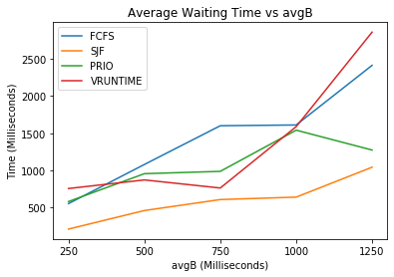

This experiment was done to compare the scheduling algorithms’ average waiting time with respect to avgB (average burst length). The command to conduct such experiments was:

./schedule 5 5 100 avgB 250 500 ALG

There were 5 bursts for each thread which had an average length of avgB ms. Each thread had an average inter arrival time of 500 ms.

The results suggest us that the average waiting time all of the algorithms have a tendency to increase as avgB increases. This is because as burst lengths increase, the CPU bursts waiting in the ready queue waits more. When observed the graph, it can be seen that FCFS algorithm has the most average waiting times, where SJF algorithm has the least average waiting times. This is because FCFS does not optimize any metric and SJF schedules according to the burst lengths and therefore, optimizes average waiting time.

**Experiment 4:**

|  |  |
| --- | --- |
| avgA | Average Waiting Time (ms) |
| 250 | 269.88 |
| 500 | 285.16 |
| 750 | 81.52 |
| 1000 | 138.16 |
| 1250 | 178.40 |

|  |  |
| --- | --- |
| avgA | Average Waiting Time (ms) |
| 250 | 323.12 |
| 500 | 141.64 |
| 750 | 213.20 |
| 1000 | 130.68 |
| 1250 | 110.96 |

Table 13. FCFS & avgA Table 14. SJF & avgA

|  |  |
| --- | --- |
| avgA | Average Waiting Time (ms) |
| 250 | 512.44 |
| 500 | 541.04 |
| 750 | 413.12 |
| 1000 | 169.72 |
| 1250 | 81.24 |

|  |  |
| --- | --- |
| avgA | Average Waiting Time (ms) |
| 250 | 508.48 |
| 500 | 427.72 |
| 750 | 180.44 |
| 1000 | 122.92 |
| 1250 | 27.00 |

*Table 15. PRIO & avgA Table 16. VRUNTIME & avgA*

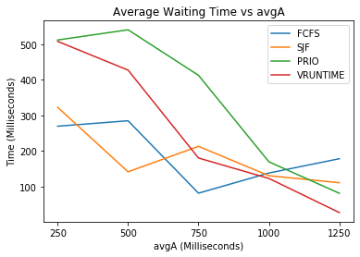

This experiment was done to compare the scheduling algorithms’ average waiting time with respect to avgA (average inter arrival time). The command to conduct such experiments was:

./schedule 5 5 100 150 250 avgA ALG

There were 5 bursts for each thread which had an average length of 150 ms. Each thread had an average inter arrival time of avgA ms.

The results suggest us that the average waiting time all of the algorithms have a tendency to decrease as avgA increases. This is because as inter arrival times increase, the arrival time of the CPU bursts and their insertion in the ready is delayed, therefore, they spend less time in the ready queue.