Homework 2
EEE361 -Linear Algebra in Data Analysis and Machine Learning

Arda Can Aras
21704036

Introduction
In this assignment, we are asked to investigate the performance of the three alternative least square solver for $Ax=b$. These are Generalized Minimum Residual (GMRES), Conjugate Gradients (CG) and Pseudoinverse of A. There are total of 6 different A matrices which are constructed according to specifications in the report. With the following lines of code, I generate my 6 different matrix and corresponding 10 x0s.
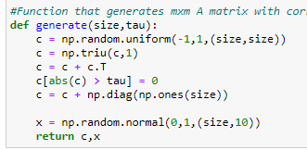
After that we are asked to find corresponding b values for A and x. Then we add 3 different levels for each of b that comes out from 10 x0. Therefore, in total we have 30 b vectors.
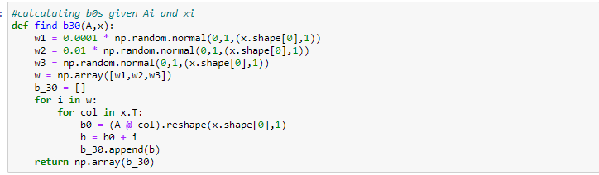
Return of this function will be in the format of (30 x m x 1) where m is the dimension of the column vector b. To follow same notation with assignment, we can simply cast it to (3 x 10 x m x 1) where 3 denotes different noise levels. In my function first 10 elements corresponds to first noise level and so on. In my code I investigate the matrixes in the order of Pseudo Inverse, CG and GMRES.

Pseudo Inverse Method
For the full column rank or full row rank matrices there is closed form solution that can be find that minimizes the following equation.
$$\hat{x}=argmin∥b-A\hat{x}∥^{2}, where \hat{x} ∈R^{nx1}$$
However, a general way to evaluate this problem when our matrix is not column rank or row rank is finding the SVD of matrix A since SVD is valid for every matrix.
$$\text{t}\text{he pseudoinverse of }A=UΣV^{T}\text{ is }A^{+}=VΣ^{+}U^{T}$$
$$Σ^{+} has\frac{1}{σ_{i}}values and is transposed version of Σ$$
$$\hat{x}=A^{+}b$$
We can simply use the “pinv” method of the numpy library to evaluate this. But it also simple to write our own algorithm. After constructing my algorithm, I evaluate the following error function:
$$E_{S,i}=\sqrt{\frac{1}{10}\sum_{j=1}^{10}{ }{∥e_{i,j}∥}_{2}^{2}}, where e_{i,j}= x_{0,j}-{\hat{x}}_{i,j} and {\hat{x}}_{i,j}=A^{+}b_{i,j}$$
Where each i corresponds to different noise level in w.

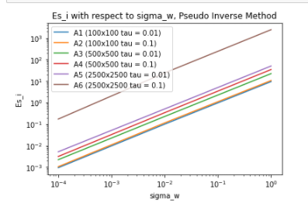
Figure 1: E_{S,i} values with respect to different noise levels in logarithmic scale by Pseudo Inverse

From this figure above it is obvious that error increases as noise level increases. For the A6 matrix where size is 2500x2500 and tau = 0.1 error is considerably large. This might occur due to less sparsity and failure in being positive definite matrix. One can also observe that, small tau values have less error and as size of the matrix getting smaller error also decreases. For the small size matrix like 100x100 tau value is not even important. However, when we observe 2500x2500 error changes a lot as tau changes.

Conjugate Gradient Method:
For symmetric positive definite matrices, we can propose a powerful algorithm that solves
Sx = b where S is used for symmetric positive definite matrix. For the convention with previous notations, A will be used instead of S. For Hessenberg matrix generated in GMRES is tridiagonal when A is symmetric. Also, A norm of x which is ${∥x∥^{2}}_{A}=x^{T}Ax$ gives an appropriate norm to measure the error after k steps, where k is the iteration number. Using the derivations in the class we can construct the procedure as:
$$\begin{aligned}&x_{0}=0,r_{0}=b,d_{0}=r_{0} \\ &\text{ for }k=1\text{ to }N \\ &α_{k}=\left(r_{k-1}^{T}r_{k-1}\right)/\left(d_{k-1}^{T}Sd_{k-1}\right) \\ &x_{k}=x_{k-1}+α_{k}d_{k-1} \\ &r_{k}=r_{k-1}-α_{k}Sd_{k-1} \\ &β_{k}=\left(r_{k}^{T}r_{k}\right)/\left(r_{k-1}^{T}r_{k-1}\right) \\ &d_{k}=r_{k}+β_{k}d_{k-1}\end{aligned}$$

To stop iteration, I also propose a condition such that residual square is smaller than a specific tolerance that will be find by trial and error. After that we are asked to find another type of error that measures the RMSE for different values of tau values. Its formula was given in the assignment as follows:
$$E_{O,i}=\sqrt{\frac{1}{10}\sum_{j=1}^{10}{ }{∥b_{i,j}-A{\hat{x}}_{i,j}∥}_{2}^{2}} where {\hat{x}}_{i,j} is the estimated solution of CG$$
After following the algorithm I obtained the following graphs of E_{S,I} and E_{S,O.}

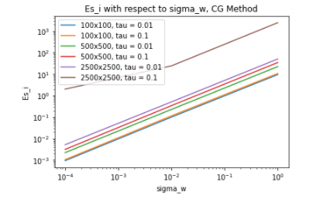
Figure 2: E_{S,i} values with respect to noise levels logarithmic plot CG
We can also observe that error increases as noise level increases. It reaches its peak for 2500x2500 matrix with tau = 0.1. Again, it can occur because of the less sparsity and failure in being positive definite matrix. One can also observe that, small tau values have less error and as size of the matrix getting smaller error also decreases. For the small size matrix like 100x100 tau value is not even important. However, when we observe 2500x2500 error changes a lot as tau changes.
For the other type of error, there are 6 different matrices with 3 different noise levels. Therefore, in total we have 18 graphs of error with respect to number of iterations.

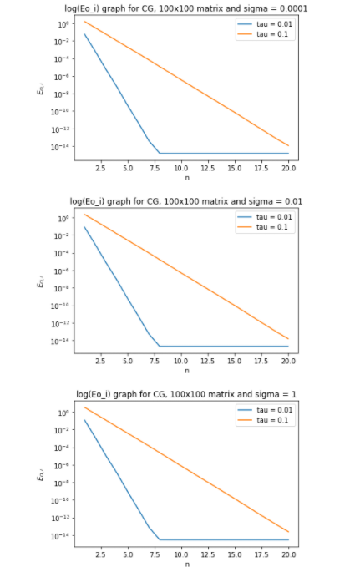

Figure 3: Log(E_oi) graph for CG with 100x100 matrix for all different sigma values

For 100x100 matrices we can conclude that regardless of the noise levels graphs are approximately equal. For tau = 0.01 we can obtain solution in 8 steps which is same as in the example given. Also, convergence is not a problem when tau = 0.1. We can still observe pretty good results.
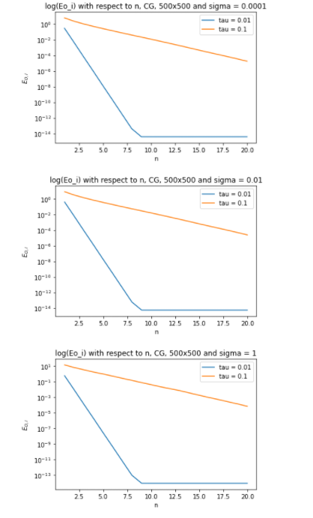
Figure 4: Log(E_oi) graph for CG with 500x500 matrix for all different sigma values

For 500x500 matrices we can conclude that regardless of the noise levels graphs are approximately equal. For tau = 0.01 we can obtain solution in 9 steps which is same as in the example given. Also, convergence is not a problem when tau = 0.1. We can still observe pretty good results.

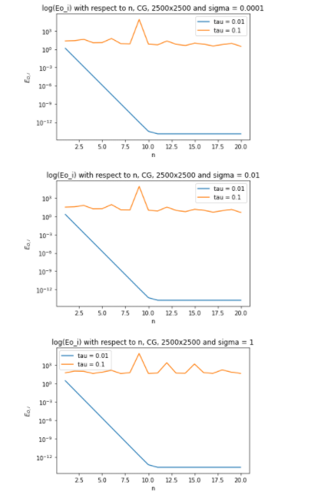
Figure 5: Log(E_oi) graph for CG with 2500x2500 matrix for all different sigma values

For 2500x2500 matrices we can observe that, regardless of the noise levels graphs are approximately equal. For tau = 0.01 we can obtain solution in 11 iterations. Unlike previous 100x100 and 500x500 matrices, we cannot converge with tau = 0.1. However, we can still solve large matrices with small tau values.
One can observe that for tau = 0.01 or close to zero, we find solutions in 8,9 and 11 iterations. When this compared with Pseudo Inverse method, we can say that it is much faster.

Stopping Criteria for CG
As it was already mentioned, there need to be a stopping criterion for CG. One can use a tolerance level for a residual. It can be formulated as follows
$$r_{k}={∥b-{A\hat{x}}_{k}∥}_{2}^{1}<tolerance$$
However, it is also possible to check orthogonality condition for bases of Krylov subspace. Since we do not need to calculate each element of orthonormal vectors in a matrix for CG, choosing tolerance level for stopping criteria will be beneficial to decrease computational process.
From figures we can observe that for tau = 0.01, there is no need to iterate over all size of A. Even very small number like 8 is enough for convergence. However, for cases like 2500x2500 with tau = 0.1 there is no convergence
Orthogonality Check of the Basis of Krylov Subspace with CG
$${⟦Q_{k}^{T}Q_{k}-I_{k}⟧}_{F}$$
Formula above is used to check orthogonality of the basis of Krylov subspace. Simply I stored the error in each iteration and tried to whether this error is negligible or not. The output of the code is as follows:
The number of iterations are 8
Frobenius_norm of(Q_k.T Q_k - I_k) for iterations up to 8:[2.220446049250313e-16, 2.0615012487730452e-14, 2.0834224059487134e-14, 3.318216646683312e-14, 5.540714045129809e-14, 1.1134973711241468e-13, 1.6428535618937574e-13, 2.27978310343056e-13]

Since the errors are in the order of 1e-13 at most, they are negligible for finite precision arithmetic. Even this output is for 100x100 matrix, I also observe orthogonality for higher dimensions. However, when we run algorithm for size of A even it is 100x100 matrix, we can observe that orthogonality fails.
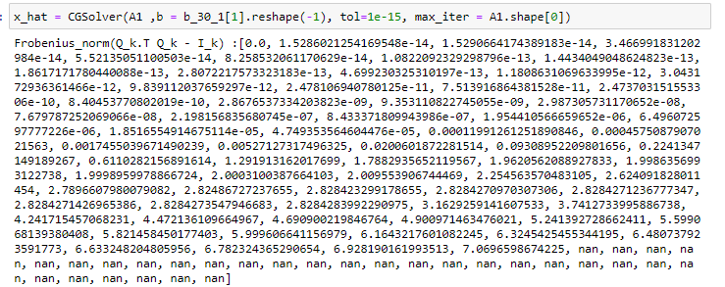

One should note that orthogonality is not satisfied after higher number of iterations especially when it exceeds the number of iterations where convergence occurs. Therefore, we need to use stopping criteria to rely on our method.

GMRES Method
The key idea of GMRES is to compute Ab is fast when A is a sparse matrix. Therefore, we can quickly obtain Krylov subspace. There are two type of iterations which are Lanczos and Arnoldi. Since our matrix is symmetric, I used Lanczos iteration. It procedure can be formulated as follows:

$$\begin{aligned}v&=Sq_{k} \\ a_{k}&=q_{k}^{T}v \\ v&=v-b_{k-1}q_{k-1}-a_{k}q_{k} \\ b_{k}&=∥v∥ \\ q_{k+1}&=v/b_{k}\end{aligned}$$

Then I evaluate the performance of the GMRES solver with Lanczos iteration using the following formula:
$$E_{S,i}=\sqrt{\frac{1}{10}\sum_{j=1}^{10}{ }{∥e_{i,j}∥}_{2}^{2}}, where e_{i,j}= x_{0,j}-{\hat{x}}_{i,j}$$

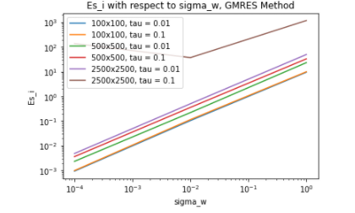
Figure 6: E_{S,i} values with respect to noise levels in logarithmic scale plot, GMRES Method

From figure above, one can observe that error increases as noise level increase. For the matrix 2500x2500 with tau = 0.1, error reaches its peak. Again, we can say that since the matrix has less sparsity and fails on being positive definite this error value occurs.

Stopping Condition for GMRES
The stopping criteria used here is like CG. The same formulation above can be used to check for tolerance value.
$$r_{k}={∥b-{A\hat{x}}_{k}∥}_{2}^{1}<tolerance$$
From that tolerance, what we expect is matrix converges to some certain value so that we do not need the iterate all over Krylov subspace. Possibly some k value smaller than n will be sufficiently enough for convergence. However, for all matrices choosing tolerance as 1e-15 was problematic. Error does not converge to that value so iterates for max iteration. It is also possible to use orthogonality concept for stopping condition. Using columns of Q matrix, we can observe whether it is orthogonal or not by taking following Frobenius norm:
$${⟦Q_{k}^{T}Q_{k}-I_{k}⟧}_{F}$$
Therefore, I implement my stopping criteria such that when the frobenius norm of the error reaches some certain threshold level the algorithm stops. With that approach, computational time is decreased significantly.
Orthogonality of Basis in GMRES Method
By checking the formula above in each iteration, we can store the frobenius norm to see when orthogonality is not valid for the matrices that converge to some tolerance level. We can observe some of the results as follows:
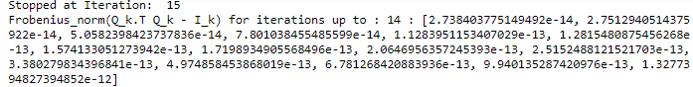
Since my stopping criteria relies on the orthogonality concept, I iterate through some certain threshold (1e-12) value. When the frobenius norm of the error reaches this value, I assume that orthogonality does not exists.

