**Theoretical Background**

1. **Kalman Filter**
2. **Extended Kalman Filter**
3. **Iterative Extended Kalman Filter**
4. **Beamformers**
5. **Delay and Sum Beamformer**
6. **Capon Beamformer**
7. **Element Pattern of Antenna**
8. **Near Field – Far Field**

**Methodology**

**Implemented Spatial Filtering Methods**

1. **Maximum Peak Filter:** The filter identifies the peaks in the beamformer pattern. Based on the approximate position of the target, target is removed from the listed peaks. Remaining peaks are sorted based on their amplitudes. The peak with maximum amplitude is regarded as reflection source. The signal coming from the reflection source is extracted by the beamformer. Extracted signal’ s phase is adjusted based on the location of the antenna elements. Phase adjusted signals are subtracted from the initially received signal to obtain the filtered signal.
2. **Ground Reflection Filter:** The filter identifies the peaks in the beamformer pattern. Based on the approximate position of the target, the direction of ground reflection is computed. The ground reflection position is found based on the phi angle of the target. The peaks with approximately same phi angle as the target are sorted based on their amplitudes and the peak with maximum amplitude is regarded as reflection source.The signal coming from the reflection source is extracted by the beamformer. Extracted signal’ s phase is adjusted based on the location of the antenna elements. Phase adjusted signals are subtracted from the initially received signal to obtain the filtered signal.

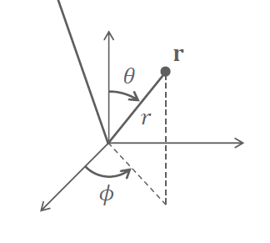

Figure : Coordinate system

1. **Target Only Filter:** Based on the approximate position of the target, the maximum peak near the approximate position is found. During this operation conic filtering is used.The signal coming from the target source is extracted by the beamformer. Extracted signal’ s phase is adjusted based on the location of the antenna elements. Phase adjusted signals are used as the filtered signal and used by the IHEKF algorithm.
2. **Conic Filter:** This filter keeps only 3D points inside a conical shape defined by a top angle alpha. The points outside the conical shape are filtered out. Conical shape is defined by its direction and its angle alpha. The points are normalized so that they are placed on the unit sphere. Then, each points’ projection to the direction vector is computed. The projections with amplitude larger than cos(alpha) are kept and other points are filtered out.

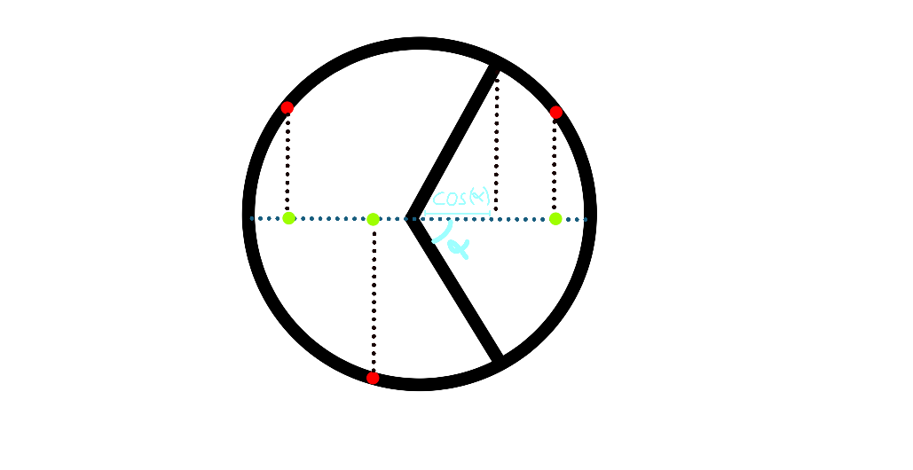

Figure : Projection operation in conical filter

1. **Iterative Filter:** Based on the approximate position of the target, the maximum peak near the approximate position is found. During this operation conic filtering is used. The signal coming from the target source is extracted by the beamformer. Extracted signal’ s phase is adjusted based on the location of the antenna elements. Phase adjusted signals are removed from the original signal to obtain multipath only signal. The filter identifies the peaks in the beamformer pattern of multipath only signal. Then identified peaks are used to find signals coming those directions. The signal with maximum amplitude is removed from both origianl signal and multipath only signal. Then beamforming is applied to multipath only signal to find peaks again. The process is repeated.

**Iterations (shown with 8x8, lambda/2 array):**

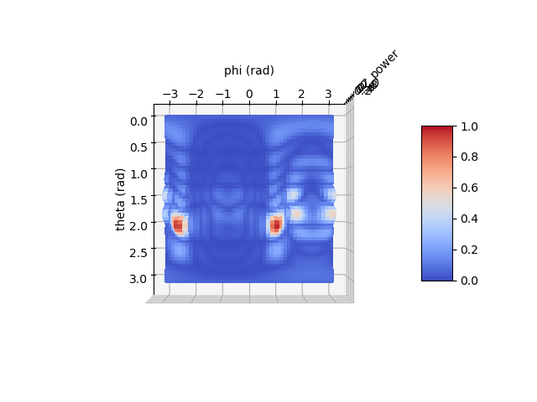

Figure :Iteration 0 (original)

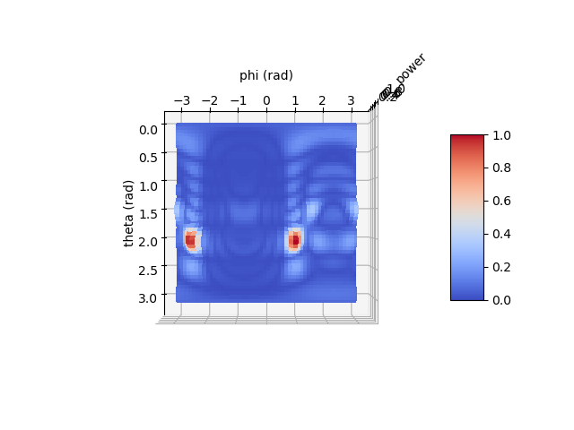

Figure : :Iteration 1

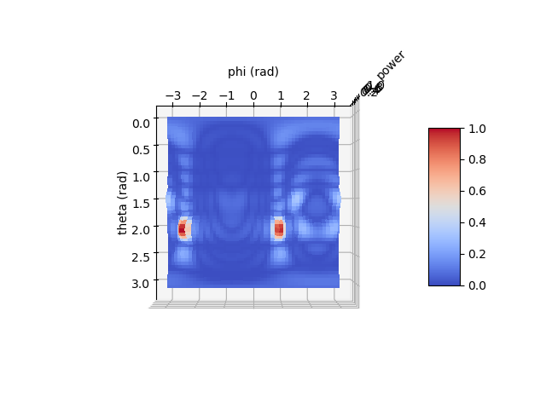

Figure : :Iteration 2

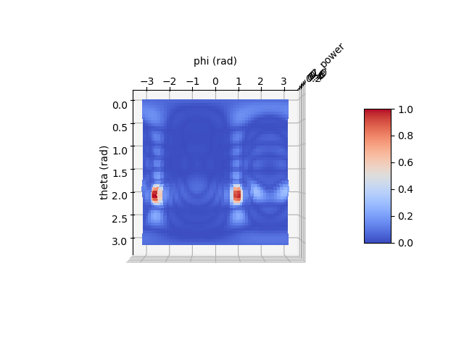

Figure : :Iteration 3

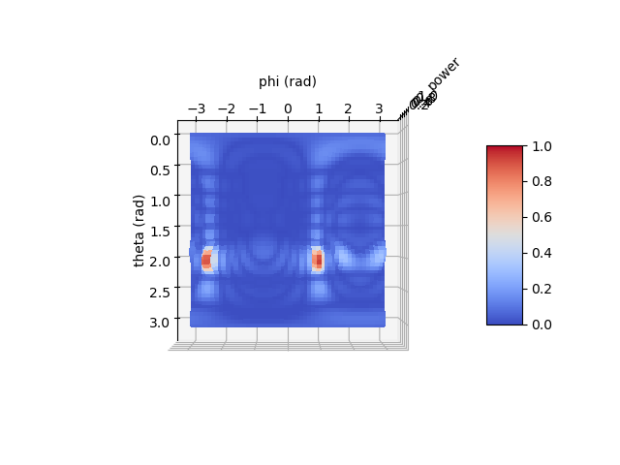

Figure : :Iteration 4

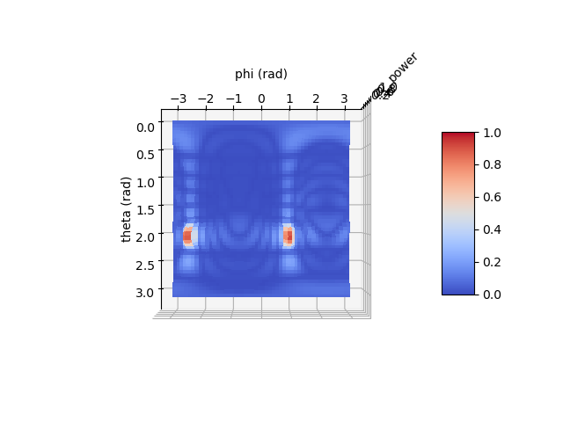

Figure : :Iteration 5

**Tested Beamformer Types**

1. **Delay and Sum**

antenna configuration: 8x2 (d = lambda*0.5)

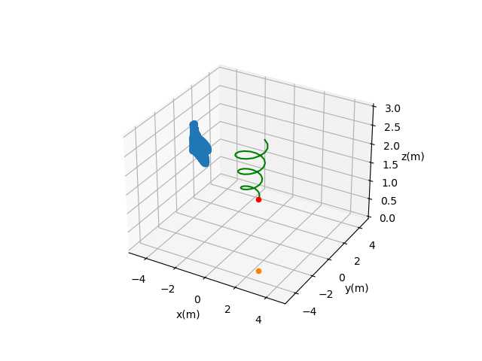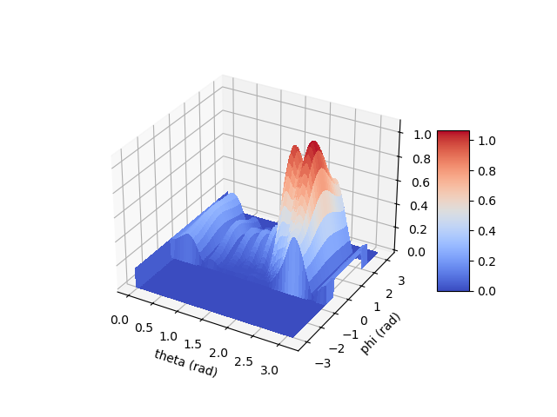

antenna configuration: 8x2 (d = lambda*0.8)

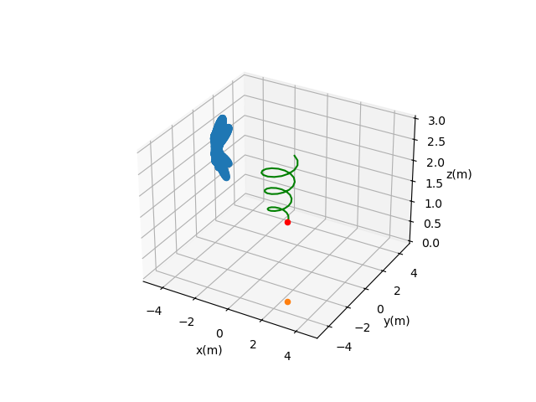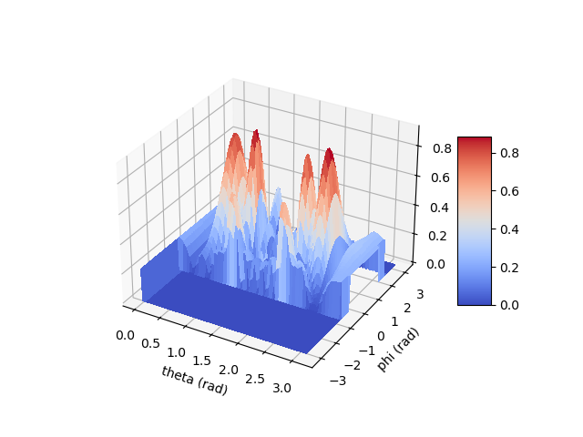

antenna configuration: 8x2 (d = lambda*1)

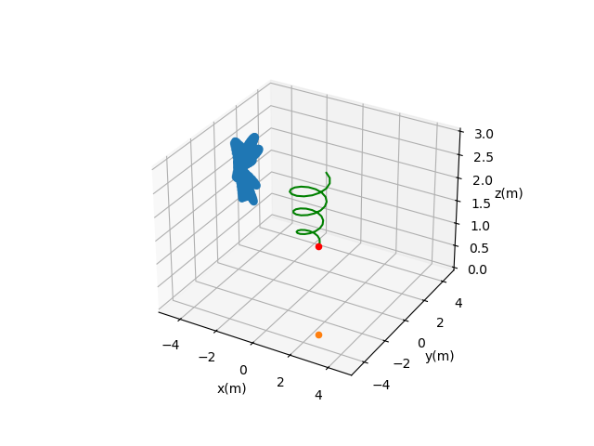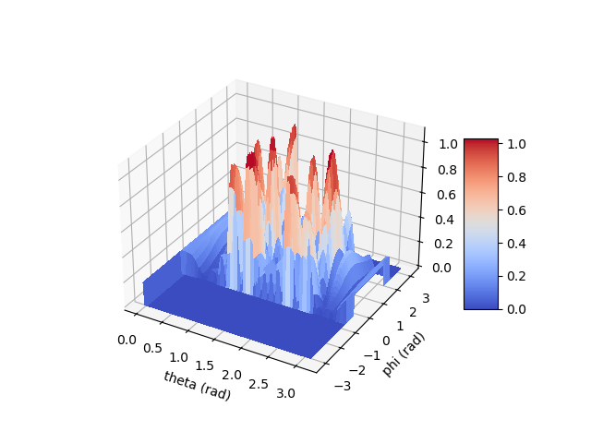

antenna configuration: 8x2 (d = lambda for first 7 rows, d=4 lambda for last row)

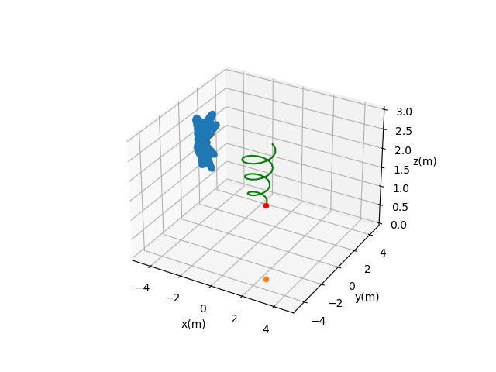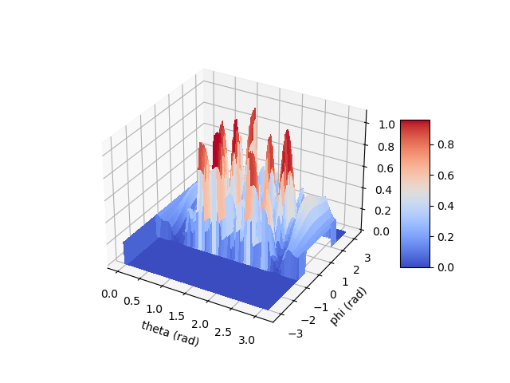

1. **Capon**

antenna configuration: 8x2 (d = lambda*0.5)

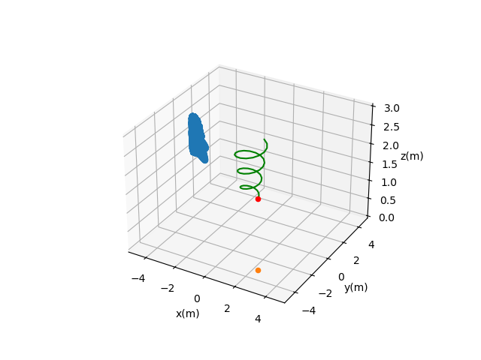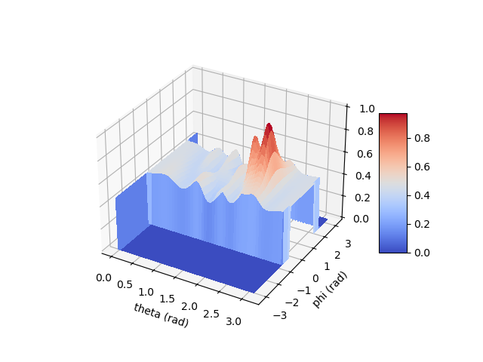

antenna configuration: 8x2 (d = lambda*0.8)

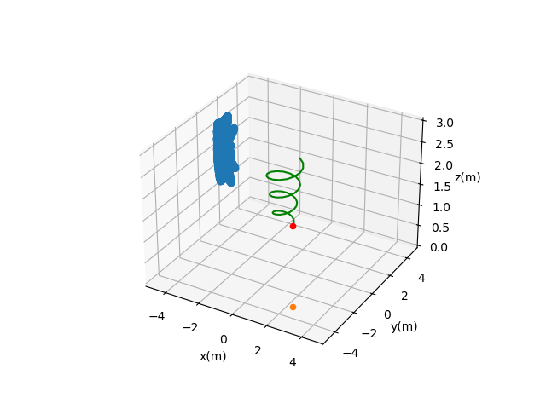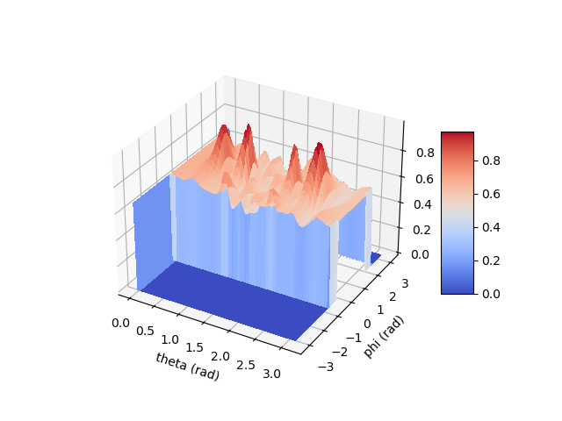

antenna configuration: 8x2 (d = lambda*1)

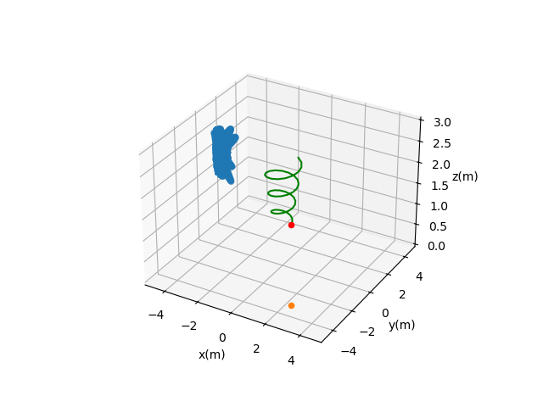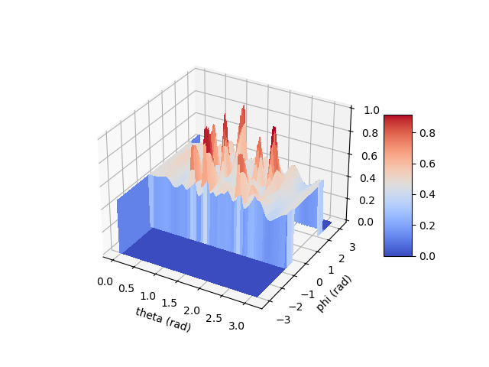

antenna configuration: 8x2 (d = lambda for first 7 rows, d=4 lambda for last row)

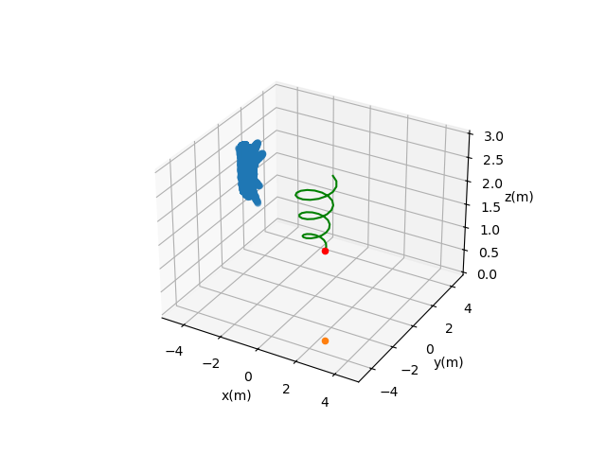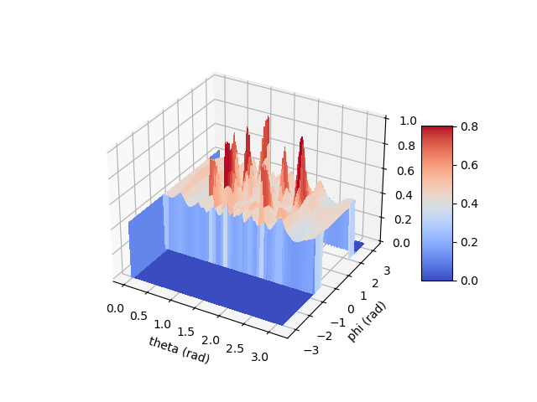

**Phase Difference Error Tests**

In this section, the effect of filtering on phase difference error is presented. Phase differences between concecutive antennas are computed.

1)

antenna configuration: 8x2 (d = lambda/2)

multipath source: ground reflection N(mean=0.9, std=0.1)

beamformer: delay and sum

spatial filter: ground filter

phase RMSE without filter: 2.22

phase RMSE with filter: 1.45

2)

antenna configuration: 8x2 (d = lambda/2)

multipath source: ground reflection N(mean=0.9, std=0.1)

beamformer: delay and sum

spatial filter: target only filter

phase RMSE without filter: 2.22

phase RMSE with filter: 1.32

3)

antenna configuration: 8x2 (d = lambda)

multipath source: ground reflection N(mean=0.9, std=0.1)

beamformer: delay and sum

spatial filter: target only filter

phase RMSE without filter: 2.10

phase RMSE with filter: 1.15

4)

antenna configuration: 8x2 (d = lambda)

multipath source: ground reflection N(mean=0.9, std=0.1)

beamformer: delay and sum

spatial filter: ground reflection filter

phase RMSE without filter: 2.10

phase RMSE with filter: 1.08

5)

antenna configuration: 8x2 (d = lambda for first 7 rows, d=4 lambda for last row)

multipath source: ground reflection N(mean=0.9, std=0.1)

beamformer: delay and sum

spatial filter: ground reflection filter

phase RMSE without filter: 2.16

phase RMSE with filter: 1.19

6)

antenna configuration: 8x2 (d = lambda for first 7 rows, d=4 lambda for last row)

multipath source: ground reflection N(mean=0.9, std=0.1)

beamformer: delay and sum

spatial filter: target only filter

phase RMSE without filter: 2.16

phase RMSE with filter: 1.53

7)

antenna configuration: 8x2 (d = lambda*0.8)

multipath source: ground reflection N(mean=0.9, std=0.1)

beamformer: delay and sum

spatial filter: ground reflection filter

phase RMSE without filter: 2.03

phase RMSE with filter: 1.07

8)

antenna configuration: 8x2 (d = lambda*0.8)

multipath source: ground reflection N(mean=0.9, std=0.1)

beamformer: delay and sum

spatial filter: target only filter

phase RMSE without filter: 2.03

phase RMSE with filter: 1.01

9)

antenna configuration: 8x2 (d = lambda*0.8 for first 7 rows, d=3.2 lambda for last row)

multipath source: ground reflection N(mean=0.9, std=0.1)

beamformer: delay and sum

spatial filter: target only filter

phase RMSE without filter: 2.04

phase RMSE with filter: 1.12

10)

antenna configuration: 8x2 (d = lambda*0.8 for first 7 rows, d=3.2 lambda for last row)

multipath source: ground reflection N(mean=0.9, std=0.1)

beamformer: delay and sum

spatial filter: ground filter

phase RMSE without filter: 2.04

phase RMSE with filter: 1.34

**Localization Error Tests**

1)

antenna configuration: original

multipath source: ground reflection N(mean=0.9, std=0.1)

sigma: 0.05

sigma_a: 1

use multipath: no

spatial filter: no

used antennas: [3, 5, 10]

RMSE: 0.07 (m)

2)

antenna configuration: original

multipath source: ground reflection N(mean=0.9, std=0.1)

sigma: 0.05

sigma_a: 1

use multipath: yes

spatial filter: no

used antennas: [3, 5, 10]

RMSE: 2.10 (m)

3)

antenna configuration: 8x2 (d = lambda*0.5)

multipath source: ground reflection N(mean=0.9, std=0.1)

sigma: 0.05

sigma_a: 2.5

use multipath: yes

spatial filter: no

used antennas: [16]

RMSE: 0.28 (m)

4)

antenna configuration: 8x2 (d = lambda*0.5)

multipath source: ground reflection N(mean=0.9, std=0.1)

sigma: 0.05

sigma_a: 2.5

use multipath: yes

spatial filter: ground filter

used antennas: [16]

RMSE: 0.19 (m)

5)

antenna configuration: 8x2 (d = lambda*0.8)

multipath source: ground reflection N(mean=0.9, std=0.1)

sigma: 0.05

sigma_a: 2.5

use multipath: yes

spatial filter: no

used antennas: [16]

RMSE: 0.40 (m)

6)

antenna configuration: 8x2 (d = lambda*0.8)

multipath source: ground reflection N(mean=0.9, std=0.1)

sigma: 0.05

sigma_a: 2.8

use multipath: yes

spatial filter: ground filter

used antennas: [16]

RMSE: 0.10 (m)

7)

antenna configuration: 8x2 (d = lambda*1)

multipath source: ground reflection N(mean=0.9, std=0.1)

sigma: 0.05

sigma_a: 0.5

use multipath: yes

spatial filter: no

used antennas: [16]

RMSE: 0.80 (m)

8)

antenna configuration: 8x2 (d = lambda*1)

multipath source: ground reflection N(mean=0.9, std=0.1)

sigma: 0.05

sigma_a: 3

use multipath: yes

spatial filter: ground filter

used antennas: [16]

RMSE: 0.07 (m)

9)

antenna configuration: 8x2 (d = lambda*2)

multipath source: ground reflection N(mean=0.9, std=0.1)

sigma: 0.05

sigma_a: 1

use multipath: yes

spatial filter: no

used antennas: [16]

RMSE: 0.51 (m)

10)

antenna configuration: 8x2 (d = lambda*2)

multipath source: ground reflection N(mean=0.9, std=0.1)

sigma: 0.05

sigma_a: 2.5

use multipath: yes

spatial filter: ground filter

used antennas: [16]

RMSE: 0.56 (m)

11)

antenna configuration: 8x2 (d = lambda*0.8 for first 7 rows, d=3.2 lambda for last row)

multipath source: ground reflection N(mean=0.9, std=0.1)

sigma: 0.05

sigma_a: 2

use multipath: yes

spatial filter: no

used antennas: [16]

RMSE: 0.85 (m)

12)

antenna configuration: 8x2 (d = lambda*0.8 for first 7 rows, d=3.2 lambda for last row)

multipath source: ground reflection N(mean=0.9, std=0.1)

sigma: 0.05

sigma_a: 2

use multipath: yes

spatial filter: ground filter

used antennas: [16]

RMSE: 0.95 (m)

13

antenna configuration: 8x2 (d = lambda*0.8 for first 7 rows, d=3.2 lambda for last row)

multipath source: ground reflection N(mean=0.9, std=0.1)

sigma: 0.05

sigma_a: 0.5

use multipath: yes

spatial filter: no

used antennas: [14, 16]

RMSE: 0.75 (m)

14)

antenna configuration: 8x2 (d = lambda*0.8 for first 7 rows, d=3.2 lambda for last row)

multipath source: ground reflection N(mean=0.9, std=0.1)

sigma: 0.05

sigma_a: 1.2

use multipath: yes

spatial filter: ground filter

used antennas: [14, 16]

RMSE: 0.10 (m)

**Simulation Results**

**Antenna Type – Phase Difference Error (average of 10 runs)**

* 2 random multipath sources
* Target only filter

|  |  |  |
| --- | --- | --- |
| **Antenna Type** | **Phase RMSE (Filter)** | **Phase RMSE (No Filter)** |
| Original | 0.23 | 0.27 |
| Square_4_4 | 0.21 | 0.27 |
| Regular_8_2 | 0.19 | 0.25 |
| 2_6-3-8-d=0.8 | 0.14 | 0.26 |
| 2_6-3-8-d=1 | 0.14 | 0.26 |
| 2_6-3-8-d=2 | 0.26 | 0.28 |
| plus | 0.19 | 0.25 |
| Square_8_8 | 0.16 | 0.27 |
|  |  |  |

* 2 random multipath sources
* Iterative filter peak_threshold: 0.1 (1 iteration)

|  |  |  |
| --- | --- | --- |
| **Antenna Type** | **Phase RMSE (Filter)** | **Phase RMSE (No Filter)** |
| Original | 0.26 | 0.27 |
| Square_4_4 | 0.22 | 0.27 |
| Regular_8_2 | 0.21 | 0.25 |
| 2_6-3-8-d=0.8 | 0.19 | 0.26 |
| 2_6-3-8-d=1 | 0.20 | 0.26 |
| 2_6-3-8-d=2 | 0.25 | 0.28 |
| plus | 0.19 | 0.25 |
| Square_8_8 | 0.20 | 0.27 |
|  |  |  |

* 2 random multipath sources
* Iterative filter peak_threshold: 0.1 (2 iteration)

|  |  |  |
| --- | --- | --- |
| **Antenna Type** | **Phase RMSE (Filter)** | **Phase RMSE (No Filter)** |
| Original | 0.25 | 0.27 |
| Square_4_4 | 0.21 | 0.27 |
| Regular_8_2 | 0.20 | 0.25 |
| 2_6-3-8-d=0.8 | 0.16 | 0.26 |
| 2_6-3-8-d=1 | 0.20 | 0.26 |
| 2_6-3-8-d=2 | 0.24 | 0.28 |
| plus | 0.19 | 0.25 |
| Square_8_8 | 0.15 | 0.27 |
|  |  |  |

* 2 random multipath sources
* Iterative filter peak_threshold: 0.1 (3 iteration)

|  |  |  |
| --- | --- | --- |
| **Antenna Type** | **Phase RMSE (Filter)** | **Phase RMSE (No Filter)** |
| Original | 0.24 | 0.27 |
| Square_4_4 | 0.21 | 0.27 |
| Regular_8_2 | 0.20 | 0.25 |
| 2_6-3-8-d=0.8 | 0.16 | 0.26 |
| 2_6-3-8-d=1 | 0.16 | 0.26 |
| 2_6-3-8-d=2 | 0.25 | 0.28 |
| plus | 0.19 | 0.25 |
| Square_8_8 | 0.15 | 0.27 |
|  |  |  |

**Effect of Multipath Count**

antenna_name: “2_6-3-8-d=1”

filter: target only

|  |  |
| --- | --- |
| **Multipath Count** | **RMSE(m)** |
| 0 | 0.02 |
| 1 | 0.06 |
| 2 | 0.06 |
| 3 | 0.05 |
| 4 | 0.05 |
| 5 | 8.82 |
| 6 | 10.64 |
| 7 | 1.60 |
| 8 | 6.16 |
| 9 | 1.35 |
| 10 | 6.46 |

antenna_name: “2_6-3-8-d=1”

filter: iterative filter (iteration: number of multipath)

|  |  |
| --- | --- |
| **Multipath Count** | **RMSE(m)** |
| 0 | 0.02 |
| 1 | 0.02 |
| 2 | 0.04 |
| 3 | 0.05 |
| 4 | 0.07 |
| 5 | 0.17 |
| 6 | 9.03 |
| 7 | 1.98 |
| 8 | 8.17 |
| 9 | 0.65 |
| 10 | 1.46 |

**Effect of sigma_a (Ex)**

antenna_name: “2_6-3-8-d=1”

filter: target only

4 multipath (0.2 – 0.8)

|  |  |  |  |
| --- | --- | --- | --- |
| **Sigma_a** | **Antenna elements in iteration** | **RMSE(m)** | **RMSE(m) No Filter** |
| 5 | 12 | 0.47 | 2.96 |
| 5 | 12,14 | 0.08 | 0.13 |
| 5 | 12,14,16 | 0.12 | 7.87 |
| 6 | 12 | 0.20 | 0.22 |
| 6 | 12,14 | 0.08 | 0.17 |
| 6 | 12,14,16 | 0.07 | 0.43 |
| 7 | 12 | 0.18 | 0.47 |
| 7 | 12,14 | 0.09 | 0.09 |
| 7 | 12,14,16 | 3.83 | 1.94 |
| 8 | 12 | 0.14 | 0.19 |
| 8 | 12,14 | 0.10 | 4.80 |
| 8 | 12,14,16 | 0.09 | 0.07 |
| 9 | 12 | 0.14 | 1.24 |
| 9 | 12,14 | 0.09 | 3.10 |
| 9 | 12,14,16 | 0.12 | 5.12 |
| 10 | 12 | 0.16 | 0.17 |
| 10 | 12,14 | 0.08 | 1.13 |
| 10 | 12,14,16 | 0.06 | 0.14 |

antenna_name: “2_6-3-8-d=1”

filter: iterative filter (iteration number of multipath)

4 multipath (0.2 – 0.8)

|  |  |  |  |
| --- | --- | --- | --- |
| **Sigma_a** | **Antenna elements in iteration** | **RMSE(m)** | **RMSE(m) No Filter** |
| 5 | 12 | 0.16 | 0.84 |
| 5 | 12,14 | 0.12 | 0.15 |
| 5 | 12,14,16 | 0.11 | 8.02 |
| 6 | 12 | 0.17 | 0.65 |
| 6 | 12,14 | 0.10 | 0.15 |
| 6 | 12,14,16 | 0.24 | 4.36 |
| 7 | 12 | 0.17 | 3.60 |
| 7 | 12,14 | 0.10 | 0.30 |
| 7 | 12,14,16 | 0.10 | 3.47 |
| 8 | 12 | 0.14 | 0.16 |
| 8 | 12,14 | 0.10 | 0.85 |
| 8 | 12,14,16 | 0.10 | 3.41 |
| 9 | 12 | 0.16 | 0.20 |
| 9 | 12,14 | 0.06 | 0.15 |
| 9 | 12,14,16 | 0.07 | 3.01 |
| 10 | 12 | 0.11 | 2.50 |
| 10 | 12,14 | 0.08 | 3.50 |
| 10 | 12,14,16 | 0.05 | 3.81 |

**Test Results**