**Measurement System**

Measurements are done with a 2-dimensional servo motor system with a PM400 power meter attached. Measurements are performed by pointing the laser to a specified target position and then sweeping the power meter in a linear trajectory. Power recordings are recorded with recording times and plotted to find the instance with maximum power. This point gives the center position of the laser. Power measurements are performed by a Python script which has a loop with a period of around 0.01s. This sampling period is not constant throughout the measurements and might deviate from 0.01s. For this reason, after the measurement, cubic interpolation is performed to get a uniformly sampled signal.

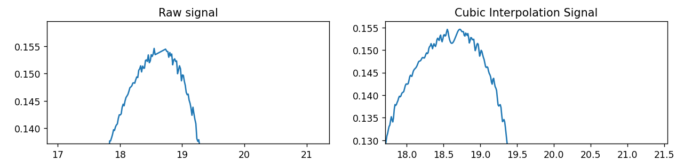

Interpolation solves the nonuniform sampling problem. Obtained signal still has noise in it which might alter the maximum position. To remove the noise a low pass filter in the form of a moving average filter is applied. The figure below depicts the signal before and after the low pass filter is applied. High-frequency noise components are removed from the signal while keeping the original signal mostly intact. This operation produced a smoother signal which is more suitable to peak finding operation.

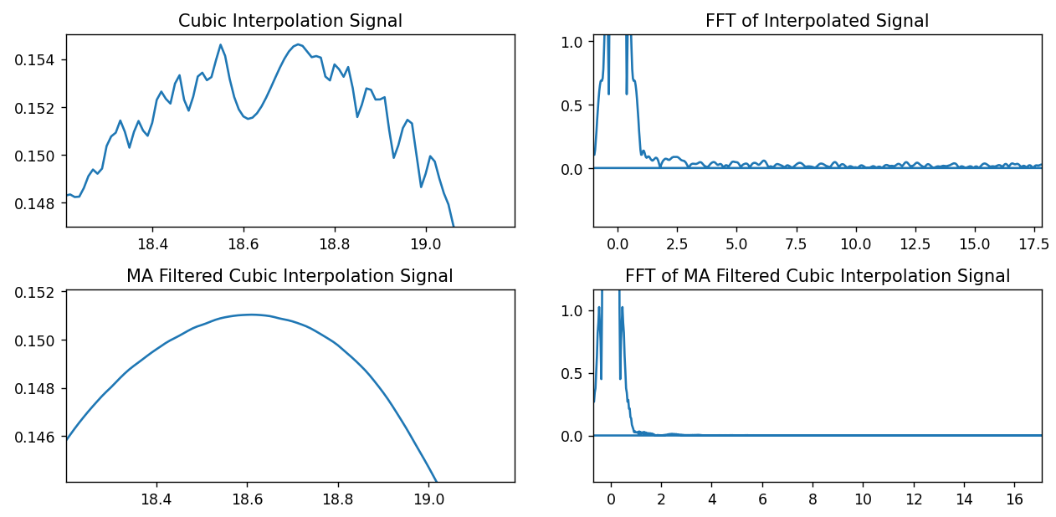The recorded power signal is plotted with respect to distance in order to find the position of the laser’s center. This method gives the position of the laser relative to the initial position of the servo motor. The figure below shows the power levels with respect to time and position. Position with maximum power is written in the fourth graph in millimeters.

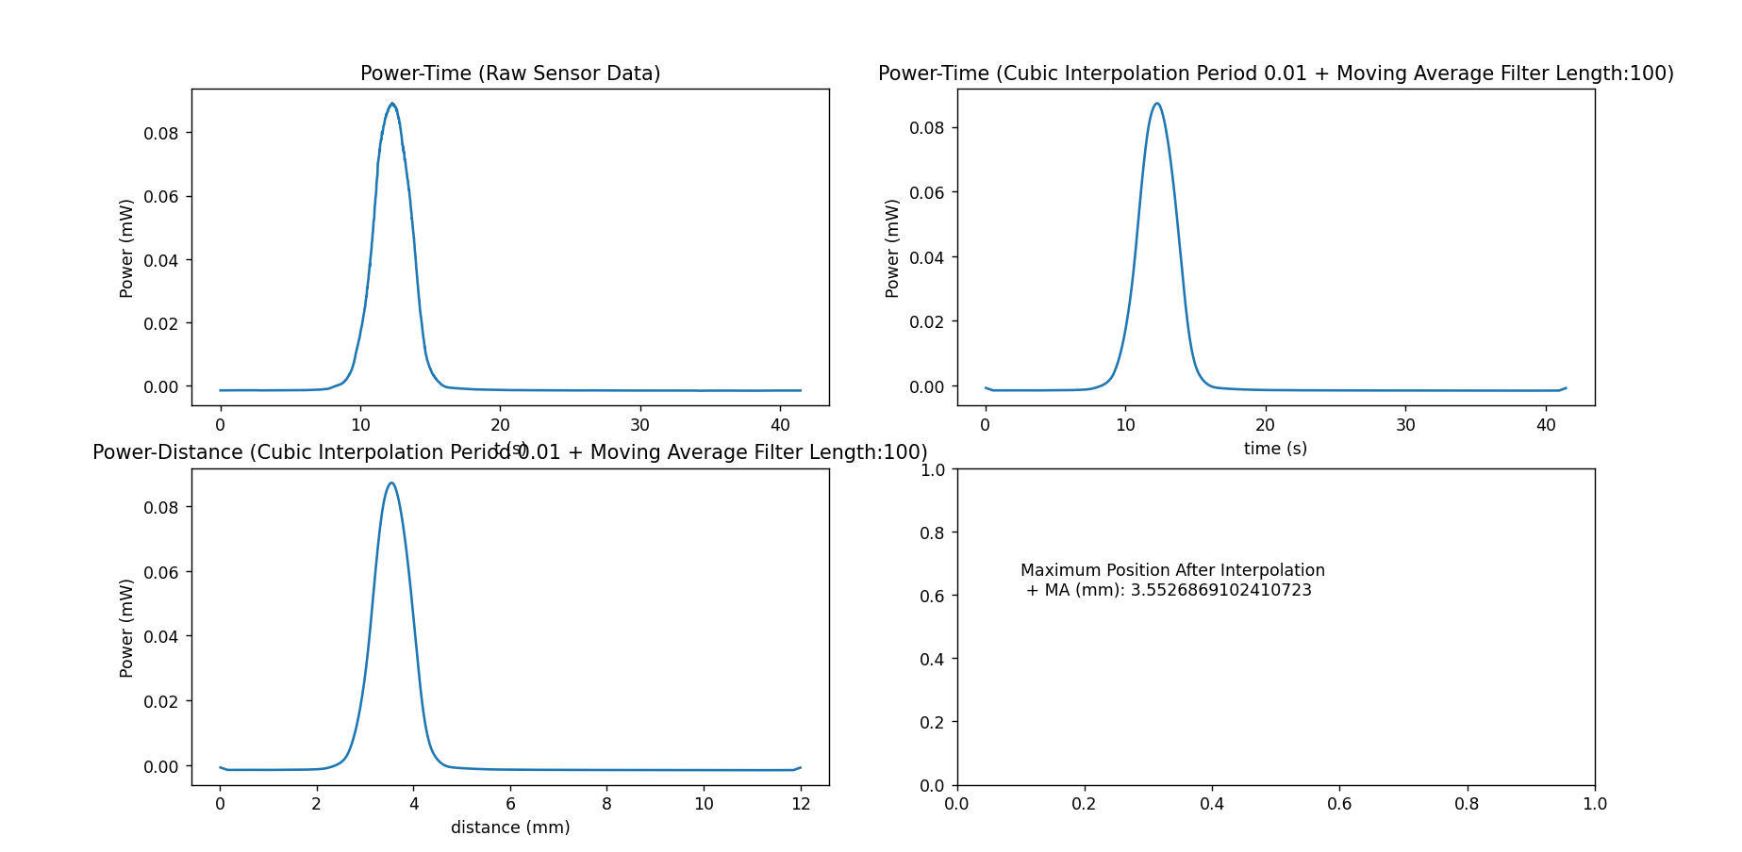

Measurements are performed with different parameters such as distance between mirror and target plane, different sweep locations.

**Horizontal Measurements D=410mm (actual distance 425mm)**

Table : Distance between mirror and target plane: 410mm. Mirror input y coordinate: -5mm

|  |  |  |  |
| --- | --- | --- | --- |
| **Mirror Input x (mm)** | **Mirror Input y (mm)** | **Peak Power Position (mm)** | **Relative Distance (mm)** |
| -3 | -5 | 2.322 | -3.096 |
| -2.5 | -5 | 2.853 | -2.565 |
| -2 | -5 | 3.372 | -2.046 |
| -1.5 | -5 | 3.868 | -1.550 |
| -1 | -5 | 4.392 | -1.026 |
| -0.5 | -5 | 4.905 | -0.513 |
| 0 | -5 | 5.418 | 0 |
| 0.5 | -5 | 5.921 | 0.503 |
| 1 | -5 | 6.446 | 1.028 |
| 1.5 | -5 | 6.923 | 1.505 |
| 2 | -5 | 7.427 | 2.009 |
| 2.5 | -5 | 7.937 | 2.519 |
| 3 | -5 | 8.452 | 3.034 |

Table : Distance between mirror and target plane: 410mm. Mirror input y coordinate: 0mm

|  |  |  |  |
| --- | --- | --- | --- |
| **Mirror Input (mm)** | **Mirror Input y (mm)** | **Peak Power Position (mm)** | **Relative Distance (mm)** |
| -3 | 0 | 2.278 | -3.089 |
| -2.5 | 0 | 2.792 | -2.575 |
| -2 | 0 | 3.311 | -2.056 |
| -1.5 | 0 | 3.829 | -1.538 |
| -1 | 0 | 4.327 | -1.040 |
| -0.5 | 0 | 4.860 | -0.507 |
| 0 | 0 | 5.367 | 0 |
| 0.5 | 0 | 5.878 | 0.511 |
| 1 | 0 | 6.379 | 1.012 |
| 1.5 | 0 | 6.880 | 1.513 |
| 2 | 0 | 7.392 | 2.025 |
| 2.5 | 0 | 7.880 | 2.513 |
| 3 | 0 | 8.390 | 3.023 |

Table : Distance between mirror and target plane: 410mm. Mirror input y coordinate: 5mm

|  |  |  |  |
| --- | --- | --- | --- |
| **Mirror Input (mm)** | **Mirror Input y (mm)** | **Peak Power Position (mm)** | **Relative Distance (mm)** |
| -3 | 5 | 2.391 | -3.097 |
| -2.5 | 5 | 2.909 | -2.579 |
| -2 | 5 | 3.424 | -2.064 |
| -1.5 | 5 | 3.949 | -1.539 |
| -1 | 5 | 4.468 | -1.020 |
| -0.5 | 5 | 4.974 | -0.514 |
| 0 | 5 | 5.488 | 0 |
| 0.5 | 5 | 6.013 | 0.525 |
| 1 | 5 | 6.534 | 1.046 |
| 1.5 | 5 | 7.042 | 1.554 |
| 2 | 5 | 7.547 | 2.059 |
| 2.5 | 5 | 8.052 | 2.564 |
| 3 | 5 | 8.561 | 3.073 |

**Horizontal Measurements D=425mm (actual distance 425mm)**

Table 4: Distance between mirror and target plane: 425mm. Mirror input y coordinate: -5mm

|  |  |  |  |
| --- | --- | --- | --- |
| **Mirror Input x (mm)** | **Mirror Input y (mm)** | **Peak Power Position (mm)** | **Relative Distance (mm)** |
| -3 | -5 | 6.723 | -2.999 |
| -2.5 | -5 | 7.225 | -2.497 |
| -2 | -5 | 7.727 | -1.995 |
| -1.5 | -5 | 8.218 | -1.504 |
| -1 | -5 | 8.716 | -1.007 |
| -0.5 | -5 | 9.228 | -0.494 |
| 0 | -5 | 9.722 | 0.0 |
| 0.5 | -5 | 10.212 | 0.49 |
| 1 | -5 | 10.695 | 0.973 |
| 1.5 | -5 | 11.191 | 1.469 |
| 2 | -5 | 11.673 | 1.951 |
| 2.5 | -5 | 12.151 | 2.429 |
| 3 | -5 | 12.653 | 2.931 |

Table 5: Distance between mirror and target plane: 425mm. Mirror input y coordinate: 0mm

|  |  |  |  |
| --- | --- | --- | --- |
| **Mirror Input (mm)** | **Mirror Input y (mm)** | **Peak Power Position (mm)** | **Relative Distance (mm)** |
| -3 | 0 | 6.788 | -2.956 |
| -2.5 | 0 | 7.275 | -2.469 |
| -2 | 0 | 7.777 | -1.967 |
| -1.5 | 0 | 8.289 | -1.455 |
| -1 | 0 | 8.758 | -0.986 |
| -0.5 | 0 | 9.248 | -0.496 |
| 0 | 0 | 9.744 | 0.0 |
| 0.5 | 0 | 10.225 | 0.481 |
| 1 | 0 | 10.711 | 0.967 |
| 1.5 | 0 | 11.207 | 1.463 |
| 2 | 0 | 11.666 | 1.922 |
| 2.5 | 0 | 12.156 | 2.412 |
| 3 | 0 | 12.654 | 2.91 |

Table 6: Distance between mirror and target plane: 425mm. Mirror input y coordinate: 5mm

|  |  |  |  |
| --- | --- | --- | --- |
| **Mirror Input (mm)** | **Mirror Input y (mm)** | **Peak Power Position (mm)** | **Relative Distance (mm)** |
| -3 | 5 | 6.849 | -2.978 |
| -2.5 | 5 | 7.364 | -2.463 |
| -2 | 5 | 7.867 | -1.959 |
| -1.5 | 5 | 8.359 | -1.468 |
| -1 | 5 | 8.843 | -0.984 |
| -0.5 | 5 | 9.34 | -0.487 |
| 0 | 5 | 9.826 | 0.0 |
| 0.5 | 5 | 10.308 | 0.481 |
| 1 | 5 | 10.824 | 0.998 |
| 1.5 | 5 | 11.304 | 1.478 |
| 2 | 5 | 11.793 | 1.967 |
| 2.5 | 5 | 12.279 | 2.453 |
| 3 | 5 | 12.781 | 2.954 |

**Horizontal Measurements D=210mm (actual distance 225mm)**

Table : Distance between mirror and target plane: 210mm. Mirror input y coordinate: -5mm

|  |  |  |  |
| --- | --- | --- | --- |
| **Mirror Input (mm)** | **Mirror Input y (mm)** | **Peak Power Position (mm)** | **Relative Distance (mm)** |
| -3 | -5 | 3.387 | -3.230 |
| -2.5 | -5 | 3.913 | -2.704 |
| -2 | -5 | 4.454 | -2.163 |
| -1.5 | -5 | 5.000 | -1.617 |
| -1 | -5 | 5.533 | -1.084 |
| -0.5 | -5 | 6.082 | -0.535 |
| 0 | -5 | 6.617 | 0 |
| 0.5 | -5 | 7.170 | 0.553 |
| 1 | -5 | 7.700 | 1.083 |
| 1.5 | -5 | 8.233 | 1.616 |
| 2 | -5 | 8.765 | 2.148 |
| 2.5 | -5 | 9.296 | 2.679 |
| 3 | -5 | 9.843 | 3.226 |

Table : Distance between mirror and target plane: 210mm. Mirror input y coordinate: 0mm

|  |  |  |  |
| --- | --- | --- | --- |
| **Mirror Input (mm)** | **Mirror Input y (mm)** | **Peak Power Position (mm)** | **Relative Distance (mm)** |
| -3 | 0 | 3.359 | -3.204 |
| -2.5 | 0 | 3.888 | -2.675 |
| -2 | 0 | 4.416 | -2.147 |
| -1.5 | 0 | 4.954 | -1.609 |
| -1 | 0 | 5.490 | -1.073 |
| -0.5 | 0 | 6.026 | -0.537 |
| 0 | 0 | 6.563 | 0 |
| 0.5 | 0 | 7.104 | 0.541 |
| 1 | 0 | 7.647 | 1.084 |
| 1.5 | 0 | 8.179 | 1.616 |
| 2 | 0 | 8.692 | 2.129 |
| 2.5 | 0 | 9.221 | 2.658 |
| 3 | 0 | 9.754 | 3.191 |

Table : Distance between mirror and target plane: 210mm. Mirror input y coordinate: 5mm

|  |  |  |  |
| --- | --- | --- | --- |
| **Mirror Input (mm)** | **Mirror Input y (mm)** | **Peak Power Position (mm)** | **Relative Distance (mm)** |
| -3 | 5 | 3.553 | -3.189 |
| -2.5 | 5 | 4.077 | -2.665 |
| -2 | 5 | 4.604 | -2.138 |
| -1.5 | 5 | 5.158 | -1.584 |
| -1 | 5 | 5.679 | -1.063 |
| -0.5 | 5 | 6.212 | -0.529 |
| 0 | 5 | 6.742 | 0.0 |
| 0.5 | 5 | 7.27 | 0.528 |
| 1 | 5 | 7.807 | 1.065 |
| 1.5 | 5 | 8.343 | 1.601 |
| 2 | 5 | 8.873 | 2.131 |
| 2.5 | 5 | 9.404 | 2.662 |
| 3 | 5 | 9.934 | 3.192 |

**Horizontal Measurements D=225mm (actual distance 225mm)**

Table : Distance between mirror and target plane: 225mm. Mirror input y coordinate: -5mm

|  |  |  |  |
| --- | --- | --- | --- |
| **Mirror Input (mm)** | **Mirror Input y (mm)** | **Peak Power Position (mm)** | **Relative Distance (mm)** |
| -3 | -5 | 4.985 | -3.044 |
| -2.5 | -5 | 5.503 | -2.526 |
| -2 | -5 | 6.007 | -2.023 |
| -1.5 | -5 | 6.505 | -1.524 |
| -1 | -5 | 7.034 | -0.995 |
| -0.5 | -5 | 7.536 | -0.494 |
| 0 | -5 | 8.029 | 0.0 |
| 0.5 | -5 | 8.539 | 0.509 |
| 1 | -5 | 9.045 | 1.016 |
| 1.5 | -5 | 9.546 | 1.517 |
| 2 | -5 | 10.045 | 2.015 |
| 2.5 | -5 | 10.529 | 2.499 |
| 3 | -5 | 11.009 | 2.98 |

Table : Distance between mirror and target plane: 225mm. Mirror input y coordinate: 0mm

|  |  |  |  |
| --- | --- | --- | --- |
| **Mirror Input (mm)** | **Mirror Input y (mm)** | **Peak Power Position (mm)** | **Relative Distance (mm)** |
| -3 | 0 | 4.989 | -2.992 |
| -2.5 | 0 | 5.493 | -2.488 |
| -2 | 0 | 5.999 | -1.982 |
| -1.5 | 0 | 6.49 | -1.491 |
| -1 | 0 | 6.998 | -0.984 |
| -0.5 | 0 | 7.459 | -0.523 |
| 0 | 0 | 7.981 | 0.0 |
| 0.5 | 0 | 8.461 | 0.479 |
| 1 | 0 | 8.952 | 0.971 |
| 1.5 | 0 | 9.485 | 1.503 |
| 2 | 0 | 9.976 | 1.994 |
| 2.5 | 0 | 10.464 | 2.483 |
| 3 | 0 | 10.956 | 2.975 |

Table 12: Distance between mirror and target plane: 225mm. Mirror input y coordinate: 5mm

|  |  |  |  |
| --- | --- | --- | --- |
| **Mirror Input (mm)** | **Mirror Input y (mm)** | **Peak Power Position (mm)** | **Relative Distance (mm)** |
| -3 | 5 | 5.156 | -2.982 |
| -2.5 | 5 | 5.664 | -2.475 |
| -2 | 5 | 6.153 | -1.986 |
| -1.5 | 5 | 6.649 | -1.49 |
| -1 | 5 | 7.154 | -0.985 |
| -0.5 | 5 | 7.64 | -0.498 |
| 0 | 5 | 8.138 | 0.0 |
| 0.5 | 5 | 8.634 | 0.496 |
| 1 | 5 | 9.126 | 0.988 |
| 1.5 | 5 | 9.635 | 1.497 |
| 2 | 5 | 10.126 | 1.988 |
| 2.5 | 5 | 10.609 | 2.47 |
| 3 | 5 | 11.103 | 2.965 |