**Homework**

**March 23, 2023**

**1)** Consider the following MLP network.

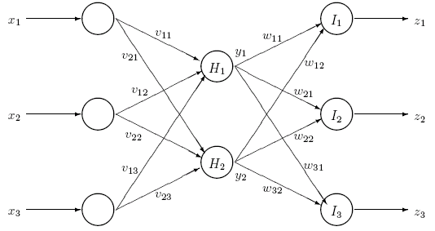

After some training, the units in the neural network have the following weight vectors:

, , , , and 

Assume that all units have sigmoid activation functions given by



and that each unit has a bias  = 0 (zero).

The inputs of the network are given by  and the corresponding desired outputs are given by .

1. What is the error (local gradient) for each of the output units?
2. Update the output weights.
3. What is the error for each of the hidden units?
4. Update the input weights.

**-------------------------------------------------------------------------------------------------------------**

**2)** Consider the following MLP network. A new input pattern is presented to the network and training proceeds as follows. The actual outputs of the network are given by  and the corresponding target values are given by . The weights are also shown in the figure.



1. What is the error (local gradient) for each of the output units?
2. What is the error for each of the hidden unit-2 given that its activation for he pattern being processed is currently ?

-----------------------------------------------------------------------------------------------------------------