Lists

- Can you name some lists?
  - Groceries to be purchased
  - Job to-do list
  - List of assignments
  - Dean's list
  - Can you name some others?

- We will look at the list as an ADT (abstract data type)
- Lists are Homogeneous data types
- lists of same (but any) type of data elements
- Finite length
- Sequential elements
- Sounds like array, right?

Basic Operations on lists
- Construct an empty list
- Is the list empty?
- Insert an element into the list
- Delete an element from the list
- Traverse the list to
  - Modify
  - Output
  - Search
  - Copy
  - Rearrange

Designing a Link Class
- Should contain at least the following function members
- Constructor
- empty()
- insert()
- delete()
- display()
- Implementation involves
- Defining data members
- Defining function members from design phase

Array based linked list implementation

- An array is a viable choice for storing list elements
- Element are sequential
- It is a commonly available data type
- Algorithm development is easy
- Normally sequential orderings of list elements match with array elements
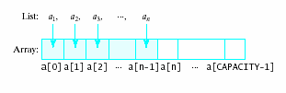

Implementing Operations
- Constructor
- Static array allocated at compile time
- Empty
- Check if size == 0
- Traverse
Use a loop from 0th element to size – 1
- Insert
- Shift elements to right of insertion point
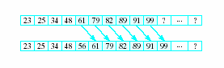
- Delete
Shift elements back

Array Based Linked List Implemtation

#include <iostream>
using namespace std;

const int CAPACITY = 1024; // arrays should have a capacity
typedef int ElementType; // can be any built in type, such as int

class List {
public:
List(); //An empty list object is constructed, of size 0
bool empty() ;

//void display (ostream &out) const;
void finditem(ElementType item, int &pos);
void erase(int pos);
void insert(ElementType item, int pos);
void display(ostream & out) const;

private:
int mySize; // current size of list
ElementType myArray[CAPACITY]; //static array decleration
}; //--- end of List class

List::List(){ //Constructor
mySize=0;
}

bool List::empty(){
if (mySize == 0 ) return true;
else return false;
}

// Definition of display()
void List::display(ostream &out) const {
for (int i = 0; i < mySize; i++)
out << myArray[i] << " ";
out << endl;
}

void List::finditem(ElementType item, int &pos) {
pos = -1;
for (int i =0 ; i < mySize ; i++)
if ( item == myArray[i] ) {
pos = i;
break;
}
}

void List::erase(int pos)
{
if (mySize == 0) {
cerr << "*** List is empty ***" << endl;
return;
}
if (pos < 0 || pos >= mySize)
{
cerr << "Illegal location to delete -- " << pos
<< ". List unchanged. ***\n";
return;
}

// Shift array elements left to close the gap
for(int i = pos; i < mySize; i++)
myArray[i] = myArray[i + 1];

// Decrease list size
mySize--;
}

//--- Definition of insert()
void List::insert(ElementType item, int pos)
{
if (mySize == CAPACITY) exit(1);
if (pos < 0 || pos > mySize) return;
// shift array elements right to make room for item
for(int i = mySize; i > pos; i--)
myArray[i] = myArray[i - 1];
// insert item at pos and increase list size
myArray[pos] = item;
mySize++;
}

int main()
{
List intList;
for (int i = 0; i < 9; i++) // Test insert()
{
cout << "Inserting " << i << " at position " << i/2 <<" : ";
intList.insert(i, i/2); //Insert i
//Test output
intList.display(cout) ;
}
cout << "Erasing el. at position " << 5 <<" : ";
intList.erase(5); //delete element at position i
intList.display(cout);
cout << "Erasing el. at position " << 2 <<" : ";
intList.erase(2); //delete element at position i
intList.display(cout);
}

Output of the Execution:

Inserting 0 at position 0 : 0
Inserting 1 at position 0 : 1 0
Inserting 2 at position 1 : 1 2 0
Inserting 3 at position 1 : 1 3 2 0
Inserting 4 at position 2 : 1 3 4 2 0
Inserting 5 at position 2 : 1 3 5 4 2 0
Inserting 6 at position 3 : 1 3 5 6 4 2 0
Inserting 7 at position 3 : 1 3 5 7 6 4 2 0
Inserting 8 at position 4 : 1 3 5 7 8 6 4 2 0
Erasing el. at position 5 : 1 3 5 7 8 4 2 0
Erasing el. at position 2 : 1 3 7 8 4 2 0
Press any key to continue . . .

Problems
- Stuck with “one size fits all”
  - Could be wasting space
  - Could run out of space
- Better to be able to change the capacity
- Thus we consider creating a List class with dynamically-allocated array--

Adding Copy constructor and overloading Assignment statement

#include <iostream>
using namespace std;

const int CAPACITY = 1024; // arrays should have a capacity
typedef int ElementType; // can be any built in type, such as int

class List {
public:
List(); //An empty list object is constructed, of size 0
bool empty() ;

//void display (ostream &out) const;
void finditem(ElementType item, int &pos);
void erase(int pos);
void insert(ElementType item, int pos);
void display(ostream & out) const;
/***** Copy constructor *****/
List(const List & origList);
/***** Assignment operator *****/
List & operator=(const List & origList);

private:
int mySize; // current size of list
ElementType myArray[CAPACITY]; //static array decleration
}; //--- end of List class

List::List(){ //Constructor
mySize=0;
}

bool List::empty(){
if (mySize == 0 ) return true;
else return false;
}

// Definition of display()
void List::display(ostream &out) const {
for (int i = 0; i < mySize; i++)
out << myArray[i] << " ";
out << endl;
}

void List::finditem(ElementType item, int &pos) {
pos = -1;
for (int i =0 ; i < mySize ; i++)
if ( item == myArray[i] ) {
pos = i;
break;
}
}

void List::erase(int pos)
{
if (mySize == 0) {
cerr << "*** List is empty ***" << endl;
return;
}
if (pos < 0 || pos >= mySize)
{
cerr << "Illegal location to delete -- " << pos
<< ". List unchanged. ***\n";
return;
}

// Shift array elements left to close the gap
for(int i = pos; i < mySize; i++)
myArray[i] = myArray[i + 1];

// Decrease list size
mySize--;
}

//--- Definition of insert()
void List::insert(ElementType item, int pos)
{
if (mySize == CAPACITY) exit(1);
if (pos < 0 || pos > mySize) return;
// shift array elements right to make room for item
for(int i = mySize; i > pos; i--)
myArray[i] = myArray[i - 1];
// insert item at pos and increase list size
myArray[pos] = item;
mySize++;
}
//--- Definition of the copy constructor
List::List(const List & origList){

mySize= origList.mySize;
for(int i = 0; i < origList.mySize; i++)
myArray[i] = origList.myArray[i];
}

//--- Definition of the assignment operator
List & List::operator=(const List & origList)
{
if (this != &origList) // check for list = list
{
mySize = origList.mySize;

//--- Copy origList's array into this new array
for(int i = 0; i < mySize; i++)
myArray[i] = origList.myArray[i];
}
return *this;
}

int main()
{
List intList;
for (int i = 0; i < 9; i++) // Test insert()
{
cout << "Inserting " << i << " at position " << i/2 <<" : ";
intList.insert(i, i/2); //Insert i
//Test output
intList.display(cout) ;
}
cout << "Erasing el. at position " << 5 <<" : ";
intList.erase(5); //delete element at position i
intList.display(cout);
cout << "Erasing el. at position " << 2 <<" : ";
intList.erase(2); //delete element at position i
intList.display(cout);

List B=intList;
cout << "Copied List intList to B. Contents of B is: " << endl;
B.display(cout);
B.erase(4) ;

List C;
C= B;
cout << "Copied List B to C. Contents of C is: " << endl;
C.display(cout);

}

Program Output
Inserting 0 at position 0 : 0
Inserting 1 at position 0 : 1 0
Inserting 2 at position 1 : 1 2 0
Inserting 3 at position 1 : 1 3 2 0
Inserting 4 at position 2 : 1 3 4 2 0
Inserting 5 at position 2 : 1 3 5 4 2 0
Inserting 6 at position 3 : 1 3 5 6 4 2 0
Inserting 7 at position 3 : 1 3 5 7 6 4 2 0
Inserting 8 at position 4 : 1 3 5 7 8 6 4 2 0
Erasing el. at position 5 : 1 3 5 7 8 4 2 0
Erasing el. at position 2 : 1 3 7 8 4 2 0
Copied List intList to B. Contents of B is:
1 3 7 8 4 2 0
Copied List B to C. Contents of C is:
1 3 7 8 2 0
Press any key to continue . . .

Dynamic Array for List Class

- Changes required in data members
  - Eliminate const declaration for CAPACITY
  - Add variable data member to store capacity specified by client program
  - Change array data member to a pointer
  - Constructor requires considerable change
  - Little or no changes required for
  - empty()
  - display()
  - erase()
  - insert()

Dynamic_array_List.cpp file

#include <iostream>
#include <cassert>
#include <new>

using namespace std;

typedef int ElementType;
class List
{
public:
/******** Function Members ********/
/***** Class constructor *****/
List(int maxSize = 1024);

/***** Class destructor *****/
~List();

/***** Copy constructor *****/
List(const List & origList);

/***** Assignment operator *****/
List & operator=(const List & origList);

/***** empty operation *****/
bool empty() const;
/***** insert and erase *****/
void insert(ElementType item, int pos);

void erase(int pos); // Remove value at position pos.

void display(ostream & out) const;

private:
/******** Data Members ********/
int mySize; // current size of list stored in array
int myCapacity; // capacity of array
ElementType * myArrayPtr;// pointer to dynamically-
// allocated array

}; //--- end of List class

//------ Prototype of output operator
ostream & operator<< (ostream & out, const List & aList);

//--- Definition of class constructor
List::List(int maxSize)
: mySize(0), myCapacity(maxSize)
{
myArrayPtr = new(nothrow) ElementType[maxSize];
assert(myArrayPtr != 0);
}

//--- Definition of class destructor
List::~List()
{
delete [] myArrayPtr;
}

//--- Definition of the copy constructor
List::List(const List & origList)
: mySize(origList.mySize), myCapacity(origList.myCapacity)

{
//--- Get new array for copy
myArrayPtr = new(nothrow) ElementType[myCapacity];

if (myArrayPtr != 0) // check if memory available
//--- Copy origList's array into this new array
for(int i = 0; i < myCapacity; i++)
myArrayPtr[i] = origList.myArrayPtr[i];
else
{
cerr << "*Inadequate memory to allocate stack ***\n";
exit(1);
}
}

//--- Definition of the assignment operator
List & List::operator=(const List & origList)
{
if (this != &origList) // check for list = list
{
mySize = origList.mySize;
myCapacity = origList.myCapacity;

//-- Allocate a new array if necessary
if (myCapacity != origList.myCapacity)
{
delete[] myArrayPtr;
myArrayPtr = new(nothrow) ElementType[myCapacity];

if (myArrayPtr == 0) // check if memory available
{
cerr << "*Inadequate memory to allocate stack ***\n";
exit(1);
}
}
//--- Copy origList's array into this new array
for(int i = 0; i < myCapacity; i++)
myArrayPtr[i] = origList.myArrayPtr[i];
}
return *this;
}

//--- Definition of empty()
bool List::empty() const
{
return mySize == 0;
}

//--- Definition of display()
void List::display(ostream & out) const
{
for (int i = 0; i < mySize; i++)
out << myArrayPtr[i] << " ";
}

//--- Definition of output operator
ostream & operator<< (ostream & out, const List & aList)
{
aList.display(out);
return out;
}

//--- Definition of insert()
void List::insert(ElementType item, int pos)
{
if (mySize == myCapacity)
{
cerr << "*** No space for list element -- terminating "
"execution ***\n";
exit(1);
}
if (pos < 0 || pos > mySize)
{
cerr << "*** Illegal location to insert -- " << pos
<< ". List unchanged. ***\n";
return;
}

// First shift array elements right to make room for item

for(int i = mySize; i > pos; i--)
myArrayPtr[i] = myArrayPtr[i - 1];

// Now insert item at position pos and increase list size
myArrayPtr[pos] = item;
mySize++;
}

//--- Definition of erase()
void List::erase(int pos)
{
if (mySize == 0)
{
cerr << "*** List is empty ***\n";
return;
}
if (pos < 0 || pos >= mySize)
{
cerr << "Illegal location to delete -- " << pos
<< ". List unchanged. ***\n";
return;
}

// Shift array elements left to close the gap
for(int i = pos; i < mySize; i++)
myArrayPtr[i] = myArrayPtr[i + 1];

// Decrease list size
mySize--;
}

/***********List Testing program *********************/
/* listtester.cpp is a program for testing class List. */

// f() is a function with
void f(List aList) // List value parameter
{ // to test the copy constructor
for (int i = 1; i < 5; i++)
{
aList.insert(100*i, i); // insert into the copy
cout << aList << endl; // output the copy
}
}

int main()
{
// Test the class constructor
List intList;
cout << "Constructing intList\n";

// Test empty() and output of empty list
if (intList.empty())
cout << "Empty List: \n"
<< intList << endl; // Test output of empty list

// Test insert()
for (int i = 0; i < 9; i++)
{
intList.insert(i, i/2); // -- Insert i at position i/2
//Test output
cout << intList << endl;
}
cout << "List empty? " << (intList.empty() ? "Yes" : "No") << endl;

// Test destructor
// Note, scope rules apply here. After the block, anotherList does not exists.
{
List anotherList;
for (int i = 0; i < 10; i++)
anotherList.insert(100*i, i);
cout << "\nHere's another list:\n" << anotherList << endl;
cout << "Now destroying this list\n";
}

// Test the copy constructor
cout << "\n\n";
f(intList);

cout << "\n\nOriginal list:"; // Output the original to make
cout << intList<< endl; // sure it hasn't been changed

// Test erase
int index;
while (!intList.empty())
{
cout << "Give an index of list element to remove: ";
cin >> index;
intList.erase(index);
cout << intList << endl;
}
cout << "List is empty" << endl;
}

Program Output:
Constructing intList
Empty List:

0
1 0
1 2 0
1 3 2 0
1 3 4 2 0
1 3 5 4 2 0
1 3 5 6 4 2 0
1 3 5 7 6 4 2 0
1 3 5 7 8 6 4 2 0
List empty? No

Here's another list:
0 100 200 300 400 500 600 700 800 900
Now destroying this list

1 100 3 5 7 8 6 4 2 0
1 100 200 3 5 7 8 6 4 2 0
1 100 200 300 3 5 7 8 6 4 2 0
1 100 200 300 400 3 5 7 8 6 4 2 0

Original list:1 3 5 7 8 6 4 2 0
Give an index of list element to remove: 6
1 3 5 7 8 6 2 0
Give an index of list element to remove: 3
1 3 5 8 6 2 0
Give an index of list element to remove: 1
1 5 8 6 2 0
Give an index of list element to remove: 0
5 8 6 2 0
Give an index of list element to remove: 4
5 8 6 2
Give an index of list element to remove: 4
Illegal location to delete -- 4. List unchanged. ***
5 8 6 2
Give an index of list element to remove: 2
5 8 2
Give an index of list element to remove: 1
5 2
Give an index of list element to remove: 1
5
Give an index of list element to remove: 0

List is empty
Press any key to continue . . .

TIP:
- If a class allocates memory at run time using the new, then a it should provide
- A destructor
- A copy constructor
- An assignment operator
- Look at the header file, List.h, given above. With the pointer definition, we are now able to allocate memory dynamically for our array.

- Now it is possible to specify different
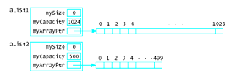
size lists
cin >> maxListSize;
List aList1 (maxListSize);
List aList2 (500)

1. Destructor; ~C()

- Here, C is the class name
- A destructor looks like as follows:
List::~List(){ delete [] myArrayPtr;}

- The destructor deletes the allocated memory in constructor, when it is called.
- Like a constructor, a destructor does not have a return type.
- Unlike a constructor, destructor does not have parameters.
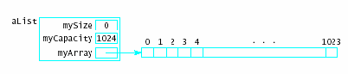

2. Copy Constructor
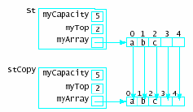

- Makes a “deep copy” of an object
When in program:
List stCopy(st);
We want exactly
a copy like

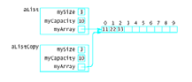

- If copy constructor function is not explicitly
available, by default, a member by member
copying is done. While this is fine in general,
it does not accomplish the task when a data
member of a class is a pointer.

- Example: For our List class, after this call
List aListCopy(aList);
aListCopy.mySize = mySize; //contents of mySize is copied
aListCopy.myCapacity= MyCapacity; //contents of myCapacity is copied
aListCopy.myArray= myArray; // Address in myArray is copied. Data is not.
// This is called shallow copying.

- Aliasing Problem: There are two names for the same data. One is aList.myArray and the other aListCopy.myArray. A change in ones data elements, affects the other one.
- Hence, when a class has no copy constructor but does have a data member that is a pointer, the default copy constructor does not make a distinct copy. This can be a problem, if it is not intended.
- Deep copy: Make a distinct copy of aList. Here is the code

Copy Constructor Code

• In the class declaration:
List(const List & origList);
• The implementation:
List::List(const List & origList): mySize(origList.mySize), myCapacity(origList.myCapacity) {
myArrayPtr = new ElementType[myCapacity];
if (myArrayPtr != 0)
for(int i = 0; i < myCapacity; i++)
myArrayPtr[i] = origList.myArrayPtr[i];
else {
cerr << "*Inadequate memory to allocate*\n";
exit(1);
}

- Note; parameter of the copy constructor must be a reference parameter.
- Otherwise, passing original as a value parameter implies a call to copy constructor to copy the values to temporary variables.
- Once the temporary variables (parameters) are formed, again a call to the copy constructor is made to copy them, which creates temporary parameters again.
- Hence, we have an infinite chain of function calls! Will run out of memory!
- Pass by reference solves this problem!

3) Assignment Operator:

- Default assignment operator makes shallow copy
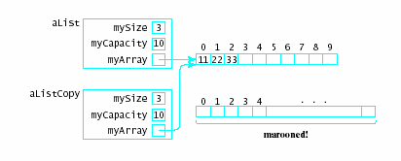
- For example,
- aListCopy = aList;

aListCopy.mySize = aList.mySize;
aListCopy.myCapacity= aList.MyCapacity;
aListCopy.myArray= aList.myArray;

- Can cause memory leak, dynamically-allocated memory has nothing pointing to it
- Need to overload = with deletion of old one, allocate new one and do the deep copy!
.
//--- Definition of the assignment operator
List & List::operator=(const List & origList)
{
if (this != &origList) // check for list = list
{
mySize = origList.mySize;
myCapacity = origList.myCapacity;

//-- Allocate a new array if necessary
if (myCapacity != origList.myCapacity)
{
delete[] myArrayPtr;
myArrayPtr = new(nothrow) ElementType[myCapacity];

if (myArrayPtr == 0) // check if memory available
{
cerr << "*Inadequate memory to allocate stack ***\n";
exit(1);
}
}
//--- Copy origList's array into this new array
for(int i = 0; i < myCapacity; i++)
myArrayPtr[i] = origList.myArrayPtr[i];
}
return *this;
}

Pointers and Structures

Brief overview of structures:

struct Student {
char Name[20] ;
char Last[20] ;
int SSN;
int Phone;
};

- Assume you have a c++ program, such as
main() {
Student JOHN ; // structure variable JOHN is declared
JOHN.SSN = 555759970 ;
JOHN.Phone = 7166732211 ;
strcpy(JOHN.Name, “Name”) ;
strcpy(JOHN.Last, “Lname”);
cout << JOHN.Last << “ “ << JOHN.SSN << endl ; //outputs Lname and 555759970
}

- Dot operator, “.”, is used to access a field of the structure.

// The structure below describes a node, which consists of an int data type and a pointer type. We can define this in two different ways.

struct node {  int Data ;  node * Next ;  } ; // end struct | typedef struct node* ptrType; // ptr to node  struct node {  int Data ;  ptrType Next;  } ; // end struct

- ptrType P ; or node* P;

- Above statements declare a pointer of Node type.

- P = new node ; //allocates a node structure, with two fields (data, next).

- Hence, the variable P has the address of a node. That is,
Data Next
P

- P has the address of the node, hence we use the term P points to the node.
- We can access the fields of the node again by using the “.” For example,
(*P).Data = 10 ; // copy 10 to the data portion of the node, pointed by P. We write (*P), since the “.” operator has precedence over the * operator.
- To avoid writing (*Q).field, we use the -> operator. For example,
P->Data = 10 ; // Equivalent to (*P).Data

- Okay, what’s the purpose of having a pointer field in the structure above?

- In certain applications, like sparse matrix, sparse polynomial, or database applications, we do not know in advance how many elements exist. We may waste memory if we use arrays, or array of structures.
- There comes, the need for Linked lists.

Pointer based Linked List data structure using Structs

#include <iostream>
using namespace std;

typedef int ItemType ;

typedef struct ListNode* ptrType; // ptr to node

struct ListNode {
ItemType Item ;
ptrType Next;
} ; // end struct

class Lclass {
public:
Lclass() ;
Lclass (const Lclass & L) ; // Copy constructor
~Lclass() ; // Destructor
// list operations
int EmptyL() ;
int ListLength() ;
void FindElement(ItemType Item, ptrType CurLoc, ptrType PrevLoc);
void DeleteFront();
// void DeleteElement (ItemType Item) ;
void InsertFront ( ItemType NewItem) ;
void PrintList() ;
private:
int Size ;
ptrType Head;
}; // end class

Lclass::Lclass() {
Size = 0 ;
Head = NULL ;
} //end of default constructor

Lclass::Lclass(const Lclass & L) {
ptrType NewP;
Size = L.Size ;
if (L.Head == NULL) Head = NULL ;
else {
Head = new ListNode ;
if ( Head == NULL) {
cout << "No memory" << endl;
exit(0) ; // quit the program
}
else {
Head->Item = L.Head->Item ; // copy the head element
NewP = Head ; // get a backup of Head pointer
for (ptrType Cur = L.Head->Next ; Cur != NULL ; Cur = Cur->Next) {
if ( (NewP->Next = new ListNode ) == NULL) {
cout << "No memory" << endl;
exit(0) ; // quit the program
}
else { // we have gotten a memory cell
NewP = NewP->Next ;
NewP->Item = Cur->Item;
}
} // end for
NewP->Next = NULL ; //attached NULL to the last node’s Next
} //else
} // end if-else
} // end copy function

Lclass::~Lclass() {
while (!EmptyL()) DeleteFront() ;
} // end Destructor

int Lclass::EmptyL() {
if (Size == 0 ) return 1 ;
else return 0 ;
}
int Lclass::ListLength() {
return Size ; // private variable Size holds the length of the list
}
void Lclass::FindElement(ItemType Item, ptrType CurLoc, ptrType PrevLoc) {
int MoreToSearch = 1; // set initially to True
CurLoc = Head ;
PrevLoc = NULL ;
while ((MoreToSearch) && ( CurLoc != NULL)) {
if ( CurLoc->Item < Item ) {
PrevLoc = CurLoc ;
CurLoc = CurLoc->Next ;
}
else MoreToSearch = 0 ;
} // end while loop
// if CurLoc does not point to a node containing Item, reset CurLoc to NULL
if ( CurLoc != NULL)
if ( CurLoc->Item != Item) CurLoc = NULL ;
}
void Lclass::InsertFront(ItemType Item) {
ptrType Cur;
Cur = new ListNode;
Cur->Item = Item;
Cur->Next = Head;
Head= Cur; // make Head point to new element
Size++;
}

void Lclass::DeleteFront() {
ptrType Cur;
if (Head != NULL ) { // check if Head is empty
Cur = Head ;
Head = Head->Next ;
delete Cur ;
Size--;
} // end if
} // end DeleteFront
void Lclass::PrintList(){
ptrType ptr;
ptr = Head;
cout<<"Contents of the List is: ";
while (ptr != NULL ) {
cout << ptr->Item << " " ;
ptr= ptr->Next;
}
cout << endl;
}

void main(){
Lclass A;

for (int i=0 ; i < 10; i++){
A.InsertFront( i % 5);
A.PrintList();
}
//Find and delete a node
A.DeleteFront() ;
A.PrintList();
A.DeleteFront() ;
A.PrintList();

Lclass B=A;
cout << "Copied List A to B. B, " << endl;
B.PrintList();
B.DeleteFront() ;

Lclass C;
C= B;
cout << "Copied List B to C. C, " << endl;
C.PrintList();

}

Program I/O

Contents of the List is: 0
Contents of the List is: 1 0
Contents of the List is: 2 1 0
Contents of the List is: 3 2 1 0
Contents of the List is: 4 3 2 1 0
Contents of the List is: 0 4 3 2 1 0
Contents of the List is: 1 0 4 3 2 1 0
Contents of the List is: 2 1 0 4 3 2 1 0
Contents of the List is: 3 2 1 0 4 3 2 1 0
Contents of the List is: 4 3 2 1 0 4 3 2 1 0
Contents of the List is: 3 2 1 0 4 3 2 1 0
Contents of the List is: 2 1 0 4 3 2 1 0
Copied List A to B. B,
Contents of the List is: 2 1 0 4 3 2 1 0
Copied List B to C. C,
Contents of the List is: 1 0 4 3 2 1 0
Press any key to continue . . .

How is the insertion done?

When the following statement is executed:

Lclass A;

Default Constructor,
Lclass::Lclass() {
Size = 0 ;
Head = NULL ;
} //end of default constructor

We will have the following picture
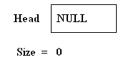
Subsequently, when
A.InsertFront(i%5) is executed for i=0;
The following function is called,

void Lclass::InsertFront(ItemType Item) {
ptrType Cur;
Cur = new ListNode;
Cur->Item = Item;
Cur->Next = Head;
Head= Cur; // make Head point to new element
}
Once the following two statements are executed

ptrType Cur;
Cur = new ListNode
a new Node of ListNode type is created, and its address is copied into Cur pointer variable. We usually, consider this as if Cur points to the new node. Because, you can access to new node using the address in Cur. Note that in each addition Size will be incremented by one.
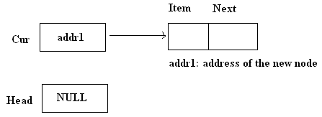
After executing the statement
Cur->Item = Item;
The picture will look like as the following
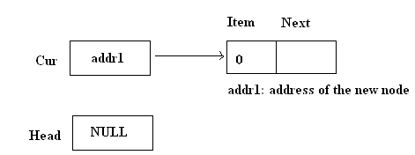

After executing the statement
Cur->Next = Head;
The picture will look like as the following
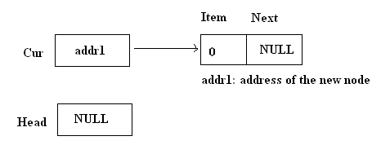

And, when the following statement is executed
Head= Cur;
The picture will look like as follows:
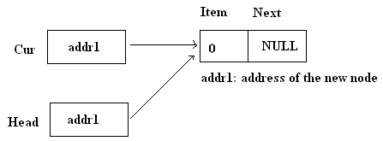

Finally, when the function is returned to the main program since Cur is no longer available, the picture is as follows:
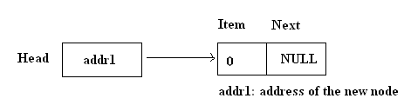

Subsequently, when
A.InsertFront(i%5) is executed for i=1;
Once the following two statements are executed

ptrType Cur;
Cur = new ListNode

a new Node of ListNode type is created, and its address is copied into Cur pointer variable. The picture is depicted below:

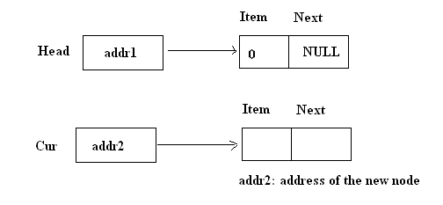
After executing the statement
Cur->Item = Item;
The picture will look like as the following
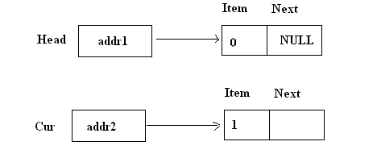
After executing the statement
Cur->Next = Head;
The picture will look like as the following
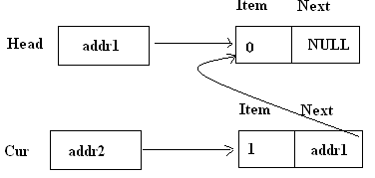

And, when the following statement is executed
Head= Cur;
The picture will look like as follows

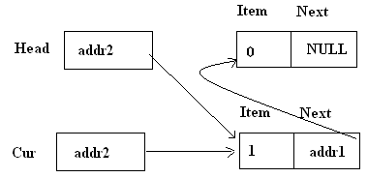

And, of course when the function returns, the picture is depicted as:

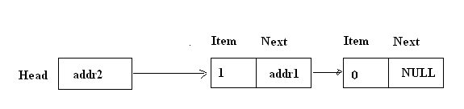

Exercise: Once you execute A.InsertFront(3), the above picture will look like as following. Execute the statements one at a time to obtain the picture below.
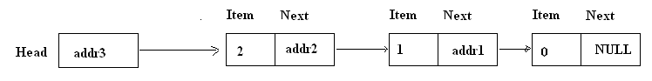

Deletion: Assume we have the following picture of object A Listnode:

When the following code is executed, we check if the Head is NULL. If so, there is nothing to delete. Otherwise,

void Lclass::DeleteFront() {
ptrType Cur;
if (Head != NULL ) { // check if Head is empty
Cur = Head ;
Head = Head->Next ;
delete Cur ;
Size--;
} // end if
} // end DeleteFront

After executing
Cur=Head;

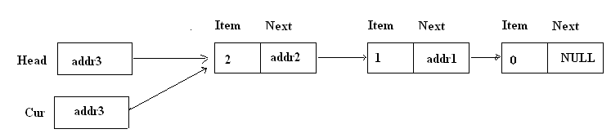

After executing
Head= Head->Next;
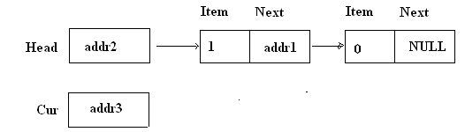

And, after executing
delete Cur;
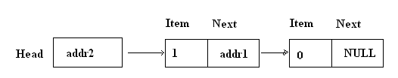

Note: Above Linked List implementation is also can be consider to be a Dynamic implementation of Stack data structure!

With simple modification, you can use class definition for ListNode. The rest being same, change the following:
typedef class ListNode* ptrType; // ptr to node

class ListNode {
public:
ItemType Item ;
ptrType Next;
} ; // end ListNode

Sorted Linked List Implementation

#include <iostream>
using namespace std;

typedef int ItemType ;

typedef class ListNode* ptrType; // ptr to node

class ListNode {
public:
ItemType Data ;
ptrType Next;
} ; // end ListNode class

class ListClass {
public:
ListClass() ;
ListClass (const ListClass & L) ; // Copy constructor
ListClass & operator= (const ListClass & anotherList); //assignment
~ListClass() ;
// list operations
int EmptyList() ;
int LengthList() ;
void FindElement(ItemType Item, ptrType &CurLoc, ptrType &PrevLoc);
void DeleteElement (ItemType Item) ;
void InsertElement ( ItemType Item) ;
void PrintList() ;
private:
int Size ;
ptrType Head;
}; // end class

ListClass::ListClass() {
Size = 0 ;
Head = NULL ;
} //end of default constructor
ListClass::ListClass(const ListClass & L) { //copy constructor
Size = L.Size ;
if (L.Head == NULL) Head = NULL ;
else {
Head = new ListNode ;
Head->Data = L.Head->Data ; // copy the head element
ptrType NewP = Head ; // get a backup of Head pointer
for (ptrType Cur = L.Head->Next ; Cur != NULL ; Cur = Cur->Next) {
NewP ->Next = new ListNode ;// we have gotten a memory cell
NewP = NewP->Next ;
NewP->Data= Cur->Data;

} // end for
NewP->Next = NULL ; //attached NULL to the last node's Next
} // end else
} // end copy function

// assignment operator
ListClass & ListClass::operator=(const ListClass & Original)
{
Head= NULL;
// if (Original.Head == NULL) return *this;

if (this != &Original) // check that not st = st
{
// Copy first node
Head = new ListNode;
Head->Data= Original.Head->Data;
Head->Next= Original.Head->Next;

// Set pointers to run through the linked lists
ptrType newListPtr = Head;
ptrType origPtr = Original.Head->Next;

while (origPtr != NULL)
{
newListPtr->Next = new ListNode;
newListPtr->Next->Data = origPtr->Data;
newListPtr->Next->Next= NULL;
newListPtr = newListPtr->Next; //move
origPtr = origPtr->Next; // move pointer
}

}
Size=Original.Size;
return *this;
}

ListClass::~ListClass() {
ptrType ptr, currPtr;
ptr = Head;
currPtr = Head;
while ( currPtr->Next != 0 ){
ptr= currPtr;;
currPtr= currPtr->Next;
delete ptr;
Size--;
}
delete currPtr;
Head=0;
cout << endl << "Destructor is called " << endl;
}

int ListClass::LengthList() {
return Size ; // private variable Size holds the length of the list
}
// NOTE pointers CurLoc and PrevLoc are passed by REFERENCE
void ListClass::FindElement(ItemType Item, ptrType &CurLoc, ptrType &PrevLoc) {
int MoreToSearch = 1; // set initially to True
CurLoc = Head ;
PrevLoc = NULL ;
while ((MoreToSearch) && (CurLoc != NULL)) {
if ( CurLoc->Data < Item ) {
PrevLoc = CurLoc ;
CurLoc = CurLoc->Next ;
}
else MoreToSearch = 0 ;
} // end while loop
// if CurLoc does not point to a node containing Item, reset CurLoc to NULL
if ( CurLoc != NULL)
if ( CurLoc->Data != Item) CurLoc = NULL ;
} // end FindElement

void ListClass::InsertElement(ItemType Item){
ptrType PrevLoc ; // pointer to previous location
ptrType Ignore; // pointer ignored
ptrType NewP ; // used to allocate a node
NewP = new ListNode;
NewP->Data = Item ;
cout << "Inserting " << Item << " : " ;
FindElement(Item, Ignore,PrevLoc); // Find the position of Insertion
if (PrevLoc == NULL) { // List is empty or inserting to the beginning of the list
NewP->Next = Head; // insert the first element
Head = NewP ;
}
else { // inserting into the middle or at the end
NewP->Next = PrevLoc->Next ;
PrevLoc->Next = NewP ;
} // end else
Size++ ; //Incerase the Size
} // End ListInsert
void ListClass::DeleteElement (ItemType Item){
ptrType Location; // points to the delete node
ptrType PrevLoc ; // points to preceding Node

cout << "Deleting " << Item << " : " ;
FindElement(Item, Location, PrevLoc) ;
if (PrevLoc == NULL) Head = Location->Next; // deleting first node
else PrevLoc->Next = Location->Next ; // connect the previous node to one ahead
delete Location ; // delete the node pointed by Location
} // end DeleteElement

void ListClass::PrintList() {
ptrType Cur;
Cur = Head ;
while (Cur != NULL) {
cout << Cur->Data <<" " ;
Cur= Cur->Next ;
}
cout << endl;
return ;
} // end Print

void main(){
ListClass A;

for (int i=0 ; i < 10; i++){
A.InsertElement( i);
A.PrintList();
}
//delete a node
cout << endl;
A.DeleteElement(5) ;
A.PrintList();
A.DeleteElement(0) ;
A.PrintList();
A.DeleteElement(9) ;
A.PrintList();

cout << endl;
ListClass B=A;
cout << "Copied List A to B. B, " << endl;
B.PrintList();
B.DeleteElement(2);
B.PrintList();
B.DeleteElement(1);
B.PrintList();

cout << endl;
ListClass C;

C= B;
C.PrintList();

return;
}

Program Output:
Inserting 0 : 0
Inserting 1 : 0 1
Inserting 2 : 0 1 2
Inserting 3 : 0 1 2 3
Inserting 4 : 0 1 2 3 4
Inserting 5 : 0 1 2 3 4 5
Inserting 6 : 0 1 2 3 4 5 6
Inserting 7 : 0 1 2 3 4 5 6 7
Inserting 8 : 0 1 2 3 4 5 6 7 8
Inserting 9 : 0 1 2 3 4 5 6 7 8 9

Deleting 5 : 0 1 2 3 4 6 7 8 9
Deleting 0 : 1 2 3 4 6 7 8 9
Deleting 9 : 1 2 3 4 6 7 8

Copied List A to B. B,
1 2 3 4 6 7 8
Deleting 2 : 1 3 4 6 7 8
Deleting 1 : 3 4 6 7 8

3 4 6 7 8

Destructor is called

Destructor is called

Destructor is called
Press any key to continue . . .

Three cases of Insertion:

    - Inserting to the End of the list.
Assume we have the following list and would like to insert 25.

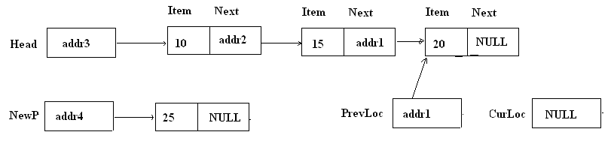

After the following statements are executed,

NewP->Next = PrevLoc->Next ;
PrevLoc->Next = NewP ;

The pictures looks as follows:

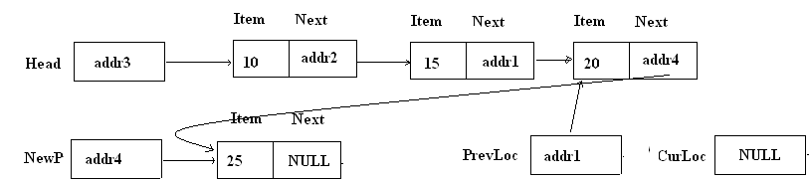

    - Inserting to the middle of the linked list ( assume inserting 12 )

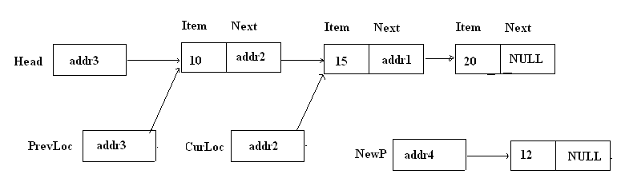

After the following statements are executed,

NewP->Next = PrevLoc->Next ;
PrevLoc->Next = NewP ;
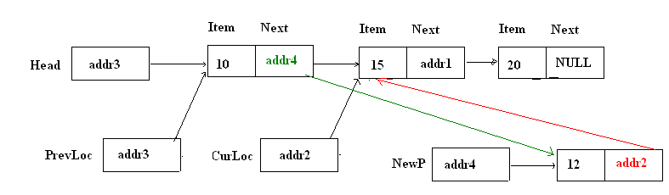

    - Inserting to the front (assume inserting 5)

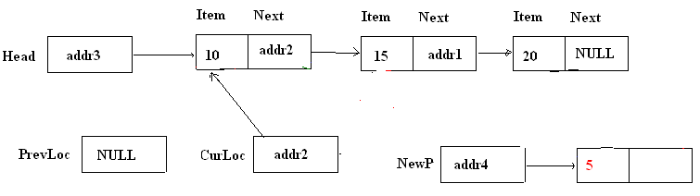

After the following statements are executed,

NewP->Next = PrevLoc->Next ;
PrevLoc->Next = NewP ;

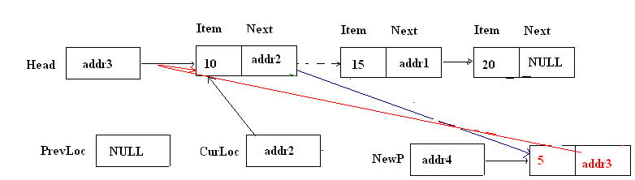

Linked List Example with Templates
#include <iostream>
using namespace std;

template <class ItemType> //overloading data with template
class ListNode {
public:
ItemType Data ;
ListNode <ItemType> * Next;
} ; // end struct

template <class ItemType>
class ListClass {
public:
ListClass() ;
ListClass (const ListClass & L) ; // Copy constructor
ListClass & operator= (const ListClass<ItemType> & anotherList); //assignment
~ListClass() ;
// list operations
int EmptyList() ;
int LengthList() ;
void FindElement(ItemType Item, ListNode <ItemType>* &CurLoc, ListNode <ItemType>* &PrevLoc);
void DeleteElement (ItemType Item) ;
void InsertElement ( ItemType Item) ;
void PrintList() ;
private:
int Size ;
ListNode <ItemType> * Head;
}; // end class

template <class ItemType>
ListClass<ItemType>::ListClass() {
Size = 0 ;
Head = NULL ;
} //end of default constructor

template <class ItemType>
ListClass<ItemType>::ListClass(const ListClass<ItemType> & L) { //copy constructor
Size = L.Size ;
if (L.Head == NULL) Head = NULL ;
else {
Head = new ListNode<ItemType> ;
Head->Data = L.Head->Data ; // copy the head element
ListNode <ItemType> * NewP = Head ; // get a backup of Head pointer
for (ListNode <ItemType> * Cur = L.Head->Next ; Cur != NULL ; Cur = Cur->Next) {
NewP ->Next = new ListNode<ItemType> ;// we have gotten a memory cell
NewP = NewP->Next ;
NewP->Data= Cur->Data;

} // end for
NewP->Next = NULL ; //attached NULL to the last node's Next
} // end else
} // end copy function

// assignment operator

template <class ItemType>
ListClass<ItemType> & ListClass<ItemType>::operator=(const ListClass<ItemType> & Original)
{
Head= NULL;
// if (Original.Head == NULL) return *this;

if (this != &Original) // check that not st = st
{
// Copy first node
Head = new ListNode<ItemType>;
Head->Data= Original.Head->Data;
Head->Next= Original.Head->Next;

// Set pointers to run through the linked lists
ListNode <ItemType> * newListPtr = Head;
ListNode <ItemType> * origPtr = Original.Head->Next;

while (origPtr != NULL)
{
newListPtr->Next = new ListNode<ItemType>;
newListPtr->Next->Data = origPtr->Data;
newListPtr->Next->Next= NULL;
newListPtr = newListPtr->Next; //move
origPtr = origPtr->Next; // move pointer
}

}
Size=Original.Size;
return *this;
}
template <class ItemType>
ListClass<ItemType>::~ListClass() {
ListNode <ItemType> * ptr;
ListNode <ItemType> * currPtr;
ptr = Head;
currPtr = Head;
while ( currPtr->Next != 0 ){
ptr= currPtr;;
currPtr= currPtr->Next;
delete ptr;
Size--;
}
delete currPtr;
Head=0;
cout << endl << "Destructor is called " << endl;
}

template <class ItemType>
int ListClass<ItemType>::LengthList() {
return Size ; // private variable Size holds the length of the list
}

// NOTE pointers CurLoc and PrevLoc are passed by REFERENCE

template <class ItemType>
void ListClass<ItemType>::FindElement(ItemType Item, ListNode <ItemType> * &CurLoc, ListNode <ItemType> * &PrevLoc) {
int MoreToSearch = 1; // set initially to True
CurLoc = Head ;
PrevLoc = NULL ;
while ((MoreToSearch) && (CurLoc != NULL)) {
if ( CurLoc->Data < Item ) {
PrevLoc = CurLoc ;
CurLoc = CurLoc->Next ;
}
else MoreToSearch = 0 ;
} // end while loop
// if CurLoc does not point to a node containing Item, reset CurLoc to NULL
if ( CurLoc != NULL)
if ( CurLoc->Data != Item) CurLoc = NULL ;
} // end FindElement

template <class ItemType>
void ListClass<ItemType>::InsertElement(ItemType Item){
ListNode <ItemType> * PrevLoc ; // pointer to previous location
ListNode <ItemType> * Ignore; // pointer ignored
ListNode <ItemType> * NewP ; // used to allocate a node
NewP = new ListNode<ItemType>;
NewP->Data = Item ;
cout << "Inserting " << Item << " : " ;
FindElement(Item, Ignore,PrevLoc); // Find the position of Insertion
if (PrevLoc == NULL) { // List is empty or inserting to the beginning of the list
NewP->Next = Head; // insert the first element
Head = NewP ;
}
else { // inserting into the middle or at the end
NewP->Next = PrevLoc->Next ;
PrevLoc->Next = NewP ;
} // end else
Size++ ; //Incerase the Size
} // End ListInsert

template <class ItemType>
void ListClass<ItemType>::DeleteElement (ItemType Item){
ListNode <ItemType> * Location; // points to the delete node
ListNode <ItemType> * PrevLoc ; // points to preceding Node

cout << "Deleting " << Item << " : " ;
FindElement(Item, Location, PrevLoc) ;
if (PrevLoc == NULL) Head = Location->Next; // deleting first node
else PrevLoc->Next = Location->Next ; // connect the previous node to one ahead
delete Location ; // delete the node pointed by Location
} // end DeleteElement

template <class ItemType>
void ListClass<ItemType>::PrintList() {
ListNode<ItemType> * Cur;
Cur = Head ;
while (Cur != NULL) {
cout << Cur->Data <<" " ;
Cur= Cur->Next ;
}
cout << endl;
return ;
} // end Print

void main(){
ListClass<int> A;

for (int i=0 ; i < 10; i++){
A.InsertElement( i);
A.PrintList();
}
//delete a node
cout << endl;
A.DeleteElement(5) ;
A.PrintList();
A.DeleteElement(0) ;
A.PrintList();
A.DeleteElement(9) ;
A.PrintList();

cout << endl;
ListClass<int> B=A;
cout << "Copied List A to B. B, " << endl;
B.PrintList();
B.DeleteElement(2);
B.PrintList();
B.DeleteElement(1);
B.PrintList();

cout << endl;

ListClass <char> C, D;
cout << endl <<"Forming Char list D: " << endl;
for (int i=65 ; i < 91; i+=2){
D.InsertElement( char(i));
D.PrintList();
}

C= D;
C.PrintList();

return;
}

Program Output:
Inserting 0 : 0
Inserting 1 : 0 1
Inserting 2 : 0 1 2
Inserting 3 : 0 1 2 3
Inserting 4 : 0 1 2 3 4
Inserting 5 : 0 1 2 3 4 5
Inserting 6 : 0 1 2 3 4 5 6
Inserting 7 : 0 1 2 3 4 5 6 7
Inserting 8 : 0 1 2 3 4 5 6 7 8
Inserting 9 : 0 1 2 3 4 5 6 7 8 9

Deleting 5 : 0 1 2 3 4 6 7 8 9
Deleting 0 : 1 2 3 4 6 7 8 9
Deleting 9 : 1 2 3 4 6 7 8

Copied List A to B. B,
1 2 3 4 6 7 8
Deleting 2 : 1 3 4 6 7 8
Deleting 1 : 3 4 6 7 8

Forming Char list D:
Inserting A : A
Inserting C : A C
Inserting E : A C E
Inserting G : A C E G
Inserting I : A C E G I
Inserting K : A C E G I K
Inserting M : A C E G I K M
Inserting O : A C E G I K M O
Inserting Q : A C E G I K M O Q
Inserting S : A C E G I K M O Q S
Inserting U : A C E G I K M O Q S U
Inserting W : A C E G I K M O Q S U W
Inserting Y : A C E G I K M O Q S U W Y
A C E G I K M O Q S U W Y

Destructor is called

Destructor is called

Destructor is called

Destructor is called
Press any key to continue . . .

