C-Strings

Review of the Internal Storage of Strings
In C++, a sting is a sequence of characters stored in consecutive memory locations, terminated by a null character. For example:
H | e | l | l | o | D | e | a | r | ! | \0

Example:
// This program contains string constants
#include <iostream>
using namespace std;
void main(void){
char Again;
do{
cout << "C++ programming is great fun!" << endl;
cout << "Do you want to see the message again? ";
cin >> Again;
} while (Again == 'Y' || Again == 'y');
}

Example:
// This program cycles through a character array, displaying
// each element until a null terminator is encountered.
#include <iostream>
using namespace std;
void main(void){
char Line[80];
int Count = 0;
cout << "Enter a sentence of no more than 79 characters:\n";
cin.getline(Line, 80);
cout << "The sentence you entered is:\n";
while (Line[Count] != '\0'){
cout << Line[Count];
Count++;
}
}

Program Output
Enter a sentence of no more than 79 characters:
C++ is challenging but fun! [Enter]
The sentence you entered is:
C++ is challenging but fun!

Library Functions for Working with Strings
The C++ library has numerous functions for handling strings.
These functions perform various tests and manipulations.
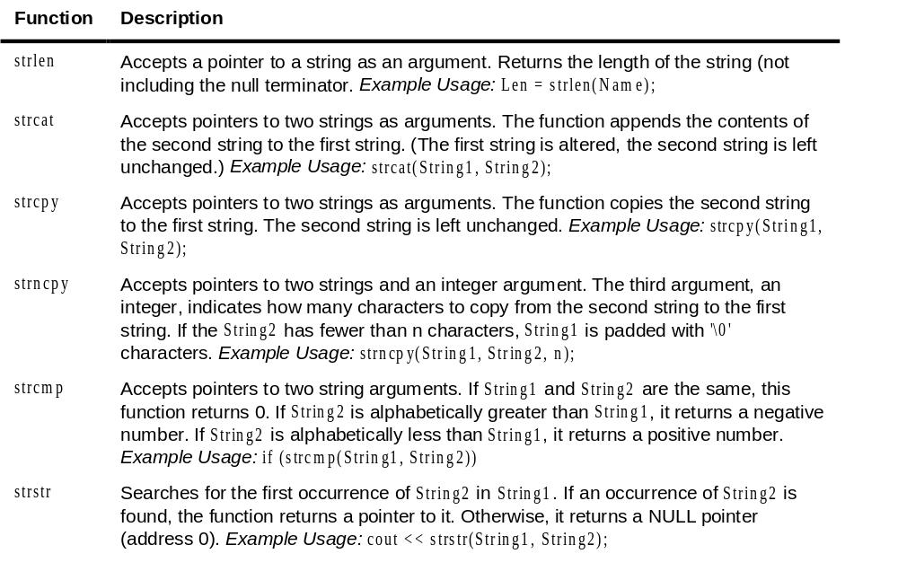
Example:
// This program uses the strstr function to search an array
// of strings for a name.
#include <iostream>
#include <string> // For strstr
using namespace std;

void main(void)
{
char Prods[5][27] = {"TV327 31 inch Television",
"CD257 CD Player",
"TA677 Answering Machine",
"CS109 Car Stereo",
"PC955 Personal Computer"};
char LookUp[27], *StrPtr = NULL;
int Index;

cout << "\tProduct Database\n\n";
cout << "Enter a product number to search for: ";
cin.getline(LookUp, 27);
for (Index = 0; Index < 5; Index++){
StrPtr = strstr(Prods[Index], LookUp);
if (StrPtr != NULL)
break;
}
if (StrPtr == NULL)
cout << "No matching product was found.\n";
else
cout << Prods[Index] << endl;
}
Program Output
Product Database

Enter a product to search for: CD257 [Enter]
CD257 CD Player
Program Output
Product Database

Enter a product to search for: CS [Enter]
CS109 Car Stereo

String/Numeric Conversion Functions
The C++ library provides functions for converting a string representation of a number to a numeric data type, and vice-versa.
The functions in this section require the stdlib.h file to be included.
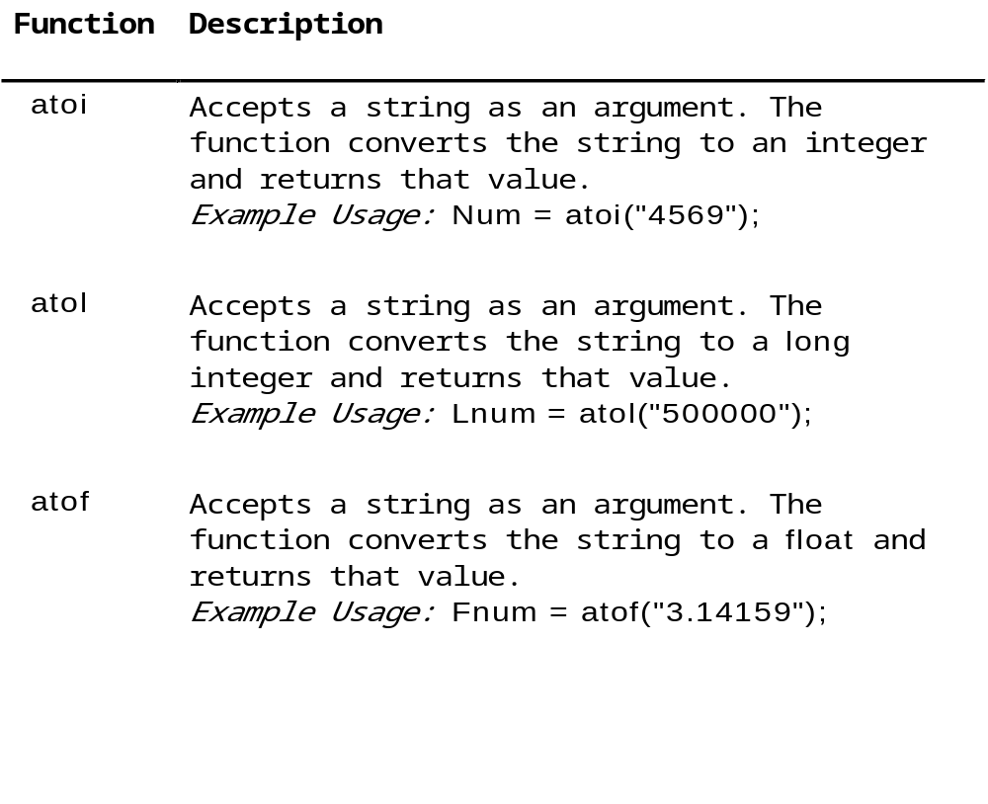

Example:
// This program demonstrates the strcmp and atoi functions.

#include <iostream>
#include <string> // For strcmp
#include <stdlib.h> // For atoi
using namespace std;

void main(void){
char Input[20];
int Total = 0, Count = 0;
float Average;
cout << "This program will average a series of numbers.\n";
cout << "Enter the first number or Q to quit: ";
cin.getline(Input, 20);
while ((strcmp(Input, "Q") != 0)&&(strcmp(Input, "q") != 0)){
Total += atoi(Input); // Keep a running total
Count++; // Keep track of how many numbers entered
cout << "Enter the next number or Q to quit: ";
cin.getline(Input, 20);
}
if (Count != 0)
{
Average = Total / Count;
cout << "Average: " << Average << endl;
}
}

Program Output
This program will average a series of numbers.
Enter the first number or Q to quit: 74 [Enter]
Enter the next number or Q to quit: 98 [Enter]
Enter the next number or Q to quit: 23 [Enter]
Enter the next number or Q to quit: 54 [Enter]
Enter the next number or Q to quit: Q [Enter]
Average: 62

Writing Your Own String-Handling Functions
You can design your own specialized functions for manipulating strings.
Example:
// This program uses a function to copy a string into an array.
#include <iostream>
using namespace std;
void StringCopy(char [], char []); // Function prototype
void main(void){
char First[30], Second[30];
cout << "Enter a string with no more than 29 characters:\n";
cin.getline(First, 30);
StringCopy(First, Second);
cout << "The string you entered is:\n" << Second << endl;
}
void StringCopy(char String1[], char String2[]){
int Index = 0;
while (String1[Index] != '\0'){
String2[Index] = String1[Index];
Index++;
}
String2[Index] = '\0';
}

Program Output
Enter a string with no more than 29 characters:
Thank goodness it’s Friday! [Enter]
The string you entered is:
Thank goodness it's Friday!

