**Experimental Evaluation:**

1. **Algo: RL N:10 Without Blocking**

Origin: 0 Goal: 9

N: 10 Iterations: 1000 Data: data10-1000a.csv

Sparsity: 0.65

Blocked: []

Path length: 3

Shortest path: [0, 1, 2, 9]

Time: 0.0785512924194336

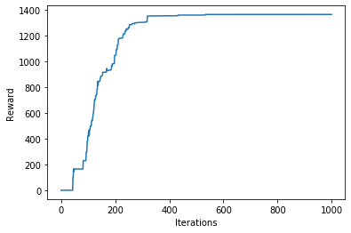

Correct path

------------------------------------------------------------------------

1. **Algo: GL N:10 Without Blocking**

Iteration 0: Best so far is 9 steps for a distance of 8.000000

best_route [0 4 7 4 5 3 6 2 9]

Iteration 1: Best so far is 7 steps for a distance of 6.000000

best_route [0 4 5 3 6 2 9]

Iteration 2: Best so far is 5 steps for a distance of 4.000000

best_route [0 4 5 2 9]

Iteration 4: Best so far is 4 steps for a distance of 3.000000

best_route [0 1 2 9]

============================================================================

Origin: 0 Goal: 9

N: 10 Iterations: 10 Data: data10-1000a.csv

Sparsity: 0.65

Blocked: []

Path length: 3

Shortest path: [0 1 2 9]

Time: 0.05389881134033203

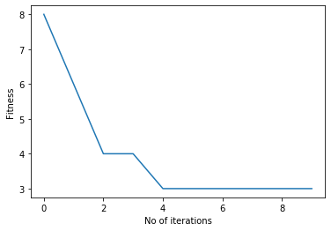

---------------------------------------------------------------------------------------------------------------------------

1. **Algo: RL N:10 With Blocking**

Origin: 0 Goal: 9

N: 10 Iterations: 1000 Data: data10-1000a.csv

Sparsity: 0.65

Blocked: [1]

Path length: 4

Shortest path: [0, 4, 3, 2, 9]

Time: 0.06761837005615234

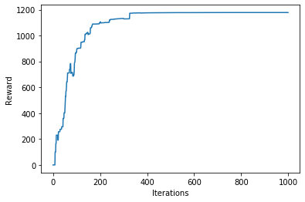

Correct path

---------------------------------------------------------------------------

1. **Algo: GL N:10 With Blocking**

Iteration 0: Best so far is 8 steps for a distance of 7.000000

best_route [0 4 3 2 5 3 2 9]

Iteration 2: Best so far is 7 steps for a distance of 6.000000

best_route [0 4 3 6 3 2 9]

Iteration 3: Best so far is 6 steps for a distance of 5.000000

best_route [0 4 5 3 2 9]

Iteration 4: Best so far is 5 steps for a distance of 4.000000

best_route [0 4 5 2 9]

============================================================================

Origin: 0 Goal: 9

N: 10 Iterations: 10 Data: data10-1000a.csv

Sparsity: 0.65

Blocked: [1]

Path length: 4

Shortest path: [0 4 6 2 9]

Time: 0.05086398124694824

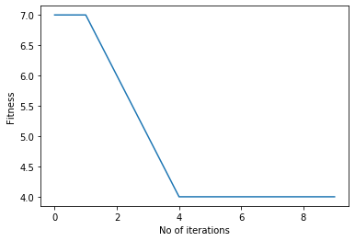

-------------------------------------------------------------------------------------------------------------------------------

1. **Algo: RL N:100 Without Blocking**

Origin: 0 Goal: 99

N: 100 Iterations: 6000 Data: data100-6000a.csv

Sparsity: 0.95 gamma: 0.65

Blocked: []

Path length: 3

Shortest path: [0, 29, 17, 99]

Time: 0.6395816802978516

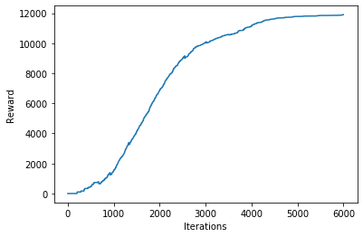

Correct path

1. **Algo: GL N:100 Without Blocking**

Iteration 0: Best so far is 31 steps for a distance of 30.000000

best_route [ 0 29 17 29 22 96 9 96 76 8 81 40 81 97 28 0 82 0 76 29 17 73 17 6

79 34 29 17 50 17 99]

Iteration 1: Best so far is 20 steps for a distance of 19.000000

best_route [ 0 82 0 28 1 79 58 87 62 87 47 90 50 2 59 29 17 73 17 99]

Iteration 4: Best so far is 14 steps for a distance of 13.000000

best_route [ 0 76 29 98 24 70 80 6 23 45 98 73 17 99]

Iteration 5: Best so far is 12 steps for a distance of 11.000000

best_route [ 0 28 97 2 83 2 9 2 59 29 17 99]

Iteration 6: Best so far is 5 steps for a distance of 4.000000

best_route [ 0 76 29 17 99]

Iteration 18: Best so far is 4 steps for a distance of 3.000000

best_route [ 0 29 17 99]

============================================================================

Origin: 0 Goal: 99

N: 100 Iterations: 100 Data: data100-6000a.csv

Sparsity: 0.65

Blocked: []

Path length: 3

Shortest path: [ 0 29 17 99]

Time: 3.432793140411377

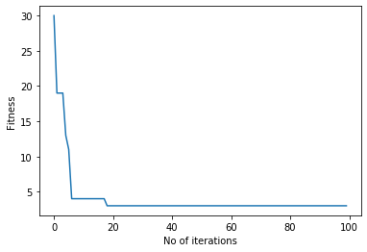

-----------------------------------------------------------------------

1. **Algo: RL N:100 With Blocking**

Origin: 0 Goal: 99

N: 100 Iterations: 10000 Data: data100-6000a.csv

Sparsity: 0.95 gamma: 0.65

Blocked: [17]

Path length: 5

Shortest path: [0, 29, 34, 68, 95, 99]

Time: 3.067688465118408

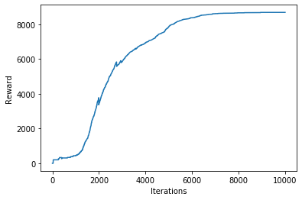

Correct path

-----------------------------------------------------------------------

1. **Algo: GL N:100 With Blocking**

Iteration 0: Best so far is 19 steps for a distance of 18.000000

best_route [ 0 29 2 38 35 65 35 15 38 2 59 29 13 77 70 26 66 95 99]

Iteration 2: Best so far is 18 steps for a distance of 17.000000

best_route [ 0 29 59 63 59 2 36 34 24 15 25 22 37 67 26 66 95 99]

Iteration 4: Best so far is 10 steps for a distance of 9.000000

best_route [ 0 29 98 4 57 70 26 66 95 99]

Iteration 31: Best so far is 9 steps for a distance of 8.000000

best_route [ 0 82 0 1 91 23 33 95 99]

Iteration 51: Best so far is 7 steps for a distance of 6.000000

best_route [ 0 1 91 23 33 95 99]

============================================================================

Origin: 0 Goal: 99

N: 100 Iterations: 100 Data: data100-6000a.csv

Sparsity: 0.65

Blocked: [17]

Path length: 6

Shortest path: [ 0 1 91 23 33 95 99]

Time: 2.945128917694092

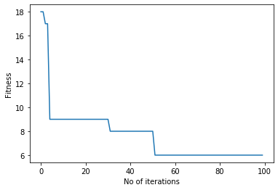

-----------------------------------------------------------------------

1. **Algo: RL N:250 Without Blocking**

Origin: 0 Goal: 249

N: 250 Iterations: 20000 Data: data250-20000a.csv

Sparsity: 0.97 gamma: 0.65

Blocked: []

Path length: 4

Shortest path: [0, 158, 10, 55, 249]

Time: 12.722759485244751

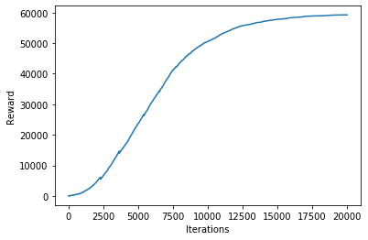

Correct path

---------------------------------------------------------------------------

1. **Algo: GL N:250 Without Blocking**

Iteration 0: Best so far is 30 steps for a distance of 29.000000

best_route [ 0 237 217 241 113 219 120 78 120 248 50 218 243 218 243 66 46 63

161 63 81 201 174 150 167 221 167 19 186 249]

Iteration 3: Best so far is 23 steps for a distance of 22.000000

best_route [ 0 163 228 215 19 167 221 167 150 174 184 174 201 217 123 22 119 146

40 146 119 70 249]

Iteration 4: Best so far is 19 steps for a distance of 18.000000

best_route [ 0 158 162 96 72 107 72 107 64 130 181 193 136 234 40 146 119 70

249]

Iteration 5: Best so far is 11 steps for a distance of 10.000000

best_route [ 0 163 228 215 19 167 221 244 238 15 249]

Iteration 10: Best so far is 8 steps for a distance of 7.000000

best_route [ 0 33 3 178 241 27 177 249]

Iteration 14: Best so far is 5 steps for a distance of 4.000000

best_route [ 0 147 115 55 249]

============================================================================

Origin: 0 Goal: 249

N: 250 Iterations: 100 Data: data250-20000a.csv

Sparsity: 0.65

Blocked: []

Path length: 4

Shortest path: [ 0 147 115 55 249]

Time: 6.893573760986328

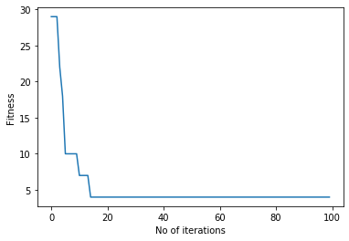

In [ ]:

-----------------------------------------------------------------------

1. **Algo: RL N:250 With Blocking**

Origin: 0 Goal: 249

N: 250 Iterations: 40000 Data: data250-20000a.csv

Sparsity: 0.97 gamma: 0.65

Blocked: [158, 10, 55]

Path length: 4

Shortest path: [0, 63, 169, 211, 249]

Time: 26.032241344451904

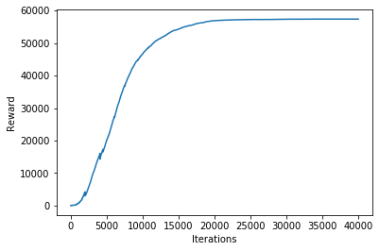

Correct path

-----------------------------------------------------------------------

1. **Algo: GL N:250 With Blocking**

Iteration 0: Best so far is 24 steps for a distance of 23.000000

best_route [ 0 237 75 89 121 190 82 60 86 60 2 60 217 60 138 60 82 56

6 26 54 93 54 249]

Iteration 1: Best so far is 16 steps for a distance of 15.000000

best_route [ 0 237 75 89 121 190 82 60 86 60 2 60 217 246 186 249]

Iteration 4: Best so far is 13 steps for a distance of 12.000000

best_route [ 0 158 162 39 162 96 162 244 238 15 238 15 249]

Iteration 7: Best so far is 11 steps for a distance of 10.000000

best_route [ 0 158 162 39 162 244 238 15 238 15 249]

Iteration 9: Best so far is 9 steps for a distance of 8.000000

best_route [ 0 150 231 223 240 102 109 15 249]

Iteration 12: Best so far is 7 steps for a distance of 6.000000

best_route [ 0 158 162 244 238 15 249]

Iteration 17: Best so far is 6 steps for a distance of 5.000000

best_route [ 0 158 71 222 211 249]

============================================================================

Origin: 0 Goal: 249

N: 250 Iterations: 100 Data: data250-20000a.csv

Sparsity: 0.65

Blocked: [147, 115, 55]

Path length: 5

Shortest path: [ 0 158 71 222 211 249]

Time: 2.981276750564575

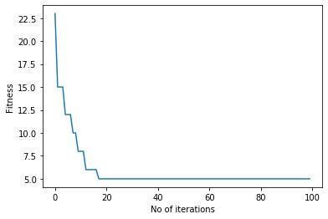

In [ ]:

-----------------------------------------------------------------------

1. **Algo: RL N:500 Without Blocking**

Origin: 0 Goal: 499

N: 500 Iterations: 70000 Data: data500-70000a.csv

Sparsity: 0.97 gamma: 0.65

Blocked: []

Path length: 3

Shortest path: [0, 118, 354, 499]

Time: 193.21558046340942

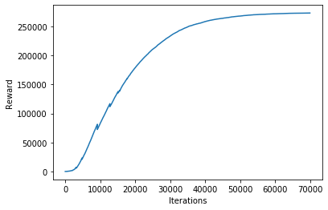

Correct path

-----------------------------------------------------------------------

1. **Algo: GL N:500 Without Blocking**

Iteration 0: Best so far is 58 steps for a distance of 57.000000

best_route [ 0 154 0 402 153 205 12 431 213 185 481 275 58 181 197 102 173 125

60 494 125 497 51 286 96 286 96 201 20 437 187 95 318 298 24 219

51 429 165 36 165 220 491 44 11 194 142 150 142 75 72 210 56 251

468 12 238 499]

Iteration 1: Best so far is 57 steps for a distance of 56.000000

best_route [ 0 357 358 301 243 424 486 407 281 272 215 385 474 454 30 221 135 56

29 106 359 372 253 169 58 465 58 16 453 301 367 137 85 137 187 374

353 51 280 186 280 307 419 345 169 299 116 111 245 29 292 107 292 282

147 470 499]

Iteration 2: Best so far is 28 steps for a distance of 27.000000

best_route [ 0 118 326 270 318 95 498 10 439 370 326 413 412 125 55 226 55 490

55 291 250 331 100 51 99 472 470 499]

Iteration 4: Best so far is 9 steps for a distance of 8.000000

best_route [ 0 103 295 391 194 406 280 208 499]

Iteration 8: Best so far is 7 steps for a distance of 6.000000

best_route [ 0 154 183 363 299 414 499]

Iteration 22: Best so far is 6 steps for a distance of 5.000000

best_route [ 0 57 312 227 453 499]

Iteration 31: Best so far is 4 steps for a distance of 3.000000

best_route [ 0 118 380 499]

============================================================================

Origin: 0 Goal: 499

N: 500 Iterations: 100 Data: data500-70000a.csv

Sparsity: 0.65

Blocked: []

Path length: 3

Shortest path: [ 0 118 380 499]

Time: 4.009281873703003

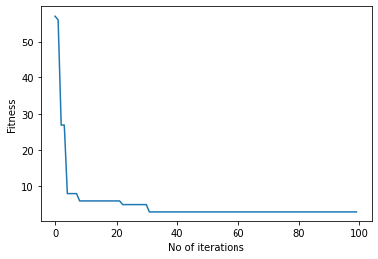

-----------------------------------------------------------------------

1. **Algo: RL N:500 With Blocking**

Origin: 0 Goal: 499

N: 500 Iterations: 70000 Data: data500-70000a.csv

Sparsity: 0.97 gamma: 0.65

Blocked: [118, 397, 227, 453, 429, 104]

Path length: 3

Shortest path: [0, 154, 354, 499]

Time: 194.10709738731384

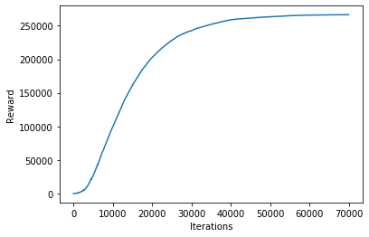

Correct path

-------------------------------------------------------------------------------------------------------------------------------

1. **Algo: GL N:500 With Blocking**

Iteration 0: Best so far is 8 steps for a distance of 7.000000

best_route [ 0 41 220 51 128 125 15 499]

Iteration 24: Best so far is 7 steps for a distance of 6.000000

best_route [ 0 319 117 123 233 169 499]

Iteration 70: Best so far is 4 steps for a distance of 3.000000

best_route [ 0 334 441 499]

============================================================================

Origin: 0 Goal: 499

N: 500 Iterations: 100 Data: data500-70000a.csv

Sparsity: 0.65

Blocked: [118, 397, 227, 453, 429, 104]

Path length: 3

Shortest path: [ 0 334 441 499]

Time: 5.426528453826904

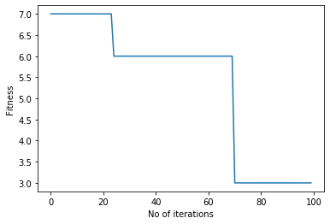

-------------------------------------------------------------------------------------------------------------------------------

1. **Algo: RL N:1000 Without Blocking**

Origin: 0 Goal: 999

N: 1000 Iterations: 100000 Data: data1000-10000.csv

Sparsity: 0.97 gamma: 0.65

Blocked: []

Path length: 2

Shortest path: [0, 155, 999]

Time: 1540.7415761947632

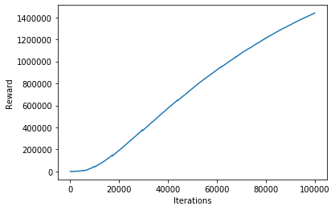

Correct path

-------------------------------------------------------------------------------------------------------------------------------

1. **Algo: GL N:1000 Without Blocking**

Iteration 0: Best so far is 102 steps for a distance of 101.000000

best_route [ 0 825 301 791 614 816 987 486 795 58 583 92 11 843 846 92 675 26

978 56 717 921 961 994 290 174 571 941 306 98 498 814 268 89 925 106

585 218 325 532 577 794 14 926 869 659 930 331 475 143 306 937 829 738

990 445 92 975 831 792 581 72 963 222 272 769 968 249 664 362 820 256

875 331 291 368 86 766 738 392 962 499 272 981 477 961 977 973 943 761

700 353 241 392 962 452 419 993 624 444 839 999]

Iteration 1: Best so far is 42 steps for a distance of 41.000000

best_route [ 0 560 784 916 525 578 242 269 299 694 241 184 288 184 687 686 150 703

735 718 70 571 941 66 701 793 872 407 242 26 239 609 29 253 185 983

543 678 223 142 259 999]

Iteration 3: Best so far is 20 steps for a distance of 19.000000

best_route [ 0 560 784 916 525 578 242 269 299 694 241 392 962 452 419 993 624 444

839 999]

Iteration 7: Best so far is 16 steps for a distance of 15.000000

best_route [ 0 21 155 621 370 877 436 672 638 379 328 740 401 963 155 999]

Iteration 12: Best so far is 12 steps for a distance of 11.000000

best_route [ 0 991 668 368 874 952 586 369 805 666 259 999]

Iteration 13: Best so far is 4 steps for a distance of 3.000000

best_route [ 0 21 155 999]

Iteration 87: Best so far is 3 steps for a distance of 2.000000

best_route [ 0 155 999]

============================================================================

Origin: 0 Goal: 999

N: 1000 Iterations: 100 Data: data1000-10000.csv

Sparsity: 0.65

Blocked: []

Path length: 2

Shortest path: [ 0 155 999]

Time: 35.36421990394592

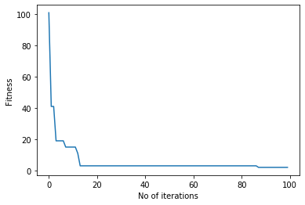

-------------------------------------------------------------------------------------------------------------------------------

1. **Algo: RL N:1000 With Blocking**

Origin: 0 Goal: 999

N: 1000 Iterations: 50000 Data: data1000-10000.csv

Sparsity: 0.97 gamma: 0.65

Blocked: [155]

Path length: 3

Shortest path: [0, 244, 542, 999]

Time: 1068.1458992958069

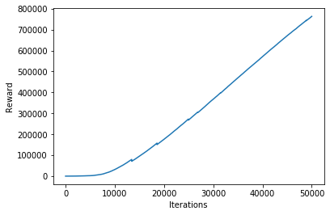

Correct path

-------------------------------------------------------------------------------------------------------------------------------

1. **Algo: RL N:1000 With Blocking**

Iteration 0: Best so far is 35 steps for a distance of 34.000000

best_route [ 0 567 708 810 580 805 901 448 804 192 756 539 181 167 310 122 30 902

538 679 704 565 478 316 620 638 855 42 414 292 181 724 286 251 999]

Iteration 4: Best so far is 16 steps for a distance of 15.000000

best_route [ 0 567 708 810 580 805 901 448 804 192 756 539 181 167 16 999]

Iteration 6: Best so far is 15 steps for a distance of 14.000000

best_route [ 0 621 389 706 747 191 284 186 853 891 92 181 167 16 999]

Iteration 12: Best so far is 9 steps for a distance of 8.000000

best_route [ 0 621 365 700 491 602 662 809 999]

Iteration 27: Best so far is 5 steps for a distance of 4.000000

best_route [ 0 875 337 632 999]

============================================================================

Origin: 0 Goal: 999

N: 1000 Iterations: 100 Data: data1000-10000.csv

Sparsity: 0.65

Blocked: [155]

Path length: 4

Shortest path: [ 0 875 337 632 999]

Time: 52.747963428497314

