Part 3

a)

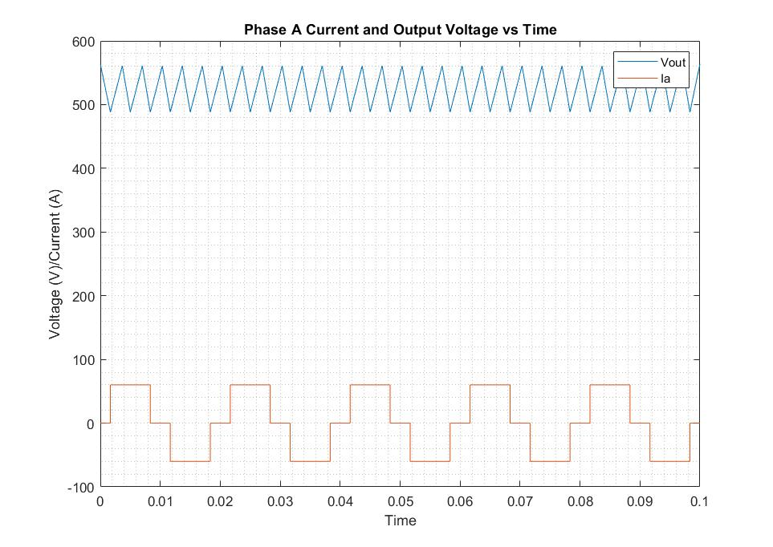

In the plot we achieved, we observed an expected phase current plot. Meanwhile the output voltage plot has a more triangular characteristics, unlike the expected trimmed-sinusoidal characteristics. We believe that this is caused by directly connecting the diodes to a DC current source, and how they are modeled in Matlab. When we decreased the stop time, we achieved a more successful result:

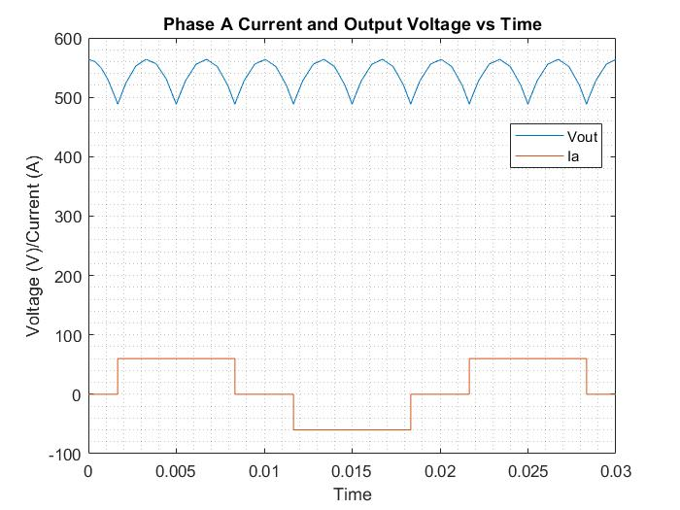

b)

Displayed average output voltage:

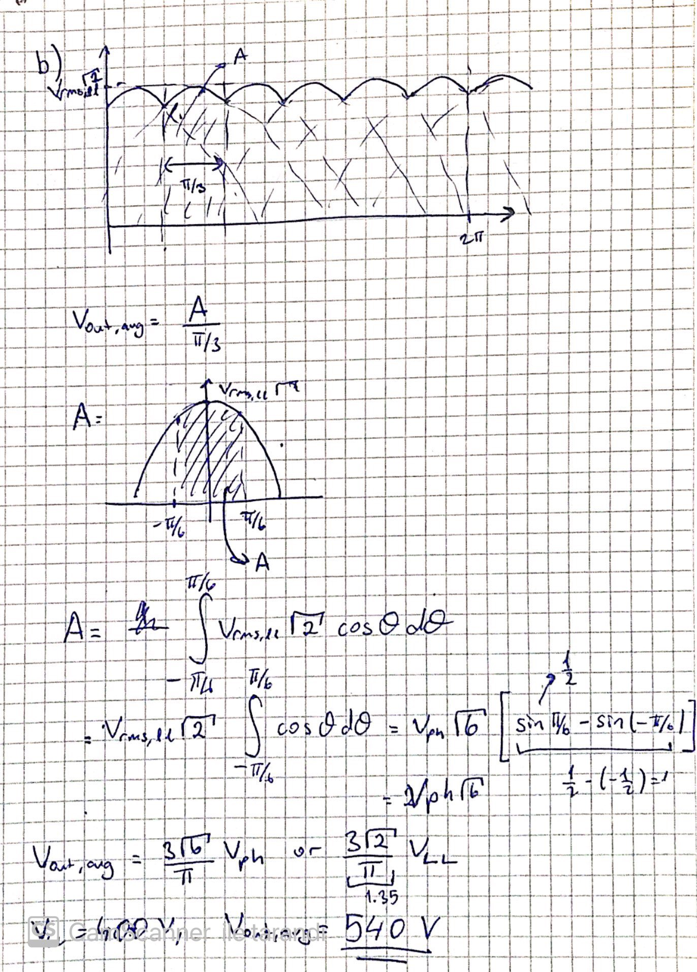

From the analytical calculations, we arrived in an average output voltage of 540 V. However, the simulated average output voltage is 537.8, which very close to the analytical result. However we achieved this result by decreasing stop time of the simulation. With higher simulation times, we observed a greater change in the analytical and simulation values. This might occurred because of the fact that decreasing the stop time increased the output plots’ resolution. The reason between this resolution difference might be about the relation between input sources sampling time and the stop time.

c)

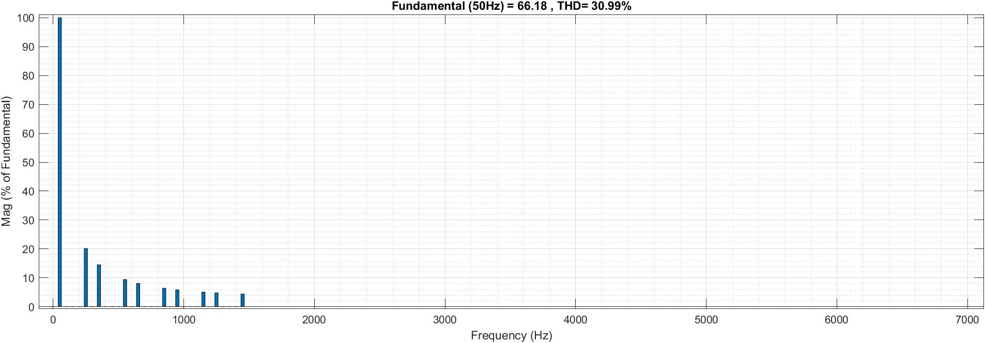

*Figure: Line current harmonics*

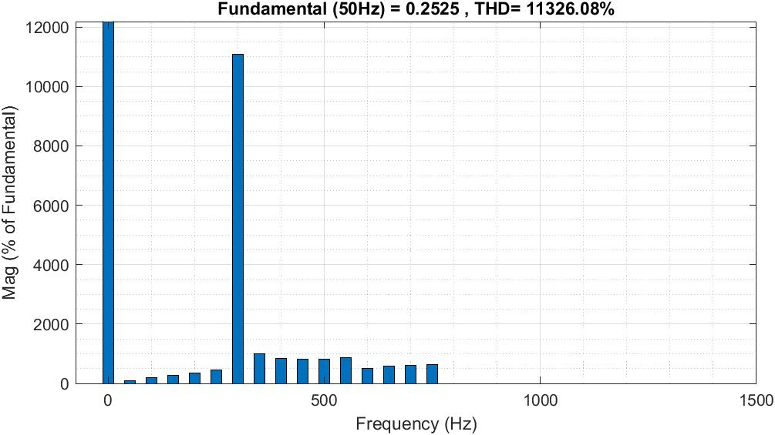

*Figure: Output voltage harmonics*

In the harmonics calculations, we observe that line current has no even harmonics, and has no three-multiplied harmonics. In the output voltage we observed a great peak at DC part, because of the fact that output voltage has a great DC component. We also observed a similar characteristic at 6th harmonics. The output voltage has many harmonics so the THD value is extremely high. However the line current THD is 30.43% which is high for a real life application, but still is an expected value.

d)

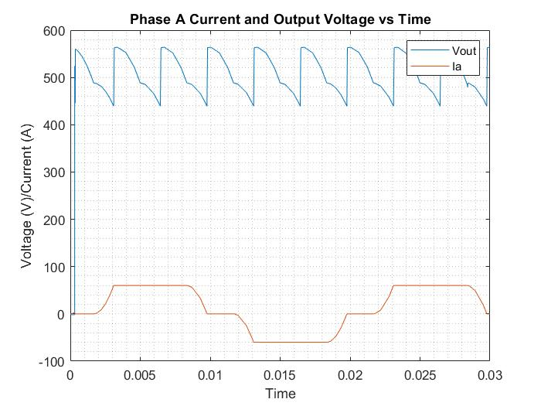

When a parasitic inductance is introduced to the model ,we observed some differences in characteristics of the plots. The current is has slope on its increase and decreases. This is caused by the fact that inductor voltage is directly proportional with current’s rate of change and 90 degree changes will result in infinite inductor voltage mathematically, but such thing is not possible practically. We also see some distortions on the output voltage caused by the phase difference between the input current and voltage, which is called commution. Commution also results with smaller average output voltage.

e)



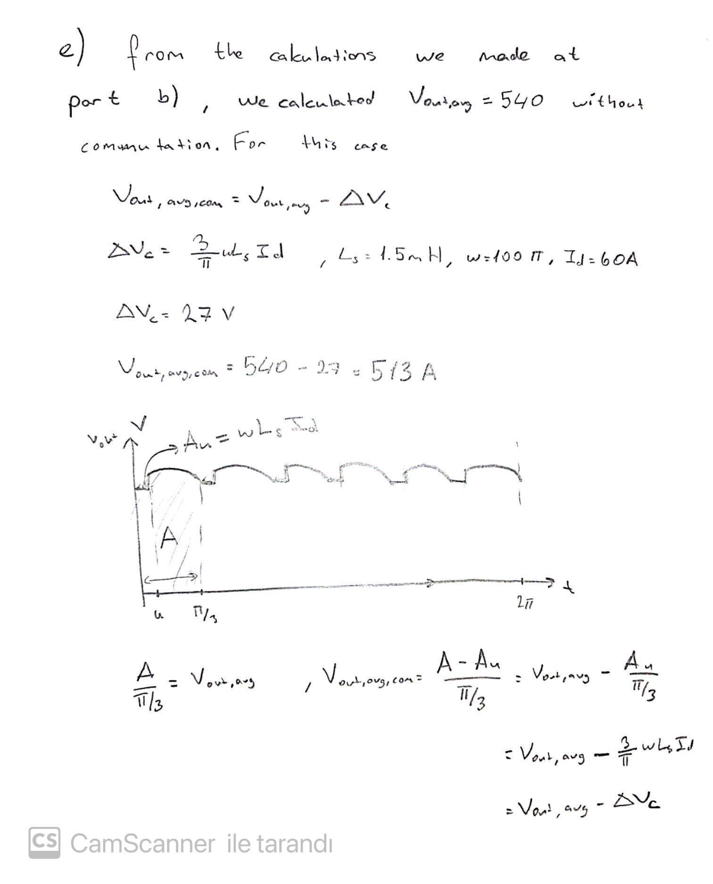

We analytically calculated that the average output voltage should be 513 V. We observed a value of 510.9 V in the simulation. The difference is really small, and the reason behind might be the non-ideal characteristics of the Simulink model, just like in part b). On the other hand, if we subtract the simulation values, we will get a value of 26.9, which holds the analytical calculation.

f)



*Figure: Line current harmonics for L=0*

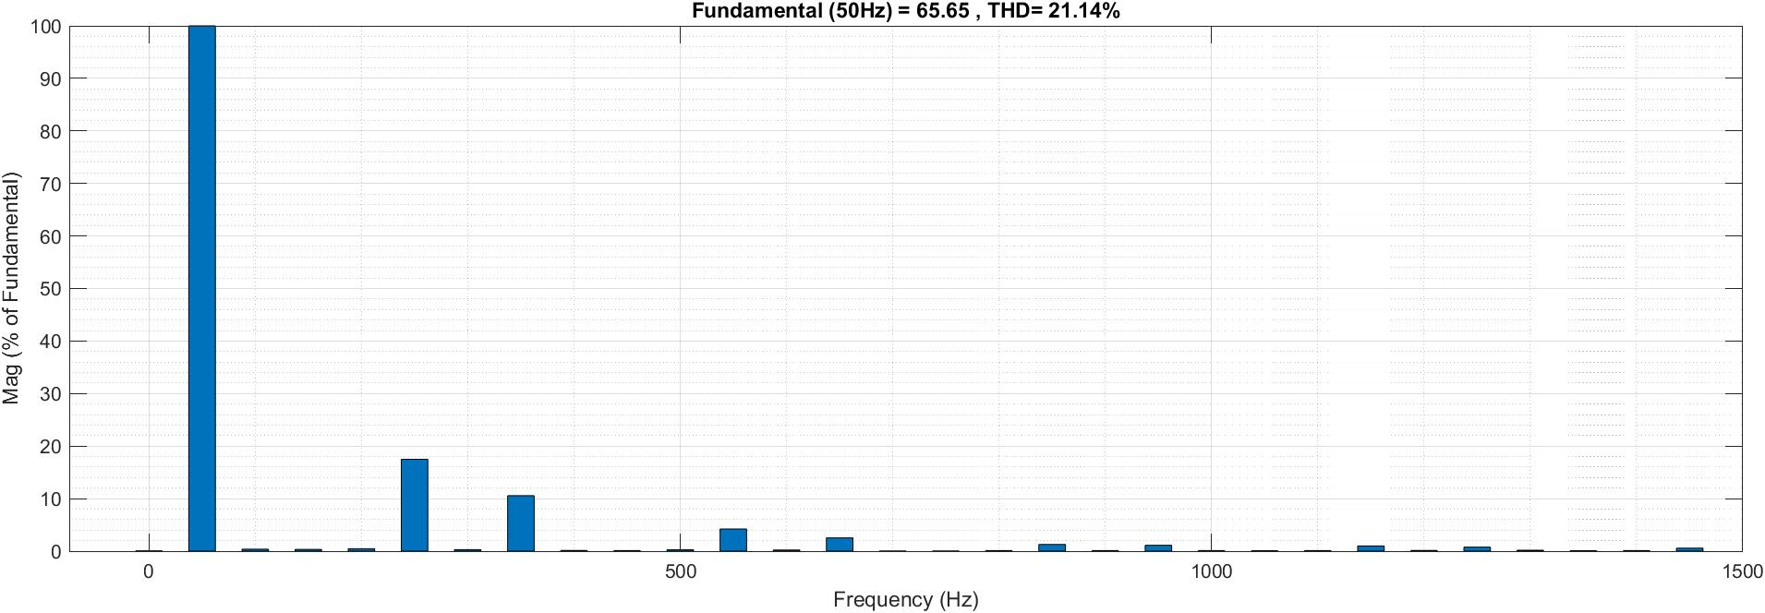

*Figure: Line current harmonics for L=1.5mH*

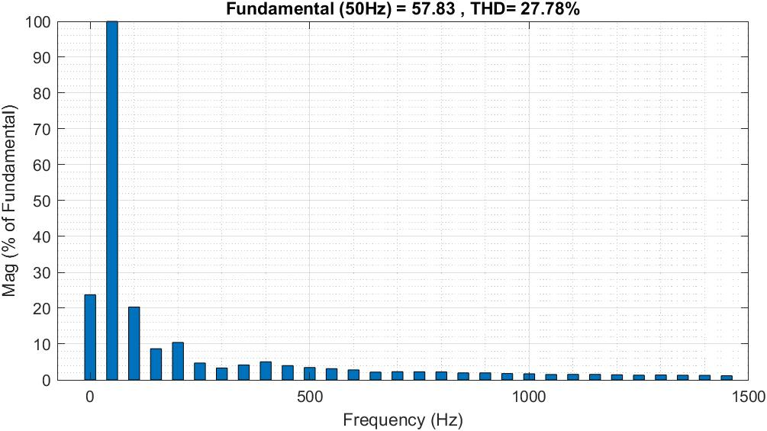

*Figure: Line current harmonics for L=15mH*

In the bar graphs, we observe the introductor of 1.5mH induction to the model decreased its harmonics and THD. But increasing the inductance to 15mH not only increased the THD but also changed the characteristics of the graph. With 1.5mH, we observed that the three-multiplied harmonics characteristics of no inductance model is disturbed, but a similar pattern can be seen. But with such pattern, no such pattern can be seen. IEEE 519-2014 recommends THD value smaller than 8% for voltage values smaller than 1kV, so none of these models fit this requirement, with a great margin.