## **Practical Implementation Process**

While implementing our half controlled rectifier design, we encountered some problems with the design we did not foresee. In the design process, we assumed that, if we could decrease the voltage of the gate signal generated so that the voltage is in thyristors operation range, we would observe the desired characteristics at the output voltage. However as we found a solution by connecting a zener diode with high breakdown voltage, 9.1 V exactly, to output in reverse so that the voltage drop in the zener will decrease the output to our desired levels.

However, as we set up the controller circuit and observed the output signals as we expected, we connected the gate signals to the thyristors and completed the half controlled full wave rectifier and observed no output signal. With further inspection, we observed that we cannot fire the thyristors with gate signals. Even worse, we observed unexpected waveforms in the gate signals that we previously did not observed, such as sine waves and square-like waves. After further inspections, we could not determine the reason behind these waveforms, and decided to follow our back-up plan, triac dimmer circuit.

## **Triac Dimmer**

Triac Dimmer is a topology that relies on capacitor charging and decharging, and opening the triac with the help of a diac. The circuit is connected to the motor in series. The main principle of motor control in the triac dimmer design is controlling charging speed of the capacitor by changing the time constant by changing the resistance. We know the voltage seperates on the capacitor and the resistance, much like a voltage divider, while the triac is off. By changing the resistance, we can control the voltage on the capacitor. For 50 Hz case, 100 nF capacitor has an impedance of around 160 kΩ. A diac is connected between the gate of triac and the node between resistor and capacitor. As the capacitor voltage reaches the value where diac opens, which is theoretically 32 V in the design, however can be between 28-36 V in practical applications. When diac opens, the triac lets current through, which results in almost no voltage on the control branch of the circuit, but capacitor slowly discharges and a current flow occurs on diac, which keeps the triac open. We also added shunt 100 nF 400V capacitor to the triac as a snubber, since while we tried out our controller on the series excited DC motor, we encountered a problem where the controller loses its control over the motor after a certain rotational speed is achieved.

**Cost Analysis**

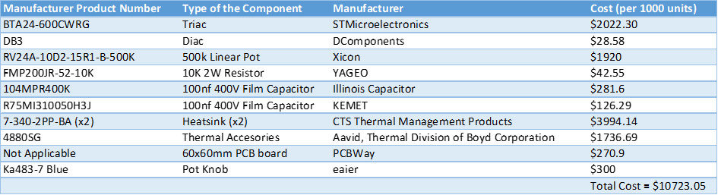

Table 1. Cost Analysis

As can be seen from table 1. total cost for 1000 units is $10423.05. In this calculation I could not find exact heatsink we used in this project because heatsink we bought from konya sokak did not have the manufacturer product number so I selected a heatsink which have similar size to half of our heatsink. I wrote 2 heatsinks on the table because we bought 1 bigger heatsink and divided it into two and connected them to each other. I did not take the cost of the case into account because we made it with square cable conduit we painted. I took all costs from Digikey except PCB and Pot Knob.

**Thermal Analysis**

We do not have datasheet of heatsink we used so I will take 7-340-2PP-BA heatsink I chosen as approximation. We connected two parts of same heatsink back to back because heatsink we used was designed for two TO-220 devices and was too long to fit the case. I will take thermal resistance of second heatsink as three times of its original value because two parts of heatsink was not touching each other fully even with thermal paste we applied (Which was design error on our part and from also from figures 2. and 3. we can see the side of the heatsink which is not touching BTA24 significantly colder than the other side). I will also take junction to case thermal resistance of BTA24 and thermal pad between case to heatsink as double their original value because only half of BTA24 and thermal pad was touching the heatsink (Which was an another design error on our part). I take thermal resistance of thermal pad as 0.5°C/W as approximation because I could not find its datasheet. From data sheets we can find thermal resistance of BTA24 and Heatsink as 0.8°C/W and 6.67°C/W respectively. Current passing through triac at max load was 10.6 Arms. According to datasheet power dissipation of BTA24 at 10.6 Arms is 9.5 W. Also from data sheet we can find average gate power dissipation as 1W. So total power loss at triac is 10.5W. From these values we can create thermal circuit as seen from figure 1 (I took ambient temperature as 25°C). From these we can calculate Junction temperature.

Tjunction = Tambient + PLoss*(Rj-c + Rc-h + Rh-a)

Tjunction = 25 + 10.5*(1.6 + 1 + 6.67//20) = 104.8°C

From these calculations our junction temperature must be within our limits (Barely). But from figure 2. we can see that case temperature we observed while testing is 110°C. This value should have been smaller than 104.8°C because we can not measure temperature of junction. But it was higher. We think heat generated by connections in PCB caused rise in effective ambient temperature and this effected temperature of the BTA24. Datasheet states maximum operating junction temperature of BTA24 is 125°C. 110°C we observed is pushing this limit because junction temperature must be higher than measured value. We could connected BTA24 and heatsink better such that they are fully touching each other or chosen heatsink that is one piece instead of two poorly connected ones to improve thermal performance of our circuit.

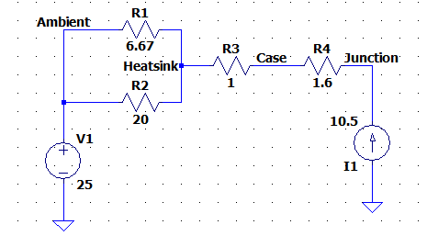

figure 1. Thermal circuit

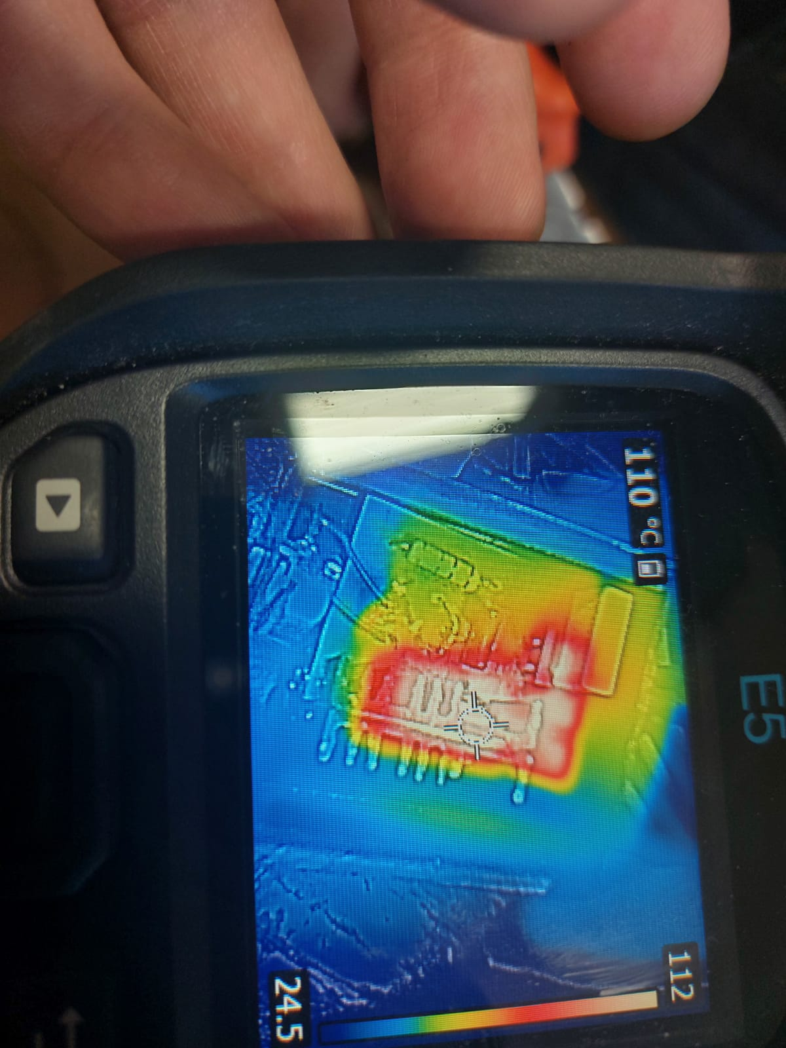

figure 2. Case Temperature of BTA24

But we think our biggest mistake which caused thermal failure of our circuit was making power connection lines on our PCB too thin. As can be seen from Figure 3. these lines reached temperatures more than 170°C and burned. Maximum temperature of these lines was likely higher because conducting line is other side of where we measure the temperature. We observed visible smoke after we measured 170°C and our circuit stopped working. After that we observed that copper lining of PCB which terminals of BTA24 was connected to was destroyed. Heat produced by these lines likely effected temperature of BTA24 thus further effecting thermal performance of our circuit. We used 30 thou thick PCB traces in all parts of our project. This is fine for control part of the circuit but it is too thin for non-gate connections of triacs. Current carrying capacity of 1oz/ft^2 thick, 30th wide trace is 3.2 A is even with a lenient 30°C temperature rise limit[1]. In order for trace to carry 10.5 A current it has to be at least 156th wide[2]. So to be safe we should at least used 200th wide traces in power connections. But this would have been impossible with our current PCB configuration because there is not enough space to use 200th traces. It also would have been difficult connect traces to triac because average distance between legs of triac is 2.55mm2 but width of 200th trace is 5.06mm2. This why most practical solution of our problem would have been using 2.5mm2 thick cables for our power connection. Minimum current carrying capacity of 2.5mm2 cable is 17A [3] so it would have been sufficient for our application.

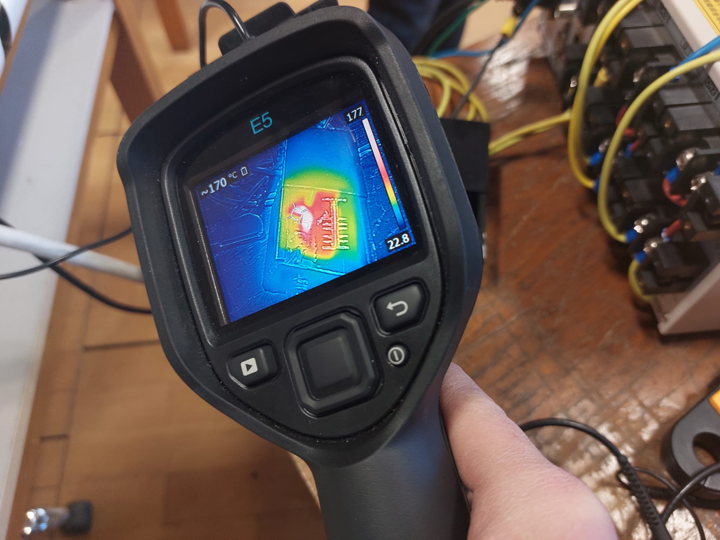

figure 3. Temperature of power connection lines of our PCB

**Conclusion**

In this term project, we experienced many challenges that an engineering working at power electronics experience frequently. We designed a DC Motor Drive, simulated it, chose components for it, and reckoned hardships we could encounter. In the process of putting our initial design, half controlled rectifier, encountered hardships we did not expect to encounter, therefore failed at this design. We failed to schedule our progress properly, and failed to implement our design. Later as we switched to a different design, we encountered even more troubles we did not foresee. Even after successfully implementing our design, the circuit observed some thermal problems we didn’t assumed we will observe. In the light of these occurrences, we learned valuable lessons as electrical and electronics engineers. We learned that in the process of designing power electronics, we could face problems and errors at any step, and assuming these will not occur and scheduling the progress as these will not occur may result in catastrophic.

In conclusion, we learned how to design a DC Motor Drive and choose proper components. We designed our own PCB and printed it on our own. We learned the importance of thermal calculations and adjusting PCB path width for the circuits’ performance. We also learned that assuming the best may fail the team, and assumption of possible failure at every step of the design will be the most certain way to design power electronics, first hand.

**References**

1. https://www.apogeeweb.net/tools/external-pcb-trace-max-current.html#:~:text=1.,can%20stand%20is%202.6amps.
2. https://www.4pcb.com/trace-width-calculator.html
3. https://www.energy-solutions.co.uk/technical-information