c) Vout,rms = 482.1

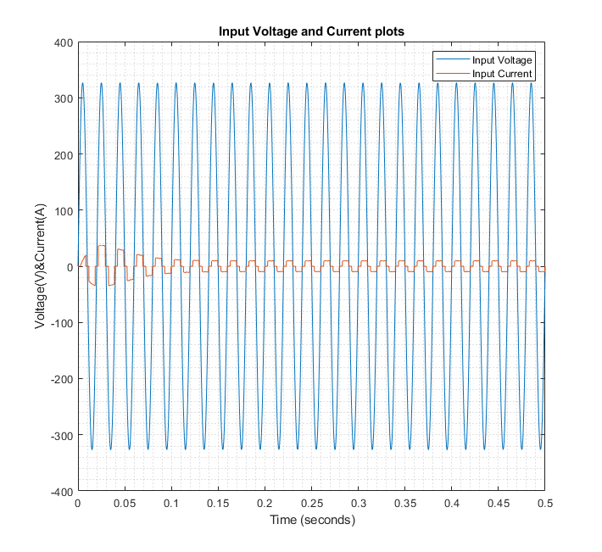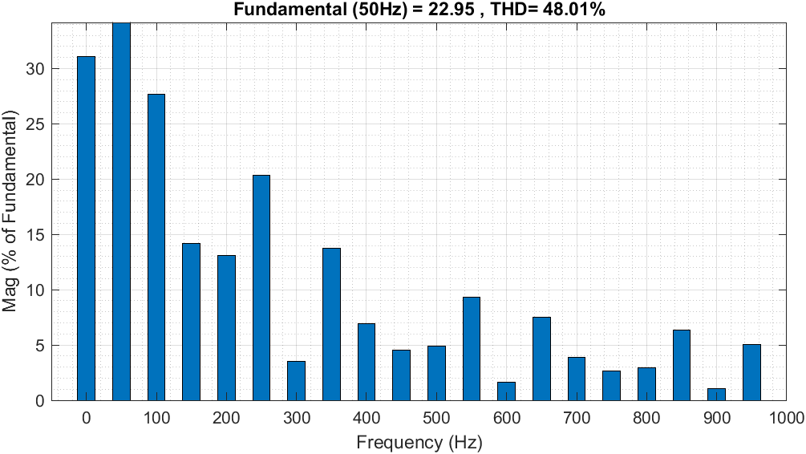

d)

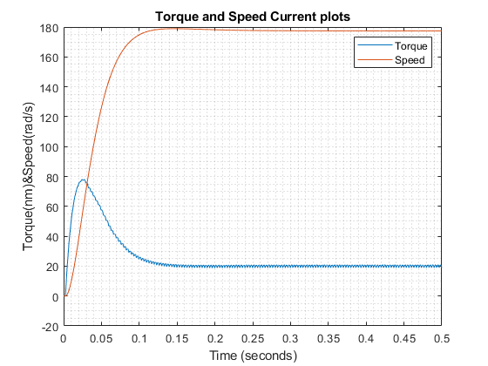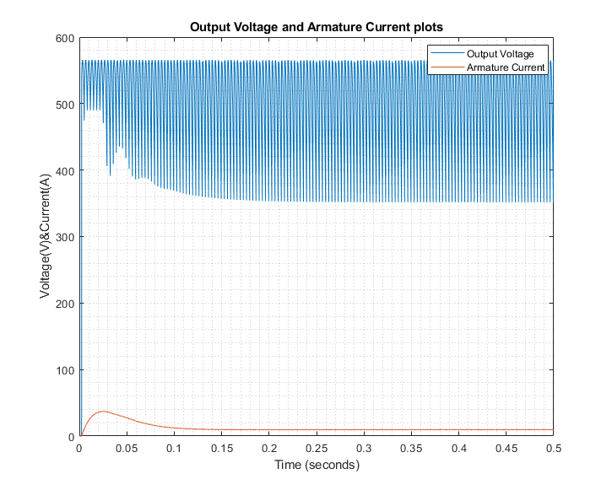

e)

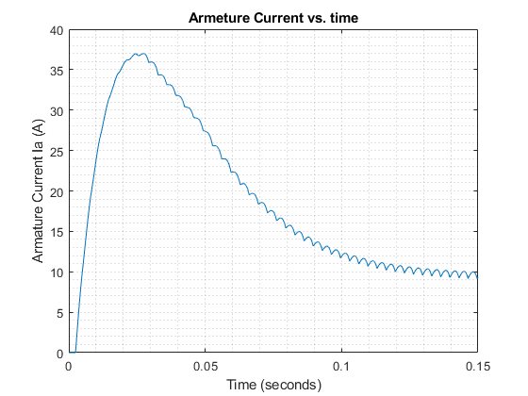

Figure 1. Transient part of armature current

After certain time (around 0.015 seconds for this setup) ripple in armature current becomes noticeable. Armature current is directly correlated with electrical torque this torque waveform will be like this as well. This will cause torque to be applied to change rapidly and this will negatively affect performance. This is caused by high voltage ripple on output of the rectifier. Because DC machine designed to work with DC voltage with no ripple our performance suffers because of that. In order to prevent that we can add capacitor with high impedance to the output voltage of rectifier. This will increase the firing angle so we must increase firing angle to compensate this.

Also From figure 1. we can see peak of armature current as 37 A. Current is higher than 30 A for approximately 0.3 seconds. High current can burn the cables and damage the system because of heat it produces. Also armature resistance is high (11.2 Ω) and this can cause significant losses.



f) If line inductance is 10 mH this will cause commutation. Output voltage loss per commutation Au = wLsId repeats itself every π/3 wt so Vout can be seen from formula 1.

metin içeren bir resim

Açıklama otomatik olarak oluşturuldu

formula 1

w = 100\*π, Ls = 10 mH, Vout = 500 V, Id can be seen from plot as approximately 9.5 A, Vll,rms = √3\* Vln,rms, Vln,rms = 230V

so formula becomes 500 = (3√6/π)\*230\*cos(a) – 3\*100\* π\*10-2 \*9.5/π

cos(a) = (500 + 3\*100\* π\*10-2 \*9.5/π)/(3√6/π\*230)

a = arccos((500 + 3\*100\* π\*10-2 \*9.5/π)/(3√6/π\*230))

a = 10.78°. So lower activation angle required to reach same voltage.

g) Vout,rms = 485 V. Vout is more than 3V bigger than in c. This may be caused by me taking the current as approximate value or error in Simulink plot. But difference is small.

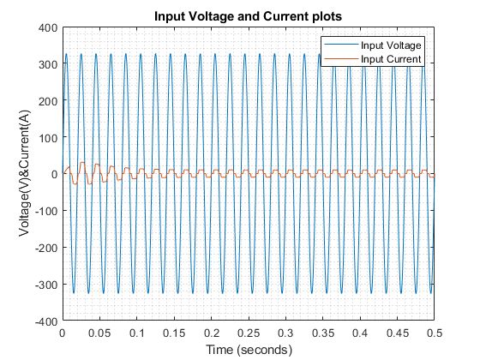

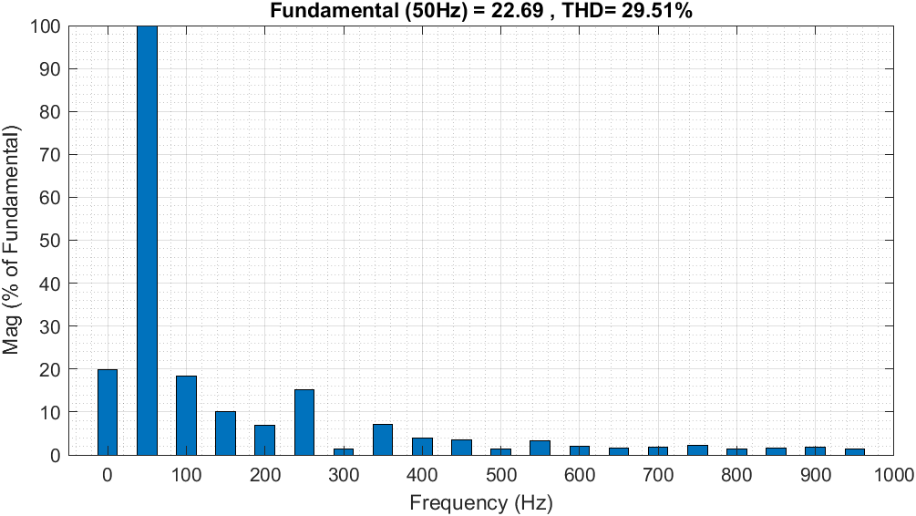

We can se input voltage waveform is same but current waveform have more round edges and more sinusoidal. We can see that from harmonic analysis as well. Without inductors THD was 48.01% with inductors it was 29.51%.

h) We can invert polarity of supplied voltage to reverse DC motors direction. But there is more practical way for non-permanent magnet DC motors. This is inverting polarity of field voltage. This will achieve same effect by inverting direction of magnetic field that will be applied to rotor. And it requires smaller switch gear because field current is smaller than armature current.