EE463

2021-2022 Fall Semester

Homework Assignment #4

### Özgür Arda Küçükaslan 2305050

### Mert Eren Kandilli 2304855

# Introduction

In this homework Step-Up and Step-Down DC/DC converters are investigated. Their CCM and DCM characteristics are examined with boundary conditions. In addition, ideal and realistic voltage gain are compared. In rush current and its solution methods are discussed and implemented.

# Part 1:

c)

For 15-3.3 V conversion, D=0.22 is required. To achieve boundary condition, current should be equal to:

When we substitute the values, we will have a current equal to 0.286 A. And we will this current value when we implied a resistive load equal to VO/IOL = 11.538 Ω.

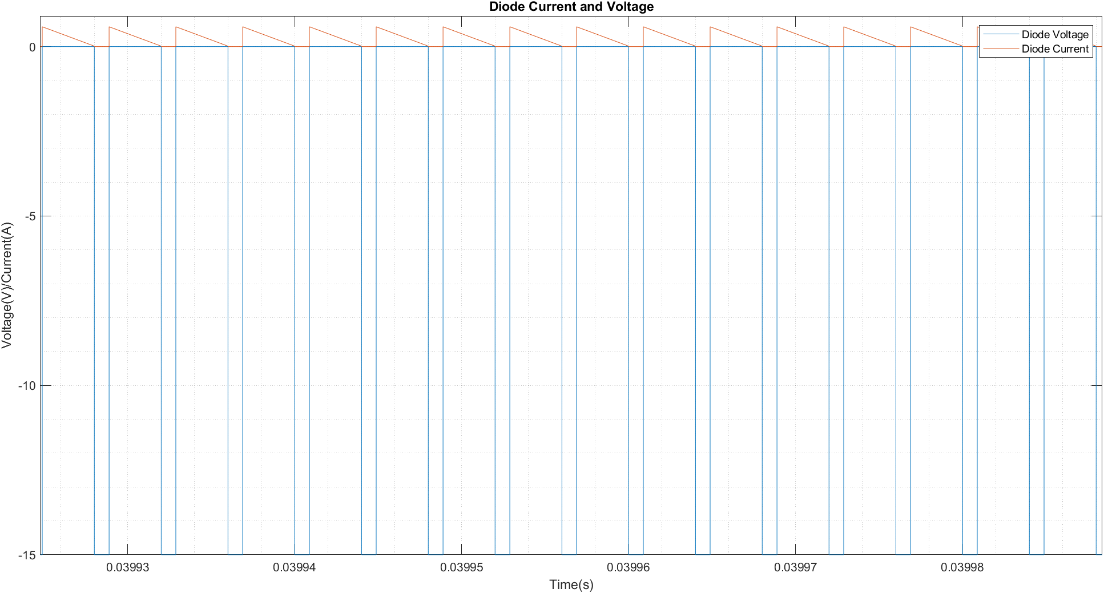

**Figure: Diode voltage and current**

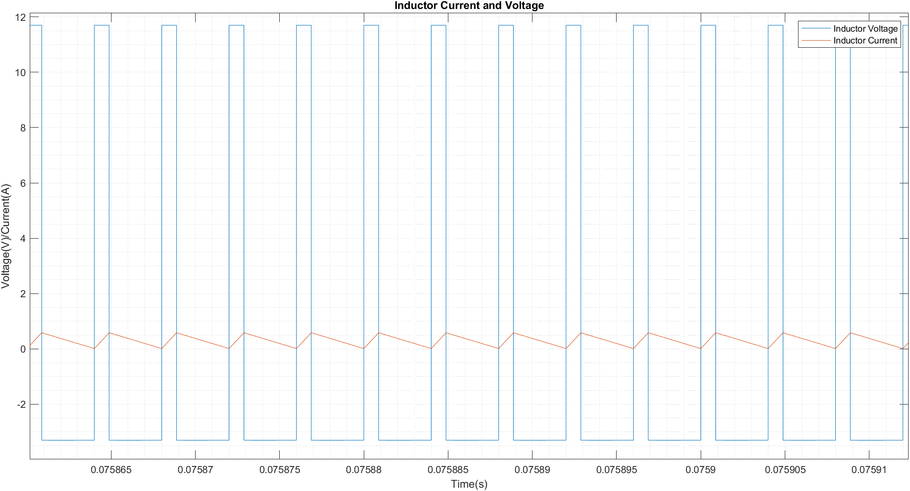

**Figure: Inductor Current and Voltage**

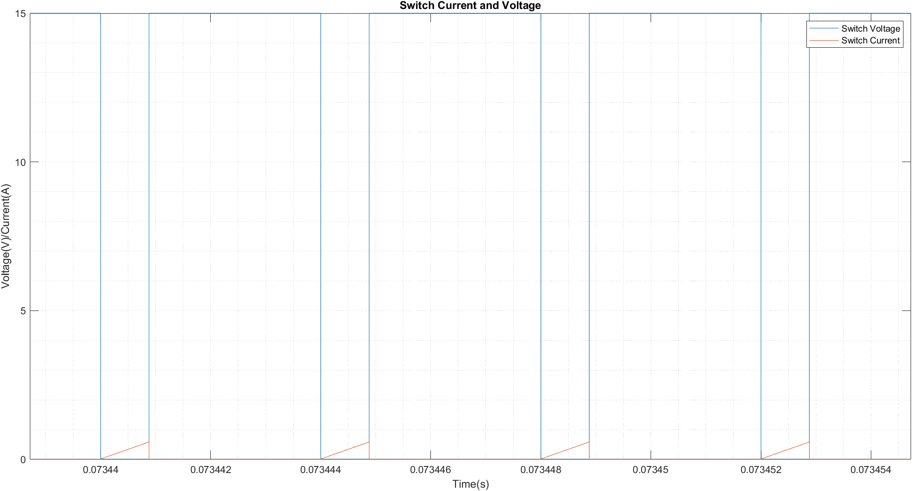

**Figure: Switch Voltage and Current**

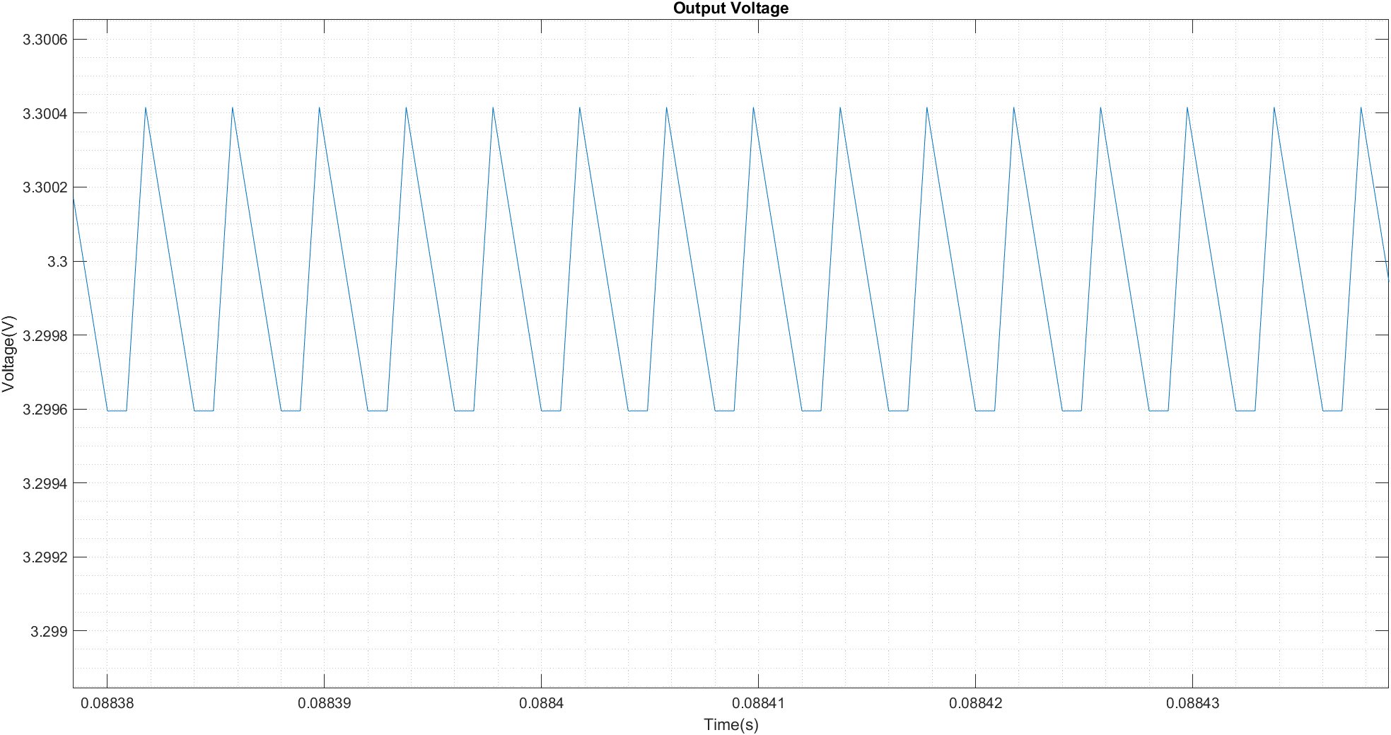

**Figure: Output Voltage**

In this part, we observed that the theoretical load resistance required for boundary condition did not generate a boundary condition, instead it caused DCM condition for a small percentage of the period. Instead, we applied a slightly smaller resistance which is equal to 11.05 Ω. We believe this error caused by the fact that the output voltage has some voltage ripple we did not account for theoretical calculation.

d)

For 12 V input and 5W output, we need D=0.275 and R=2.178 Ω.

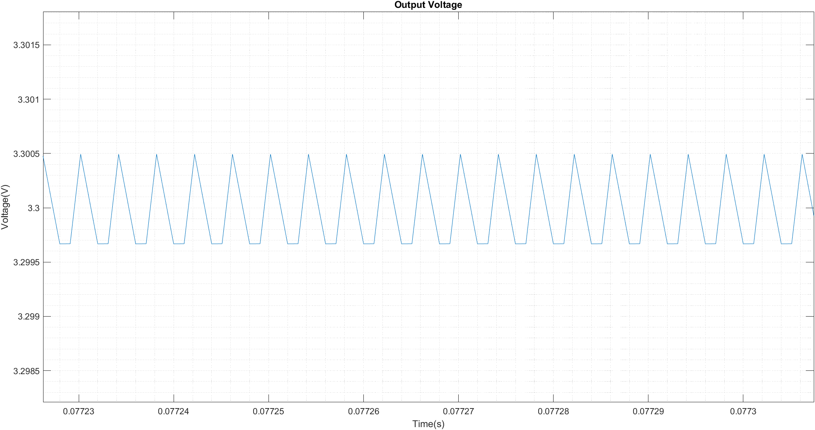

**Figure: Output Voltage**

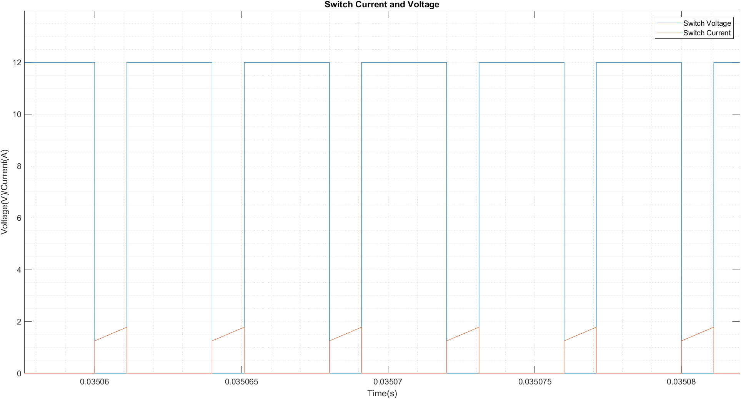

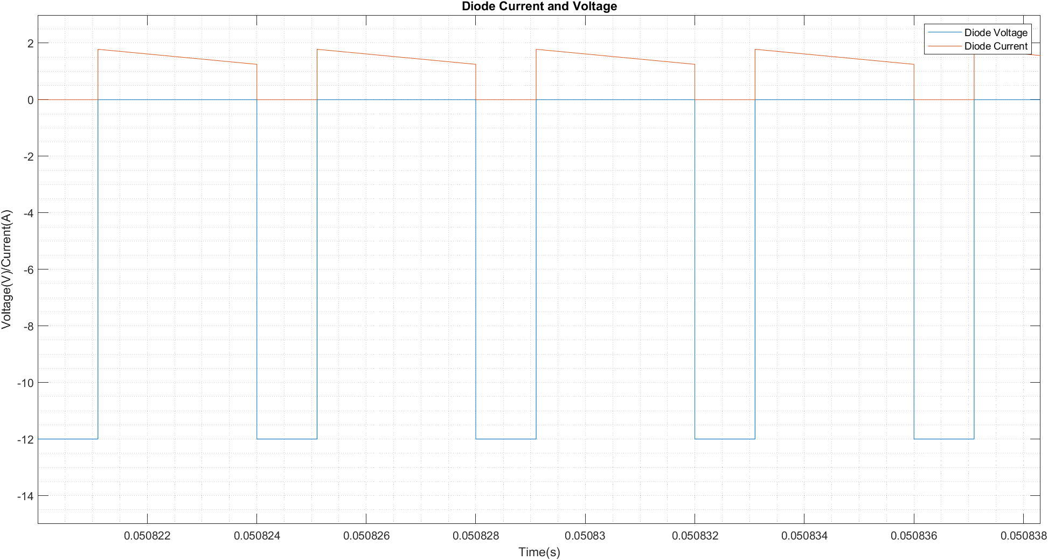

Figure: Diode Voltage and Current

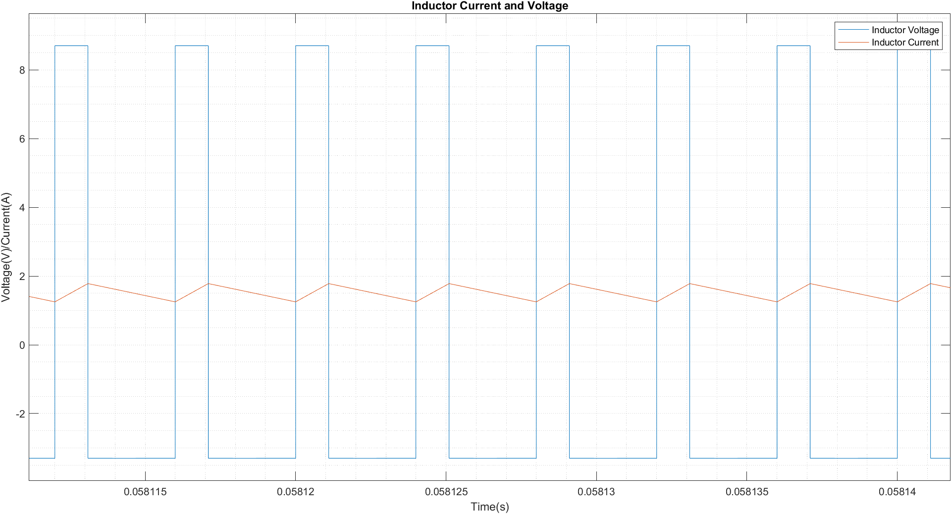

Figure: Inductor Voltage and Current

In this part we observed a CCM operation, since lower boundary current is equal to 0.266 A and load current is equal to 1.515 A which is greater. Also, the output voltage ripple and inductor current ripples are slightly decreased.

e)

For 6 V input and 0.33 W output, we need D = 0.55 and R=33 Ω. However, since lower boundary current is equal to 0.165 A, while load current is equal to 0.055 A which is significantly smaller, so the previously calculated duty cycle value will not be sufficient. The new duty cycle will be calculated from:

We calculated D = 0.428.

Figure: Inductor Voltage and Current

Figure : Output Voltage

Figure : Diode Current and Voltage

Figure: Switch Current and Voltage

As expected, the converter works in DCM operation range. We observed voltage drops on diode and switch during discontinuous period. We get an output voltage of approximately 3.23. We believe this is caused by a rounding error during calculating the new duty cycle for DCM.

f)

Inrush current is the transient current that occurs when a switch is closed, or a motor is started from inertia at rated voltage. To prevent it, inductors with appropriate sizes are applied to the circuit. In part e) inrush current is:

Figure: Inductor Voltage and Current

Which reaches a peak of 9.16 A. To decrease it, we can apply two solutions. First one is increasing the inductor size, however this solution might not be applicable since there are design and physical constraints for inductor sizing. The other one is applying a soft-start method to the converter. We can apply a manual or automated method. A manual method will be increasing duty cycle from a value lower than desired than increasing up to desired value. Automated one will be an implication of a closed loop controller that will control the duty cycle.

Figure: Inductor Current

I implemented a bigger inductance to the circuit. By increasing the inductance from 18 uH to 22 uH, I decreased the peak current to 8.25 A. However, the problem with this method is that we might require to modify other parameters such as duty cycle after changing the inductance.

g)

Figure: Output Voltage

The most significant change is observed with the output voltage. Since the average output is approximately same. However, ripple is significantly increased from 0.303% levels to 1.52% levels, which is around a 500% times increase.

To decrease the ESR of the capacitor, we can use several parallel identical capacitors instead of one capacitor, since we can achieve same total capacitance by parallel connecting several smaller capacitors, while decreasing equivalent resistance.

# Part 2:

a) We know the boundary inductor current for transition to DCM.

To find minimum inductance for CCM operation choose **D = 0.5**

**TS =**  is given

In order to get 24V output voltage at **D=0.5** input voltage should be

**Vin = 12V**

It is given that output power is 10W, then output current is

**Iout = = 0.417A**

to find input current

**Iout × (1-D) = Iin­ Iin = 0.834A = ILB**

Then minimum inductor current

**Lmin=7.2uH**

**b)**

Output ripple formula

For maximum ripple D=0.58 (choose V­in = 10V and Vout = 24V)

C = 4.9uF

**c)**

**Figure Boost Converter Circuit**

**Figure : Inductor Current and Voltage**

Since we are at the boundary of the DCM, inductor current touches zero. Therefore inductor voltage is square waveform as expected.

**Figure: Output Voltage**

**Figure : Diode Current and Voltage**

**Figure : Switch Voltage**

**Figure : Switch Current**

**d)**

**Figure : Circuit Diagram of Boost Converter When Switch is ON**

When switch is ON voltage on inductor VL=VD­ - IL×RL

**Figure : Circuit Diagram of Boost Converter When Switch is OFF**

When switch is OFF voltage on inductor VL=VD­-Vo- IL×RL

**Figure : Inductor Voltage Graph**

Then

*(1)*

*(2)*

Then substituting (2) into (1)

Then voltage gain is

*Where RL = 57mΩ and RLOAD = 12Ω (Rated Load Resistance)*

**Figure :Voltage Gain vs Duty Cycle**

e)

Output power POUT is then

**Figure : Efficiency vs Duty Cycle**

**f) For Capacitor**

Würth Elektronik 860020672008 Aluminum capacitor is chosen

**For Inductor**

PD0120.702NL is chosen

**For MOSFET**

FDMA7672 is chosen

RDS = 25mOhm Trr = 20ns ION = 3.5A

**Conduction Loss**

=

=

=

**Switching Loss**

**For Diode**

90SQ035 is chosen

VF = 0.5V ION = 3.5A

Since our diode is Schottky there is no switching loss

**Conduction Loss**

=

**Total Loss**

Any increase in duty cycle will cause more loss on both diode and switch. This makes sense because duty cycle basically represents the ON time of the circuit.

g) Total Power Loss on MOSFET is about 0.12W and loss on diode is about 0.66W. Since these losses are quite small, there is no need for heatsink.

# Conclusion:

In this homework assignment, we worked with both buck and boost converters. We inspected their boundary conditions, DCM and CCM characteristics and real-life engineering problems associated with them. We observed the result of ESR on the output of the converter, inrush current and its possible solutions, the problems that can occur with these solutions, and real design problems such as efficiency and heat. In conclusion, we are more familiar with these DC-DC converter topologies and their possible challenges.