Alperen TIR, 2149490

Arda SERTKAYA, 2293520

Gökhan ERDEN, 2220515

**ESTIMATION FOR NUMBER OF ARRIVALS TO TURKEY AND GREECE**

Tourism is very important revenue sources for Turkey and Greece. These two countries host millions of foreign visitors in a year. These countries are very suitable for vacations in terms of their climates, wide sea areas and natural beauties. Thanks to these features, people from other countries choose these two countries for vacation.

An investor wants to buy a hotel from one of these countries. He asked us to which one is more profitable. He wants to learn which country will grow in terms of number of arrivals in 2020.

In order to give him a reliable information, we decided to use estimation methods from python. We took data from ?. This data covers numbers of arrivals to Turkey and Greece between 2007 and 2019. In the figures below, you can see how this data’s line graphs look like.

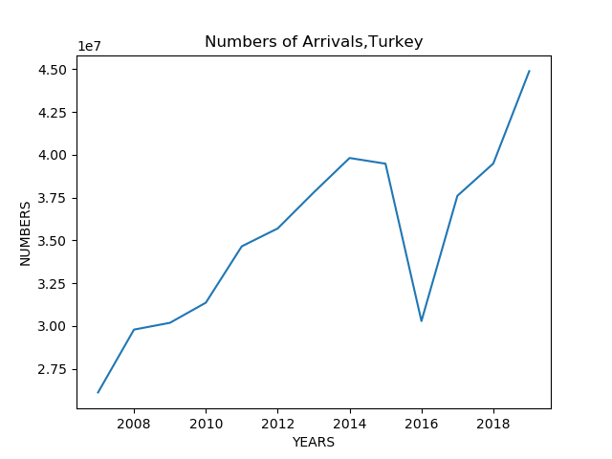

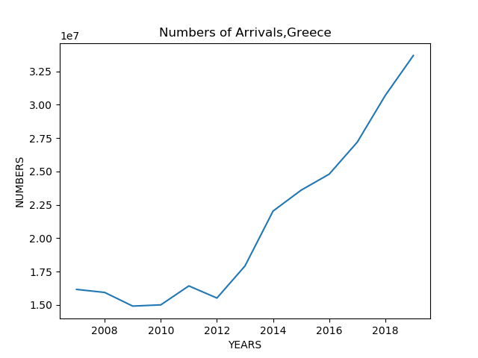

We used naive estimation, moving average method, simple exponential smoothing and holt estimation methods. Firstly, we estimated numbers of arrivals in 2019 by using all methods we determined. We compared results with real numbers. With this way, we chose best method. This method is Holt estimation. Results that we found by using Holt estimation were closer to real numbers. Then, we did estimation for 2020. The results are:

* For Turkey, estimated numbers of arrivals are 46,060,669 people.
* For Greece, estimated numbers of arrivals are 35,167,767 people.

After we found estimated numbers, we calculated growth rates for countries in terms of numbers of arrivals. Growth rates are:

* For Turkey, growth rate will be % 2.63.
* For Greece, growth rate will be % 4.38.

As a result of these results, we decided to recommend Greece. Growth rate for Greece in terms of numbers of arrivals will be higher than Turkey. Therefore, it is better to buy a hotel from Greece. Estimated numbers of arrivals for Turkey are higher, however demand in Greece will increase more than Turkey. Need for accommodation will increase.