Frequency control of a Single-Area Power System Using a PI Controller and Solar PV Generation in MATLAB/Simulink
MIHAI VLAD, PERRICK NOULA NBOUNGA, ARDA GUR DENIZ, DESTINY IMARIABE , ENZO DRAULI

Supervisor: Abdul Latif
Date: 01/12/2026

1. Introduction
The objective of this work is to model and simulate a single-area power system comprising a conventional generator and solar photovoltaic (PV) generation, and to investigate its frequency response to load and PV disturbances under proportional–integral (PI) control. The nominal frequency is 50 Hz. The model was built and simulated in MATLAB/Simulink 2026 as a linear, small-signal model in per-unit (pu) deviation variables. The controller was tuned analytically and validated by time-domain simulation.

2. Problem Description
Frequency deviation reflects the instantaneous mismatch between generation and demand. PV generation is inverter-interfaced and provides no rotational inertia, and its output varies with irradiance and cloud cover. It therefore acts as an additional disturbance alongside load variation, and a higher PV share lowers the effective inertia of the system.
The control goal is to maintain Δf ≈ 0 despite step variations of the load, ΔP_{L}, and of the PV output, ΔP_{PV}: the frequency must return to 50 Hz with a damped transient and zero steady-state error.

3. System Model and Parameters
The conventional generation chain and the generator–load dynamics are first-order transfer functions.
Governor:
G_{gov}(s) = 1/(0.2s + 1)
Turbine:
G_{tur}(s) = 1/(0.5s + 1)
Generator–load (swing equation), with H = 5 s and D = 1 pu:
G_{gen}(s) = 1/(2Hs + D)
2H = 2 × 5 = 10
G_{gen}(s) = 1/(10s + 1)
Droop gain, with R = 0.05 pu:
1/R = 1/0.05
1/R = 20
Power balance at the generator–load junction:
ΔP_{net} = ΔP_{m} + ΔP_{PV} − ΔP_{L}
Δf(s) = G_{gen}(s) · ΔP_{net}(s)
Parameter | Symbol | Value
Nominal frequency | f₀ | 50 Hz
Inertia constant | H | 5 s
Load damping | D | 1 pu
Droop | R | 0.05 pu (gain 1/R = 20)
Governor time constant | T_{g} | 0.2 s
Turbine time constant | T_{t} | 0.5 s
Generator–load time constant | 2H/D | 10 s
Simulation time | T_{sim} | 100 s

4. PI Controller Design and Analysis
A parallel-form continuous PI controller was used with K_{p} = 1 and K_{i} = 9.89387, obtained with pidtune(G_{ref}, 'PI') and validated qualitatively:
C(s) = K_{p} + K_{i}/s
C(s) = 1 + 9.89387/s
C(s) = (s + 9.89387)/s
A preliminary comparison on the reference-to-frequency response (Figure 1) showed a lower overshoot for the PI controller (0.55 %) than for the integral controller (1.32 %); both converge to the reference.
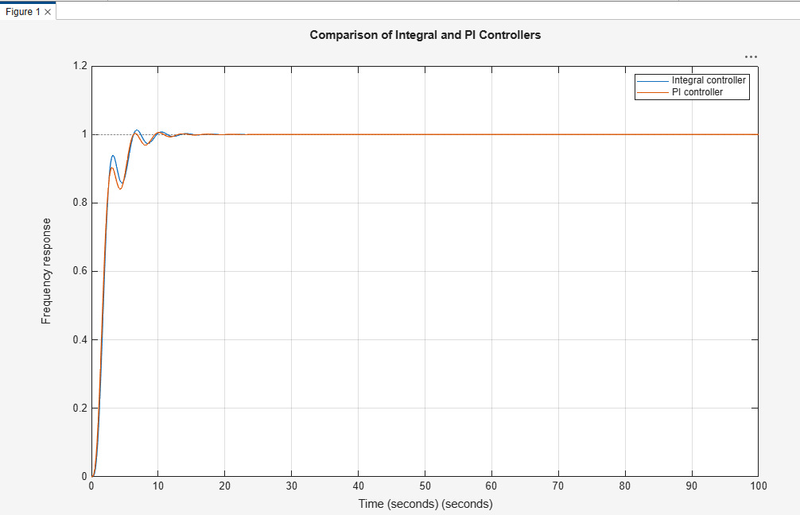
Figure 1 – Step response: integral controller vs. PI controller.

4.1 Closed-loop transfer function
Reference = 0 and net disturbance d = ΔP_{PV} − ΔP_{L}. Step 1 – governor input (PI action plus droop feedback):
u = −C(s)·Δf − 20·Δf
Step 2 – mechanical power:
ΔP_{m} = G_{gov}·G_{tur}·u
ΔP_{m} = −G_{gov}·G_{tur}·(C(s) + 20)·Δf
Step 3 – insert in the power balance:
Δf = G_{gen}·(ΔP_{m} + d)
Δf = G_{gen}·d − G_{gen}·G_{gov}·G_{tur}·(C(s) + 20)·Δf
Δf·[1 + G_{gen}·G_{gov}·G_{tur}·(C(s) + 20)] = G_{gen}·d
Δf/d = G_{gen} / [1 + G_{gen}·G_{gov}·G_{tur}·(C(s) + 20)]
Step 4 – numerical substitution:
C(s) + 20 = (s + 9.89387)/s + 20
C(s) + 20 = (21s + 9.89387)/s
(0.2s + 1)(0.5s + 1) = 0.1s² + 0.7s + 1
(10s + 1)(0.1s² + 0.7s + 1) = s³ + 7.1s² + 10.7s + 1
Multiplying numerator and denominator by s(10s + 1)(0.2s + 1)(0.5s + 1):
Δf/d = s(0.2s + 1)(0.5s + 1) / [ s(10s + 1)(0.2s + 1)(0.5s + 1) + 21s + 9.89387 ]
Numerator:
s(0.1s² + 0.7s + 1) = 0.1s³ + 0.7s² + s
Denominator:
s(s³ + 7.1s² + 10.7s + 1) + 21s + 9.89387
= s⁴ + 7.1s³ + 10.7s² + s + 21s + 9.89387
= s⁴ + 7.1s³ + 10.7s² + 22s + 9.89387
Result:
T(s) = Δf/d = (0.1s³ + 0.7s² + s) / (s⁴ + 7.1s³ + 10.7s² + 22s + 9.89387)

4.2 Stability (Routh array)
Row | Column 1 | Column 2 | Column 3
s⁴ | 1 | 10.7 | 9.89387
s³ | 7.1 | 22 | 0
s² | 7.601 | 9.89387 | 0
s¹ | 12.76 | 0 | 0
s⁰ | 9.89387 | 0 | 0

Row s²:
b₁ = (7.1 × 10.7 − 1 × 22) / 7.1
b₁ = (75.97 − 22) / 7.1
b₁ = 7.601
b₂ = (7.1 × 9.89387 − 1 × 0) / 7.1 = 9.89387
Row s¹:
c₁ = (7.601 × 22 − 7.1 × 9.89387) / 7.601
c₁ = (167.22 − 70.25) / 7.601
c₁ = 12.76
Row s⁰:
d₁ = 9.89387
All first-column entries (1; 7.1; 7.601; 12.76; 9.89387) are positive: no sign change, so the closed loop is stable.

4.3 Poles and damping
Roots of s⁴ + 7.1s³ + 10.7s² + 22s + 9.89387 = 0:
s₁ = −5.866
s₂ = −0.546
s_{3,4} = −0.344 ± j1.723
Dominant complex pair:
ω_{n} = √(0.344² + 1.723²)
ω_{n} = √3.087 = 1.757 rad/s
ζ = 0.344 / 1.757
ζ = 0.196
T_{d} = 2π / 1.723 = 3.6 s
The dominant pair is lightly damped (ζ = 0.196), which explains the oscillatory transient.

4.4 Steady-state error
With the PI controller, for a step d₀/s (final value theorem):
Δf(∞) = lim_{s→0} s · T(s) · (d₀/s)
Δf(∞) = T(0) · d₀
T(0) = 0 / 9.89387 = 0
Δf(∞) = 0
Droop only (no integral action):
Δf(∞) = d₀ / (D + 1/R)
Δf(∞) = 0.01 / (1 + 20)
Δf(∞) = 0.01 / 21 = 4.76 × 10⁻⁴ pu
Δf(∞) = 4.76 × 10⁻⁴ × 50 = 0.0238 Hz

5. MATLAB/Simulink Implementation
The signal path is: Reference (0) → error sum (reference − Δf) → PI → droop sum → governor → turbine → power-balance sum (+ + −) → generator–load → output Δf. The droop feedback (gain 20) is taken from Δf and subtracted at the droop sum. The PV step source is connected to the positive input and the load step source to the negative input of the power-balance sum. Δf is shown on a Scope and saved by a To Workspace block as the timeseries df_load.
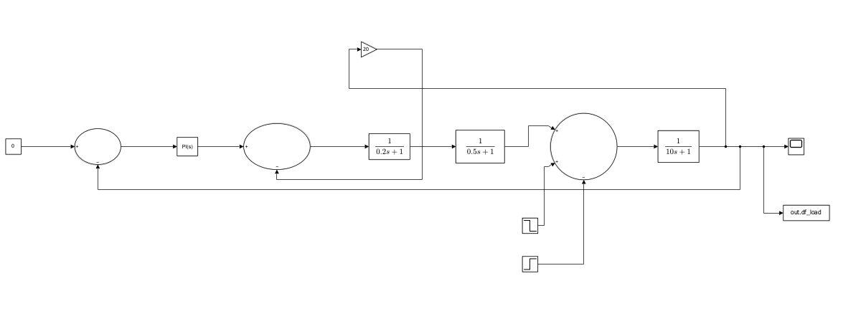
Figure 2 – Simulink block diagram of the single-area model.

6. Simulation Scenarios and Results
All scenarios use the same plant and controller (K_{p} = 1, K_{i} = 9.89387) over 100 s; disturbances are in pu and Δf is in pu (Δf in Hz = 50 × Δf in pu). Metrics were obtained by solving the closed-loop model T(s) of Section 4; the peak value agrees with the Scope axis (≈ 6.7×10⁻⁴ pu). A 2 % settling band equals 2 % of the first peak (1.35×10⁻⁵ pu).
Experiment | Step time | Initial → final | Signal | Equivalent net power
1 – Load increase | 1 s | 0 → +0.01 pu | ΔP_{L} | d = −0.01 pu
2 – Load decrease | 1 s | 0 → −0.01 pu | ΔP_{L} | d = +0.01 pu
3 – PV increase | 1 s | 0 → +0.01 pu | ΔP_{PV} | d = +0.01 pu
4 – PV fluctuation | 1 s and 20 s | +0.01 at 1 s; −0.01 at 20 s | ΔP_{PV} | d = +0.01, then −0.01 pu

6.1 Experiment 1 – Load increase. The deficit of 0.01 pu produces an initial negative deviation: peak Δf = −6.76×10⁻⁴ pu (−0.0338 Hz) at t = 2.06 s, followed by a positive overshoot of +1.64×10⁻⁴ pu (+0.0082 Hz) at t = 4.02 s. The oscillation decays and Δf enters the 2 % band at t = 11.70 s (10.7 s after the step), returning to 0 (50 Hz) with no steady-state error.
Calculation (Experiment 1). Net disturbance:
d = ΔP_{PV} − ΔP_{L} = 0 − 0.01 = −0.01 pu
Peak (from the numerical response of T(s)):
Δf_{peak} = −6.757 × 10⁻⁴ pu at t = 2.06 s
t_{peak} − t_{step} = 2.06 − 1 = 1.06 s
Δf_{peak} = −6.757 × 10⁻⁴ × 50 = −0.0338 Hz
Opposite peak:
Δf₂ = +1.640 × 10⁻⁴ pu at t = 4.02 s
Δf₂ = 1.640 × 10⁻⁴ × 50 = +0.0082 Hz
2 % settling band and time:
0.02 × 6.757 × 10⁻⁴ = 1.35 × 10⁻⁵ pu
|Δf| < 1.35 × 10⁻⁵ pu for t ≥ 11.70 s
t_{s} = 11.70 − 1 = 10.7 s
6.2 Experiment 2 – Load decrease. The surplus of 0.01 pu produces the mirror response: peak Δf = +6.76×10⁻⁴ pu (+0.0338 Hz) at t = 2.06 s, then −1.64×10⁻⁴ pu (−0.0082 Hz) at t = 4.02 s; 2 % settling at t = 11.70 s; Δf(∞) = 0.
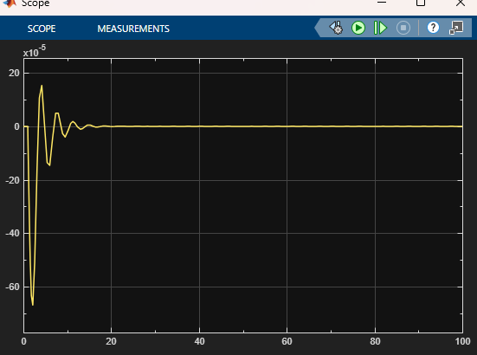  Figure 3 – Exp. 1: load increase (+0.01 pu at t = 1 s). | 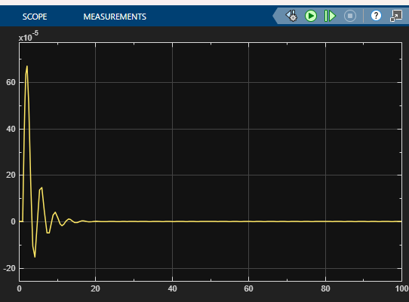  Figure 4 – Exp. 2: load decrease (−0.01 pu at t = 1 s).

6.3 Experiment 3 – PV increase. A PV step of +0.01 pu is equivalent to Experiment 2 (same d, same T(s)): peak Δf = +6.76×10⁻⁴ pu (+0.0338 Hz) at t = 2.06 s, undershoot −1.64×10⁻⁴ pu at t = 4.02 s, 2 % settling at t = 11.70 s, Δf(∞) = 0.
6.4 Experiment 4 – PV fluctuation. The first step (t = 1 s) gives the response of Experiment 3. At t = 20 s the residual deviation is 4.3×10⁻⁷ pu (0.06 % of the first peak), so the system is settled and the second step (−0.01 pu) acts by superposition: peak Δf = −6.75×10⁻⁴ pu (−0.0338 Hz) at t = 21.06 s, followed by a positive overshoot of the same magnitude as in Experiment 1, and a return to 0 within the same settling time.
Calculation (Experiment 4, second step). Residual deviation at t = 20 s relative to the first peak:
4.3 × 10⁻⁷ / 6.757 × 10⁻⁴ = 0.064 %
The system is settled, so the second step (−0.01 pu) acts by superposition:
Δf_{peak,2} = −6.75 × 10⁻⁴ pu at t = 21.06 s
Δf_{peak,2} = −6.75 × 10⁻⁴ × 50 = −0.0338 Hz
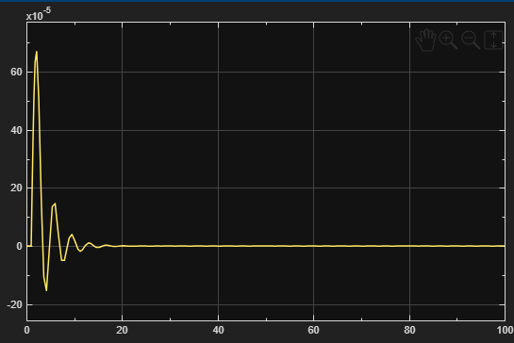  Figure 5 – Exp. 3: PV increase (+0.01 pu at t = 1 s). | 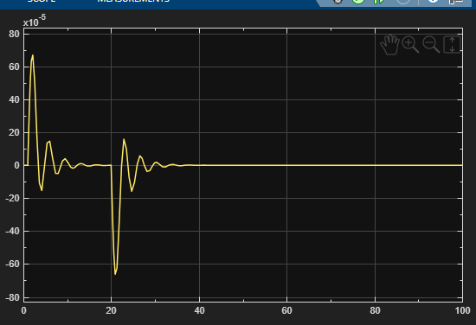  Figure 6 – Exp. 4: PV fluctuation (+0.01 pu at 1 s, −0.01 pu at 20 s).

Experiment | Peak Δf (pu) | Peak Δf (Hz) | Opposite peak (pu) | Settling 2 % (s after step)
1 – Load +0.01 | −6.76×10⁻⁴ | −0.0338 | +1.64×10⁻⁴ | 10.7
2 – Load −0.01 | +6.76×10⁻⁴ | +0.0338 | −1.64×10⁻⁴ | 10.7
3 – PV +0.01 | +6.76×10⁻⁴ | +0.0338 | −1.64×10⁻⁴ | 10.7
4 – PV +0.01 / −0.01 | +6.76×10⁻⁴ ; −6.75×10⁻⁴ | +0.0338 ; −0.0338 | −1.64×10⁻⁴ ; +1.64×10⁻⁴ | 10.7 (each step)
Table 2 – Summary of metrics. Values to be confirmed against df_load.

7. Discussion
A load increase (net deficit, d < 0) produces an initial frequency drop, whereas a PV increase (net surplus, d > 0) produces an initial rise: load and PV disturbances of the same sign yield deviations of opposite sign. A load decrease and a PV increase of equal magnitude are equivalent for the power balance and give identical responses (Figures 4 and 5). The PI controller eliminates the steady-state error in all cases (Δf(∞) = 0, compared with 4.76×10⁻⁴ pu for droop alone). The damping is the same in all scenarios (ζ = 0.196, same peak, overshoot and settling time) because the model is linear and the disturbance magnitude is constant. Experiment 5 (combined disturbance) was excluded due to unresolved signal routing verification.
The behaviour is physically correct: a generation shortfall lowers the frequency and a surplus raises it; the oscillation results from the governor–turbine lag interacting with the system inertia; the droop limits the initial deviation and the integral action restores 50 Hz. The peak deviation of 0.0338 Hz for a 1 % power imbalance is small, consistent with the stiff 1/R = 20 droop. The conclusions hold for small-signal disturbances of the tested magnitude.

8. Conclusion
The model correctly demonstrates primary frequency control with a PI controller and droop under load and PV disturbances. The closed loop is stable (Routh criterion), the frequency returns to the nominal 50 Hz in all tested scenarios with damped transients (peak 0.0338 Hz, settling ≈ 10.7 s) and no steady-state error. The objectives were met.

9. References
Das, D.C., Sinha, N., Roy, A.K. (2014). Automatic Generation Control of an Organic Rankine Cycle Solar–Thermal/Wind–Diesel Hybrid Energy System. Energy Technology, 2, 721–731. DOI: 10.1002/ente.201402024

