A Word document

2021-03-21

## Table of content

1.1. Table of content 1

1.2. Machin 2

1.3. Machine 3

1.4. Machin machine 4

1.5. List of figures 4

1.6. List of tables 4

## Machin

Lorem ipsum dolor sit amet, consectetur adipiscing elit. Nulla eu pulvinar arcu, quis aliquam dui. In at cursus ante. Curabitur ligula quam, iaculis faucibus orci quis, vestibulum lobortis lectus. Suspendisse fringilla nisl pulvinar, laoreet tellus sed, sollicitudin tortor. Curabitur ligula quam, iaculis faucibus orci quis, vestibulum lobortis lectus. Suspendisse fringilla nisl pulvinar, laoreet tellus sed, sollicitudin tortor.

Lorem ipsum dolor sit amet, consectetur adipiscing elit. Nulla eu pulvinar arcu, quis aliquam dui. In at cursus ante. Vestibulum non sagittis lacus. Duis vitae iaculis dui.

Suspendisse fringilla nisl pulvinar, laoreet tellus sed, sollicitudin tortor.

Table 1: cars

| speed | dist |
| --- | --- |
| 4 | 2 |
| 4 | 10 |
| 7 | 4 |
| 7 | 22 |
| 8 | 16 |
| 9 | 10 |

Lorem ipsum dolor sit amet, consectetur adipiscing elit. Nulla eu pulvinar arcu, quis aliquam dui. In at cursus ante. Vestibulum non sagittis lacus. Duis vitae iaculis dui.

Vivamus tempor, nibh ut pretium tempus, enim lorem dignissim quam, at euismod massa magna at magna.

## Machine

Table 2: caption 1

| mpg | cyl | disp | hp | drat | wt | qsec | vs | am | gear | carb |
| --- | --- | --- | --- | --- | --- | --- | --- | --- | --- | --- |
| 21.0 | 6 | 160.0 | 110 | 3.90 | 2.620 | 16.46 | 0 | 1 | 4 | 4 |
| 21.0 | 6 | 160.0 | 110 | 3.90 | 2.875 | 17.02 | 0 | 1 | 4 | 4 |
| 22.8 | 4 | 108.0 | 93 | 3.85 | 2.320 | 18.61 | 1 | 1 | 4 | 1 |
| 21.4 | 6 | 258.0 | 110 | 3.08 | 3.215 | 19.44 | 1 | 0 | 3 | 1 |
| 18.7 | 8 | 360.0 | 175 | 3.15 | 3.440 | 17.02 | 0 | 0 | 3 | 2 |
| 18.1 | 6 | 225.0 | 105 | 2.76 | 3.460 | 20.22 | 1 | 0 | 3 | 1 |
| 14.3 | 8 | 360.0 | 245 | 3.21 | 3.570 | 15.84 | 0 | 0 | 3 | 4 |
| 24.4 | 4 | 146.7 | 62 | 3.69 | 3.190 | 20.00 | 1 | 0 | 4 | 2 |
| 22.8 | 4 | 140.8 | 95 | 3.92 | 3.150 | 22.90 | 1 | 0 | 4 | 2 |
| 19.2 | 6 | 167.6 | 123 | 3.92 | 3.440 | 18.30 | 1 | 0 | 4 | 4 |
| 17.8 | 6 | 167.6 | 123 | 3.92 | 3.440 | 18.90 | 1 | 0 | 4 | 4 |
| 16.4 | 8 | 275.8 | 180 | 3.07 | 4.070 | 17.40 | 0 | 0 | 3 | 3 |
| 17.3 | 8 | 275.8 | 180 | 3.07 | 3.730 | 17.60 | 0 | 0 | 3 | 3 |
| 15.2 | 8 | 275.8 | 180 | 3.07 | 3.780 | 18.00 | 0 | 0 | 3 | 3 |
| 10.4 | 8 | 472.0 | 205 | 2.93 | 5.250 | 17.98 | 0 | 0 | 3 | 4 |

## Machin machine

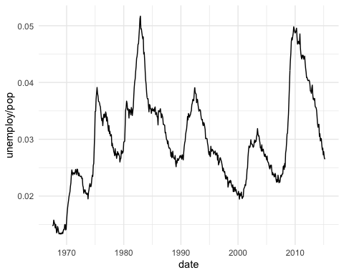

Figure 1: A boxplot

## List of figures

Figure 1: A boxplot 4

## List of tables

Table 1: cars 2

Table 2: caption 1 3