# My ggplot

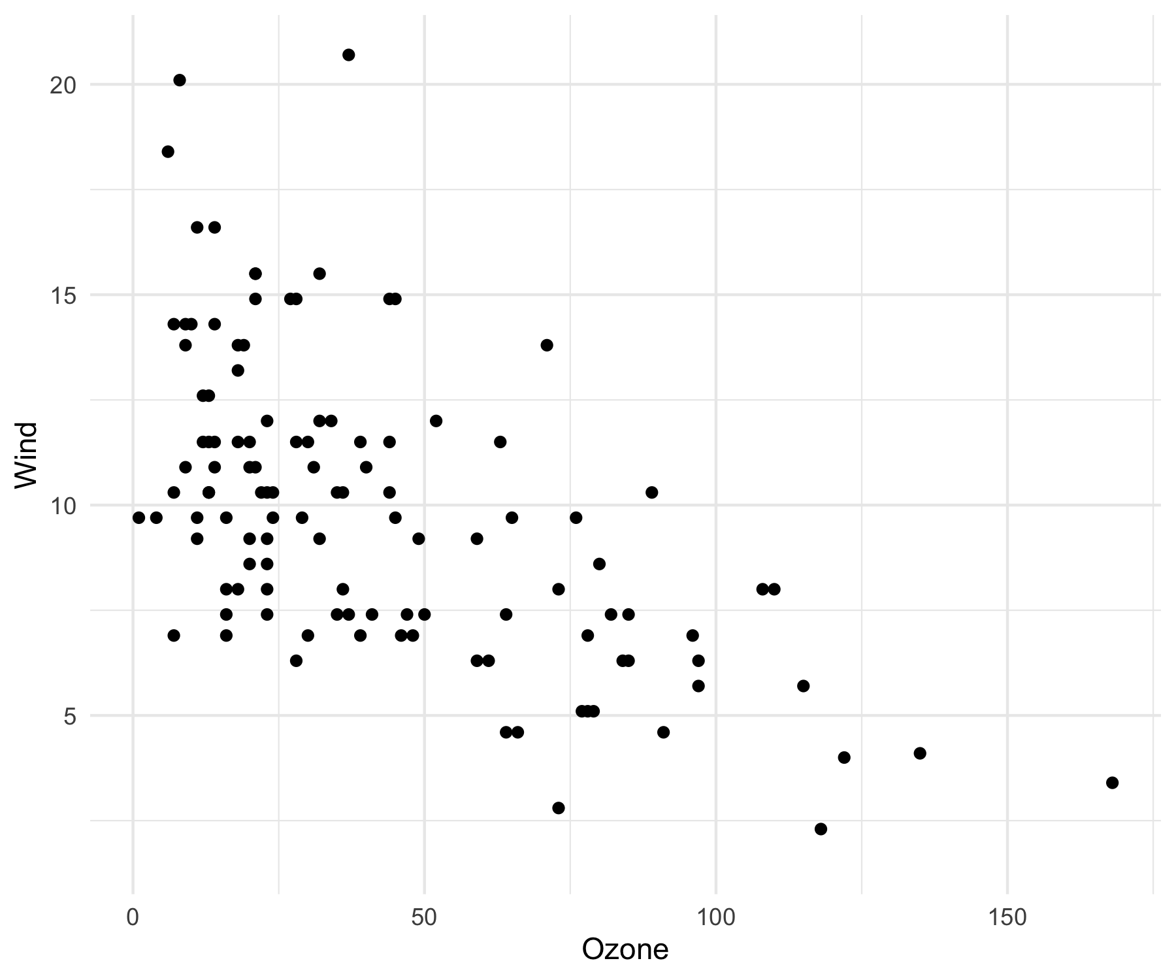

Hello Why R?

# My flextable

| **Ozone** | **Solar.R** | **Wind** | **Temp** | **Month** | **Day** |
| --- | --- | --- | --- | --- | --- |
| 41 | 190 | 7.4 | 67 | 5 | 1 |
| 36 | 118 | 8.0 | 72 | 5 | 2 |
| 12 | 149 | 12.6 | 74 | 5 | 3 |
| 18 | 313 | 11.5 | 62 | 5 | 4 |
| <na> | <na> | 14.3 | 56 | 5 | 5 |
| 28 | <na> | 14.9 | 66 | 5 | 6 |
| 23 | 299 | 8.6 | 65 | 5 | 7 |
| 19 | 99 | 13.8 | 59 | 5 | 8 |
| 8 | 19 | 20.1 | 61 | 5 | 9 |
| <na> | 194 | 8.6 | 69 | 5 | 10 |
| 7 | <na> | 6.9 | 74 | 5 | 11 |