officedown template

David

2021-03-18

This document presents most of the features of the package **officedown**.

## Table of content

## List of figures

## List of tables

## Sections

### A two columns section

Lorem ipsum dolor sit amet, consectetur adipiscing elit. Nulla eu pulvinar arcu, quis aliquam dui. In at cursus ante. Vestibulum non sagittis lacus. Duis vitae iaculis dui. Vivamus tempor, nibh ut pretium tempus, enim lorem dignissim quam, at euismod massa magna at magna. Sed facilisis dapibus diam nec volutpat. Maecenas facilisis dapibus egestas. Curabitur dignissim pharetra pulvinar. Nunc bibendum elit sed cursus congue.

Curabitur ligula quam, iaculis faucibus orci quis, vestibulum lobortis lectus. Suspendisse fringilla nisl pulvinar, laoreet tellus sed, sollicitudin tortor. Donec consequat congue erat in iaculis. Curabitur luctus tellus ut turpis iaculis, nec laoreet ligula scelerisque.

### End of two columns section

Lorem ipsum dolor sit amet, consectetur adipiscing elit. Nulla eu pulvinar arcu, quis aliquam dui. In at cursus ante. Vestibulum non sagittis lacus. Duis vitae iaculis dui. Vivamus tempor, nibh ut pretium tempus, enim lorem dignissim quam, at euismod massa magna at magna.

### Landscape section

Lorem ipsum dolor sit amet, consectetur adipiscing elit. Nulla eu pulvinar arcu, quis aliquam dui. In at cursus ante. Vestibulum non sagittis lacus. Duis vitae iaculis dui. Vivamus tempor, nibh ut pretium tempus, enim lorem dignissim quam, at euismod massa magna at magna. Sed facilisis dapibus diam nec volutpat.

Table : caption 1

| **Characters** | **Speed** | | | | **Accel** | **Weight** | **Handling** | | | | **Traction** | **M-turbo** |
| --- | --- | --- | --- | --- | --- | --- | --- | --- | --- | --- | --- | --- |
| **Land** | **Anti-G** | **Water** | **Gliding** | **Land** | **Anti-G** | **Water** | **Gliding** |
| **Baby Peach** | 2.2 | 2.0 | 2.5 | 2.8 | 4.0 | 2.0 | 5.0 | 5.0 | 4.5 | 5.0 | 4.2 | 4.0 |
| **Baby Rosalina** | 2.2 | 2.0 | 2.5 | 2.8 | 4.2 | 2.0 | 4.8 | 4.8 | 4.2 | 4.8 | 3.8 | 4.0 |
| **Baby Mario** | 2.5 | 2.2 | 2.8 | 3.0 | 4.2 | 2.2 | 4.5 | 4.5 | 4.0 | 4.5 | 4.0 | 3.8 |
| **Toadette** | 2.8 | 2.5 | 3.0 | 3.2 | 4.2 | 2.5 | 4.2 | 4.2 | 3.8 | 4.2 | 3.5 | 3.8 |
| **Koopa Troopa** | 2.8 | 2.5 | 3.0 | 3.2 | 4.0 | 2.5 | 4.5 | 4.5 | 4.0 | 4.5 | 4.2 | 3.8 |
| **Toad** | 3.0 | 2.8 | 3.2 | 3.5 | 4.0 | 2.8 | 4.2 | 4.2 | 3.8 | 4.2 | 4.0 | 3.5 |
| **Cat Peach** | 3.2 | 3.0 | 3.5 | 3.8 | 4.0 | 2.8 | 4.0 | 4.0 | 3.5 | 4.0 | 3.8 | 3.5 |
| **Peach** | 3.5 | 3.2 | 3.8 | 4.0 | 3.8 | 3.0 | 3.8 | 3.8 | 3.2 | 3.8 | 3.8 | 3.5 |
| **Tanooki Mario** | 3.5 | 3.2 | 3.8 | 4.0 | 3.8 | 3.2 | 3.8 | 3.8 | 3.2 | 3.8 | 3.2 | 3.5 |
| **Mario** | 3.8 | 3.5 | 4.0 | 4.2 | 3.5 | 3.5 | 3.5 | 3.5 | 3.0 | 3.5 | 3.5 | 3.2 |
| **Luigi** | 3.8 | 3.5 | 4.0 | 4.2 | 3.5 | 3.5 | 3.8 | 3.8 | 3.2 | 3.8 | 3.2 | 3.2 |
| **Rosalina** | 4.0 | 3.8 | 4.2 | 4.5 | 3.2 | 3.8 | 3.2 | 3.2 | 2.8 | 3.2 | 3.8 | 3.2 |
| **Metal Mario** | 4.2 | 4.0 | 4.5 | 4.8 | 3.2 | 4.5 | 3.2 | 3.2 | 2.8 | 3.2 | 3.2 | 3.0 |
| **Waluigi** | 4.5 | 4.2 | 4.8 | 5.0 | 3.2 | 4.0 | 3.0 | 3.0 | 2.5 | 3.0 | 3.0 | 3.0 |
| **Wario** | 4.8 | 4.5 | 5.0 | 5.2 | 3.0 | 4.2 | 2.8 | 2.8 | 2.2 | 2.8 | 3.2 | 2.8 |
| **Bowser** | 4.8 | 4.5 | 5.0 | 5.2 | 3.0 | 4.5 | 2.5 | 2.5 | 2.0 | 2.5 | 3.0 | 2.8 |

### Normal section

Lorem ipsum dolor sit amet, consectetur adipiscing elit. Nulla eu pulvinar arcu, quis aliquam dui. In at cursus ante. Vestibulum non sagittis lacus.

Lorem ipsum dolor sit amet, consectetur adipiscing elit. Nulla eu pulvinar arcu, quis aliquam dui. In at cursus ante. Vestibulum non sagittis lacus. Duis vitae iaculis dui. Vivamus tempor, nibh ut pretium tempus, enim lorem dignissim quam, at euismod massa magna at magna.

## Tables

### Table 1

### Table 2

Table : iris

| Sepal.Length | Sepal.Width | Petal.Length | Petal.Width | Species |
| --- | --- | --- | --- | --- |
| 5.1 | 3.5 | 1.4 | 0.2 | setosa |
| 4.9 | 3.0 | 1.4 | 0.2 | setosa |
| 4.7 | 3.2 | 1.3 | 0.2 | setosa |
| 4.6 | 3.1 | 1.5 | 0.2 | setosa |
| 5.0 | 3.6 | 1.4 | 0.2 | setosa |
| 5.4 | 3.9 | 1.7 | 0.4 | setosa |

### Table 3

Table : cars

| speed | dist |
| --- | --- |
| 4 | 2 |
| 4 | 10 |
| 7 | 4 |
| 7 | 22 |
| 8 | 16 |
| 9 | 10 |

## figures

### A boxplot

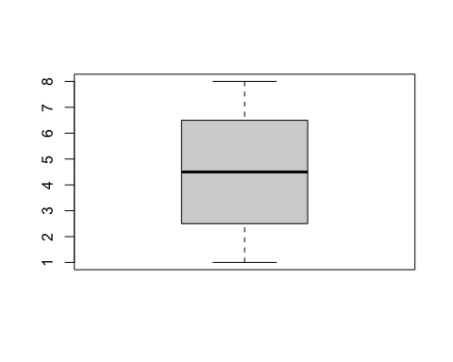

Figure : A boxplot

### Another ggplot

## Warning: Removed 37 rows containing missing values (geom_point).

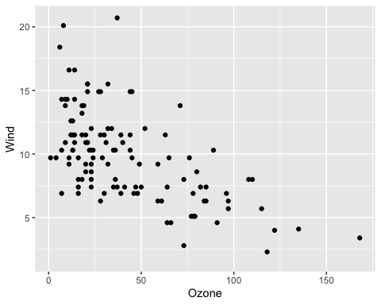

## Lists

Amet nunc eros curabitur tellus massa, eros maximus porttitor sociosqu, pellentesque.

* Erat mauris egestas finibus tincidunt sed in rhoncus a tellus etiam.
  + A adipiscing per ultricies justo tellus lorem.
    - Imperdiet ut dui primis, sed gravida, at sed nulla.
    - Sem posuere lacus consequat inceptos dapibus duis malesuada finibus.
  + Urna sed dui, ornare, eu turpis mus pellentesque amet amet bibendum.
* Himenaeos tincidunt, auctor dapibus scelerisque, montes nunc faucibus
* Erat mauris egestas finibus tincidunt sed in rhoncus a tellus etiam.
  + A adipiscing per ultricies justo tellus lorem.
    - Imperdiet ut dui primis, sed gravida, at sed nulla.
    - Sem posuere lacus consequat inceptos dapibus duis malesuada finibus.
  + Urna sed dui, ornare, eu turpis mus pellentesque amet amet bibendum.
* Himenaeos tincidunt, auctor dapibus scelerisque, montes nunc faucibus

## Reference

see figure .

see table

this is a link to mario