Bilkent University

Department of Computer Engineering

CS 319

Object Oriented Software Engineering

Final Report

Space Invaders

Group10 Members:

Ayşe Öykü Özer

Turgay Arda Usman

Yonca Yunatcı

Table of Contents

**1. Changes in the Implementation3**

**2. Status of the Project4**

**3. User's Guide4**

3.1. System Requirements.................................................................................4

3.2. Installations.................................................................................................4

3.3. Overview of the Game................................................................................5

3.3.1. Objects...............................................................................................6

3.3.2. Controller............................................................................................6

3.3.3. Game Screenshots & Menus.............................................................6

1. **Changes in the Implementation**
   1. Commons Interface added

Some final values which are common for all classes construct an interface implemented by other classes.

* 1. Sprite class added

This class adjusts the visibility of the objects that might appear on the screen.

* 1. MenuManager is replaced with GraphicsManager

All menu objects and MenuManager class is emerged into one class GraphicsManager. Only InterLeveMenu class is separated from this GraphicsManager class since it not also displays the objects but also gets input from the user to update the power-ups.

* 1. The images of the aliens and the player have been changed.
  2. ObjectManager and GameObject classes are removed.
  3. An enumerated type "BoardState" is added which has two types: WIN or LOSE.
  4. PowerUpManager is removed.

Since the input is immediately processed in InterLevelMenu class, there is no need for such class.

* 1. SoundManager is added.
  2. Collisions are handled in the Board class.
  3. MainManager is removed. Objects now communicate directly with the necessary manager object in order to satisfy the performance requirements.

1. **Status of the Project**

Space Invaders satisfies both functional and non-functional requirements.

1. **User's Guide**

**3.1. System Requirements:**

The Standard Java Runtime Environment (JRE) must be installed before installing the game. To download: <http://java.sun.com/>

Minimum system requirements:

·        Windows 2000/XP

·        Pentium2 233 MHz CPU or higher.

·        128 MB of RAM or higher.

·        Screen resolution: 800*600.

·        Integrated graphics card

Recommended system requirements:

·        Intel i5 2 MHz or equivalent processor.

·        512 MB of RAM or higher.

·        Screen resolution: 1024*768.

·        SoundBlaster compatible sound card.

**3.2. Installations:**

Unzip the alien.zip to a directory on your computer and to run the game you have 2 choices.

1) Run the alien.jar to execute the game (which it is recommended)

2) If you have knowledge of java programming, by running our code in java and can play the game.

**3.3. Overview of the Game:**

When the user starts the game from the main menu, there are two main objects: a block of aliens and the spaceship. In the game user can control the spaceship and tries to eliminate the whole block of aliens by the laser gun. If it hits an alien, the closer one gets destroyed. On the other hand, alien block also bombs the spaceship. Player begins the game with just one life; therefore, if a bomb hits the spaceship game will be over immediately. Spaceship is represented as a bar and aliens as just their heads.

 Player earns coins and points during the game by destroying the aliens. At the end of the each successful game player can improve the spaceship by spending the coins earned. Improvements include “attack damage”, “speed” and “beam speed”.

For the further levels, aliens become harder to kill. “Attack damage” power-up enables the player to destroy the aliens easily compared to the previous levels.

If “speed” power-up is purchased, the speed of the spaceship will increase. It will horizontally move faster which is a necessary skill to avoid the bombs.

The beam that goes from the spaceship to the aliens should reach at the right time in order to destroy the aliens successfully. Since only one beam can be sent at a time, “beam” power-up not only increases the speed of the beam but also offers the player to attack more often.

**3.3.1. Objects**

**-Bomb:** The bomb that aliens throw through the spaceship.



**-Fire:** Fire when the bomb hits the spaceship and game becomes over.



**-Spaceship:** Spaceship that player can control during the game.

**-Bullet:** Bullets are thrown from the spaceship through the aliens.



**-Aliens:** Aliens are the block that player must destroy in order to pass that level.

https://raw.githubusercontent.com/ardausman/Space-invaders/Code-Part/alien.gif

**3.3.2. Controller:**

 Left Arrow : moves spaceship to the left

Right Arrow : moves spaceship to the right

Space: Shooting Aliens

ESC : pausing game

**3.3.3. Game Screenshots & Menus:**

**Main Menu:**

This game has a main menu including Main menu screen has five options. They are play, high scores, credits, help, and quit. . Play game choice constructs a new game after asking player game difficulty level “easy” and “hard”. It starts a new game; the player starts the game with 0 coins and from the level 1.

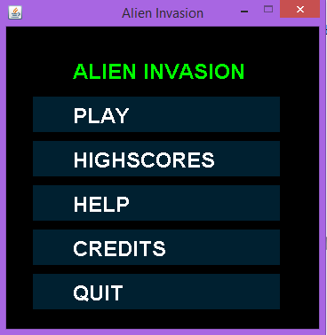

**Figure 1**. Main menu screen shot

**Play:**

**Play Game:** If Player selects “Play”, game gives to options to player about the difficulty level of the game: Easy and Hard.

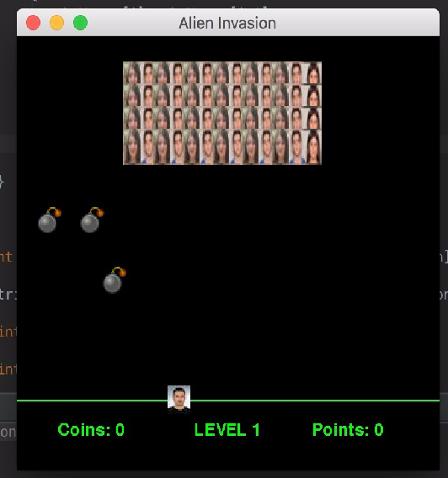

Figure 2 Play option screen shot

**High Scores:**

This mock-up shows the high score menu. In this interface player can see best 10 high scores and turn back to main menu with pressing “ok” button.

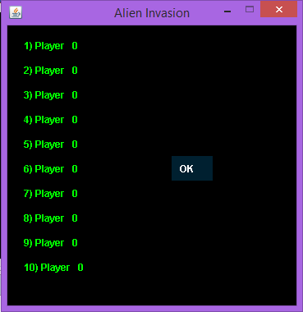

**Figure 3**. High Score screen shot

**Help:**

If user wants to learn how to play the game and which buttons would be used in this game can visit this option and learn how to play. If player chooses help option from the menu, a text is shown on screen containing instructions about game. Player can return to pervious menu by choosing “Main Menu”.

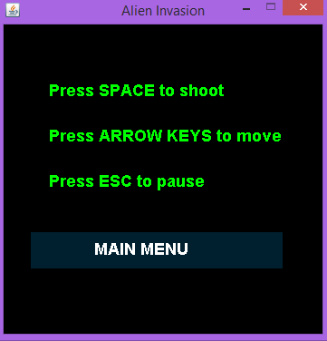

**Figure 4** Help Menu screen shot

**Credits:**

If user wants to see who are the architects of this game visit this option.

**Pause:**

If user press the “ESC” button during the game a new window opens this is our Pause Menu. User can pause the game for that particular moment. After pushing the pause button, 2 options can be chosen. User can either continue from where he/she left or exit the current game without saving and return to the main menu.

**Quit:**

If the user pushes the quit the application window will be closed. If the user wants to exit the game while playing, thescore will be lost.