Introduction:

The acpcdetect program is a module of the Automatic Registration Toolbox (ART). The program takes a 3D T1-weighted structural MRI of the human brain as input. It automatically detects the mid-sagittal plane (MSP) using the method described in [1]. It then detects the AC and PC intersection points on the MSP using the method described in [2]. Finally, it detects an additional 8 landmarks[1] (the so-called Orion landmarks) on the MSP using the method described in [3]. The obtained information is used to tilt-correct the input volume into a standard orientation. In this orientation: (1) the MSP is precisely aligned with the central plane of the FOV; (2) the anterior-posterior (AP) axis is on the MSP and aligned with the AC-PC line; (3) the inferior-superior (IS) axis is on the MSP and perpendicular to the AC-PC line; (4) the left-right (LR) axis is perpendicular to the MSP; and (5) the FOV center is approximately the mid-point between the AC and the PC on the MSP. The FOV center can alternatively be placed on the AC point using the --center-AC option.

Required argument:

-i (--input) <input-image>.nii: 3D T1-weighted structural MRI in ‘n+1’ NIFTI1 format of type short or unsigned short

Optional arguments:

-v (--verbose): Enables verbose mode

Example 1:

$ acpcdetect -i $ARTHOME/example1/v1.nii -v

Input image: /Users/ardekb01/babak_lib/example1/v1.nii

Input image orientation: ASL

Input image matrix size: 256 x 256 x 128

Input image voxel size: 1.0000 x 1.0000 x 1.2500

Output image: /Users/ardekb01/babak_lib/example1/v1_ASL.nii

Output image matrix size: 256 x 256 x 128

Output image voxel size: 1.0000 x 1.0000 x 1.2500

Output image orientation: ASL

Output transformation matrix: /Users/ardekb01/babak_lib/example1/v1.mrx

Output transformation matrix (FSL format): /Users/ardekb01/babak_lib/example1/v1_FSL.mat

Example 2:

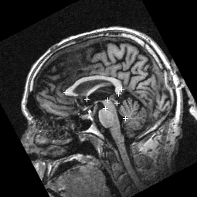

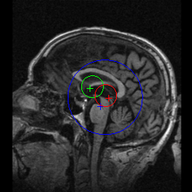

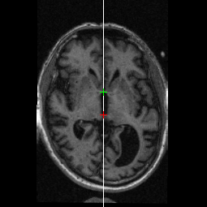

1. Actually, one of the 8 Orion landmarks happens to be very close to the AC.