Getting started with KAIBA version 3.0

1. **Introduction:**

The computer program KAIBA is a module of the Automatic Registration Toolbox (ART) package. It is designed to automatically compute a *hippocampal parenchymal fraction*[1] (HPF)marker on 3D T1-weighted (T1W) structural MRI of the human brain. KAIBA computes a HPF for each hemisphere.

HPF is a normalized measure (between 0 and 1) that estimates the brain tissue fraction within a standardized volume of interest (VOI) encompassing the hippocampus. The VOI is obtained by projecting a hippocampus probabilistic atlas onto the test MRI volume using a local 12-parameter affine transformation that is computed based on automatically detected landmark points.

HPI was found to be more sensitive than the hippocampal volume (as estimated using the FreeSurfer software) in separating between Alzheimer’s disease patients and healthy age-match controls [1]. HPI was also found to be a sensitive marker of progression from mild cognitive impairment to Alzheimer’s disease [2].

KAIBA computes the left and right HPF using the same set of landmarks following the exact same processes. Therefore, it is guaranteed that the computations are unbiased with respect to laterality. Hence bilateral HPF can be compared directly. This may be useful in disorders that are thought to affect the hippocampus asymmetrically (e.g. schizophrenia and Alzheimer’s disease).

1. **Improvements over the previous version:**

The main improvement in KAIBA 3.0 over older versions is its ability to compute the HPF on longitudinal T1W structural MRI consisting of 2 or *more* volumes scanned over time. For this purpose, the volumes must first be registered using the ATRA module of ART which should also be installed.

1. **Installation for Linux systems:**

You may need to be logged in as root, depending on the permissions of the directory on which you are installing KAIBA. The rest of this document assumes that KAIBA will be installed in /usr/local/art.

(a) Set the $ARTHOME environment variable to /usr/local/art. If this is already set on your system, then you can skip this step. To set $ARTHOME, csh and tcsh users should add the following line to their .cshr or .tcshrc files:

setenv ARTHOME /usr/local/art

sh and bash users should instead add the following line to their .profile or .bashrc files:

export ARTHOME=/usr/local/art

(b) Download kaiba3.0_LinuxCensOS6.7.tar.gz from [www.nitrc.org/projects/art](http://www.nitrc.org/projects/art) and move it to $ARTHOME. If you are installing the software on MacOS, download the MacOS tarfile instead.

(c) Unpack the package:

cd $ARTHOME

gunzip kaiba3.0_LinuxCensOS6.7.tar.gz

tar -xvf kaiba3.0_LinuxCensOS6.7.tar

The archive includes the following files:

bin/kaiba (KAIBA binary)

T1acpc.mdl (auxiliary file)

orion.mdl (auxiliary file)

lhc3.mdl (auxiliary file)

rhc3.mdl (auxiliary file)

lhc3.nii (auxiliary file)

rhc3.nii(auxiliary file)

PILbrain.nii (auxiliary file)

example1/*(test data 1)

example2/*(test data 2)

(d) Move the executable program $ARTHOME/bin/kaiba to a bin directory in your PATH. Alternatively, add the directory $ARTHOME/bin to your PATH.

(e) KAIBA assumes that you have a working version of the gnuplot Version 5.0 or higher software on your system. If not, KAIBA still works, but will generate an error message and not output the *_hist.png files (see examples below).

(f) Finally, to run KAIBA in longitudinal mode, you will need to install the ATRA module for ART which is used for unbiased and consistent registration of longitudinal T1W structural MRI.

1. **Running KAIBA:**

KAIBA can be run in cross-sectional and longitudinal modes. The objective of the cross-sectional analysis is to find the right and left hemisphere HPF on a single MRI volume. In the longitudinal case, we have two or more MRI volumes scanned at different times and would like to measure the bilateral HPF on all volumes. The main difference between the cross-sectional and longitudinal analyses is that in the latter the longitudinal images must be registered using the ATRA software of the ART package before computing the HPF. will give an example of each type of analysis below.

Example 1 (cross-sectional analysis): In this analysis, a single test T1W MRI volume is given, let’s say v3.nii in $ARTHOME/example1. We would like to determine HPF bilaterally on this volume. To do so, change directory to $ARTHOME/example1 and type the following command:

cd $ARTHOME/example1

kaiba –i v3.nii –v –o foo –png

Inputs:

–i v3.nii

Specifies v3.nii as the input volume (must be NIFTI format of type *short*)

–v

Puts KAIBA in verbose mode

–o foo

Specifies foo as the prefix for the outputted CSV file

–png

Instructs KAIBA to write some of the output images in PNG format in addition to PPM format

Outputs:

foo.csv

This is the most important output. The computed HPF values are saved in this file for the left and right hippocampi in Comma Separated Values (CSV) format. Normally, this is the only output needed. The remaining files are mainly used for quality control to ensure that everything worked smoothly.

v3_ACPC_axial.ppm, v3_ACPC_sagittal.ppm, v3_orion.ppm

Images showing the mid-sagittal plane (MSP) and MSP landmarks detected by KAIBA(shown below). These images can be viewed (e.g., using the gimp program) to ensure that these steps were performed correctly. These images are also outputted in PNG format if the –png flag is specified at the command line.

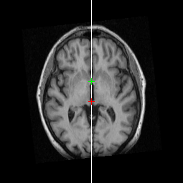 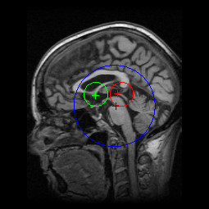

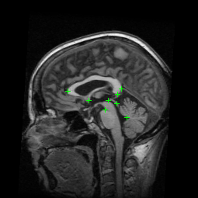

v3_LHROI1.nii and v3_LHROI2.nii

Independently estimated left hippocampus probabilistic labels in v3.nii space

v3_RHROI1.nii and v3_RHROI2.nii

Independently estimated right hippocampus probabilistic labels in v3.nii space

v3_?HROI?_hist.png

Voxel intensity histogram of v3_?HROI?.nii showing the results of histogram analysis (example shown below)

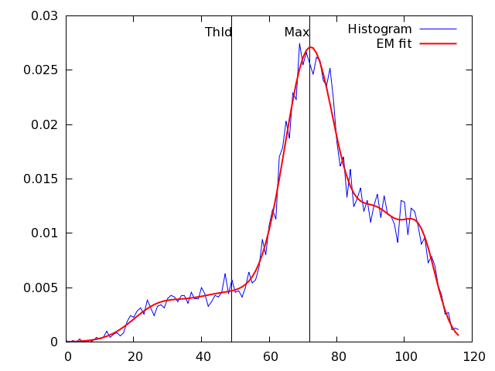

Example 2 (longitudinal analysis): In the case of longitudinal analysis, we have multiple volume acquired over time from the same individual and would like to compute the HPF on all volumes. Such a dataset is distributed under $ARTHOME/examle1 where we have 4 volumes: v1.nii, v2.nii, v3.nii and v4.nii acquired from the same subject. We can of course achieve this by running the cross-sectional analysis 4 times, each time with a new image. But we may be able to reduce within subject variance by first performing an unbiased and consistent rigid-body registration between the 4 volumes using ATRA. To do this, please see the documentation for ATRA. However, the syntax is simple. First create a text file, say imagelist containing a list of the input volumes, which is 4 in this example. Thus, the contents of the imagelist would look like:

v1.nii

v2.nii

v3.nii

v4.nii

Then register these volumes using ATRA by running the following command:

atra -i imlist -v

When finished, ATRA generates a text file called: atra.txt. The name atra.txt is customizable by using the -o argument for ATRA. However, if no such argument is specified, atra.txt would be the default name. This file contains the necessary information for running KAIBA. Following this registration step, KAIBA must be executed in the *same* directory using the following command:

kaiba –i atra.txt –v –o foo

Note that the only difference between this command line and the one used for the cross-sectional example is that the argument to -i is atra.txt which is the output from ATRA, as opposed to the case of the above cross-sectional example where the argument to -i was v3.nii, a NIFTI volume.

In this example, the foo.csv file will contain the HPF values for all input volumes on both hemispheres.

Example 3 (cross-sectional analysis – failed automatic AC, PC or RP detection): If you examine, for example, image BL_ACPC_sagittal.ppm output of Example 1 (shown above), you will see that KAIBA automatically detects the AC (the green plus), the PC (the red plus), and a reference point RP (the blue plus; vertex of the Superior Pontine Sulcus). Suppose that we run the cross-sectional analysis of Example 1 and after viewing the images BL_ACPC_axial.ppm and BL_ACPC_sagittal.ppm notice that the automatic MSP and/or AC/PC/RP detection has failed. In such a case, the (i, j, k) coordinates of these landmarks can be specified manually using the –blm option as follows:

*kaiba –b BL.nii–v –p foo –blm blm.txt*

Or if the failure happens for the follow-up image in the longitudinal Example 2, one may use:

*kaiba –b BL.nii –f FU.nii –v –p foo –flm flm.txt*

Text files blm.txt and flm.txt contain the (i, j, k) coordinates of the AC, PC, and RP, respectively. The way these coordinates are defined is the same way AFNI defines its “voxel coordinates” (i is the fastest varying index, j is the second fastest varying index, followed by k and the indices start from zero). Therefore, to specify these coordinates manually, we recommend using AFNI. In AFNI click “Define Datamode”, click “Misc”, and click “voxel Coords”. The (i, j, k) coordinates are then display by AFNI as “voxel x = …” “voxel y = …” and “voxel z = …” on the upper left region of AFNI’s main window.

1. **Troubleshooting**

**5.1. Trouble with loading shared libraries:** KAIBA uses a number of publicly available shared libraries. If it cannot find all of them on your system it will generate an error message. In that case, you can check which libraries were not found by using the *ldd* (list dynamic dependencies) command as follows:

*ldd kaiba*

There may be two reasons for not finding a shared library. (1) It does not exist on your system. (2) It does exist on your system but is not located in the usual search path for libraries. If the problem is the former, please ask your system administrator to install the missing libraries for you. The latter problem can be solved by modifying the LD_LIBRARY_PATH environment to expand the search path for libraries.

As an example, a user reported that KAIBA returned the following error message when he first tried to run the program:

*error while loading shared libraries: libblas.so.3*

He was able to successfully run KAIBA by installing the [BLAS (Basic Linear Algebra Subprograms)](https://www.google.com/url?sa=t&rct=j&q=&esrc=s&source=web&cd=1&cad=rja&uact=8&ved=0CB0QFjAAahUKEwjjstXlivrIAhXKth4KHQXtCi8&url=http%3A%2F%2Fwww.netlib.org%2Fblas%2F&usg=AFQjCNGz2pNiR_JyzMLMvLMN1Rv0SRXG3A&sig2=QQOd40F7BgNDn6ZjWnwt-w&bvm=bv.106923889,d.dmo) library using the following command:

*yum install blas*

**References:**

[1] Ardekani BA, Convit A, Bachman AH. Analysis of the MIRIAD Data Shows Sex Differences in Hippocampal Atrophy Progression. J Alzheimers Dis. 2015;50(3):847-57.

[2] Ardekani BA, Bermudez E, Mubeen AM, Bachman AH; Alzheimer’s Disease Neuroimaging Initiative. Prediction of Incipient Alzheimer's Disease Dementia in Patients with Mild Cognitive Impairment. J Alzheimers Dis. 2017;55(1):269-281.

Author: Babak A. Ardekani, Ph.D.: [Ardekani@nki.rfmh.org](mailto:Ardekani@nki.rfmh.org)

1. This quantity has also been called the hippocampal volumetric integrity (HVI). We have since decided to use the more informative term HPF.