Pen’Self

Members:
DELAIN Arthur : Designer & Co-director
COURT Tanguy : Leader

Description:
The basic idea of our product is simple, but sometimes a picture is worth a thousand words:

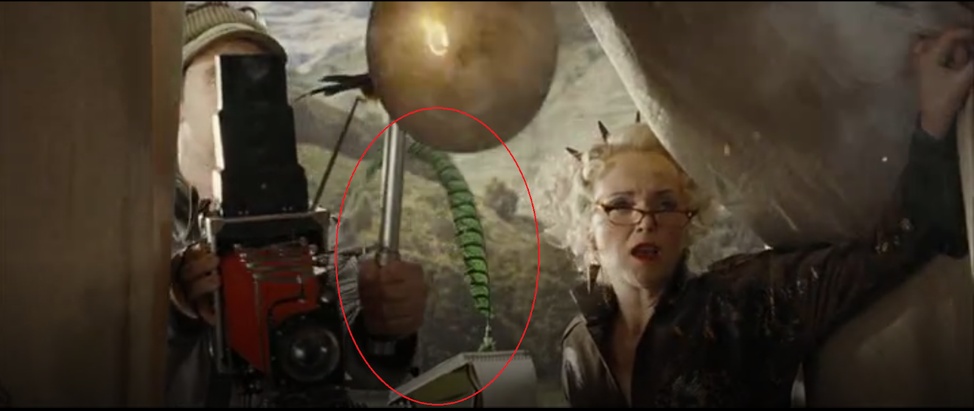

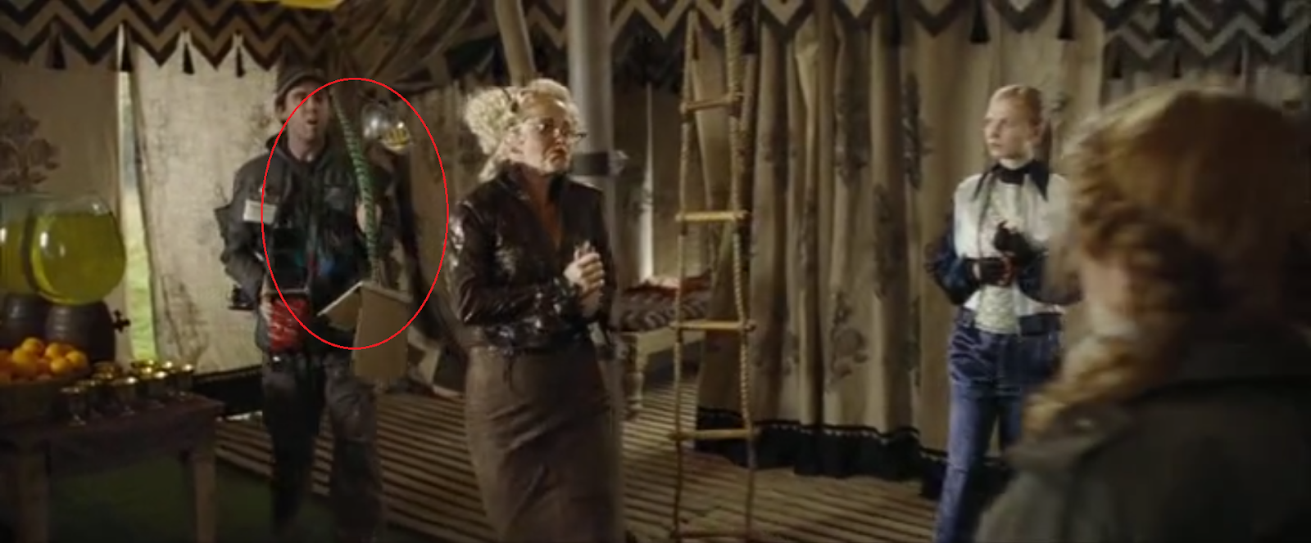

In the famous movie, Harry Potter (who live in a magic world, in case that you live in a cave) at some point, a journalist arrives, and while she is speaking, her magic feather is writing by itself. So, the interaction is more natural, she seems to be normally speaking to Harry, while she is actually writing an article about him.

Now the question is, how do we make this real ?
And the answer is, with technology ! After all, the british science fiction writer Arthur C. Clarke, said “Any sufficiently advanced technology is indistinguishable from magic.”
So, after further researches we found out that this could be something feasible, with a bunch of sensors and motors:
The pen will get his own motherboard in the inside. It will get sensors such as tilt sensors, acceleration sensors and as it will have its own micro-computer, we will be able to add some extensions with time.
For the stabilization part, it will need 3 wheels, and thanks to the sensors and the torque force that we can apply on the wheels with motors. This principle is inspired by the Cubli presented by Gajamohan Mohanarajah in 2013 during a Zurich.Minds talk.
Now that we can make the pen straight up and stabilized, we want it to write for us. To do so, we will use a machine learning process that allows to learn from data in order to reproduce actions.
It is an algorithm difficult to implement but quite easy to understand:
You have to train the algorithm with valid datas to make it understand the purpose, just like when you want teach a kid what is a cat, you will show him several photos of a cat and then he will be able to recognize it. Or, here if you want to teach him how to write the “A” letter, you will first show him what is an “A”, and then makes him reproduce it.
Thanks to that process, the pen will be able to learn from the way the user writes, and reproduce his own handwriting way. The more the user will use it to handwrite, the more the pen will learn from him and be accurate when it will write by itself.
Finally, the pen will have an embedded microphone and thanks to a simple text recognition process, it will be able to write down what it hears.

SLOGAN:

No longer write without thinking

Brainstroms:

Ideas of name :
Autono’Pen (Autonomous recalling autonomous cars + Pen )
Autono’Write (Autonomous recalling autonomous cars + Write )
Pen’self (Pencil + self )
Pencilf
Word’onomous ( Word + autonomous )

Ideas of slogan:
Stop choosing between writing and listening
Never choose between writing and listening ever again
No longer write without thinking
Writing or listening, why choose ?

Users targeted:
Students
Dyslexics
handicapped

Stats:
dyslexics :
- 8 to 10 % of the french population are dyslexic.

students :
University
2 680 400 subscriptions in france in 2017
schools
12 891 350 sub
Total general student : 15 571 750
France total 2017 : 67,2 millions of inhabitants
- So that’s around : 23%

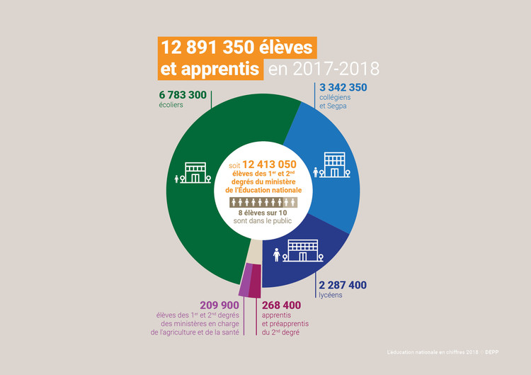

Handicapped :
- 24% of the workers.

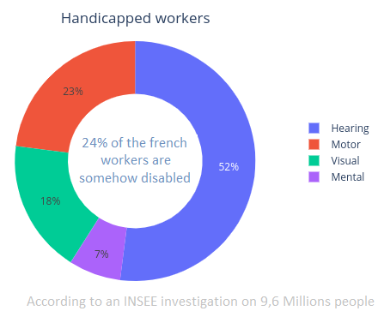

SWOT Analysis:
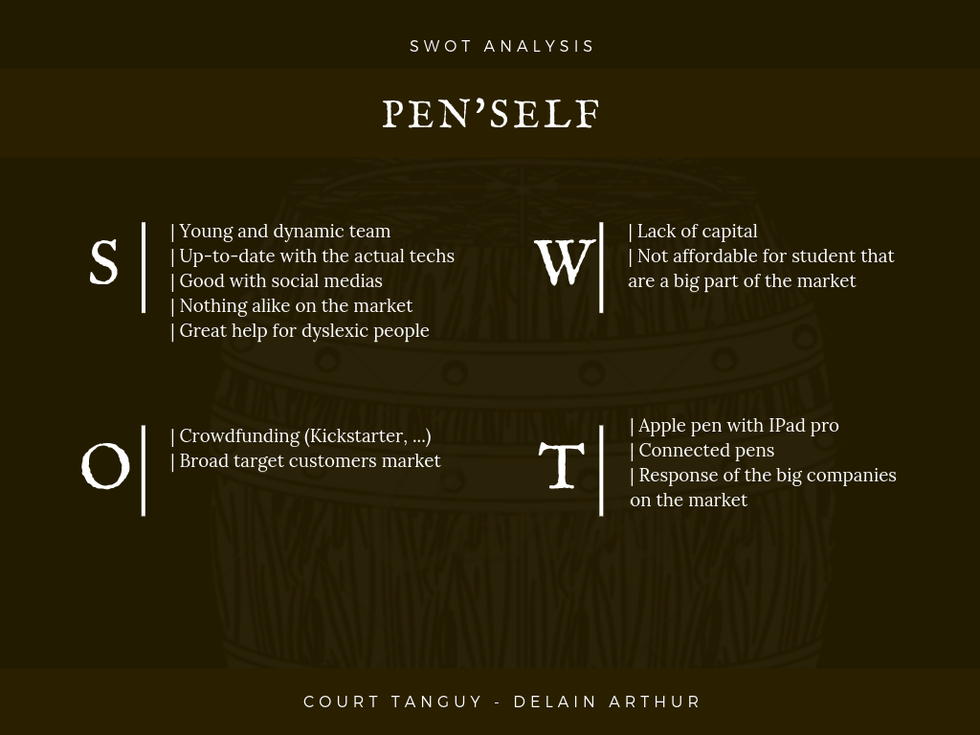

Possible extensions:
-A bluetooth Microphone that you can put on the speaker’s desk, so that the sound is clearer.
-A camera with text recognition. The AI could rewrite something already written.
-Pairing with another Pen’self, though internet, to reproduce your gesture to another one, for document signature for instance.

Timeline :
First class:
Found a feasible and innovative project : smart pen.
A lot of brainstorming and speaking about the features that it could include.

Second class:
Found the title of the project : Neo’Pen
Established Rôles : Tanguy → Leader / Arthur → Designer
Made some researches about how to stabilize the pen automatically.
Made some researches about the potential targeted users.

Third class:
SWOT Analysis
Some other research about numbers and percentages
1st graphic design

Fourth class :
Chart sheet
Stats over the handicapped
Finishing stats work
creation of differents models (normal, for children, ecological, luxury)

Fifth class :
Tedx Work
BrainStorming about a new name, more relevant (Neo’pen → Pen’self)

sixth class :
Preparation for the interview

seventh class :
Working on the presentation

External links:

Stabilisation gyroscopique cubicologique : https://www.youtube.com/watch?v=n_6p-1J551Y
Zurich.Minds talk : https://www.youtube.com/watch?v=bMuCACqwI4s
Dyslexia writing skill : https://www.thoughtco.com/how-dyslexia-impacts-writing-skills-3111195
Stats about students in france (Français) : https://etudiant.lefigaro.fr/article/le-nombre-d-etudiants-a-atteint-un-nouveau-record-en-france_e947d5be-dca2-11e6-8620-c271acfe3201/
Dyslexia in france :
https://sites.google.com/site/dixsurdys/pour-aller-plus-loin/pourcentages-et-statistiques
https://www.sciencesetavenir.fr/sante/cerveau-et-psy/combien-de-personnes-souffrent-de-troubles-dys_104323
Schools students in france:
http://www.education.gouv.fr/cid57111/l-education-nationale-en-chiffres.html
Handicapped in france:
https://www.seton.fr/infographie-handicap-france.html

