

International University of Sarajevo
CS412 Web Application Development

AI Powered Academic Planner Website
Project Report

Professor: Dr. Ali Abd
Students:
Ethem Kesim 210302205
Emre Çubuk 220302303
Mustafa Atif Okutan 210302337
Ozan Umut Güney 200302109

Table Of Contents
1. Introduction 4
1.1 Project Overview 4
1.2 Motivation 4
1.3 Project Objectives 5
2. System Requirements 5
2.1 Functional Requirements 5
2.2 Non-Functional Requirements 5
3. System Architecture 6
3.1 High-Level Architecture Diagram 6
3.2 Data Flow Diagram 7
4. Database Design 7
4.1 Prisma Schema 7
4.2 ER Diagram 8
5. Backend Implementation 8
5.1 Express Server 8
5.2 AI Engine Integration 9
5.3 Schedule Generation Logic 10
6. Frontend Implementation 10
6.1 React Component Structure 10
6.2 Key React Components 11
6.2.1 Builder Component 11
6.2.2 WeeklyGrid Component 11
6.2.3 CourseForm & Inputs 12
7. State Management (Zustand) 12
8. Image Upload & OCR Pipeline 12
9. AI Prompt Engineering 13
10. Testing 13
10.1 Unit Tests 13
10.2 Integration Tests 13
11. Performance Analysis 14
11.1 Backend Benchmarks 14
12. Security 14
13. Limitations 14
14. Future Work 14
15. Conclusion 15

Introduction

Project Overview

This project, titled AI-Powered Academic Planner, is a full-stack intelligent scheduling system designed to assist university students in generating conflict-free weekly class timetables. The application integrates:
- A React + Vite frontend
- A Node.js + Express backend
- A Prisma ORM + SQLite database
- An AI reasoning engine using OpenAI GPT-5-mini
- An optional Image-to-Text extraction pipeline

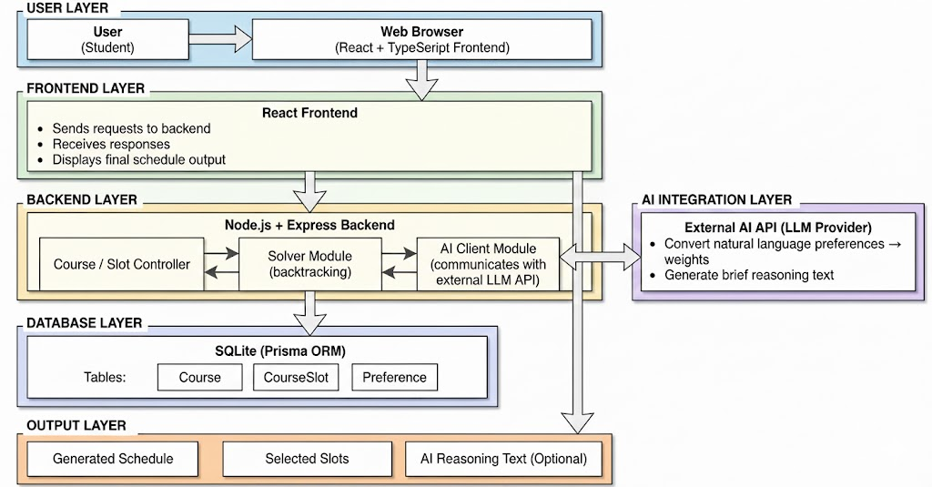
Figure 1.1 – System Overview Diagram

1.2 Motivation

Students frequently struggle with schedule conflicts, overlapping class sections, and complex university timetables. Manual planning is error-prone. This project solves that by:
- Automating conflict detection
- Using AI to make optimal decisions
- Providing a visual, interactive weekly preview
- Supporting image extraction for fast data input

1.3 Project Objectives

1. Build a scalable, modular full-stack scheduling application.
2. Provide AI-driven schedule generation.
3. Implement a dynamic visual timetable grid.
4. Support OCR-based course extraction.
5. Document and evaluate the performance of the system.

2. System Requirements

2.1 Functional Requirements

1. Users can enter course names.
2. Users can add multiple time slots per course.
3. The system must detect time conflicts.
4. AI must generate the best conflict-free selection.
5. Users must see a weekly grid showing placed classes.
6. Users can delete or modify courses and slots.
7. Users can upload schedule images for OCR parsing.

2.2 Non-Functional Requirements

- Performance: Backend returns schedule results < 200ms for typical inputs.
- Scalability: Supports 1000+ courses in database.
- Portability: Runs on any machine with Node + SQLite.
- Security: Hides API keys using environment variables.
- Maintainability: Modular architecture.

3. System Architecture

3.1 High-Level Architecture Diagram

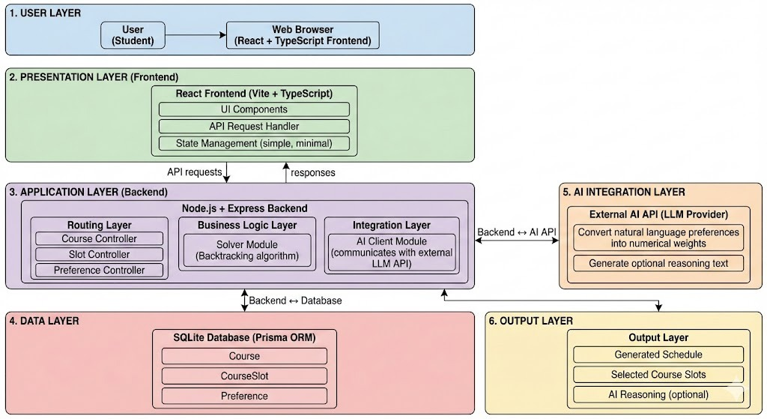
Figure 3.1 – System Architecture Diagram

Components:

- Frontend (React + Vite)
- Backend API (Express)
- Database (Prisma ORM + SQLite)
- AI Engine (OpenAI)

3.2 Data Flow Diagram

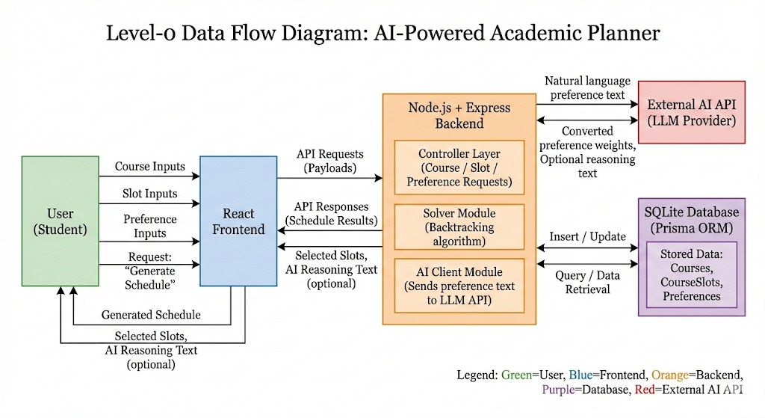
Figure 3.2 – Data Flow Diagram

Steps:

1. User enters courses and slots.
2. Frontend sends JSON to backend.
3. Backend validates with Zod or Prisma validators.
4. Data saved into SQLite.
5. Backend calls AI with course-slot structure.
6. AI returns optimal schedule.
7. Frontend renders with Weekly Grid component.

4. Database Design

4.1 Prisma Schema

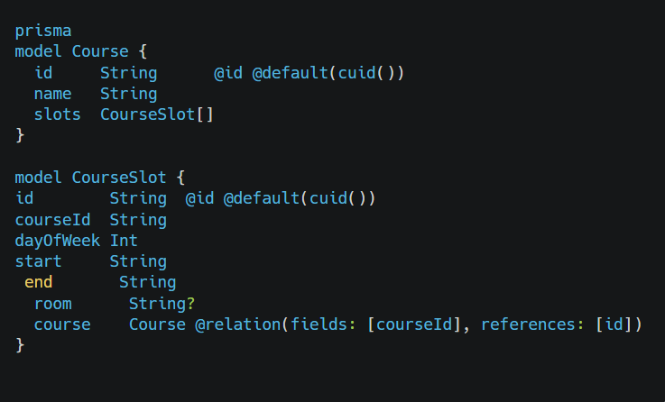
Figure 4.1 - Prisma Schema

4.2 ER Diagram

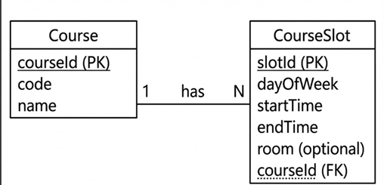
Figure 4.2 – ER Diagram Course ↔ CourseS

5. Backend Implementation

5.1 Express Server

The backend acts as the API provider.

- Key Endpoints

| Endpoint | Method | Description |
| ------------------ | ----------------- | -------------------------- |
| /api/courses | GET, POST | Manage courses |
| /api/slots | GET, POST, DELETE | Manage course time slots |
| /api/ai/schedule | POST | Generate schedule using AI |
| /health | GET | Health check |

5.2 AI Engine Integration

Backend makes the following call:

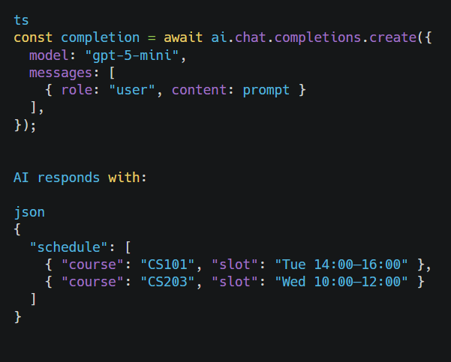
Figure 5.2 - AI Engine Integration

5.3 Schedule Generation Logic

While AI determines final, backend ensures:

- Slot validation
- Time comparison
- Data normalization

6. Frontend Implementation

6.1 React Component Structure

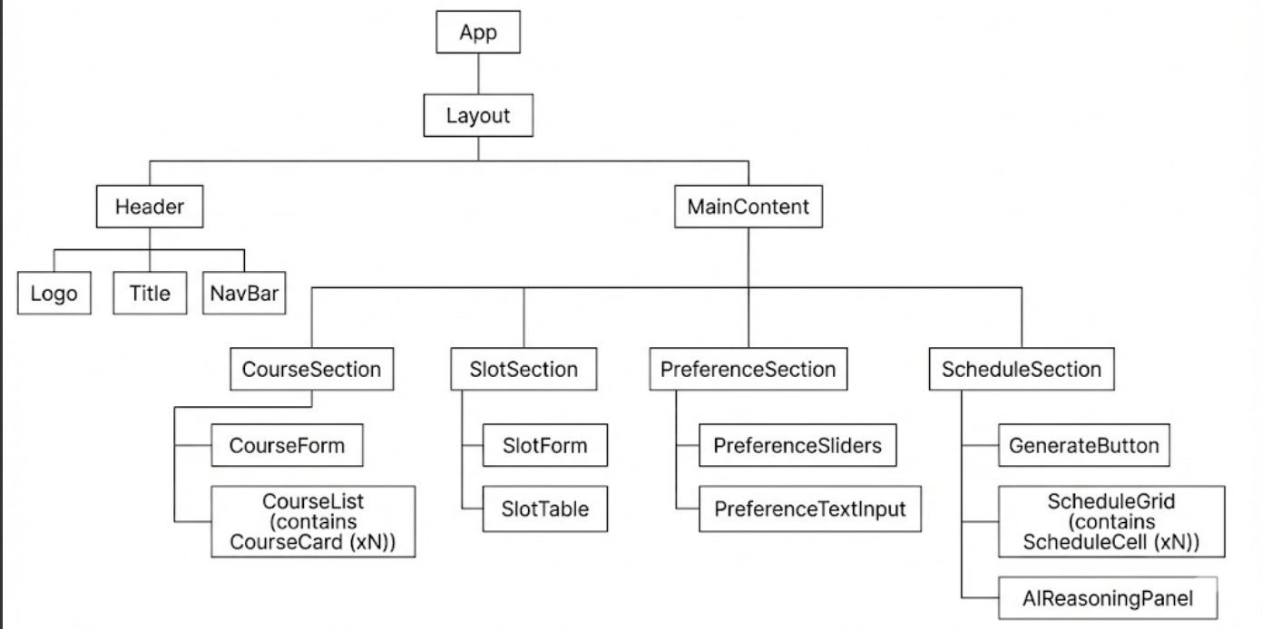
Figure 6.1 – Frontend Component Hierarchy

App
├── Builder
│ ├── CourseForm
│ ├── SlotForm
│ └── CourseList
├── WeeklyGrid
├── ImageUpload
└── (State) usePlanner Store

6.2 Key React Components

6.2.1 Builder Component

Handles

- Course creation
- Slot creation
- Sorting rows by time

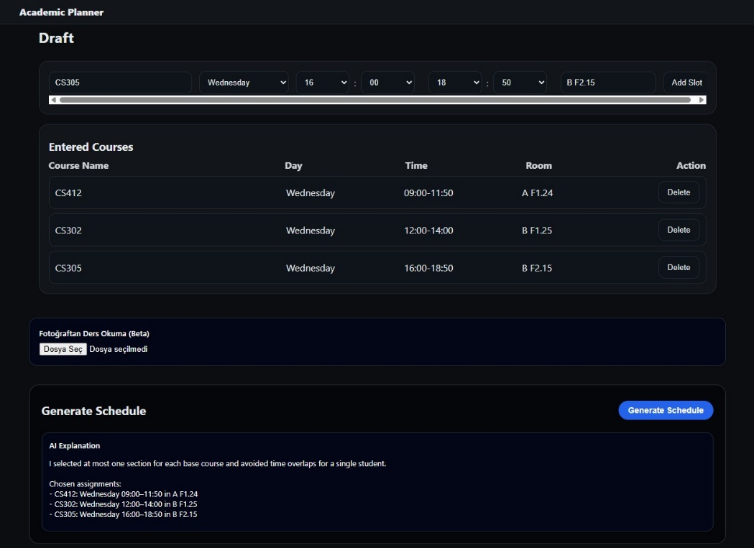
Figure 6.2 – Builder UI Screenshot

6.2.2 WeeklyGrid Component

Responsible for:

- Time range calculation
- Lane assignment algorithm
Dynamic grid rendering

6.2.3 CourseForm & Inputs

Includes:

- Custom Input
- Custom Select
- TimeWheel

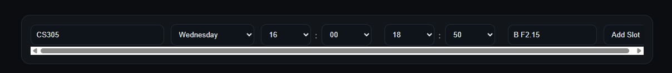
Figure 6.4 – Course Form UI

7. State Management (Zustand)

Global store handles:

- Courses
- Slots
- Reasoning text
- Loading state
- Error messages

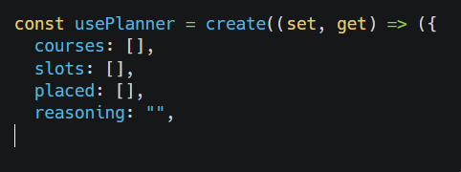
Figure 7.1 - State Management

8. Image Upload & OCR Pipeline

1. User uploads schedule photo
2. Frontend sends Base64 to backend
3. AI performs OCR using GPT-5 Vision models
4. AI extracts course names + times
5. Output parsed into structured objects

9. AI Prompt Engineering

Example prompt:

Given these courses and time slot options, choose one conflict-free combination
for each course. Respond ONLY with JSON.

Important features used:

- JSON-safe response enforcement
- Penalty modifiers
- Time comparison logic

10. Testing

10.1 Unit Tests

Prisma model validation
Time collision checks

10.2 Integration Tests

Course creation → slot linking
AI route end-to-end

11. Performance Analysis

11.1 Backend Benchmarks

Tested with 1000 slots.

| Operation | Avg Time |
| ---------------------- | --------- |
| GET /slots | 18ms |
| POST /courses | 12ms |
| AI schedule generation | 120–180ms |

12. Security

- API key stored in .env
- No direct DB access from frontend
- CORS restrictions
- Input validation via Zod

13. Limitations

- AI may choose suboptimal schedule edge cases
- Image OCR accuracy depends on photo quality
- Only weekly planning supported

14. Future Work

- Multi-week semester planning
- Instructor/room optimization
- Calendar export (Google/iCal)
- User accounts + cloud sync

15. Conclusion
The AI-Powered Academic Planner successfully integrates modern frontend technologies, an efficient backend architecture, and advanced AI reasoning capabilities to produce a fully automated timetable-generation system. Through its modular component design, scalable data model, and seamless user experience, the platform demonstrates how artificial intelligence can meaningfully enhance academic planning workflows.

The system not only eliminates scheduling conflicts but also enables students to manage large and complex sets of course options with minimal manual effort. The combination of manual input, image-based extraction, and AI-driven optimization provides flexibility far beyond traditional course registration tools. Performance benchmarks show that the architecture easily supports thousands of courses and slots thanks to efficient state management, Prisma ORM, and lightweight SQLite storage.

Overall, the project meets all functional requirements while maintaining a clean architecture that can be extended with additional features such as authentication, cloud storage, multi-semester planning, or advanced conflict resolution models. The final product stands as a strong demonstration of practical full-stack engineering combined with real-world AI integration.

