1. npm install -g ganache

ganache -p 8545 --chain.chainId 1337 --miner.blockTime 0

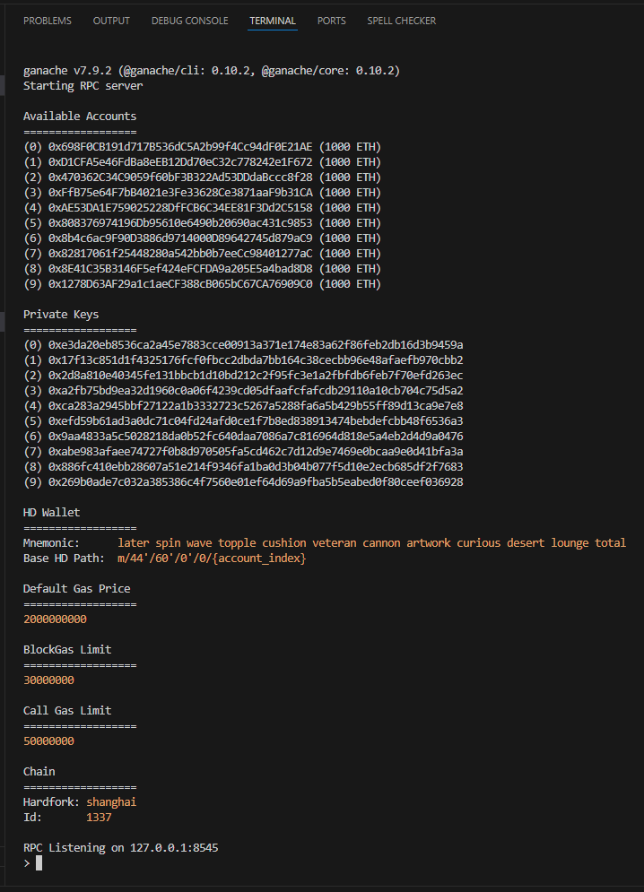

2. creating test.sol with code from task;

Setting debugger to 0.8.17;

“Compile test.sol”

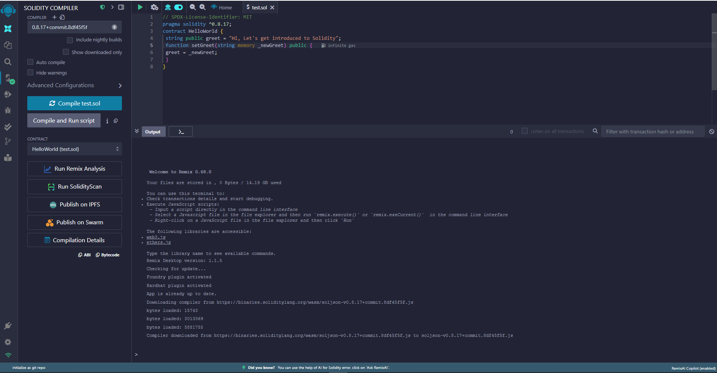

Deploy & Run Transactions -> Environment -> Customize this list -> Ganache Provider -> Set Endpoint ->

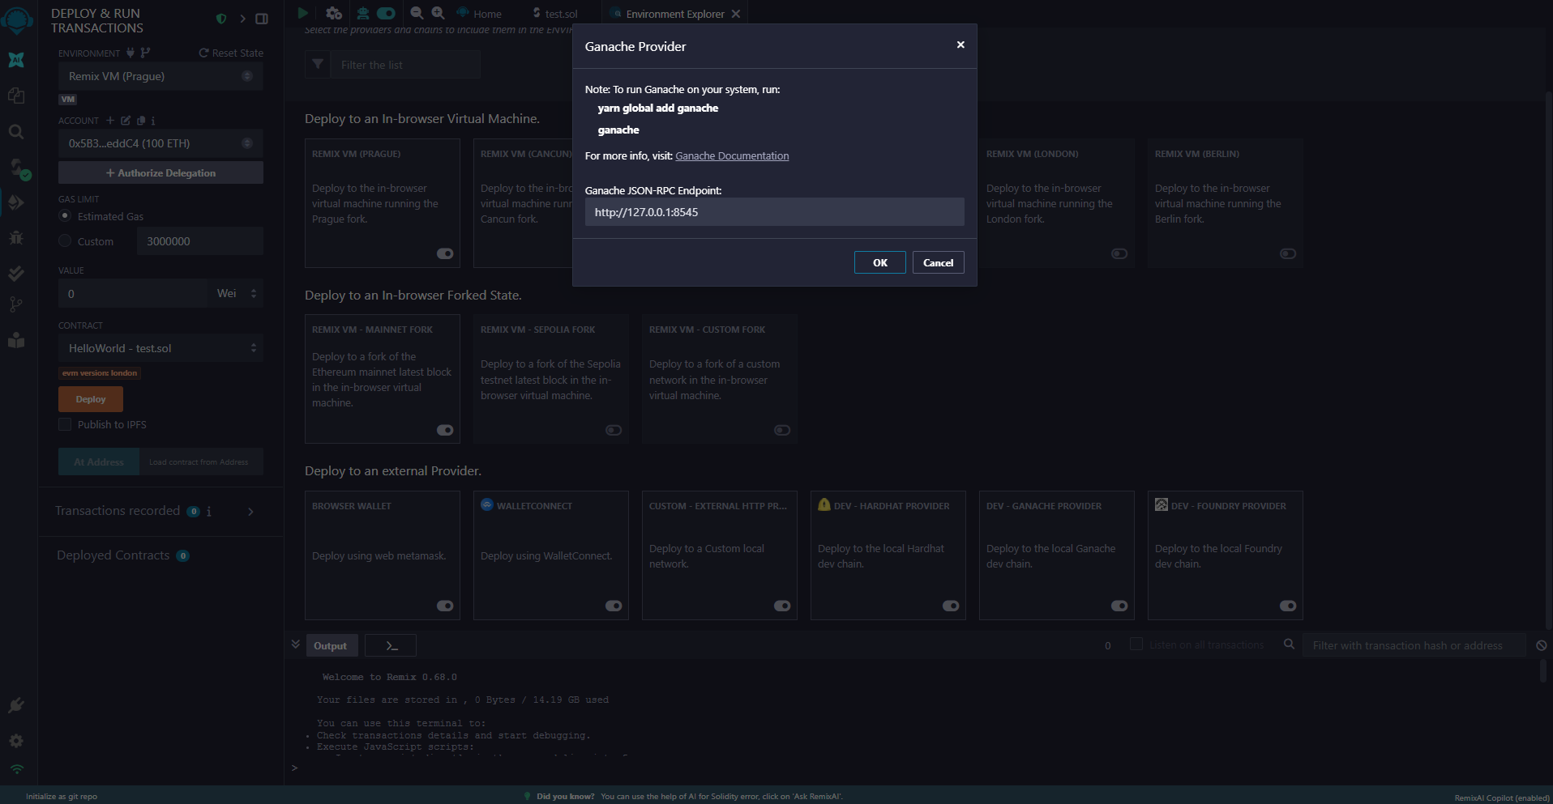

-> Deploy.

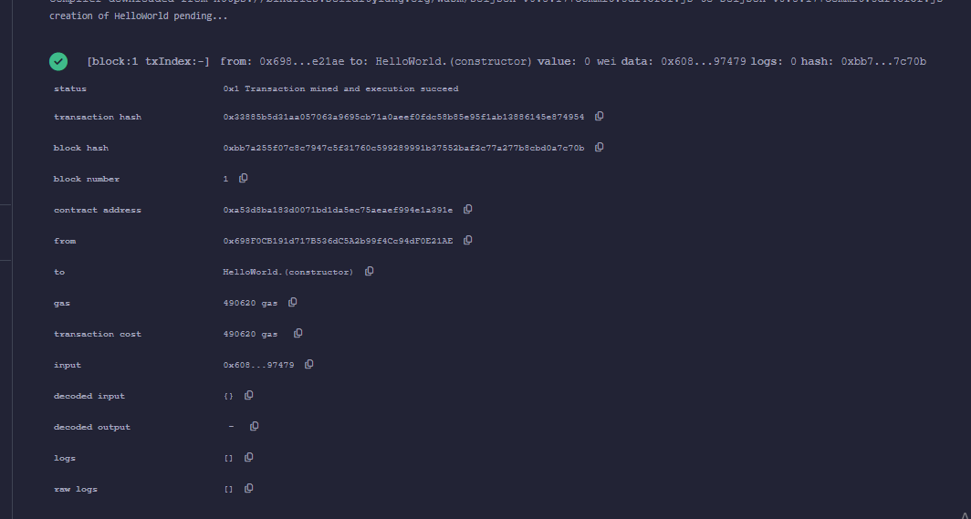

Greet button:

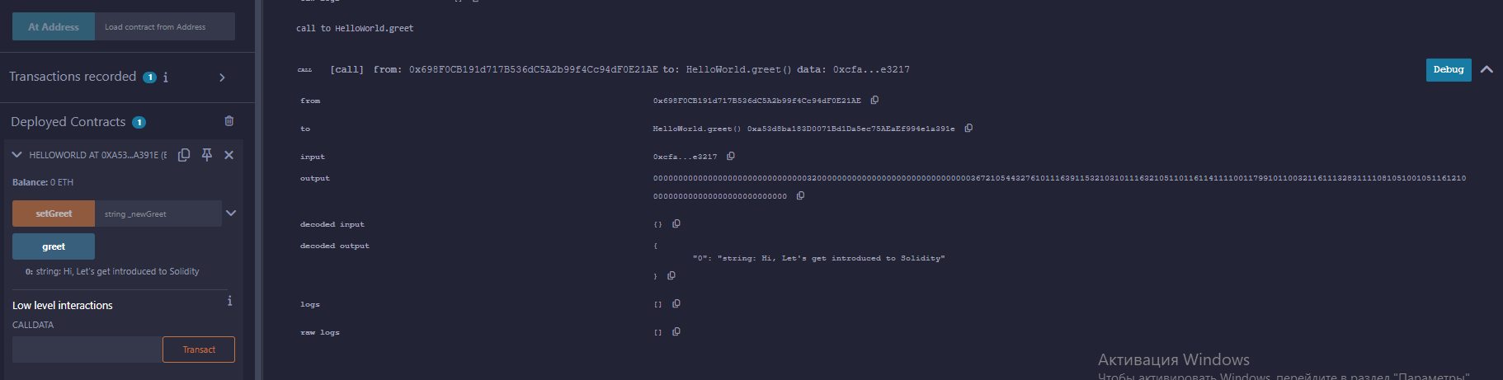

Using setGreet:

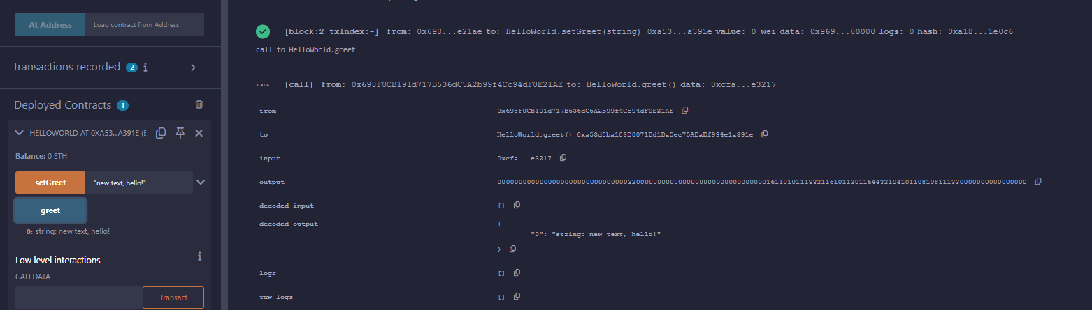

3. npm init -y;

npm install web3

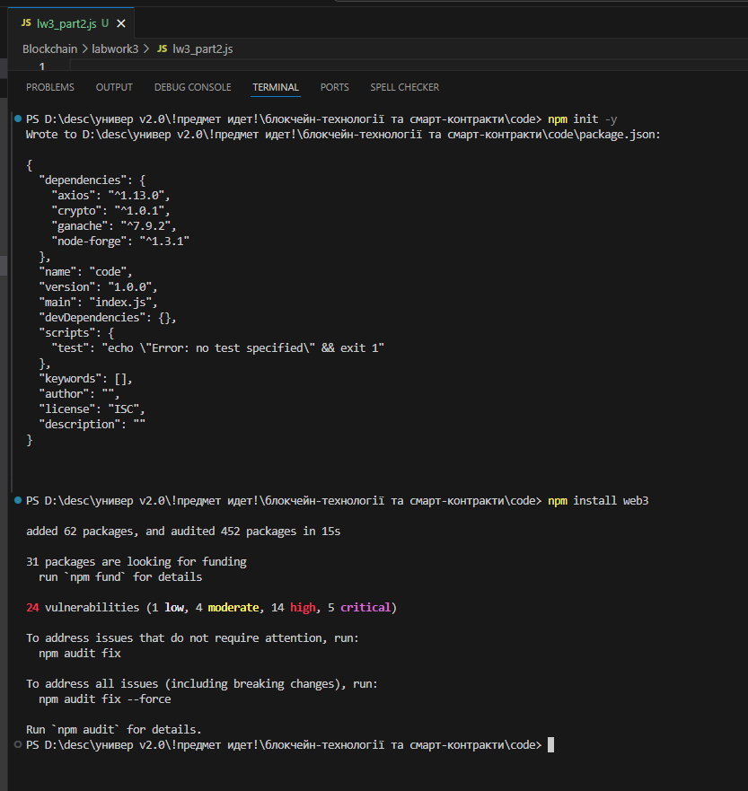

https://docs.web3js.org/api/web3-eth-contract/class/Contract/

Result of Web3:

