***Report for completing Solidity Beginner Course [8.1-10.3 chapters].*** // 7.3 doesn’t exist

**8.1 Data Structures – Arrays.**

1) Initialize a public fixed-sized array called arr3 with the values 0, 1, 2. Make the size as small as possible.

2) Change the getArr() function to return the value of arr3.

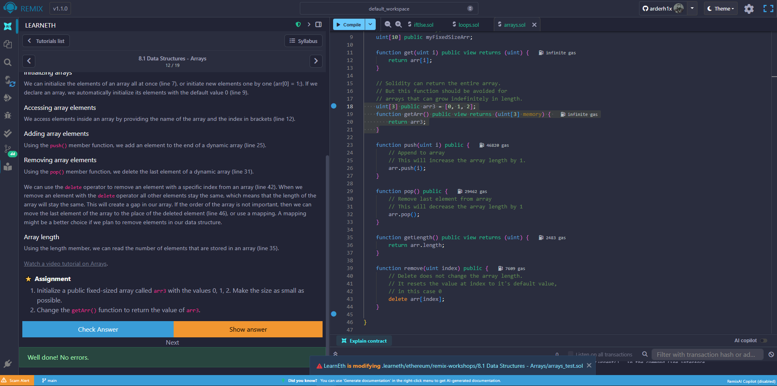

**8.2 Data Structures – Mappings.**

1) Create a public mapping balances that associates the key type address with the value type uint.

2) Change the functions get and remove to work with the mapping balances.

3) Change the function set to create a new entry to the balances mapping, where the key is the address of the parameter and the value is the balance associated with the address of the parameter.

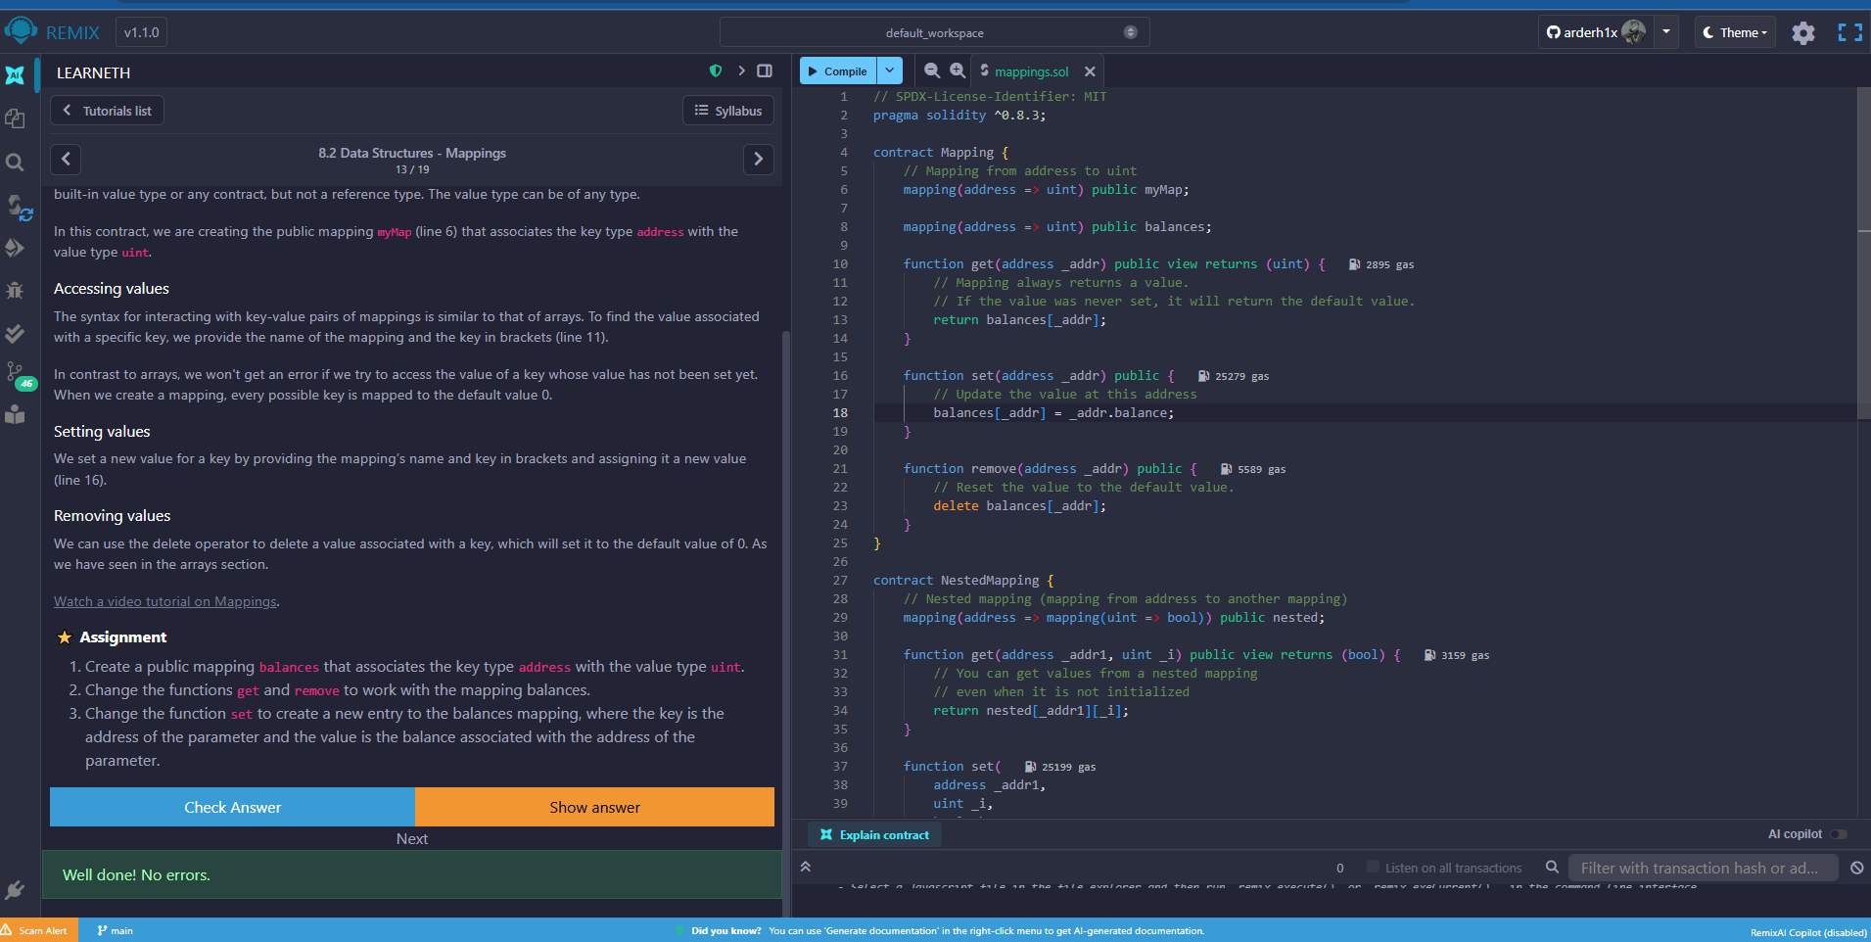

**8.3 Data Structures – Structs.**

1) Create a function remove that takes a uint as a parameter and deletes a struct member with the given index in the todos mapping.

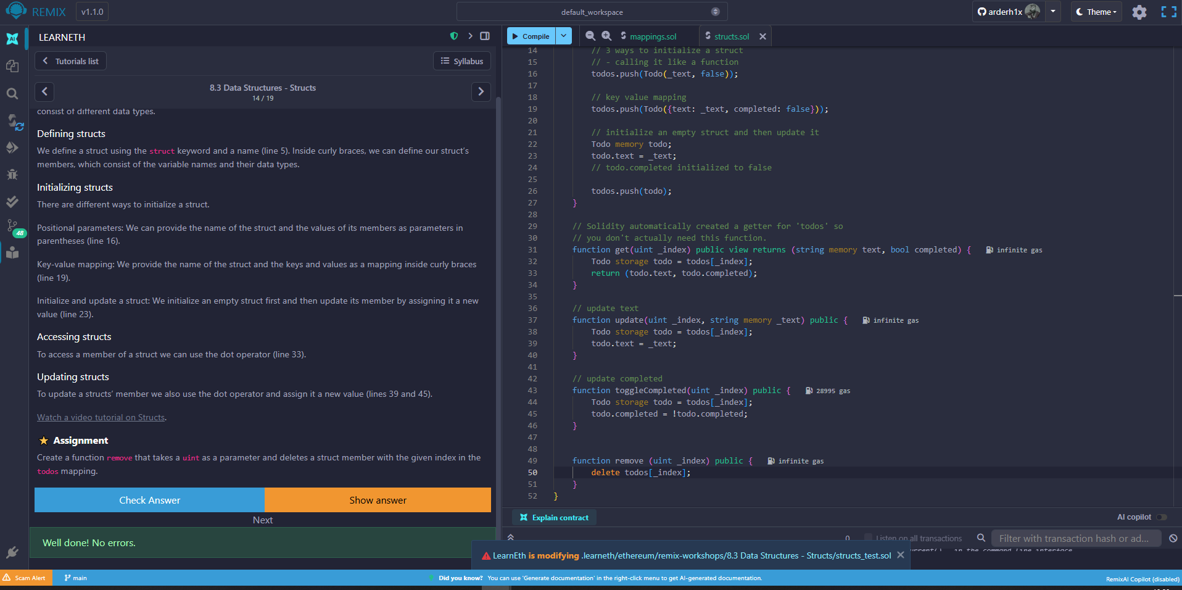

**8.4 Data Structures – Enums.**

1) Define an enum type called Size with the members S, M, and L.

2) Initialize the variable sizes of the enum type Size.

3) Create a getter function getSize() that returns the value of the variable sizes.

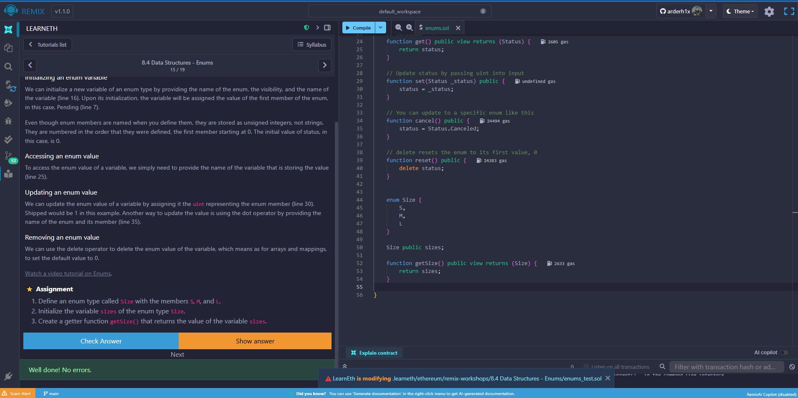

**9. Data Locations.**

1) Change the value of the myStruct member foo, inside the function f, to 4.

2) Create a new struct myMemStruct2 with the data location memory inside the function f and assign it the value of myMemStruct. Change the value of the myMemStruct2 member foo to 1.

3) Create a new struct myMemStruct3 with the data location memory inside the function f and assign it the value of myStruct. Change the value of the myMemStruct3 member foo to 3.

4) Let the function f return myStruct, myMemStruct2, and myMemStruct3.

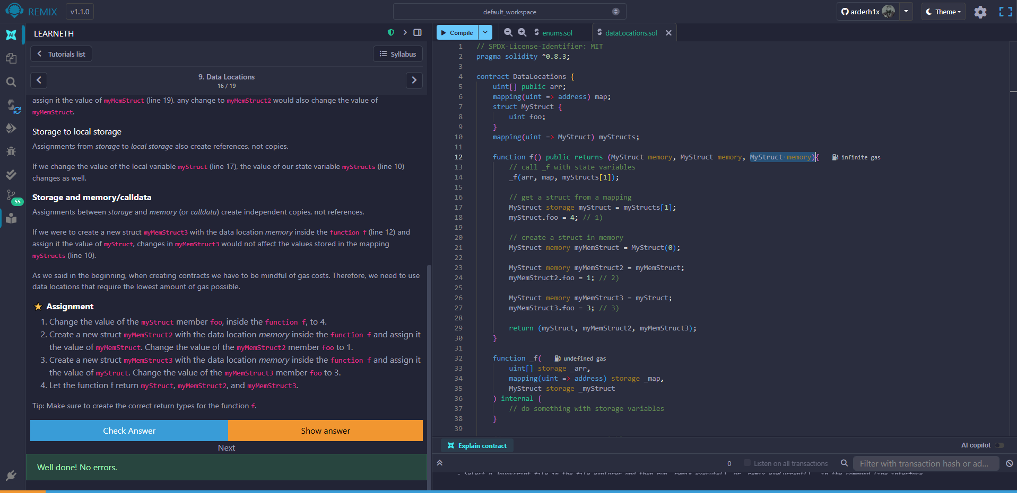

**10.1 Transactions - Ether and Wei.**

1) Create a public uint called oneGWei and set it to 1 gwei.

2) Create a public bool called isOneGWei and set it to the result of a comparison operation between 1 gwei and 10^9.

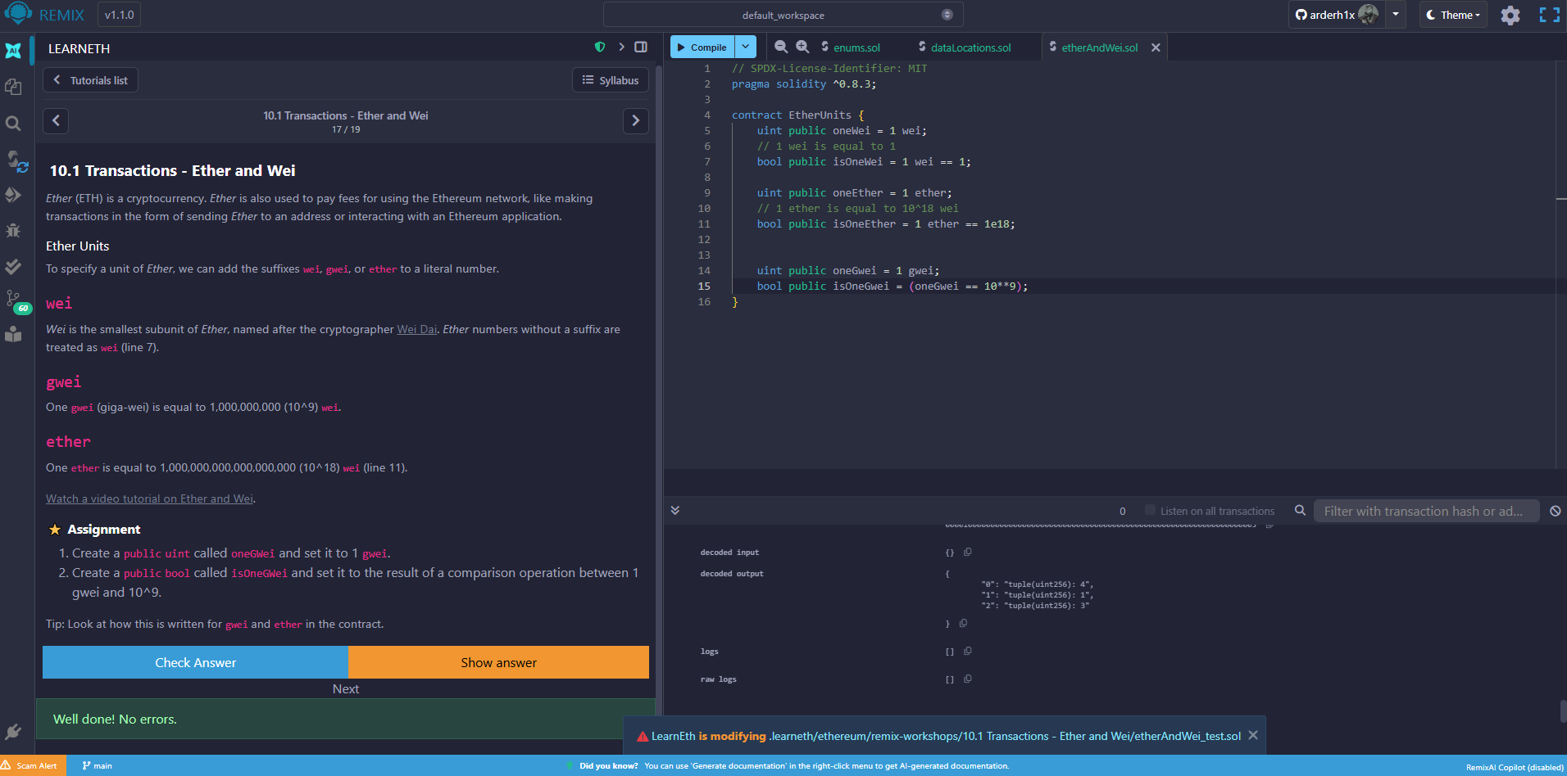

**10.2 Transactions - Gas and Gas Price.**

1) Create a new public state variable in the Gas contract called cost of the type uint. Store the value of the gas cost for deploying the contract in the new variable, including the cost for the value you are storing.

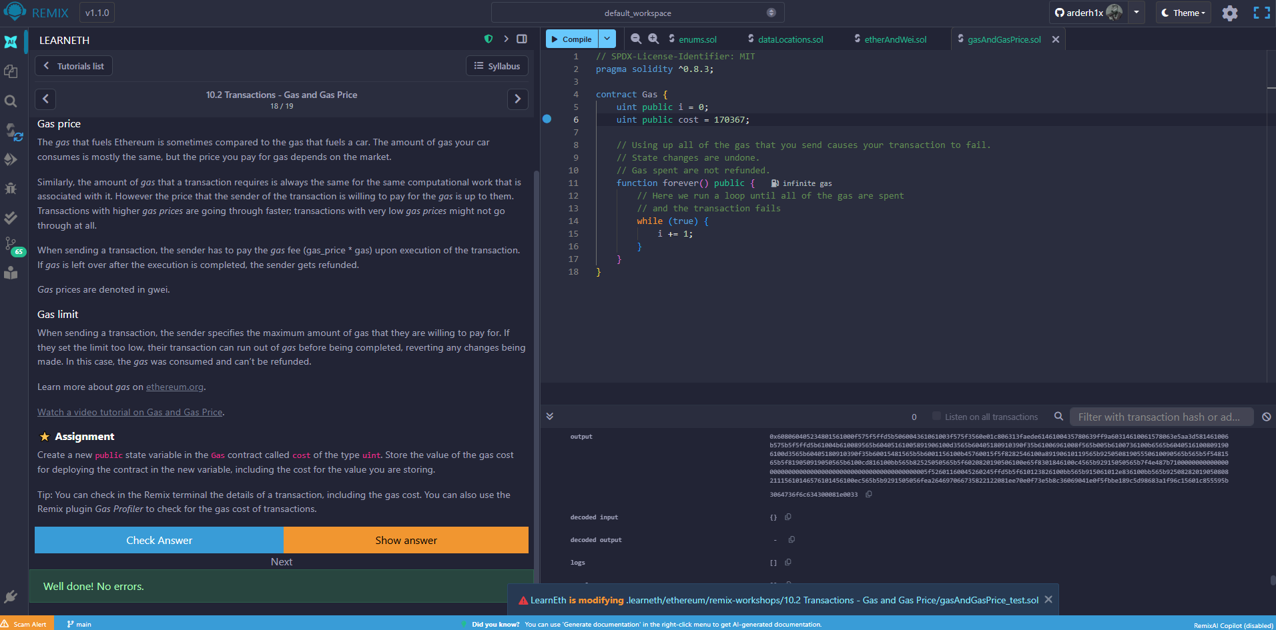

**10.3 Transactions - Sending Ether.**

1) Create a contract called Charity.

2) Add a public state variable called owner of the type address.

3) Create a donate function that is public and payable without any parameters or function code.

4) Create a withdraw function that is public and sends the total balance of the contract to the owner address.

