**REQUIREMENTS FROM MICHAEL**

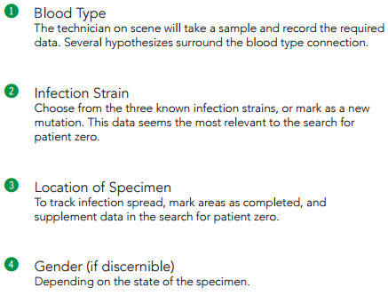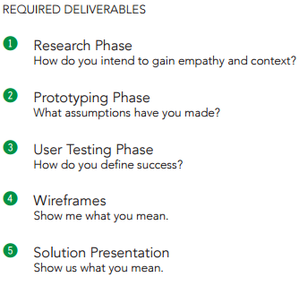

Empathy = the ability to understand and share the feelings of another.

Context = the circumstances that form the setting for an event, statement, or idea, and in terms of which it can be fully understood and assessed.

The following is the content I would like to talk about in the presentation. You can choose the title, bullets and pictures.

**Research**

~~The data collection teams~~ The Team (slide 3 of my draft)

Who are the data collectors? – Teams are made up of three courageous men and women of varying ages that are quickly trained for combat. They are willing to go anywhere and do anything to get the job done.

What do they do? – They look for zombies both brain dead and reanimated to collect blood samples from them.

Where do they work? – The teams travel everywhere and anywhere they can find zombies. They scour major cities, small towns and the countryside.

Why do they do it? – Everybody has lost someone they love to zombies so most of them take this very personally. They have a strong desire to find patient 0 with the hope of stopping the zombie epidemic to save all of mankind.

~~Everyday~~ life in the field (slide 4 of my draft)

Developers followed a data collection team around for 3 days ~~and to observed the following~~ to observe their daily activities.

Their working environment ~~they work in~~ - Teams work under harsh conditions and have to deal with both natural (adverse weather conditions) and supernatural elements (zombie dens).

~~What they do~~ Daily activities - Before heading out, they have a predetermined destination in mind where there are either areas that have not been sampled, areas that need more samples or an area of interest that just needs further evaluations. They drive around in armored vehicles in the designated area looking for zombies.

~~How do they collect data~~ Data collection - All the duties are shared among the team members. Teams are made up of 3 individuals: one to ~~shoot the dart and~~ collect the data, the other 2 for back up and to create a distraction while the data is being collected. They take samples from ~~different types of~~ zombies that are brain dead (no longer moving) or from zombies that are reanimated. ~~and in the 1-5 minutes between an infected persons’ death and reanimation.~~ (We will just leave out the 1-5 minute samples)

~~What~~ risks ~~do they take~~ – The biggest risk is being infected. They also risk being injured during a chase or flee.

~~What~~ Necessary precautions ~~are needed~~ – To reduce the risk of infection, the team members wear protective gear. Long sleeves, pants and gloves will be worn so no skin is exposed. A small face mask will be used to protect eyes, nose and mouth.

~~What~~ equipment ~~do they use~~ – Weapons, armored vehicles, cell phones, ~~dart guns~~, communication headsets, first aid kits

Empathy Map (slide 5 of my draft)

Think - Our goal is to find patient 0 to find a cure. We don’t necessarily want to kill zombies unless we have to because we WILL find a cure. We also don’t want to get ourselves infected.

Hear - The CDC tells us that they are working on a cure and the more samples we get the closer they get. We hear sob stories every day from people who have lost loved ones to this virus. We are being told that we are appreciated for what we do and to be careful while we are doing it. The CDC has informed us that the virus is mutating.

See - We see zombies everywhere. It seems like there are more zombies than live people. The infrastructure is falling apart around us. Buildings are in disrepair, abandoned cars are blocking the roadways and communication is spotty.

Say - We will do whatever it takes and go wherever we need to in order to get a good variety of samples. We will work long hours under any condition to obtain as many samples as we can. We will be careful and take all the necessary precautions.

Pain - We don’t want to infect ourselves so we don’t want to get too close in order to obtain a sample. There is not much time to get a sample because we can very easily get overcome by multiple zombies. We need to have some type of protective gear and it makes it hard at times to maneuver, so we use the best gear available that has the least hindrance. It is very painful to watch someone die and then be reanimated within 5 minutes.

Gain - Getting samples from a distance makes it safer for the team to work. Our goal is to find patient 0 so a cure can be found. Using location patterns of different strains gets us closer to our target. We are all hoping to save humanity.

**Prototyping**

Just our combined thoughts

* Dart gun: just a tool to get the dart to target
* Darts: sensors to analyze blood, with a break off tip that has a locator chip inside (to track migration for future analysis). Bluetooth – 30 feet. Need to pair phone and each dart. Download info to phone then upload later.
* Pocket in uniform to securely hold phone
* Analyze blood to determine: gender, blood type, strain or new mutation
* Use GPS locator, if not available manually enter
* Database to store samples until they can be uploaded to CDC
* Location of different strains to determine where more samples are needed.
* Location of “Safe Houses”
* Solar to charge batteries
* Indicators:
  + ~~911~~ PANIC
  + Upload complete

**User Test**

Just our combined thoughts

* Test the maximum distance to receive data transmission from dart.
* Test microchip that transmits location via GPS
* Test that blood analysis returns correct blood type, gender and strain or new mutation.
* Test upload to main database
* Test battery life and solar charging units
* Test the time it take to pair dart and phone