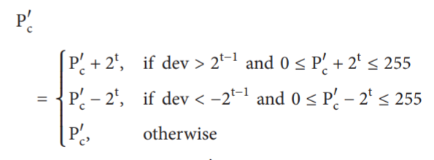

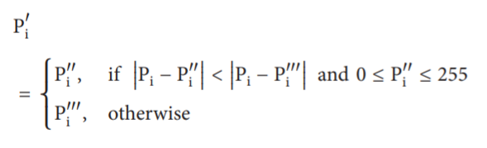

|  |  |  |
| --- | --- | --- |
| Pesan yang akan disisipi: 000 100 100 010 001 010 100 110 101, t = 3 | | |
| |  |  |  | | --- | --- | --- | | 192 | 190 | 200 | | 192 | 190 | 188 | | 192 | 190 | 200 |   Blok Original | Nilai Pc adalah 190  190 = (10111110)2  3 bits data = 000  (10111000)2 = 184  Substitusi LSB sebanyak t bit | |  |  |  | | --- | --- | --- | | 192 | 190 | 200 | | 192 | 184 | 188 | | 192 | 190 | 200 |   Setelah dilakukan substitusi LSB, maka nilai Pc’ = 184 |
| d1 = |184 − 192| = 8  d2 = |184 − 190| = 6  d3 = |184 − 200| = 16  d4 = |184 − 192| = 8  d5 = |184 − 188| = 4  d6 = |184 − 192| = 8  d7 = |184 − 190| = 6  d8 = |184 − 200| = 16 | |  |  | | --- | --- | | Range | Kapasitas | | [0,7] | 3 | | [8,15] | 3 | | [16,31] | 3 | | [32,63] | 3 | | [64,127] | 4 | | [128,255] | 4 |   Range Table | |  |  |  | | --- | --- | --- | | t1 = 3 | L1 = 8 | S1 = 4 | | t2 = 3 | L2 = 0 | S2 = 4 | | t3 = 3 | L3 = 16 | S3 = 2 | | t4 = 3 | L4 = 8 | S4 = 1 | | t5 = 3 | L5 = 0 | S5 = 2 | | t6 = 3 | L6 = 8 | S6 = 4 | | t7 = 3 | L7 = 0 | S7 = 6 | | t8 = 3 | L8 = 16 | S8 = 5 | |
| d1 = 8 + 4 = 12  d2 = 0 + 4 = 4  d3 = 16 + 2 = 18  d4 = 8 + 1 = 9  d5 = 0 + 2 = 2  d6 = 8 + 4 = 12  d7 = 0 + 6 = 6  d8 = 16 + 5 = 21 | P1’’ = 184 − 12 = 172  P2’’ = 184 − 4 = 180  P3’’ = 184 − 18 = 166  P4’’ = 184 − 9 = 175  P5’’ = 184 − 2 = 182  P6’’ = 184 − 12 = 172  P7’’ = 184 − 6 = 178  P8’’ = 184 − 21 = 163 | P1’’ = 184 + 12 = 196  P2’’ = 184 + 4 = 188  P3’’ = 184 + 18 = 202  P4’’ = 184 + 9 = 193  P5’’ = 184 + 2 = 186  P6’’ = 184 + 12 = 196  P7’’ = 184 + 6 = 190  P8’’ = 184 + 21 = 205 |
| P1’ = 196  P2’ = 188  P3’ = 202  P4’ = 193  P5’ = 186  P6’ = 196  P7’ = 190  P8’ = 205 | |  |  |  | | --- | --- | --- | | 196 | 188 | 202 | | 193 | 184 | 186 | | 196 | 190 | 200 |   Blok Stego |  |

Contoh Embeding

|  |  |  |  |  |  |  |  |  |  |  |  |  |  |  |  |  |  |  |  |  |  |  |  |  |  |  |  |  |  |  |  |  |  |  |  |  |  |  |  |  |  |  |  |  |  |  |  |  |  |  |
| --- | --- | --- | --- | --- | --- | --- | --- | --- | --- | --- | --- | --- | --- | --- | --- | --- | --- | --- | --- | --- | --- | --- | --- | --- | --- | --- | --- | --- | --- | --- | --- | --- | --- | --- | --- | --- | --- | --- | --- | --- | --- | --- | --- | --- | --- | --- | --- | --- | --- | --- |
| |  |  |  | | --- | --- | --- | | 196 | 188 | 202 | | 193 | 184 | 186 | | 196 | 190 | 200 |   Blok Stego  nilai Pc’ = 184  184 = (10111000)2 | d1 = 8 + 4 = 12  d2 = 0 + 4 = 4  d3 = 16 + 2 = 18  d4 = 8 + 1 = 9  d5 = 0 + 2 = 2  d6 = 8 + 4 = 12  d7 = 0 + 6 = 6  d8 = 16 + 5 = 21 | |  |  | | --- | --- | | Range | Kapasitas | | [0,7] | 3 | | [8,15] | 3 | | [16,31] | 3 | | [32,63] | 3 | | [64,127] | 4 | | [128,255] | 4 |   Range Table | |  |  |  | | --- | --- | --- | | t1 = 3 | L1 = 8 | S1 = 4 | | t2 = 3 | L2 = 0 | S2 = 4 | | t3 = 3 | L3 = 16 | S3 = 2 | | t4 = 3 | L4 = 8 | S4 = 1 | | t5 = 3 | L5 = 0 | S5 = 2 | | t6 = 3 | L6 = 8 | S6 = 4 | | t7 = 3 | L7 = 0 | S7 = 6 | | t8 = 3 | L8 = 16 | S8 = 5 | |
| |  |  |  |  |  |  |  |  |  |  | | --- | --- | --- | --- | --- | --- | --- | --- | --- | --- | | Si |  | 4 | 4 | 2 | 1 | 2 | 4 | 6 | 5 | | Extracted Data | 000 | 100 | 100 | 010 | 001 | 010 | 100 | 110 | 101 | | | | |

Contoh Extracting