Nama : Ivan Fadila Putra

NIM : 1541180186

Absen : 15

Model (package / model / Book.java)

Book.java

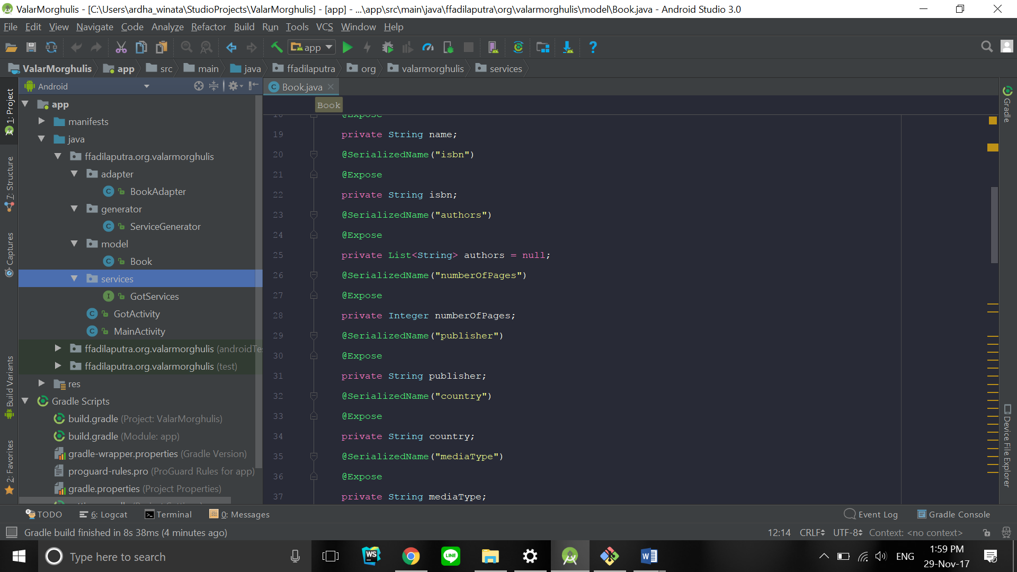

Generator ke REST API (package / generator / ServiceGenerator.java )

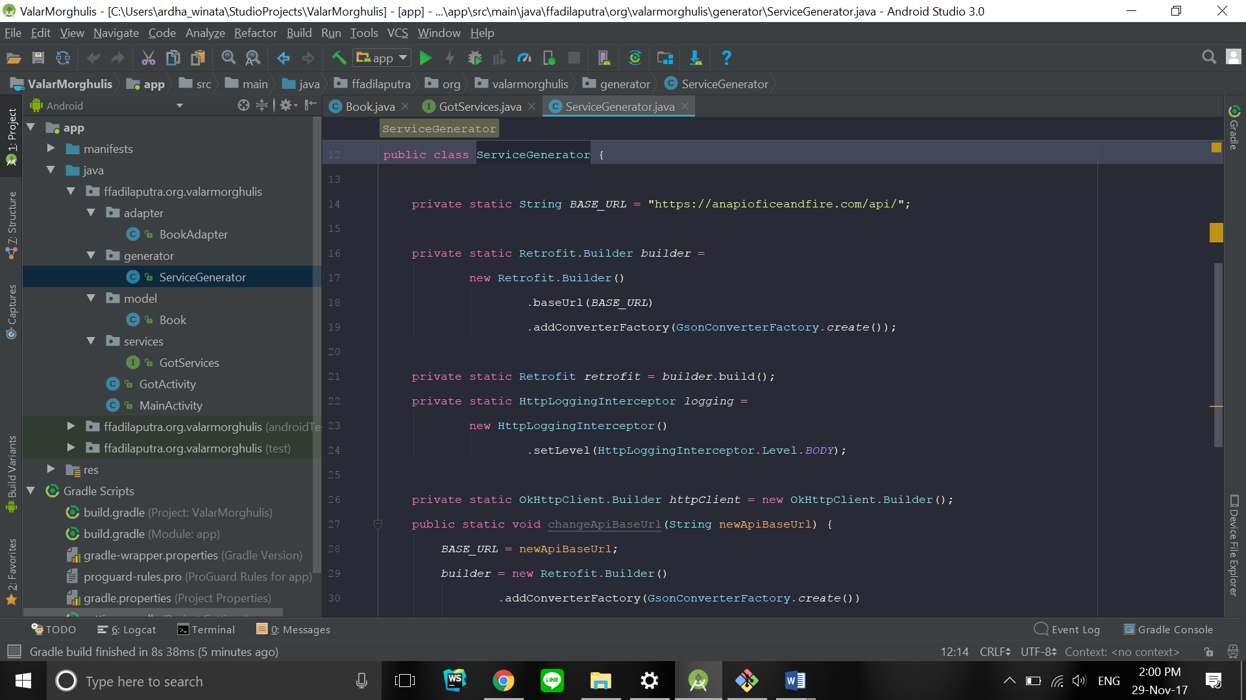

Adapter data (package / adapter / BookAdapter.java)

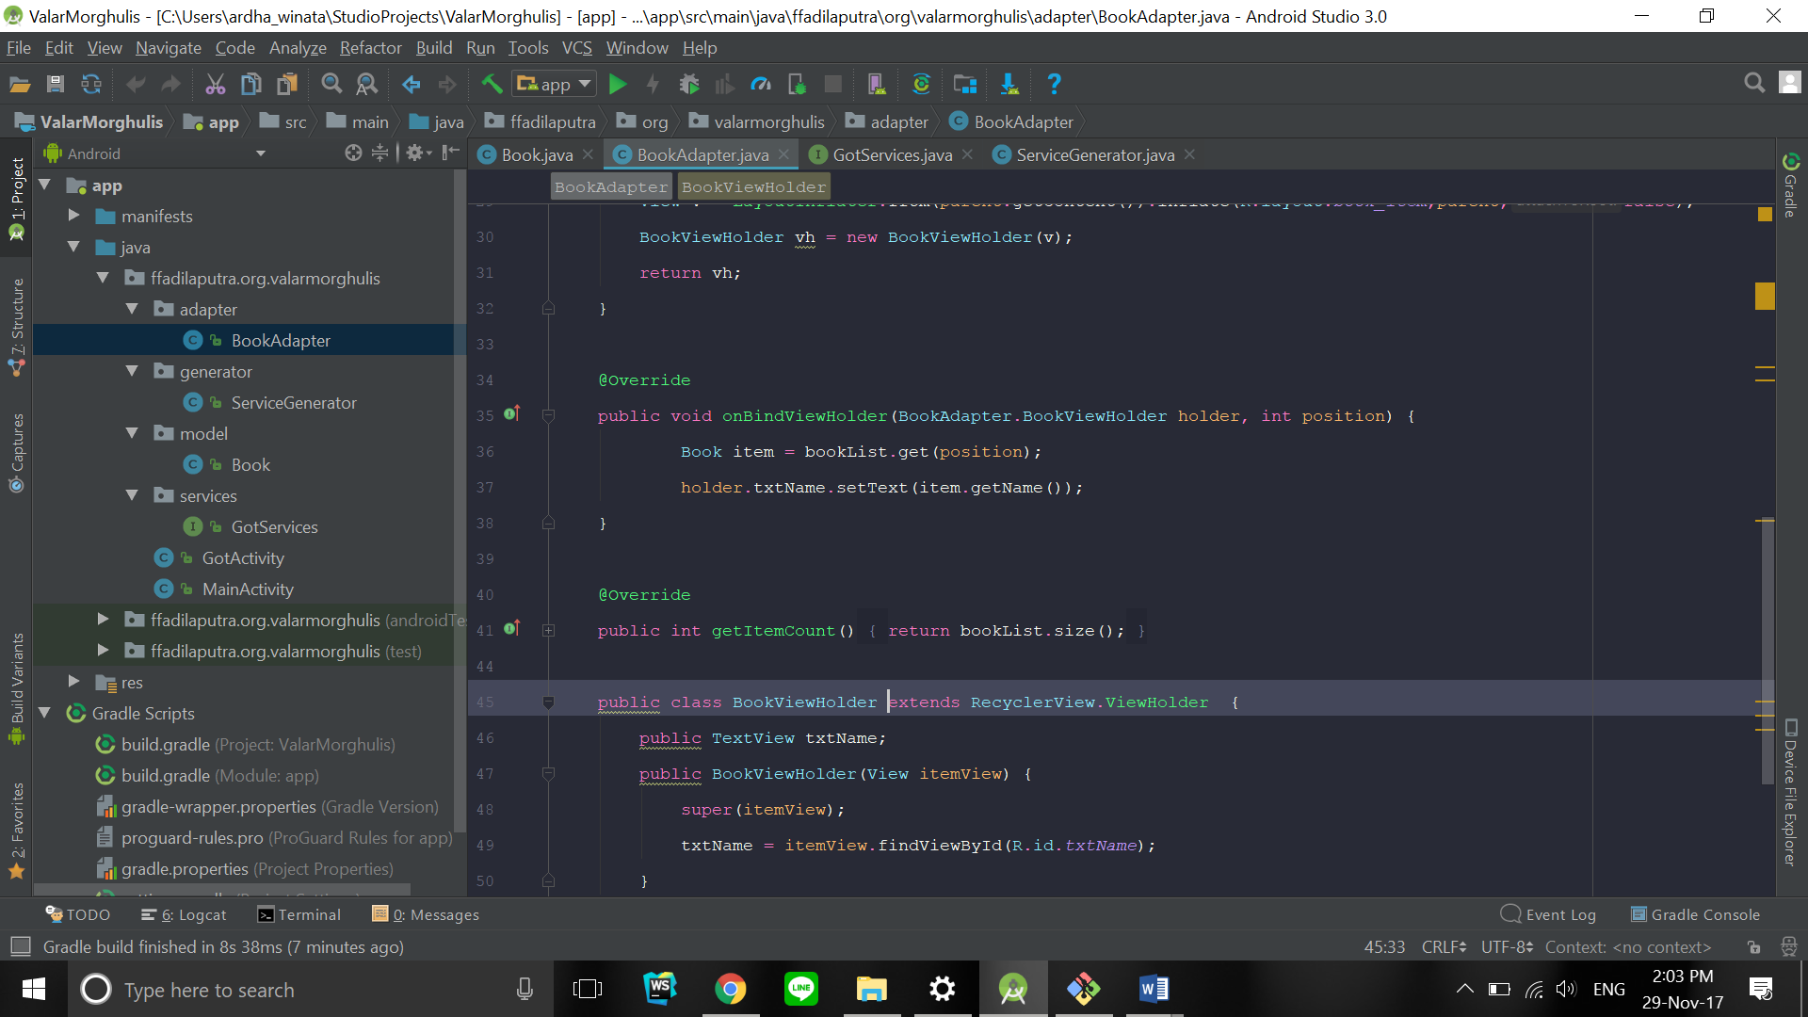

Services (package / services / GotServices)

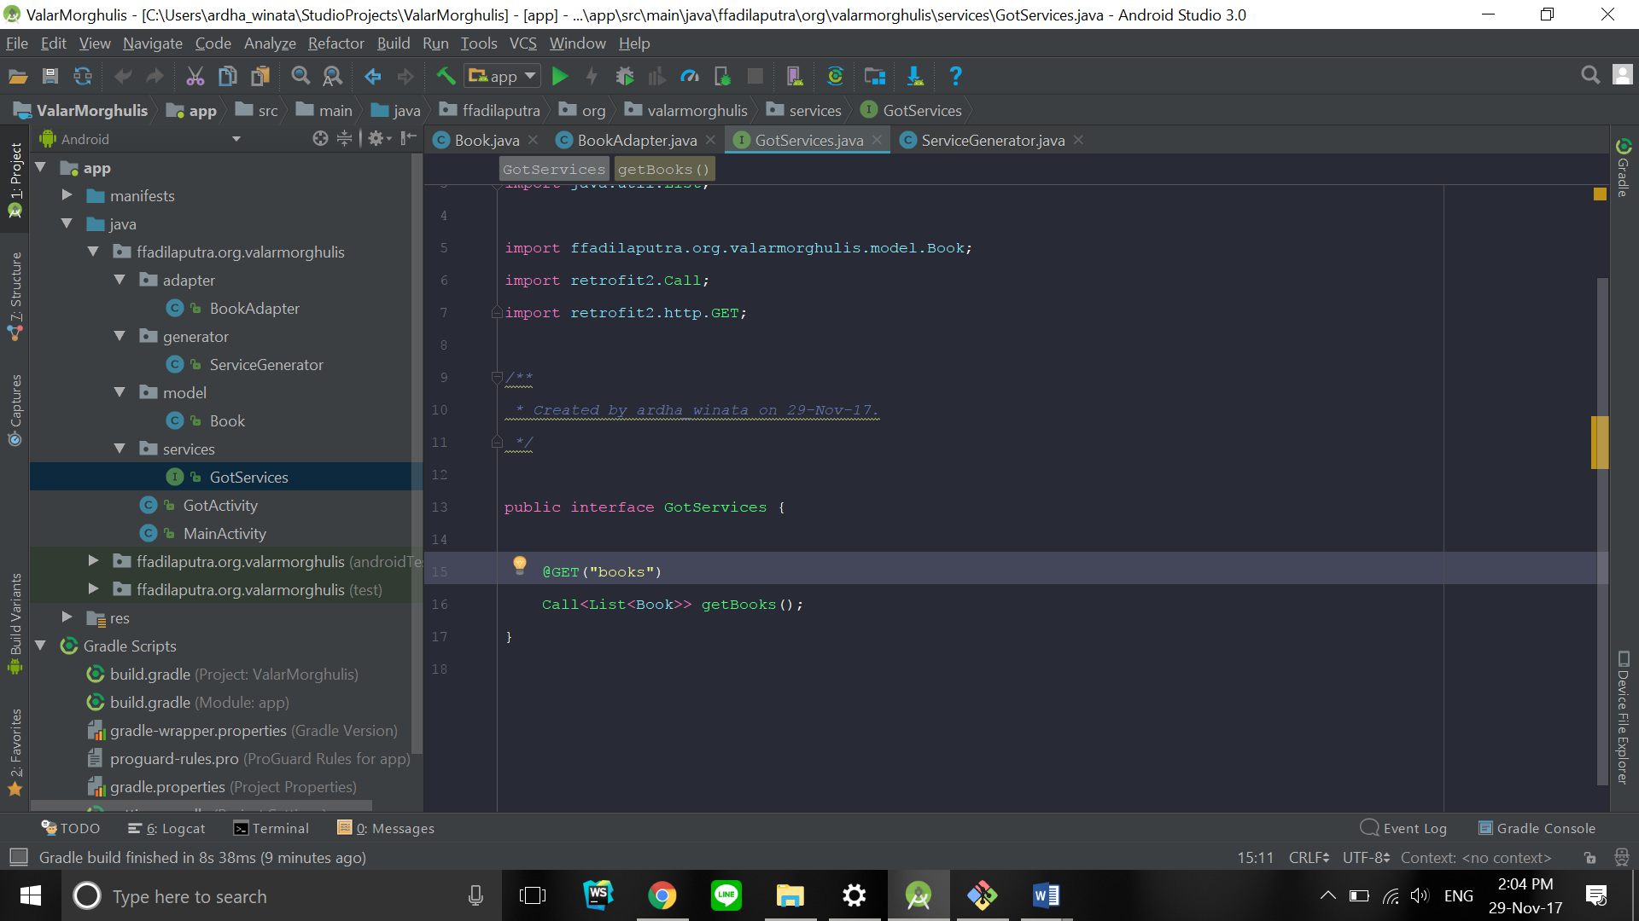

RecyclerView xml

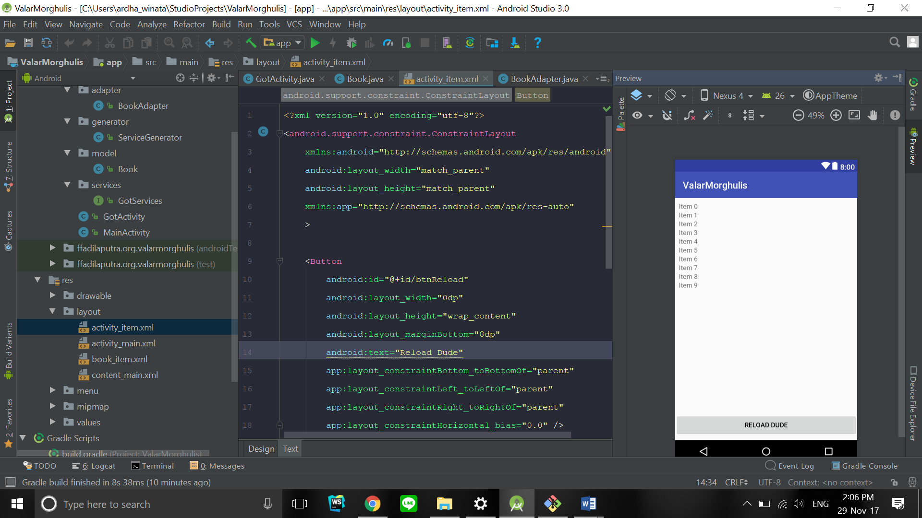

Data item recyclerview

