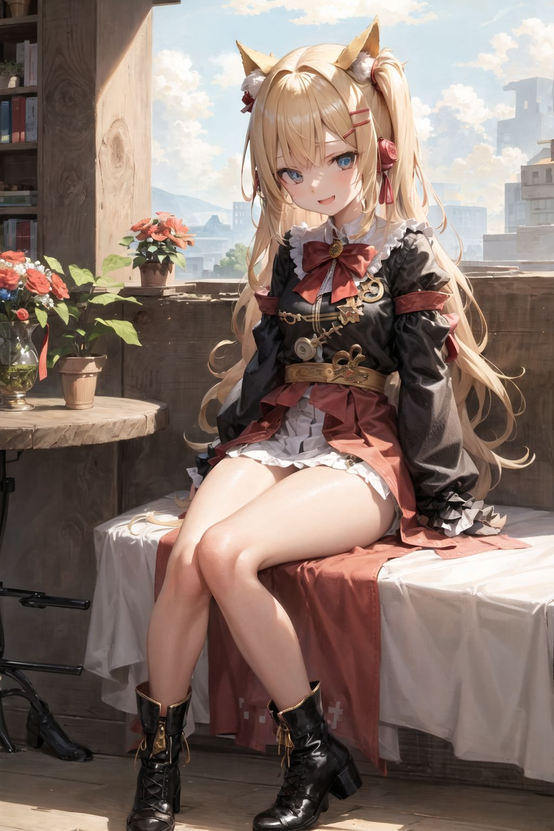test size color shade **bold** *italic* underline highlight font

***test all font attrs***

一行2个 inline

 

一行1个 横向 inline

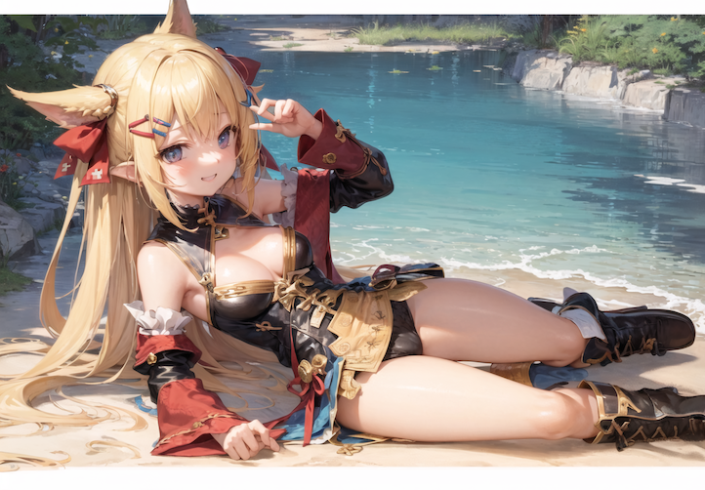

|  |  |  |  |  |  |  |  |  |
| --- | --- | --- | --- | --- | --- | --- | --- | --- |
| 1C0055 | 1C00AA | 1C55FF | 1C5555 | 1C55AA | 1CAAFF | 1CAA55 | 1CAAAA | 1CFFFF |
| 380055 | 3800AA | 3855FF | 385555 | 3855AA | 38AAFF | 38AA55 | 38AAAA | 38FFFF |
| 540055 | 5400AA | 5455FF | 545555 | 5455AA | 54AAFF | 54AA55 | 54AAAA | 54FFFF |
| 700055 | 7000AA | 7055FF | 705555 | 7055AA | 70AAFF | 70AA55 | 70AAAA | 70FFFF |
| 8C0055 | 8C00AA | 8C55FF | 8C5555 | 8C55AA | 8CAAFF | 8CAA55 | 8CAAAA | 8CFFFF |
| A80055 | A800AA | A855FF | A85555 | A855AA | A8AAFF | A8AA55 | A8AAAA | A8FFFF |
| C40055 | C400AA | C455FF | C45555 | C455AA | C4AAFF | C4AA55 | C4AAAA | C4FFFF |
| E00055 | E000AA | E055FF | E05555 | E055AA | E0AAFF | E0AA55 | E0AAAA | E0FFFF |
| FC0055 | FC00AA | FC55FF | FC5555 | FC55AA | FCAAFF | FCAA55 | FCAAAA | FCFFFF |

|  |  |
| --- | --- |
| (0, 0) | (0, 1) |
| (1, 0) | (1, 1) |
| (2, 0) | (2, 1) |

测试 AutoShape w:ln