Disentangling Signal from Noise in Hyperparameter Optimizer Evaluation: A Budget-Controlled Protocol Applied to SVM Classification

Abstract: Comparative studies of hyperparameter optimization (HPO) methods frequently rank optimizers using a single dataset, a single run, and no statistical testing, so that small accuracy differences—often within the range of cross-validation noise—are reported as evidence that one optimizer is superior to another. This paper argues that such conclusions are methodologically unsound and proposes a budget-controlled, multi-seed evaluation protocol that explicitly separates genuine between-optimizer signal from cross-validation noise. The protocol fixes the search space and the evaluation budget across all optimizers, blocks the cross-validation seed during optimization, repeats every configuration over many seeds to quantify noise, and analyses solution quality and search efficiency on separate tracks using non-parametric tests. We apply it to seven optimizers spanning exhaustive, random, model-based, population-based metaheuristic, and trajectory-based metaheuristic search—grid search, random search, Bayesian optimization with a Tree-structured Parzen Estimator, particle swarm optimization, differential evolution, a genetic algorithm, and simulated annealing—for SVM classification with the RBF kernel over the two-dimensional (C, γ) space, across ten stratified UCI and OpenML datasets with thirty seeds each. The protocol yields a clear methodological lesson: on solution quality the seven optimizers are statistically indistinguishable (Friedman p = 0.22), and in every dataset the between-optimizer spread is smaller than the seed-induced noise, so apparent accuracy rankings are artifacts of resampling rather than real differences. Genuine differences appear only in search efficiency (Friedman p < 10⁻⁷⁰), where grid search needs roughly 2.5 times as many evaluations as the adaptive methods to reach near-optimal performance. We conclude that, for low-dimensional SVM tuning, optimizer choice is irrelevant to accuracy and matters only for efficiency, and that random search is a pragmatic default. More broadly, the noise-aware protocol is a reusable template for fairer HPO comparisons.
Keywords: Hyperparameter optimization, Evaluation methodology, Cross-validation noise, Statistical comparison, Support vector machine, Metaheuristics, Reproducible benchmark.

- Introduction
Support Vector Machines (SVM) are among the most widely used supervised learning models, valued for their theoretical foundation and strong generalization on moderate-sized datasets [1]. Their performance is highly sensitive to hyperparameters: for the radial basis function (RBF) kernel, the regularization constant C and the kernel width γ jointly govern the bias–variance trade-off, and poor values degrade accuracy substantially [2]. Hyperparameter optimization (HPO) is therefore indispensable, and how it is conducted affects both the quality and the cost of the final model [3].
A broad range of HPO strategies has been applied to SVM tuning. Grid search exhaustively evaluates a discretized Cartesian product of candidate values and, while simple and reproducible, scales exponentially with the number of hyperparameters and expends evaluations on uninformative regions [3]. Random search relaxes the grid by sampling configurations independently and has been shown, both empirically and theoretically, to reach competitive solutions far more efficiently than grid search over the same domain [4]. Bayesian optimization (BO) builds a probabilistic surrogate of the objective and selects the next configuration by balancing exploration and exploitation, frequently achieving strong models with relatively few iterations [5, 6]. Metaheuristics have likewise been widely adopted for tuning the SVM regularization constant C and the RBF kernel width γ, motivated by their ability to traverse non-convex, multimodal search spaces without gradient information. These include population-based methods—Particle Swarm Optimization (PSO) [7, 14, 18], Differential Evolution (DE) [19, 20], and Genetic Algorithms (GA) [14, 21]—and the trajectory-based Simulated Annealing (SA) [8, 14, 18].
Despite this richness, optimizer choice in applied HPO is often justified by popularity rather than principled analysis: a metaheuristic is reported superior on a few datasets without characterizing the response surface, dataset properties, or statistical reliability. This sits in tension with the No Free Lunch theorem—averaged over all problems no optimizer dominates, so any advantage must come from a match between an algorithm’s bias and the problem structure [9]—and motivates treating optimizer choice as principled algorithm selection [10].
Two further issues compound the problem. First, comparisons are often made under unequal evaluation budgets or inconsistent search spaces, rendering reported “wins” difficult to interpret. Second, the objective being optimized—typically a cross-validation estimate—is itself stochastic, so differences between optimizers may reflect resampling noise rather than genuine algorithmic superiority. When the variation induced by random seeds exceeds the variation between optimizers, claims of dominance become statistically untenable. Disentangling this stochastic noise from meaningful performance differences is essential for valid conclusions, yet it is rarely addressed explicitly in applied SVM-tuning studies [11].
This study takes a rigorous, reproducible stance on comparing HPO algorithms for RBF-SVM classification. Rather than seeking a single “best” optimizer, we ask two questions: how much does optimizer choice affect the quality of the final model, and how much does it affect the efficiency with which a good model is found? Seven optimizers spanning distinct paradigms—grid search, random search, BO with a Tree-structured Parzen Estimator, and the population-based PSO, DE, GA and trajectory-based SA—are evaluated on a stratified collection of UCI and OpenML datasets covering a range of sample sizes and dimensionalities [12, 13]. All optimizers share an identical search space and budget, and every configuration is repeated over many seeds so that quality and efficiency can be separated from cross-validation noise by non-parametric testing [11].
The primary contribution of this work is methodological. First, and most importantly, we propose a budget-controlled, noise-aware evaluation protocol for comparing HPO methods: it fixes the search space and evaluation budget across all optimizers, blocks the cross-validation seed during optimization, repeats every configuration over many seeds to quantify the noise floor, and judges solution quality and search efficiency on separate tracks with appropriate non-parametric tests. This protocol is designed precisely to prevent the common failure mode in which resampling noise is mistaken for a genuine difference between optimizers. Second, applying this protocol to seven optimizers and ten stratified datasets, we demonstrate empirically that for SVM classification in the two-dimensional (C, γ) space the between-optimizer differences in accuracy are smaller than the seed-induced noise in every dataset, so optimizer choice is irrelevant to solution quality; meaningful and large differences exist only in search efficiency. Third, we provide a fully reproducible benchmark and a per-structure analysis that frames HPO optimizer choice as a problem of principled, evidence-based selection rather than convention. The remainder of this paper is organized as follows. Section 2 reviews related work; Section 3 describes the proposed protocol, datasets, and statistical methodology; Section 4 presents and discusses the results; Section 5 addresses threats to validity; and Section 6 concludes.
- Related work
  - Hyperparameter optimization methods
HPO is commonly formalized as black-box optimization: the objective—a resampling estimate of generalization—can only be queried pointwise, with no gradient [3]. Grid and manual search were long the defaults for their simplicity, but suffer the curse of dimensionality: grid points grow exponentially with the number of hyperparameters, and many evaluations fall in low-promise regions [3, 4].
Bergstra and Bengio [4] showed that random search is a markedly stronger baseline than grid search, finding equally good configurations within a fraction of the budget by allocating trials more effectively across the dimensions that matter. Sequential model-based methods followed: Bergstra et al. [5] introduced the Tree-structured Parzen Estimator (TPE) and Snoek et al. [6] popularized Gaussian-process Bayesian optimization, both using past evaluations to propose promising configurations.
Metaheuristics form a parallel line of work, split into population-based and trajectory-based methods. Population-based methods—genetic algorithms, differential evolution, and particle swarm optimization—maintain a set of candidates and are widely applied to SVM tuning for escaping local optima without gradients [7, 14, 19, 21]. Trajectory-based methods, canonically simulated annealing [8], evolve a single solution accepting occasional worsening moves under a cooling schedule, and have also tuned SVM hyperparameters [14, 18]. The review by Bischl et al. [3] unifies these within modern HPO with recommendations on evaluation and reproducibility.
  - Hyperparameter optimization for SVM

For RBF-SVM the search space is typically two-dimensional, spanning C and γ over wide logarithmic ranges [2]. Empirical comparisons repeatedly find that Bayesian optimization and random search reach strong models with far fewer evaluations than grid search, and recent studies continue to report favorable metaheuristic tuning [14, 15]. A recurring weakness is declaring one optimizer superior from a single dataset, a single run, and a raw accuracy difference, with no repetition or statistical test. Anggoro and Mukti [28], for instance, concluded from one medical dataset and one run that grid search beat random search by a margin (below one percentage point) that falls within the noise range demonstrated here—exactly the failure mode this protocol prevents. The most directly related work is Wainer and Fonseca [22], who evaluated eighteen algorithms for RBF-SVM tuning across 115 datasets and found that TPE and PSO selected slightly better hyperparameters than grid search at comparable cost, with additional search rarely improving future-data performance. Their comparison, however, neither enforced an identical budget across methods nor separated cross-validation noise from genuine differences. We complement it with a strictly budget-controlled protocol, an explicit signal-versus-noise analysis, and a two-class metaheuristic framing that tests whether the apparent differences are statistically reliable.
This gap is the point of departure for the present study. Rather than asserting the superiority of a particular optimizer, we ask under controlled conditions whether optimizer choice affects final accuracy at all, and where in the optimization process—if anywhere—the differences between optimizers become statistically meaningful.
Our questions also connect to work on whether tuning is worthwhile at all. Probst et al. [23] formalized “tunability” over 38 OpenML datasets and six algorithms, reporting that for SVM the largest gains come from tuning the kernel width while C is comparatively un-tunable. Weerts et al. [24], studying SVM and random forest across 59 datasets with a non-inferiority test, found that defaults are often non-inferior to tuning, and occasionally superior under a limited budget. Conversely, Turner et al. [25] concluded from the NeurIPS 2020 black-box optimization challenge that Bayesian optimization outperforms random search. These results are regime-dependent rather than contradictory: sophisticated search helps in higher-dimensional or harder spaces, whereas in the low-dimensional (C, γ) space studied here such advantages may vanish. We test this hypothesis directly, complementing the tuning-versus-default question of [23, 24] with a budget-matched optimizer-versus-optimizer comparison.
  - Algorithm selection and landscape analysis
That different algorithms suit different instances is the basis of the algorithm selection problem and follows from the No Free Lunch theorem [9]: since no optimizer is universally best, gains come from matching the algorithm to the problem structure. In continuous black-box optimization this is operationalized through Exploratory Landscape Analysis (ELA) [16], which characterizes an instance by numerical features from a sample of the objective. Kerschke et al. [10] survey automated algorithm selection and show such features can predict, via machine learning, which optimizer performs best on a given instance.
A practical caveat from this literature is directly relevant here: landscape-based conclusions are sensitive to the sampling strategy and to stochastic noise in the objective, so careful experimental control is necessary to obtain stable characterizations [17]. While the present study does not itself compute ELA features, it adopts the same methodological spirit—controlled sampling, fixed budgets, and explicit separation of noise from signal—and is intended as an empirical foundation on which landscape-aware algorithm selection for SVM HPO can be built.
This work also connects to research on variance in machine-learning evaluation. Bouthillier et al. [26] showed that variance from data sampling, initialization, and HPO can match the differences between methods, recommending that variation be randomized and accounted for rather than relying on a single run. Complementarily, Maria Merola [27] proposed blocking the cross-validation partition and initialization seed during tuning—“block what you can control, randomize what you cannot”—to reduce variance and yield fairer comparisons. Our design applies both: the cross-validation seed is blocked during optimization to remove fold variability, while the experiment seed is randomized over thirty repetitions to expose the residual noise against which optimizer differences must be judged.
- Materials and methods
  - Problem formulation
We consider hyperparameter optimization for an SVM classifier with an RBF kernel over the two-dimensional space defined by the regularization constant C and the kernel width γ. Following standard practice [2], both hyperparameters are searched on a base-2 logarithmic scale, with log₂C ∈ [−5, 15] and log₂γ ∈ [−15, 3]. The objective to be maximized is the mean classification accuracy obtained by stratified k-fold cross-validation on the training partition. Optimizing in logarithmic coordinates ensures that all optimizers explore the same geometry of the search space.
  - Optimization algorithms
Seven optimizers are compared, chosen to represent distinct search paradigms. Grid search evaluates a uniform 10×10 lattice over the logarithmic box. Random search draws configurations uniformly at random from the same box. Bayesian optimization uses the Tree-structured Parzen Estimator [5]. Three population-based metaheuristics—Particle Swarm Optimization, Differential Evolution, and Genetic Algorithm—are configured with a population of twenty individuals [7]. Finally, Simulated Annealing [8] represents the trajectory-based (single-solution) metaheuristic family, using a Gaussian neighborhood with a step size of ten percent of each dimension’s range and a geometric cooling schedule. The distinction between population-based and trajectory-based metaheuristics is analytically important rather than merely taxonomic: the two families embody opposite search strategies—one maintaining a distributed set of candidates that samples the space broadly, the other evolving a single point along a connected trajectory—and they are expected to behave differently on landscapes of differing ruggedness. Including a representative of each ensures that any claim of equivalence among optimizers is tested across both strategies, rather than within a single algorithmic style where a shared blind spot could go undetected.
Every optimizer is allotted an identical budget of one hundred objective evaluations within the identical search space. This value is not arbitrary: it is dictated by grid search, whose natural symmetric design in two dimensions is a 10×10 lattice, and the same budget is imposed on all others so none is advantaged. One hundred evaluations also reflect a realistic tuning effort, where each evaluation entails a full five-fold cross-validation, rather than an idealized budget of thousands of trials. It is moreover more than sufficient: every optimizer reaches ninety-nine percent of its own best cross-validation accuracy well within the allowance (typically ten to thirty evaluations), so the comparison measures convergence rather than premature truncation. This equal-budget, equal-space protocol is essential, since comparisons under unequal budgets cannot be interpreted reliably [3]; its sensitivity is considered in Section 5.
  - Datasets
The benchmark comprises ten public classification datasets from UCI and OpenML [12, 13]. Rather than maximizing their number, we selected a smaller collection stratified by sample size and feature dimensionality, so conclusions can be examined per structural regime. As Table 1 shows, the ten datasets populate every cell of a three-by-three size×dimensionality grid, leaving no regime unrepresented. They span 569–2,534 samples and 4–72 features and include multi-class as well as binary problems, broadening the range of objective shapes beyond the binary case; Table 2 lists their characteristics. Numeric features are kept as provided and categorical features one-hot encoded, as the RBF kernel requires numeric inputs. Within each run, features are mean-imputed and standardized inside a cross-validation pipeline to prevent leakage from validation folds into preprocessing.

Table 1 Dataset stratification by sample size and feature dimensionality. Every cell is populated
 | Low dim. (<10 feat.) | Mid dim. (10–30) | High dim. (≥30)
Small (<800) | diabetes, breast-w | ilpd | wdbc
Medium (800–1500) | banknote | vehicle | qsar-biodeg
Large (>1500) | car | steel-faults | ozone-8hr

Table 2 Characteristics of the ten benchmark datasets, ordered by feature count
Dataset | Samples | Features | Classes | Samples/feature
banknote | 1372 | 4 | 2 | 343.0
car | 1728 | 6 | 4 | 288.0
diabetes | 768 | 8 | 2 | 96.0
breast-w | 699 | 9 | 2 | 77.7
ilpd | 583 | 10 | 2 | 58.3
vehicle | 846 | 18 | 4 | 47.0
steel-faults | 1941 | 27 | 7 | 71.9
wdbc | 569 | 30 | 2 | 19.0
qsar-biodeg | 1055 | 41 | 2 | 25.7
ozone-8hr | 2534 | 72 | 2 | 35.2

  - Experimental protocol
Each dataset is split, by stratified sampling, into a training partition and a held-out test partition of twenty percent. Each optimizer searches using only the training partition, with the objective being five-fold stratified cross-validation accuracy under a fixed cross-validation seed during optimization, which isolates the optimizer’s search behavior from fold-to-fold variability. The best configuration found within the budget is refitted on the full training partition and evaluated once on the untouched test partition for an unbiased estimate of generalization accuracy.
To separate genuine differences from noise, the procedure is repeated across thirty seeds for every optimizer and dataset, yielding 2,100 runs. Besides final test accuracy, each run records the anytime best-so-far cross-validation accuracy versus evaluations and the number of evaluations to reach ninety-nine percent of its own best, capturing convergence and search efficiency as a distinct axis from final quality.
  - Statistical analysis
Comparisons follow Demšar’s non-parametric protocol for multiple methods over multiple datasets [11]. For each metric, optimizers are ranked per block (ties averaged) and the Friedman test assesses overall differences; when significant, the Nemenyi post-hoc test identifies which pairs differ, summarized by a critical-difference diagram. We use a significance level of 0.05 throughout.
The two metric families are treated differently. Accuracy differences are reported descriptively, with the between-optimizer spread compared against the seed-induced spread; where noise dominates, they are treated as unreliable. Efficiency metrics undergo the full inferential procedure. Experiments use scikit-learn for the SVM and cross-validation, Optuna for random search and TPE, and pymoo for the metaheuristics, with SA implemented directly; the pipeline is deterministic given the seeds and is released for reproducibility.
- Results and discussion
This section reports the full benchmark of 2,100 runs (seven optimizers × ten datasets × thirty seeds) under an identical search space and budget of one hundred evaluations. Although metaheuristic and Bayesian methods are increasingly applied to SVM tuning [14, 15], comparative studies rarely control simultaneously for search space, budget, and objective stochasticity. Results follow two axes—solution quality (Section 4.1) and search efficiency (Section 4.2)—then an algorithm-selection view (Section 4.3) and discussion (Section 4.4).
  - Solution quality
Before reporting the optimizer comparison, it is instructive to visualize the objective itself. Figure 1 shows the cross-validation accuracy surface over the (log₂C, log₂γ) search space for two contrasting datasets, computed on a dense 40×40 grid purely for illustration (this is a direct visualization of the objective, not an exploratory landscape analysis). For banknote, a dataset with a high sample-to-feature ratio, the surface is dominated by a single broad, smooth plateau of near-optimal accuracy; an optimum is easy to reach from almost anywhere in the box, which is precisely the condition under which the choice of search strategy should not matter. For ilpd, a more challenging dataset, the surface spans a much narrower accuracy range, the high-accuracy region is small and localized, and the surface is visibly more irregular. Part of this irregularity may reflect cross-validation noise on a smaller dataset rather than genuine multimodality—a distinction that is itself central to this paper—but the qualitative contrast between a wide, flat optimum and a narrow, localized one is clear and foreshadows the dataset-dependent behavior examined in Section 4.3.

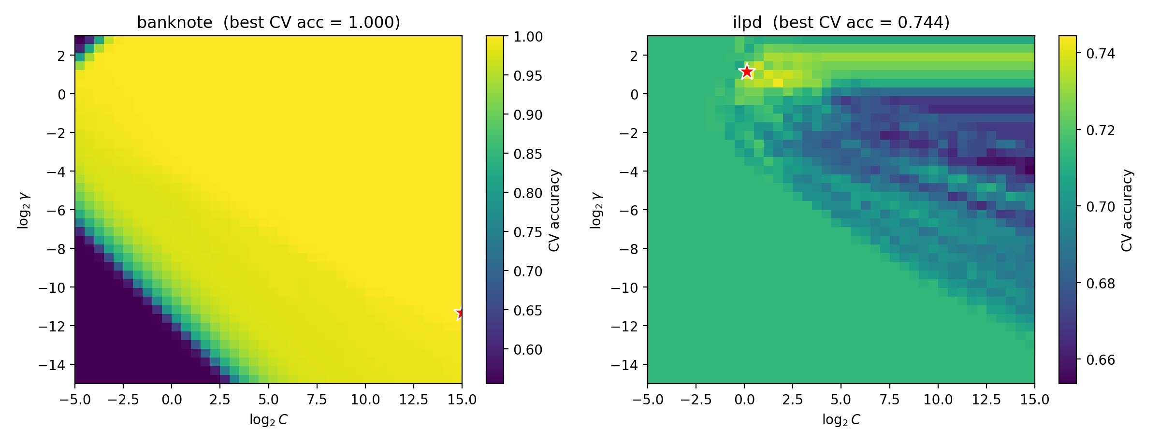
Figure 1 Cross-validation accuracy surface over the (log₂C, log₂γ) space for banknote (left) and ilpd (right); the red star marks the best grid configuration.

Table 3 summarizes the pooled final test accuracy of each optimizer. The seven optimizers are nearly identical: mean accuracies span only 0.8821 to 0.8836, a maximum difference of about 0.0015. A Friedman test over the ten datasets does not reject the null hypothesis of equal performance (χ² = 8.19, p = 0.22), so no optimizer produces more accurate models than any other—including simulated annealing, which as a trajectory-based method confirms the equivalence from a different algorithmic family.
More revealing than the means is the between-optimizer spread against the seed-induced spread. Table 4 reports, per dataset, the range of mean accuracy across the seven optimizers (signal) alongside the average standard deviation across seeds (noise). In all ten datasets noise exceeds signal, with ratios of 0.17 to 0.42, so between-optimizer differences are smaller than a single optimizer’s run-to-run variability. Claims of accuracy superiority on this kind of low-dimensional SVM problem are therefore not statistically defensible; the concern that gains may reflect resampling variability rather than genuine differences [3] is made concrete for SVM.

Table 4 Signal-versus-noise analysis for final test accuracy. In every dataset the between-optimizer range is smaller than the within-optimizer seed standard deviation (ratio < 1)
Dataset | Between-optimizer range | Within-optimizer SD (seeds) | Signal/noise ratio
banknote | 0.0001 | 0.0003 | 0.37
breast-w | 0.0021 | 0.0129 | 0.17
car | 0.0006 | 0.0033 | 0.17
diabetes | 0.0043 | 0.0258 | 0.17
ilpd | 0.0108 | 0.0258 | 0.42
ozone-8hr | 0.0029 | 0.0078 | 0.37
qsar-biodeg | 0.0055 | 0.0219 | 0.25
steel-faults | 0.0043 | 0.0213 | 0.20
vehicle | 0.0086 | 0.0235 | 0.37
wdbc | 0.0044 | 0.0130 | 0.34

Table 3. Pooled solution quality, search efficiency, and average efficiency rank for each optimizer (mean over ten datasets and thirty seeds; lower efficiency rank is better).
Optimizer | Test acc. (mean) | Test acc. (SD) | Evals to 99% (mean) | Avg. rank (eff.)
Grid | 0.8835 | 0.1061 | 28.57 | 5.95
Random | 0.8824 | 0.1071 | 10.48 | 3.35
BO-TPE | 0.8836 | 0.1054 | 11.69 | 3.67
PSO | 0.8821 | 0.1066 | 12.36 | 3.69
DE | 0.8827 | 0.1063 | 11.43 | 3.62
GA | 0.8832 | 0.1054 | 12.18 | 3.72
SA | 0.8834 | 0.1045 | 14.61 | 4.00

  - Search efficiency
While solution quality is uniform, search efficiency differs sharply. Efficiency is measured by the number of evaluations required for a run to reach ninety-nine percent of its own best cross-validation accuracy. As shown in Table 3, grid search requires on average 28.6 evaluations, whereas the six adaptive methods require only 10.5 to 14.6. A Friedman test over all 300 dataset-seed blocks is overwhelmingly significant (χ² = 341.95, p < 10⁻⁷⁰).
The Nemenyi post-hoc test (Figure 2) clarifies the structure. Grid search is significantly less efficient than every other method (all pairwise p < 0.0001), standing alone at the far right. The six adaptive methods cluster tightly but show fine structure: random search ranks best (3.35), the population-based metaheuristics and Bayesian optimization form a middle group (3.62–3.72), and simulated annealing trails at 4.00. SA differs significantly from random search (p = 0.005) and grid search (p < 0.0001), but not from the population metaheuristics or BO (all p > 0.34). This is consistent with simulated annealing being a single-solution search, marginally less sample-efficient than population- or model-based methods on this benign two-dimensional space yet far more efficient than grid search.

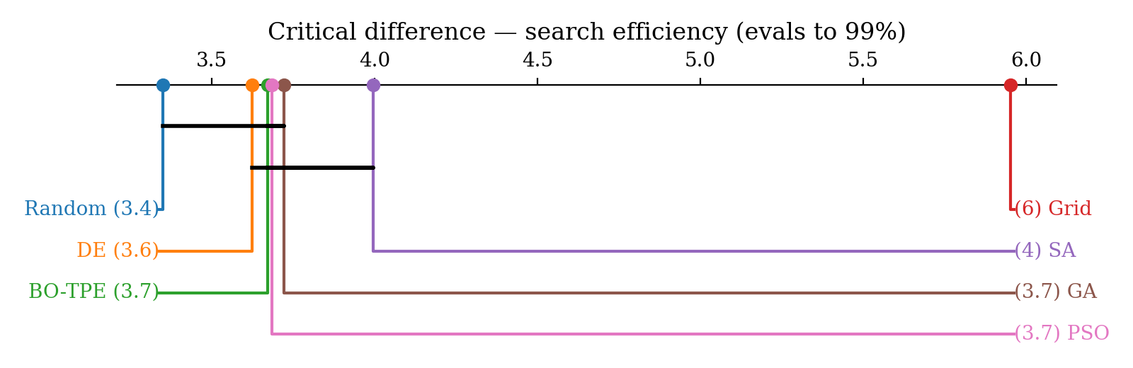
Figure 2 Critical-difference diagram for search efficiency (evaluations to 99% of best). Methods connected by a bar are not significantly different at α = 0.05. Grid search is isolated as significantly less efficient; the adaptive methods cluster, with random search best and simulated annealing at the trailing edge.

Figure 3 plots mean best-so-far cross-validation accuracy against evaluations. The adaptive methods already average about 0.80 at the first evaluation, whereas grid search begins near 0.615 and climbs in a characteristic staircase—each jump occurring as the fixed lattice enters a new kernel-width row of high-accuracy configurations. Grid search catches up only around fifty evaluations, after which all seven sit near 0.89. Simulated annealing is distinguishable in the intermediate regime (about ten to thirty evaluations), below the population- and model-based methods yet well above grid search, mirroring its intermediate rank. Figure 4 summarizes the two axes: final accuracy is essentially flat across optimizers, while evaluations to near-optimality separate grid search sharply from the adaptive group, SA marginally above the rest.
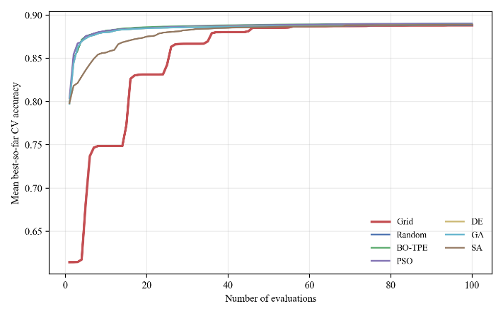
Figure 3 Anytime performance: mean best-so-far cross-validation accuracy versus number of evaluations, averaged over the ten datasets and thirty seeds. Grid search rises in a characteristic staircase and lags well behind the adaptive methods in the low-budget regime; all methods converge to a common level by roughly fifty evaluations.

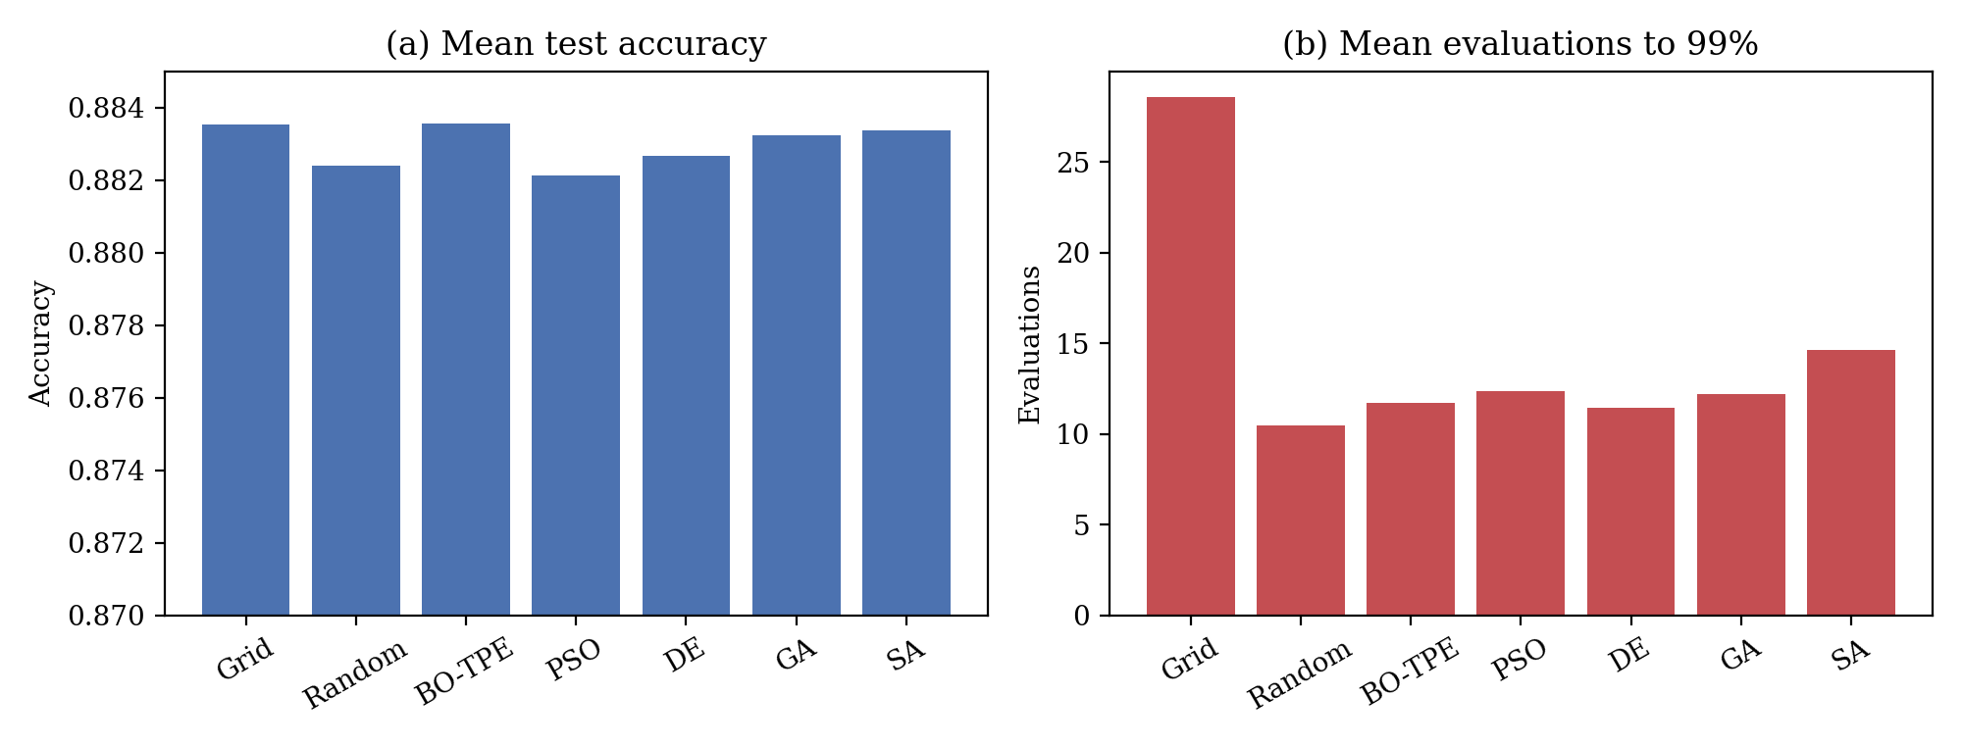
Figure 4. Contrast between the two axes: (a) final test accuracy is essentially flat across optimizers, whereas (b) the number of evaluations to near-optimality separates grid search sharply from the adaptive methods, with simulated annealing slightly above the other adaptive methods.
  - Outcomes in relation to dataset characteristics
To probe whether optimizers are preferable for kinds of datasets—the algorithm-selection perspective motivated by the No Free Lunch theorem [9, 10]—we recorded, for each dataset, the optimizer achieving the highest mean accuracy and the optimizer achieving the best efficiency, alongside dataset meta-features. The nominal accuracy winners are distributed across several optimizers and show no coherent relationship with dataset size or dimensionality. This apparent randomness is expected and consistent with Section 4.1: because between-optimizer accuracy differences lie within seed noise, the identity of the per-dataset accuracy winner is essentially arbitrary. We did observe a weak tendency for the between-optimizer accuracy spread to increase as the sample-to-feature ratio decreases (Spearman ρ = −0.66, p = 0.038), suggesting that on more challenging configurations the optimizers may begin to diverge; however, this spread remains within the band of cross-validation noise in all datasets, and the correlation does not survive correction for multiple comparisons, so it is reported only as a tentative indication and a motivation for future work on higher-dimensional spaces. We therefore refrain from drawing per-profile algorithm-selection rules; the well-supported conclusion is the absence of a dominant optimizer, itself the empirical signature anticipated by the No Free Lunch theorem when competing methods are closely matched.

Table 5. Per-dataset accuracy winner and efficiency winner, alongside dataset meta-features. The accuracy winners are scattered across several optimizers with no coherent relationship to dataset structure—consistent with the finding that between-optimizer accuracy differences lie within seed noise—whereas grid search never wins on efficiency.
Dataset | Samples | Features | Classes | Samples/feat. | Acc. winner | Eff. winner
diabetes | 768 | 8 | 2 | 96.0 | Random | Random
breast-w | 699 | 9 | 2 | 77.7 | SA | GA
vehicle | 846 | 18 | 4 | 47.0 | Grid | BO-TPE
wdbc | 569 | 30 | 2 | 19.0 | Grid | Random
car | 1728 | 6 | 4 | 288.0 | Random | PSO
ilpd | 583 | 10 | 2 | 58.3 | SA | DE
qsar-biodeg | 1055 | 41 | 2 | 25.7 | Random | Random
banknote | 1372 | 4 | 2 | 343.0 | Random | PSO
steel-faults | 1941 | 27 | 7 | 71.9 | Grid | SA
ozone-8hr | 2534 | 72 | 2 | 35.2 | Grid | DE

  - Discussion
Taken together, the results tell a coherent, counter-intuitive story. In the two-dimensional (C, γ) space, optimizer choice has no measurable effect on accuracy: all seven methods locate equally good configurations and the residual differences are pure noise. The only decision that matters is whether to use grid search, which is substantially less efficient. Including simulated annealing extends this across both metaheuristic classes: neither population-based nor trajectory-based methods, nor Bayesian optimization, beat plain random search on accuracy, and only random search holds a slight, statistically detectable efficiency edge. We discuss below how this aligns with, and diverges from, the literature.
Relation to tunability and the value of tuning. Our accuracy result is the optimizer-versus-optimizer counterpart of the tuning-versus-default findings of Probst et al. [23] and Weerts et al. [24]. Probst et al. reported that, for the SVM, the cost parameter C is comparatively un-tunable while the kernel width carries most of the tunable signal; since our search space couples C with γ, a benign, single-basin response surface—of the kind visualized in Section 4.1—is exactly what their tunability analysis would predict, and it explains why every optimizer converges to essentially the same accuracy. Weerts et al., using a non-inferiority test across 59 datasets, found that default hyperparameters are frequently non-inferior to tuned ones and occasionally superior under a limited budget. Our finding is the natural sibling of theirs: where they show that tuning often does not beat a sensible default, we show that, once one does tune, the search algorithm used does not matter for accuracy. Both results converge on the same practical message—that the marginal return to algorithmic sophistication in low-dimensional SVM tuning is small—reached from two independent directions, which lends the conclusion additional credibility.
Reconciling the apparent contradiction with the BBO challenge. Our results seem to oppose Turner et al. [25], who claim Bayesian optimization beats random search in the NeurIPS 2020 challenge, but the tension is one of regime. The challenge involved higher-dimensional, heterogeneous spaces where a surrogate exploits structure that random sampling cannot. Our two-dimensional (C, γ) space is the opposite: small, continuous, and largely unimodal, leaving little for a surrogate to exploit within a hundred evaluations. The findings thus delimit rather than contradict each other—Bayesian optimization’s advantage is real but regime-dependent—consistent with Bergstra and Bengio [4], whose case for random search rests on the low effective dimensionality of many tuning problems.
Why grid search alone is penalized. Its 2.5-fold disadvantage has a structural explanation: a fixed lattice spends early evaluations on the corners and edges of the box, many in low-accuracy regions (very small or large γ), and cannot redirect its remaining budget. Adaptive methods, including random search, sample the interior representatively from the outset; Figure 3 shows grid search alone in a slow, staircase-shaped early ascent while the others climb steeply. This mirrors Bergstra and Bengio [4] on grid search wasting evaluations along irrelevant dimensions, and Wainer and Fonseca [22], who likewise found grid search dominated at equal cost. Our contribution is to show, under a budget-matched protocol with statistical testing, that this is the only optimizer difference that survives once noise is separated from signal.
Methodological implication. A distinctive element is the explicit separation of between-optimizer signal from seed noise. Wainer and Fonseca [22] noted that procedures do not differ significantly when several good configurations exist—pointing the same way as our result—but did not quantify the spread-to-noise relationship nor enforce an identical budget. Doing both lets us state more strongly that accuracy differences here are not merely non-significant but smaller than the noise floor. That the same protocol still detects a small, reliable efficiency difference (random versus SA) shows it has discriminative power, so the accuracy equivalence is a positive finding, not a sensitivity artifact. Applied studies reporting metaheuristic superiority without such controls [14, 15] are thus likely reporting noise.
Practical recommendation. For low-dimensional SVM tuning, random search is a sound default: as simple as grid search, as sample-efficient as Bayesian optimization and the metaheuristics, and free of their overhead. More elaborate optimizers should be reserved for settings where they matter—higher-dimensional, multi-kernel, or more rugged spaces—the regime in which the BBO-challenge evidence [25] suggests their advantage re-emerges. Characterizing that transition, ideally through landscape analysis, is the natural continuation of this work.
- Conclusion
This paper proposed a budget-controlled, noise-aware protocol for comparing HPO methods and applied it to seven optimizers for RBF-SVM classification across ten stratified datasets and thirty seeds, separating solution quality from search efficiency. The protocol addresses a widespread weakness—ranking optimizers from a single run on a single dataset without statistical testing—by quantifying the noise floor and judging differences against it. In the two-dimensional (C, γ) space, optimizer choice has no significant effect on accuracy—in every dataset the between-optimizer differences are smaller than cross-validation noise—while its effect on efficiency is large, with grid search roughly 2.5 times less efficient than the adaptive methods. Those adaptive methods are closely matched, random search holding a slight edge and simulated annealing trailing marginally yet far ahead of grid search.
In practice, random search is a pragmatic default for low-dimensional SVM tuning: as simple as grid search yet as efficient as Bayesian optimization and metaheuristics, with no accuracy penalty. More broadly, the study shows the value of grounding optimizer choice in controlled analysis and distinguishing genuine differences from noise. Future work will extend to higher-dimensional and multi-kernel spaces, and to SVR, and will use exploratory landscape analysis to characterize the response surface directly—moving from the equivalence observed here toward a landscape-aware framework for algorithm selection in HPO.

Conflicts of interest
The authors declare no conflict of interest.

Author contributions
Conceptualization, Ardiansyah; methodology, Ardiansyah; software, Ardiansyah; validation, Ardiansyah, and Yanto; formal analysis, Yanto; investigation, Yanto; resources, Ardiansyah; data curation, Ardiansyah, and Yanto; writing—original draft preparation, Ardiansyah; writing—review and editing, Ardianyah, and Yanto; visualization, Ardiansyah; supervision, Yanto.

