Pet Information
Owners Name:
Proposed date of travel (dd/mm/yy):
Departure Airport:
Destination Airport:
Address at Origin:
Phone Number:
Email:
Address at Destination:
Phone number at Destination:
If shipping by cargo Name of person collecting your pet:
Pet Name:
Species & Breed:
Sex:
Color:
Date of Birth:
Microchip Number and insertion date:
Rabies vaccination? (date)
Is this Vaccination Record available?
Current vaccinations?
Preferred mode of transportation: | Cargo / excess baggage
Do you have a crate for flight?
Approximate weight (with crate):
Crate measurements (LxWxH in cm)
Please ensure you complete and return the second page

Measurements as follows for dogs / cats – please see diagram below
Length A - Tip of nose to base of tail (not including tail):
Width B - Width across (not around) shoulders:
Height C - Ground to top of head (not including ears):
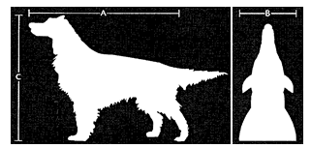

Service | Required | Not required (meet us there – instructions will be given)
Collection & return for any required blood sampling / treatments
Collection and return for Gov Health Check
Location of pet if boarding:

I, the undersigned am the Owner of the above named pets and hereby acknowledge that I am asking Equestrian Support Services PLT to act on my behalf in shipping my pet(s).
I understand that the movement of my pet(s) is entirely at my own risk.

Name:

Signature:

Date:

IMPORTANT: All pets are handled at the owner’s risk.

